Figure S1.

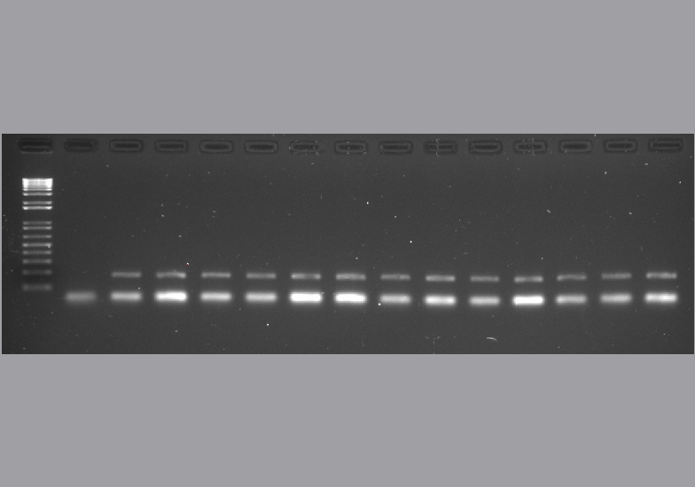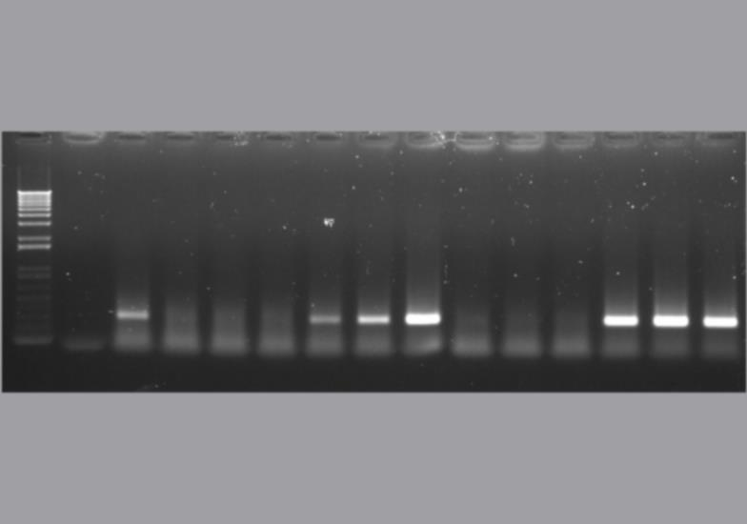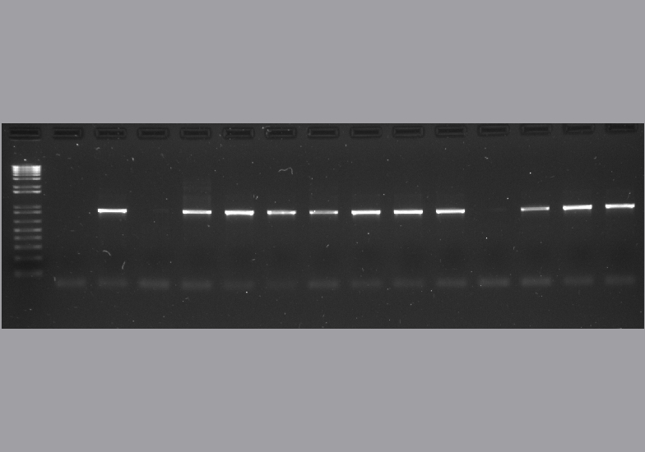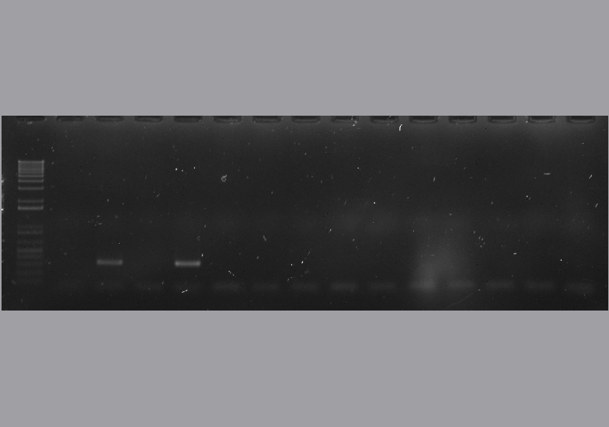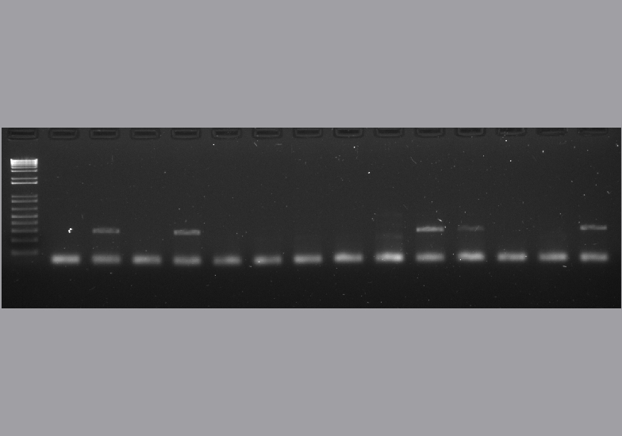

M -ve +ve asymptomatic symptomatic asymptomatic symptomatic

c.v. Merlot

c.v. Syrah

**NADH**

**GRBV**

**RSPV**

**GFLV**

**GSYV**