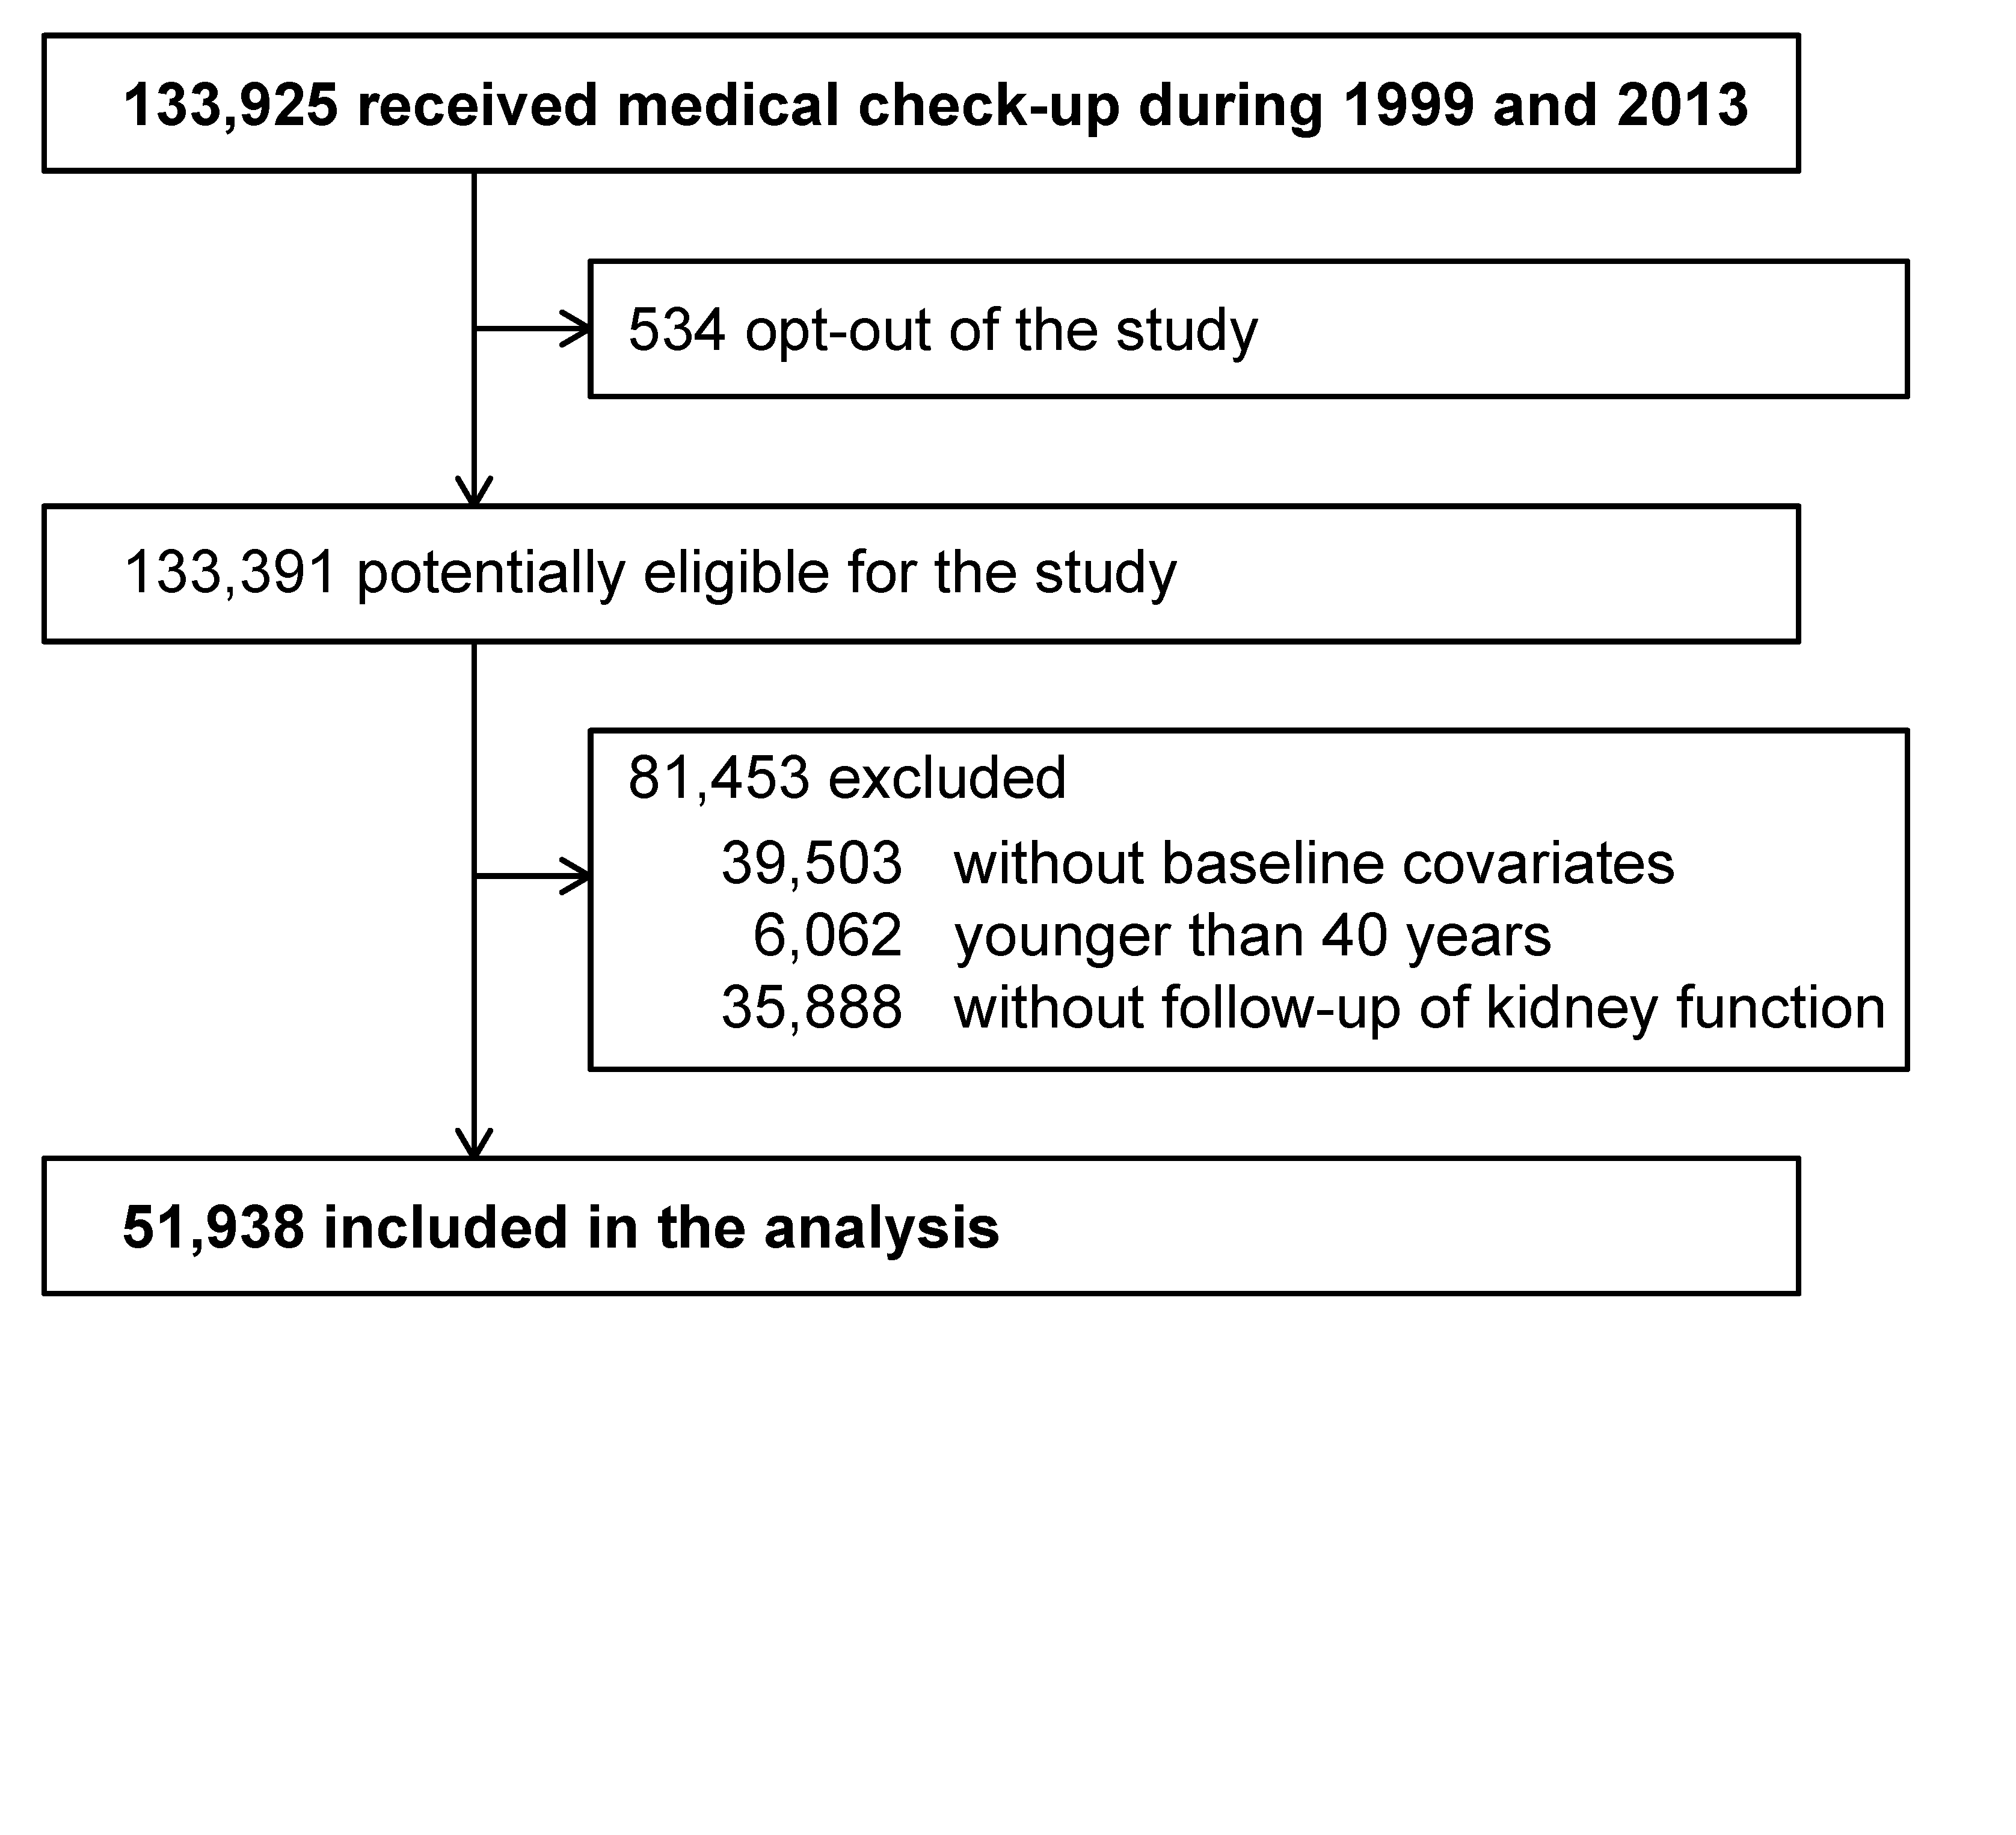
Appendix Figure 1. Flow diagram of the selection of study participants.

Appendix Figure 2. Baseline systolic blood pressure and loss of kidney function according to age groups.
Systolic blood pressure was divided at 110, 120, 130, 140, 150, 160 mmHg.
Number of people in each group: n=1,775 (age 40–49 years); n=4,396 (age 50–59 years); n=19,015 (age 60–69 years); n=18,635 (age 70–79 years); n=8,127 (age ≥80 years). Values are differences from the slope of reference group (systolic blood pressure 120–129 mmHg). Each variable was adjusted for sex, diastolic blood pressure, body mass index, proteinuria, hemoglobin, total cholesterol, smoking status, history of coronary disease, history of stroke, and diabetes mellitus. The error bars represent 95% confidence intervals.

