Flexible cotton-AuNP thread electrode for non-enzymatic sensor of uric acid in urine
Kanyapat Teekayupak¹, Nipapan Ruecha², Orawon Chailapakul^{1*}, Nadnudda Rodthongkum^{2,3*}
¹Electrochemistry and optical spectroscopy Center of Excellent (EOSCE), Department of Chemistry, Faculty of Science, Chulalongkorn University, Pathumwan, Bangkok 10330, Thailand
²Metallurgy and Materials Science Research Institute, Chulalongkorn University, Soi Chula 12, Phayathai Road, Pathumwan, Bangkok 10330, Thailand
³Center of Excellence in Responsive Wearable Materials, Chulalongkorn University, Bangkok 10330, Thailand
*Corresponding authors at E-mail addresses: Nadnudda.r@chula.ac.th, Corawon@chula.ac.th

The effect of HAuCl₄ concentration on modified cotton thread-based electrodes.
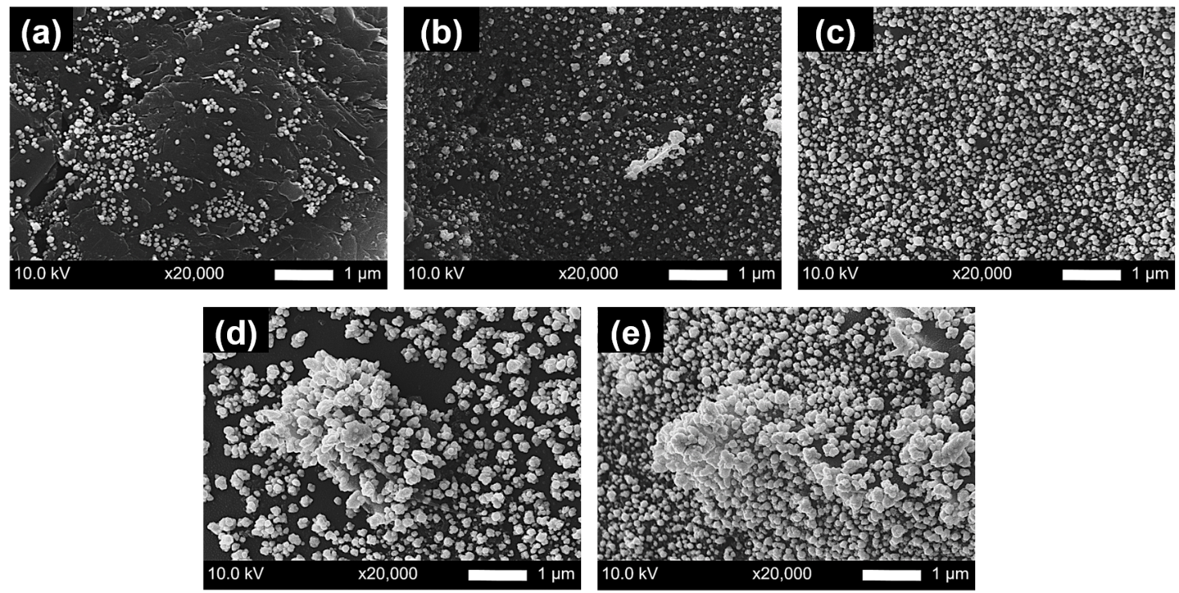
Fig. S1 SEM images of the AuNPs/carbon-coated cotton thread-based electrodes with different concentration of HAuCl₄·3H₂O, (a) 1.0 mM, (b) 2.0 mM, (c) 3.0 mM, (d) 4.0 mM and (e) 5.0 mM with magnification of 20,000×.

The effect of electrodeposition time on modified cotton thread-based electrodes.
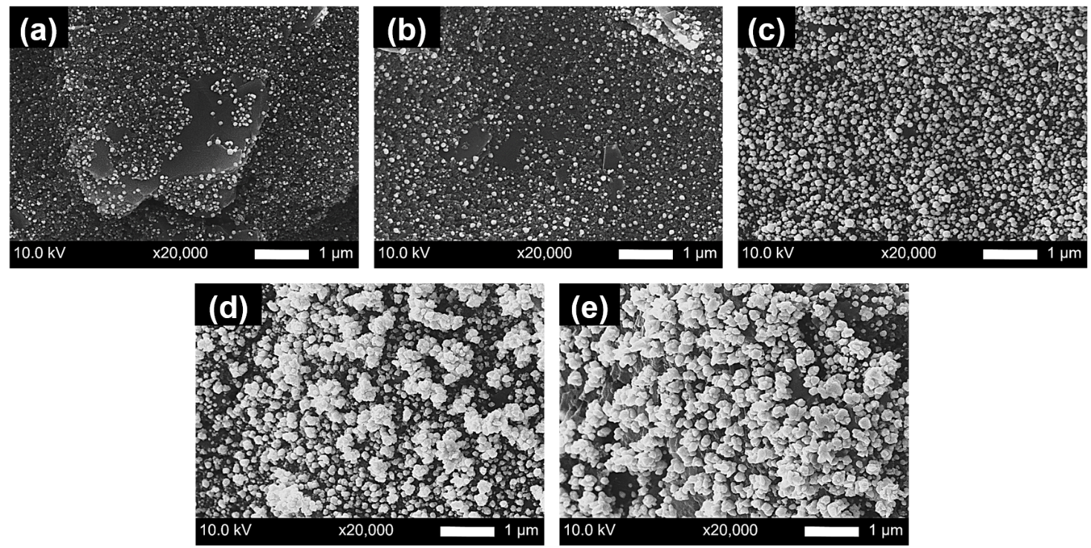
Fig. S2 SEM images of the AuNPs/carbon-coated cotton thread-based electrodes with different electrodeposition time, (a) 30 s, (b) 60 s, (c) 120 s, (d) 180 s and (e) 240 s with magnification of 20,000×.

Optimization of parameters for uric acid detection.
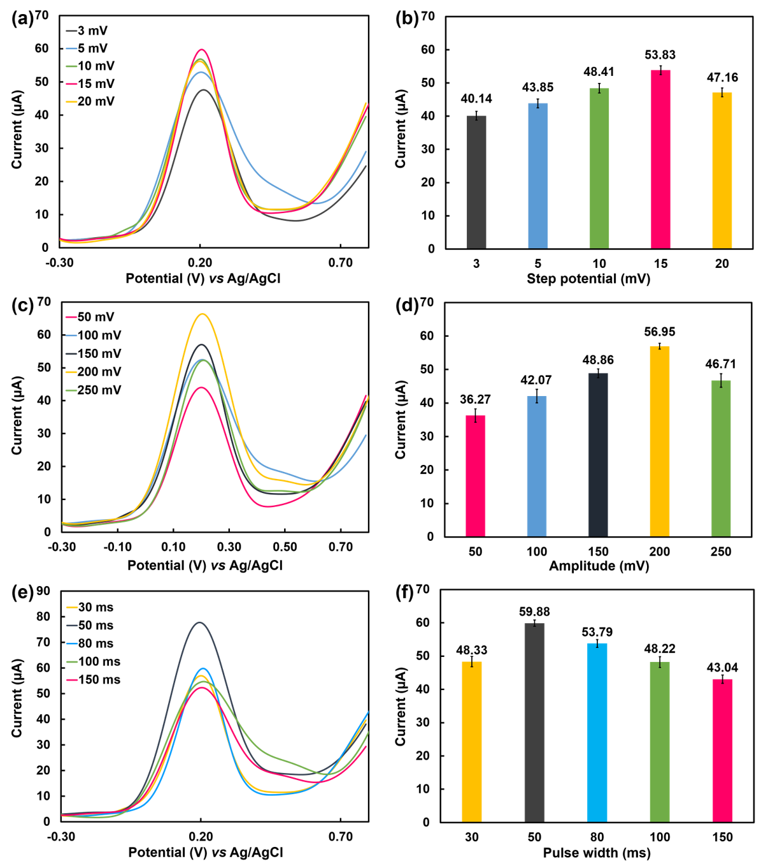
Fig. S3 Anodic current responses obtained from differential pulse voltammograms of 1.0 mM UA using the modified cotton thread-based electrodes with different (a) step potentials, (c) amplitudes, and (e) pulse widths and average anodic peak currents (n=3) obtained from differential pulse voltammograms in (b) Fig. S3a, (d) Fig. S3c, and (f) Fig. S3e, respectively.
The analytical performance of the carbon cotton thread-based sensor.
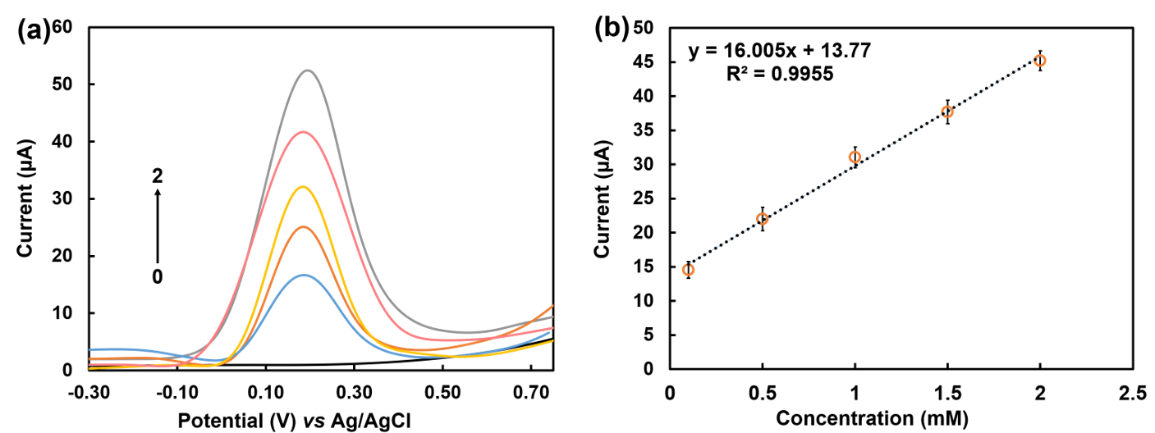
Fig. S4 (a) Differential pulse voltammograms of different concentrations of UA (0−2 mM) on the carbon coated cotton thread-based sensor and (b) linear range from 0.1−2.0 mM by measurements using 3 individual single-use electrodes (n=3).

Stability of AuNPs modified cotton thread-based electrodes.
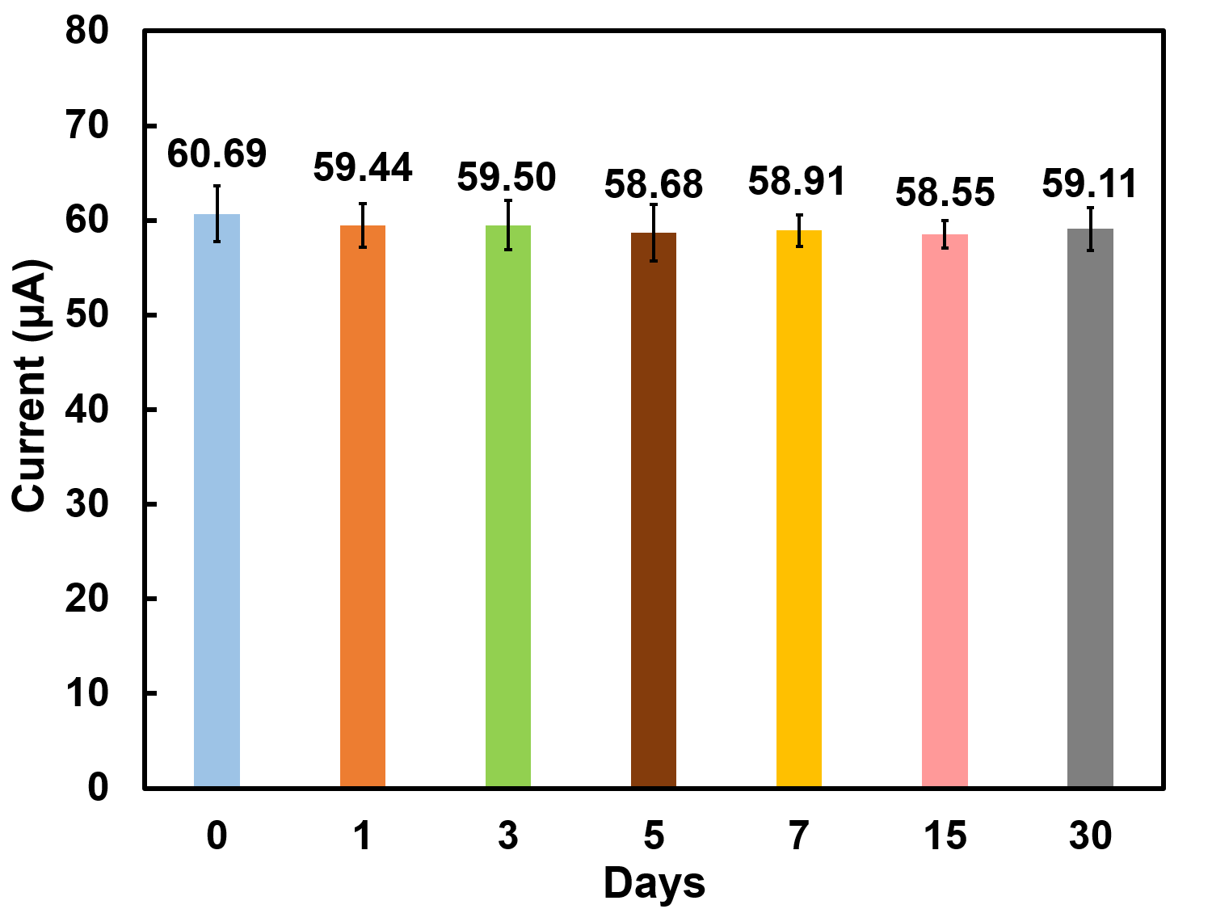
Fig. S5 Stability of AuNPs modified cotton thread-based sensor with different periods after fabrication by measurements with 3 individual single-use electrodes (n=3).

The analytical performance of the modified sensor in artificial urine samples.
Fig. S6 (a) Differential pulse voltammograms of different concentrations of UA in artificial urine (0−3.4 mM) on the modified cotton thread-based sensor and (b) linear range from 0.4−3.4 mM by measurements using 3 individual single-use electrode (n=3).

Table S1 Determination of different concentrations of UA in artificial urine samples using the modified sensor directly integrated on diaper (n=3).

Spiked UA concentration (mM) | Measured UA concentration (mM) | Recovery  (%) | RSD  (%)
1.0 | 1.05±0.09 | 105 | 8.5
2.0 | 1.92±0.11 | 96 | 5.7
3.0 | 3.03±0.09 | 101 | 3.0

