APPENDIX A
THE ENGLISH VERSION OF DEMOGRAPHIC/HEALTH VARIABLES

Demographics:

1 What is your age?
_ _ Code age in years
0 7 Don’t know / Not sure
0 9 Refused
2 Are you?
0 Male
1 Female
3 Are you…?
1 Married
2 Divorced
3 Widowed
4 Separated
5 Never married
4 How many family members live in your household?
5 What is the highest grade or year of school you completed?
1 Never attended school or only attended kindergarten
2 Grades 1 through 8 (Elementary)
3 Grades 9 through 11 (Some high school)
4 Grade 12 or GED (High school graduate)
5 College 1 year to 3 years (Some college or technical school)
6 College 4 years or more (College graduate)
9 Refused
7 Monthly household income:
1 Less than 250 JD
2 between 250-350 JD
3 between 350-450 JD
4 between 450-550 JD
5 between 550-650 JD
6 between 650-750 JD
7 between 750-850 JD
8 between 850-950 JD
9 over 950 JD
7 7 Don’t know / Not sure
9 9 Refused

Demographics (cont.)

7.8 Have you ever been admitted to hospital in the past year and how many times?
1 Yes and how many ……
2 No
8.1 Have you had any type of disabilities?
1 Yes and it is ……
2 No

Health variables:

4 Refused | 3 Don’t know / Not sure | 2 No | 1 Yes
 |  |  |  | (Ever told) you had a hypertension?
 |  |  |  | (Ever told) you had an angina, heart attack, or coronary heart disease?
 |  |  |  | (Ever told) you had a stroke?
 |  |  |  | (Ever told) you had asthma?
(Ever told) you have Chronic Obstructive Pulmonary Disease or COPD, emphysema or
chronic bronchitis?
 |  |  |  | (Ever told) you have some form of arthritis, rheumatoid arthritis, or gout?
 |  |  |  | Do you have any trouble seeing, even when wearing glasses or contact lenses?
 |  |  |  | Do you have any hearing problem?
 |  |  |  | (Ever told) you have diabetes?

APPENDIX B

MONTREAL COGNITIVE ASSESSMENT TOOL/ENGLISH VERSION

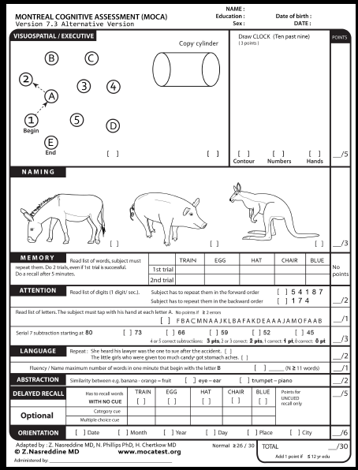

APPENDIX C

THE GERIATRIC DEPRESSION SCALE: SHORT FORM

Choose the best answer for how you have felt over the past week:
1. Are you basically satisfied with your life? YES / NO
2. Have you dropped many of your activities and interests? YES / NO
3. Do you feel that your life is empty? YES / NO
4. Do you often get bored? YES / NO
5. Are you in good spirits most of the time? YES / NO
6. Are you afraid that something bad is going to happen to you? YES / NO
7. Do you feel happy most of the time? YES / NO
8. Do you often feel helpless? YES / NO
9. Do you prefer to stay at home, rather than going out and doing new things? YES / NO
10. Do you feel you have more problems with memory than most? YES / NO
11. Do you think it is wonderful to be alive now? YES / NO
12. Do you feel pretty worthless the way you are now? YES / NO
13. Do you feel full of energy? YES / NO
14. Do you feel that your situation is hopeless? YES / NO
15. Do you think that most people are better off than you are? YES / NO

Answers in bold indicate depression. Score 1 point for each bolded answer.
A score > 5 points is suggestive of depression.
A score ≥ 10 points is almost always indicative of depression.
A score > 5 points should warrant a follow-up comprehensive assessment.
Source: http://www.stanford.edu/~yesavage/GDS.html
This scale is in the public domain.

APPENDIX D

THE HEALTH RELATED QUALITY OF LIFE (SF-36)

_____________________________________________________________
Your Health and Well-Being

This survey asks for your views about your health. This information will help keep track of how you feel and how well you are able to do your usual activities. Thank you for completing this survey!

For each of the following questions, please mark an in the one box that best describes your answer.

1. In general, would you say your health is:
Excellent | Very good | Good | Fair | Poor
 |  |  |  | 
1 | 2 | 3 | 4 | 5

2. Compared to one year ago, how would you rate your health in general now?
Much better now than one year ago | Somewhat better  now than one year ago | About the same as  one year ago | Somewhat worse  now than one year ago | Much worse now than one year ago
 |  |  |  | 
1 | 2 | 3 | 4 | 5

3. The following questions are about activities you might do during a typical day. Does your health now limit you in these activities? If so, how much?

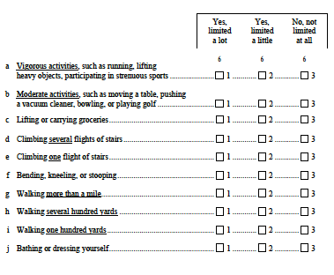
4. During the past 4 weeks, how much of the time have you had any of the following problems with your work or other regular daily activities as a result of your physical health?
 | All of  the time | Most of  the time | Some of  the time | A little of the time | None of  the time
 |  |  |  |  | 
a Cut down on the amount of
time you spent on work or
other activities 1 2 3 4 5
b Accomplished less than you
would like 1 2 3 4 5
c Were limited in the kind of
work or other activities 1 2 3 4 5
d Had difficulty performing the
work or other activities (for
example, it took extra effort) 1 2 3 4 5

5. During the past 4 weeks, how much of the time have you had any of the following problems with your work or other regular daily activities as a result of any emotional problems (such as feeling depressed or anxious)?
 | All of  the time | Most of  the time | Some of  the time | A little of the time | None of  the time
 |  |  |  |  | 
a Cut down on the amount of
time you spent on work or
other activities 1 2 3 4 5
b Accomplished less than you
would like 1 2 3 4 5
c Did work or other activities
less carefully than usual 1 2 3 4 5

6. During the past 4 weeks, to what extent has your physical health or emotional problems interfered with your normal social activities with family, friends, neighbors, or groups?
Not at all | Slightly | Moderately | Quite a bit | Extremely
 |  |  |  | 
1 | 2 | 3 | 4 | 5

7. How much bodily pain have you had during the past 4 weeks?
None | Very mild | Mild | Moderate | Severe | Very severe
 |  |  |  |  | 
1 | 2 | 3 | 4 | 5 | 6

8. During the past 4 weeks, how much did pain interfere with your normal work (including both work outside the home and housework)?
Not at all | A little bit | Moderately | Quite a bit | Extremely
 |  |  |  | 
1 | 2 | 3 | 4 | 5

9. These questions are about how you feel and how things have been with you during the past 4 weeks. For each question, please give the one answer that comes closest to the way you have been feeling. How much of the time during the past 4 weeks…

 | All of  the time | Most of  the time | Some of  the time | A little of the time | None of  the time
 |  |  |  |  | 
a Did you feel full of life? 1 2 3 4 5
b Have you been very nervous? 1 2 3 4 5
c Have you felt so down in the
dumps that nothing could
cheer you up? 1 2 3 4 5
d Have you felt calm and
peaceful? 1 2 3 4 5
e Did you have a lot of energy? 1 2 3 4 5
f Have you felt downhearted
and depressed? 1 2 3 4 5
g Did you feel worn out? 1 2 3 4 5
h Have you been happy? 1 2 3 4 5
i Did you feel tired? 1 2 3 4 5

10. During the past 4 weeks, how much of the time has your physical health or emotional problems interfered with your social activities (like visiting with friends, relatives, etc.)?
All of  the time | Most of  the time | Some of  the time | A little of  the time | None of  the time
 |  |  |  | 
1 | 2 | 3 | 4 | 5

11. How TRUE or FALSE is each of the following statements for you?
 | Definitely true | Mostly  true | Don’t  know | Mostly  false | Definitely false
 |  |  |  |  | 
a I seem to get sick a little
easier than other people 1 2 3 4 5
b I am as healthy as
anybody I know 1 2 3 4 5
c I expect my health to
get worse 1 2 3 4 5
d My health is excellent 1 2 3 4 5

Thank you for completing these questions!

APPENDIX I

THE TILBURG FRAILTY INDICATOR (TFI)

