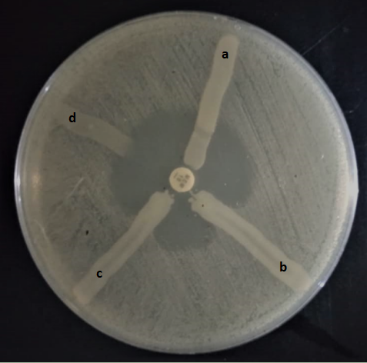
Additional file 6:
Figure S1: Modified Hodge Test showing clover leaf appearance. a. K. pneumoniae ATCC BAA 1706- MHT negative control; b. K. pneumoniae ATCC BAA 1705- MHT positive control; c. Test organism (K1)- positive result; d. Test organism (K2)- negative result

