Conjugation
R1 A B C D E M F G R27
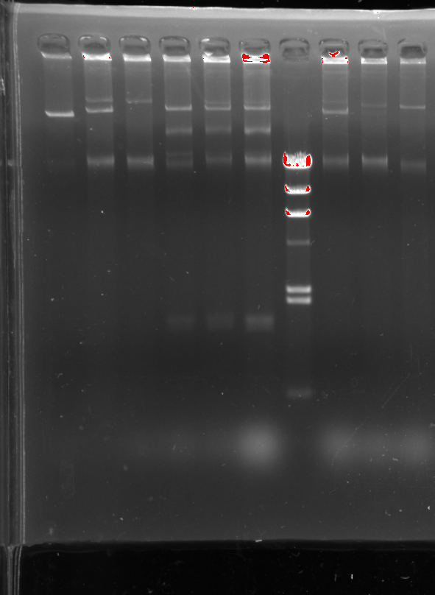
Figur 1: Plasmid profile extracted from transconjugants.
A: transconjugants 154_{c+I} of donor 154 inoculated in CTX+azide plate. B: transconjugants154_{c+I} of donor 154 inoculated in CIP+azide plate. C: transconjugants 5189_{c} of donor 5189 inoculated in CTX+azide. D: transconjugant 5189_{c+I} of donor 5189 inoculated in ctx+azide plate. E: transconjugants 5189 _{c+I} inoculated in Cip+azide plate. F: transconjugants 2116_{c+I} inoculated in ctx+azide plate, G: transconjugants 2116_{c+I} inoculated in ctx+azide plate.
Notes:
c+I: the same transconjugants give colonies on CTX+azide plate and on CIP +azide plate.
c: the transconjugant give colonies on CTX+azide plate only.

Transformation
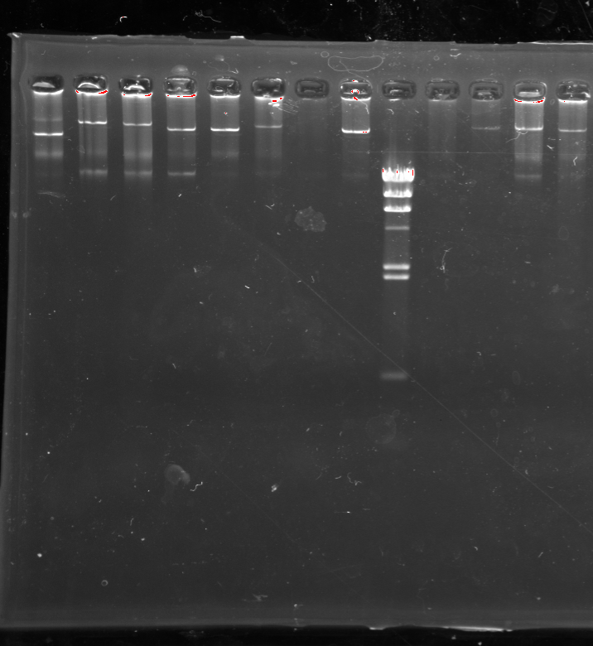
R1 A’ B’ C’ D’ E’ F’ M G’ H’ R27

Figure 2: Plasmid profile extracted from transformants.
A’: transformant with plasmid A, B’: transformant with plasmid B. C’: transformant with plasmid C, D’: transformant with plasmid D , E’: transformant with plasmid D, F’: transformant with plasmid E, G’: transformant with plasmid F, H’: transformant with plasmid G.

Original gel corresponding to transconjugation

Original gel corresponding to transformation

