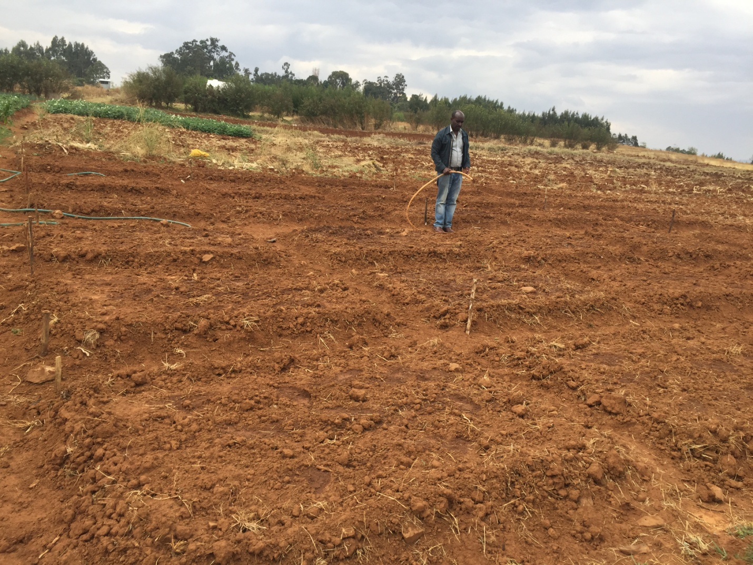(a)

a

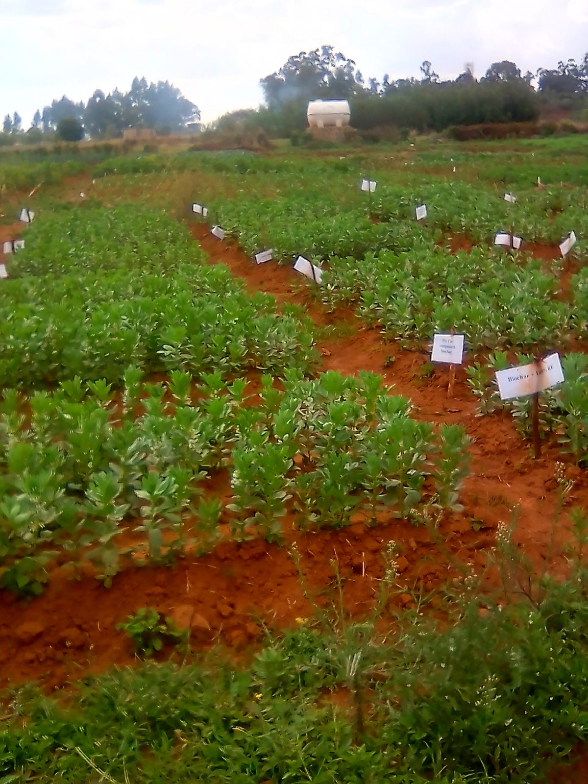 (b)

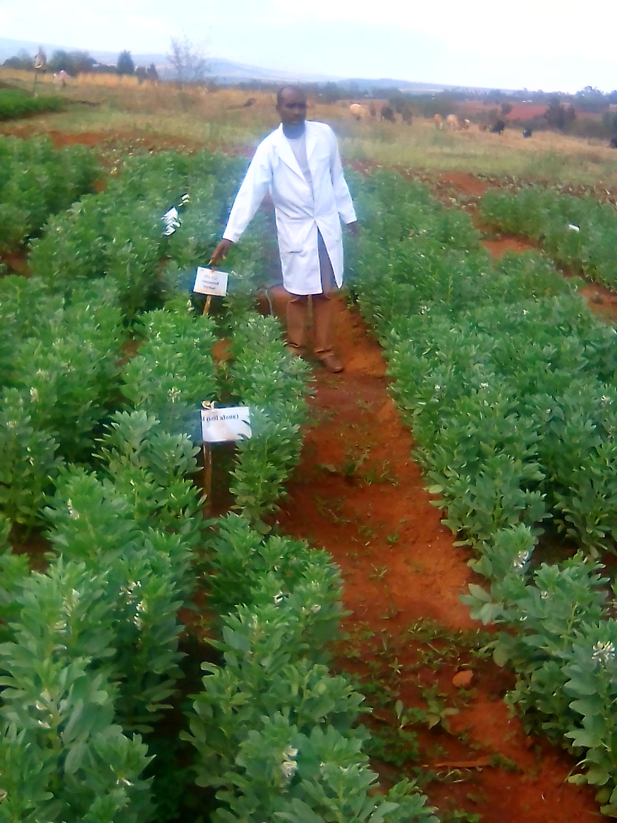 (c)

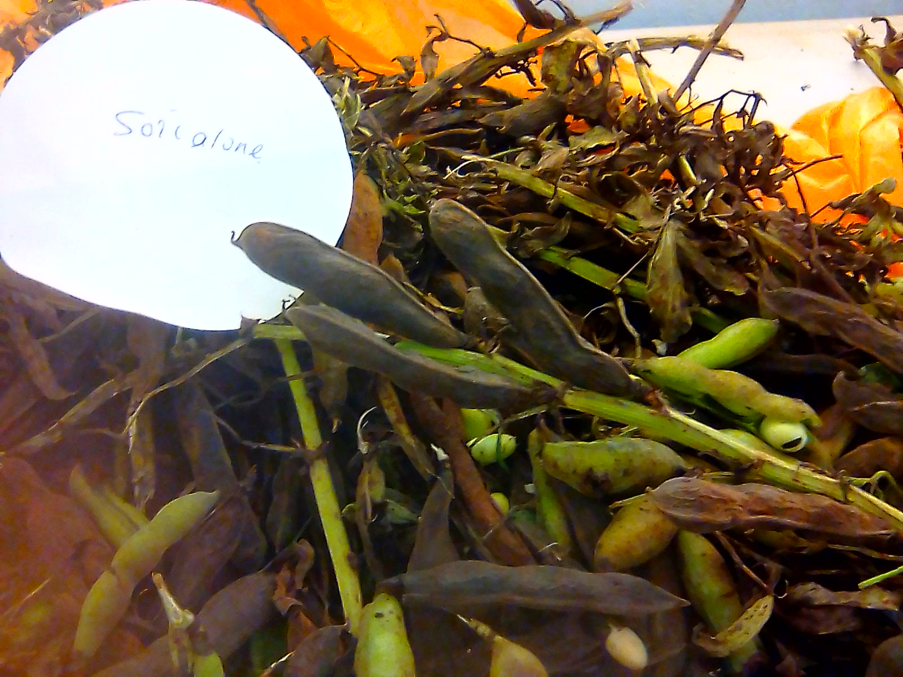 (d)

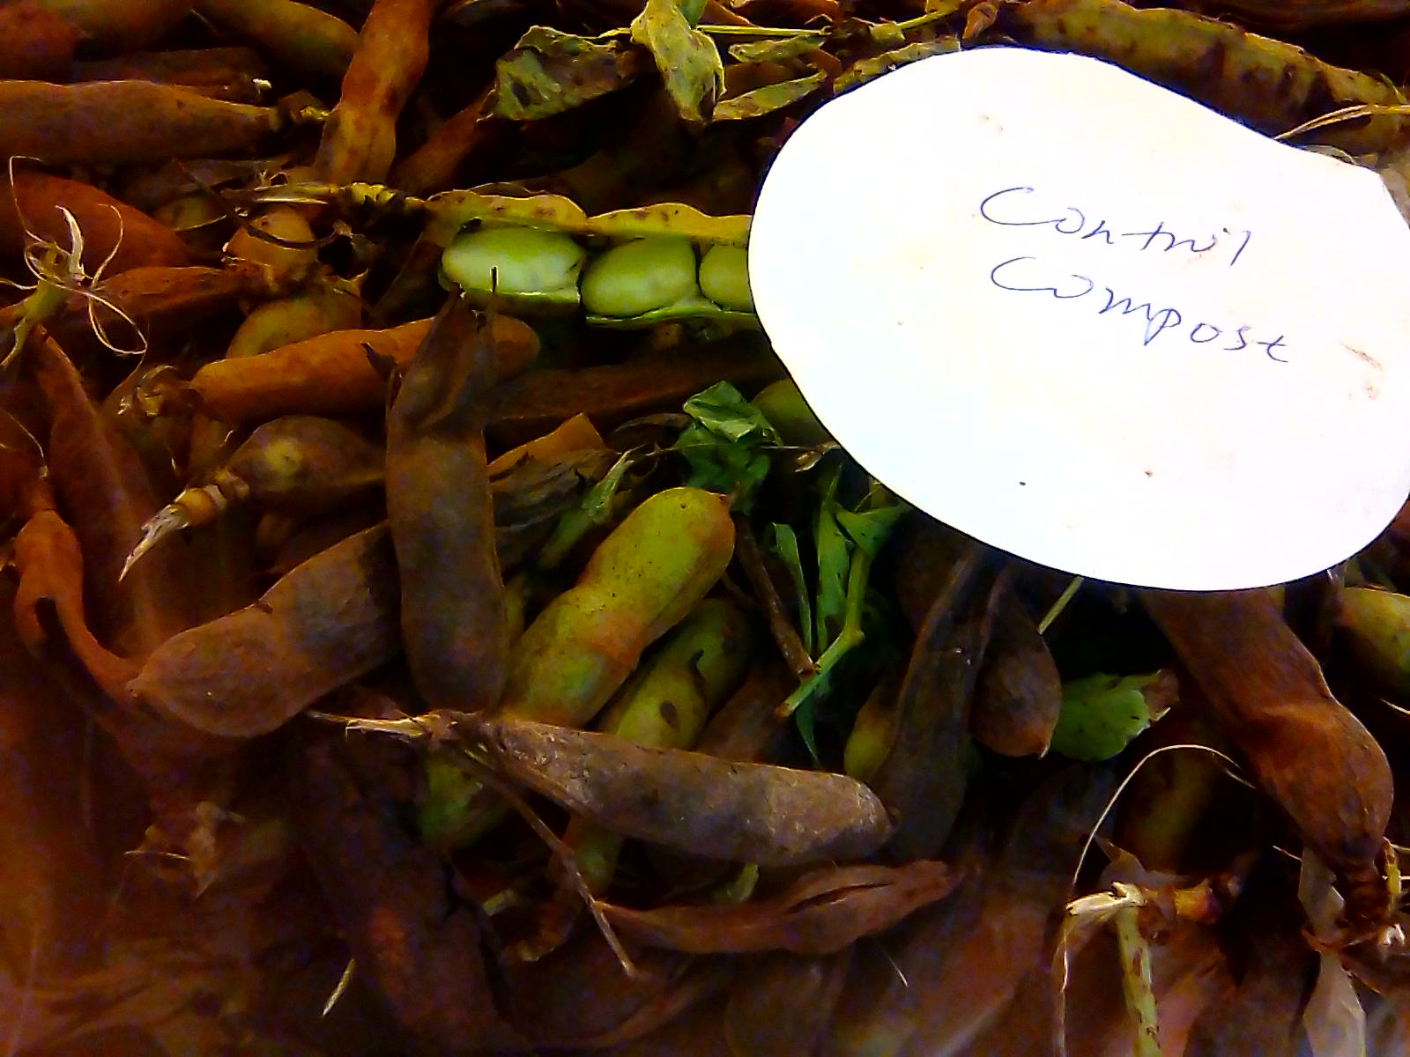 (e )

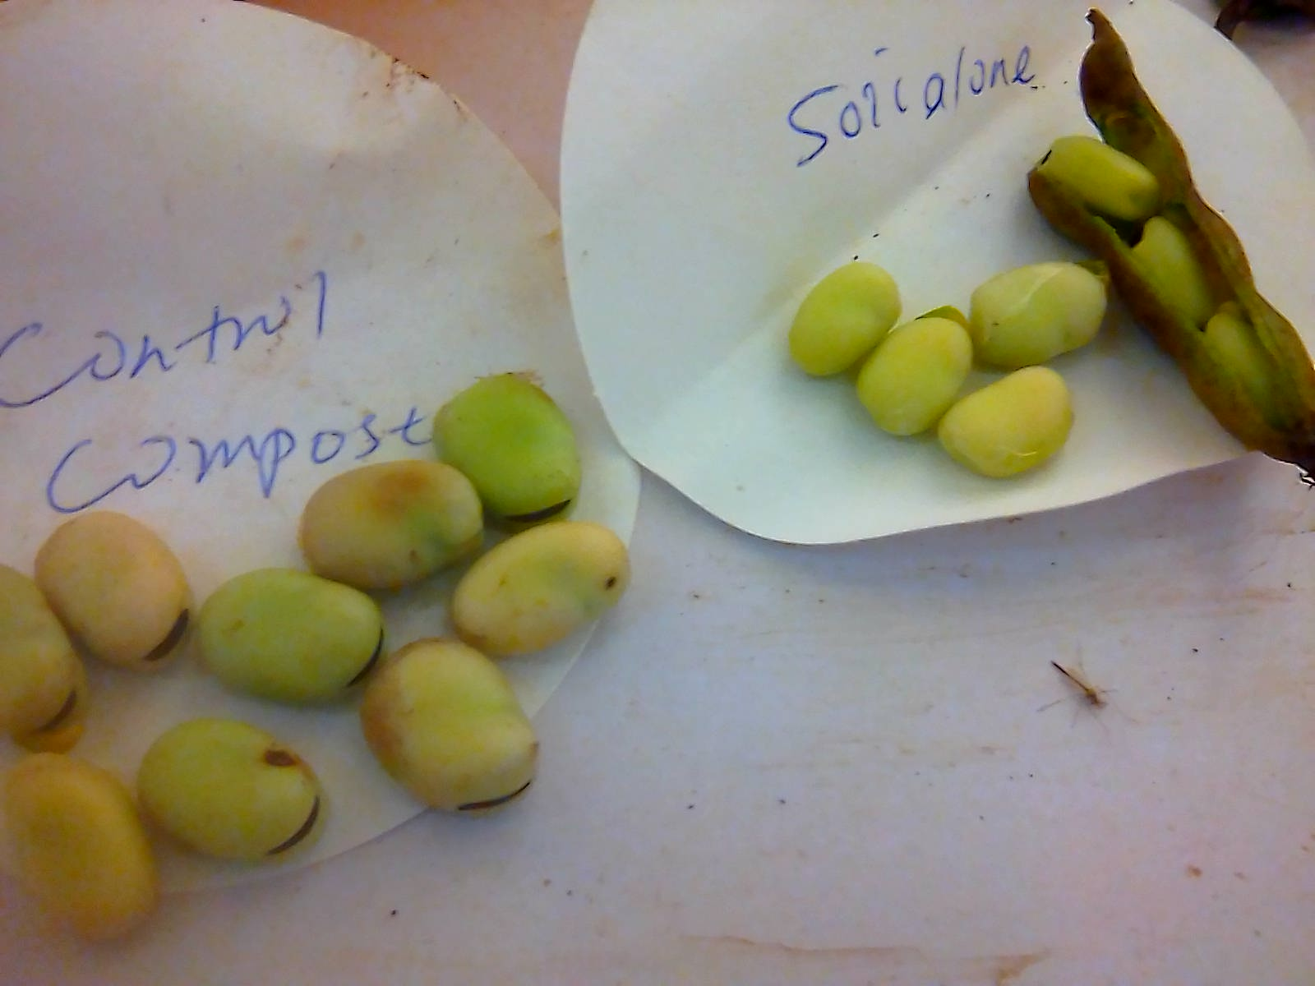(f)

**Shot-term Effects of Khat-Derived Biochar, Compost and Co-composted Biochar from Municipal Solid Waste sources on Soil quality and Faba bean Yield and Protein content**