Graphical abstract

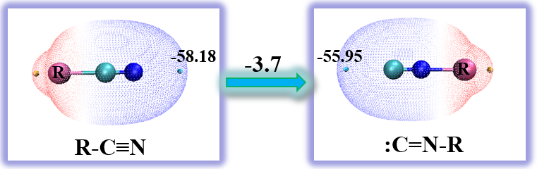
Surface electrostatic potential analyses, bond order analyses and isomerization energies for isocyanide-nitrile rearrangements were investigated systematically at B3LYP-D3(BJ)/def2-QZVP level.

