MicroRNA Profiling of Plasma Extracellular Vesicles in Bicuspid Aortopathy
Short title: Plasma EV-miRNAs in BAV aortopathy
Shichao Zhu, MD^{1,#}; Yun Zhao, MD^{1,#}; Mieradilijiang Abudupataer, MD, PhD^{1,#}; Hongqiang Zhang, MD^{1,}*; Dingqian Liu, MD¹; Wenrui Ma, MD¹; Shuolei Bu, PhD^{2,3}; Shaman Luo, PhD ^{2,3}; Shiqiang Yan, PhD^{2,3}; Yongxin Sun, MD, PhD¹; Jun Li, MD, PhD¹; Hao Lai, MD, PhD¹; Weijia Zhang, PhD^{1,2}; Chunsheng Wang, MD^{1,}*; Kai Zhu, MD, PhD^{1,}*
¹ Department of Cardiac Surgery, Zhongshan Hospital, Fudan University, and Shanghai Institute of Cardiovascular Diseases, Shanghai 200032, China
² Institutes of Biomedical Sciences, Shanghai Medical College, Fudan University, Shanghai 200032, China
³ The State Key Laboratory of Molecular Engineering of Polymers, Fudan University, Shanghai 200438, China

# These authors contribute equally to this work.
*Correspondence to Kai Zhu MD, PhD, Chunsheng Wang MD and Hongqiang Zhang MD, Department of Cardiac Surgery, Zhongshan Hospital, Fudan University, and Shanghai Institute of Cardiovascular Diseases, 1609 Xietu Road, Shanghai 200032, China. Emails: zhu.kai1@zs-hospital.sh.cn; wangchunsheng@fudan.edu.cn; zhang.hongqiang@zs-hospital.sh.cn

Table S1. The top 20 differentially expressed miRNAs

ID | logFC | FDR | Style
hsa-miR-548ar-3p | 5.754285 | 8.24E-10 | up
hsa-miR-628-3p | 5.546273 | 5.03E-36 | up
hsa-miR-454-5p | 5.307869 | 3.70E-19 | up
hsa-miR-3143 | 4.90002 | 1.75E-13 | up
hsa-miR-625-3p | 4.891198 | 1.32E-20 | up
hsa-miR-1278 | 4.849467 | 5.62E-16 | up
hsa-miR-128-3p | 4.82176 | 1.82E-54 | up
hsa-miR-335-3p | 4.818744 | 4.25E-26 | up
hsa-miR-625-5p | 4.764415 | 2.35E-20 | up
hsa-miR-223-5p | 4.494151 | 1.91E-28 | up
hsa-miR-6796-5p | -5.47925 | 1.78E-20 | down
hsa-miR-6883-5p | -5.54886 | 9.54E-23 | down
hsa-miR-1292-3p | -5.57041 | 2.95E-15 | down
hsa-miR-1273e | -5.67123 | 1.44E-20 | down
hsa-miR-6872-3p | -5.89236 | 3.08E-18 | down
hsa-miR-7156-5p | -5.8997 | 1.55E-12 | down
hsa-miR-1909-3p | -5.9451 | 7.23E-18 | down
hsa-miR-3192-3p | -6.09518 | 2.92E-11 | down
hsa-miR-6818-5p | -6.10786 | 2.83E-22 | down
hsa-miR-3611 | -6.38236 | 8.13E-20 | down

Table S2. Clinical Characteristics of the aortic tissues from patients.
Characteristic | TAV-non (n=3) | BAV-non (n=3) | BAV-dilated (n=3)
Male, % | 67% | 33% | 67%
Age, years | 59.33±3.09 | 57.00±6.53 | 53.33±5.19
Ascending aortic diameter, mm | 31.67±1.25 | 43.33±0.94 | 57.00±4.32
Hypertension, % | 67% | 33% | 67%
Diabetes, % | 33% | 0% | 0%
Hyperlipidemia, % | 0% | 0% | 0%
Sinus dilation, % | 0% | 0% | 67%
Aortic regurgitation (>moderate), % | 0% | 0% | 33%
Aortic stenosis (>moderate), % | 0% | 100% | 100%
Aortic stenosis + regurgitation, % | 0% | 0% | 33%
Aortic valve gradient, mean, mm Hg | N/A | 55.67±10.27 | 26.00±8.60
Aortic flow jet, m/s | N/A | 4.70±0.54 | 3.33±0.37
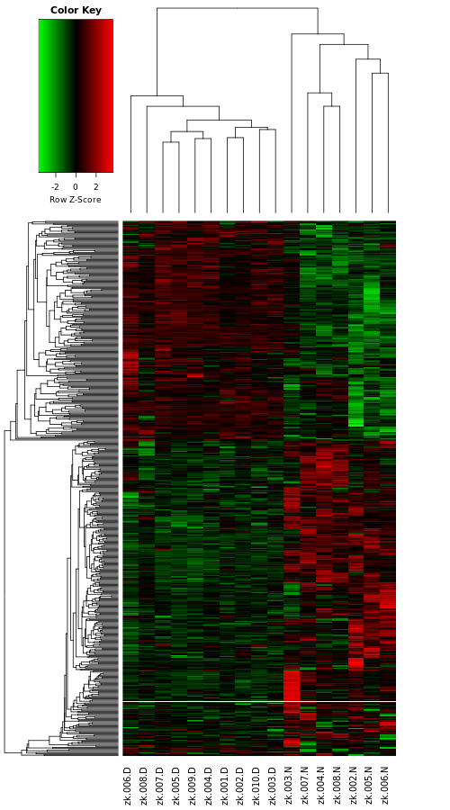
Figure S1. Results of RNA sequencing of Hierarchical clustering in BAV-dilated and BAV-non.

Figure S2. Go analysis of miR324 by miRWalk.
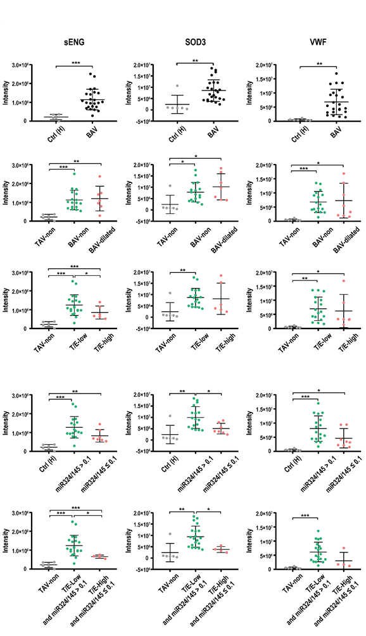
Figure S3. The expression of proteins associated with aorta aneurysm under different grouping criteria.
Figure S4. KEGG analysis of proteomics between group in T/E-high and T/E-low.

