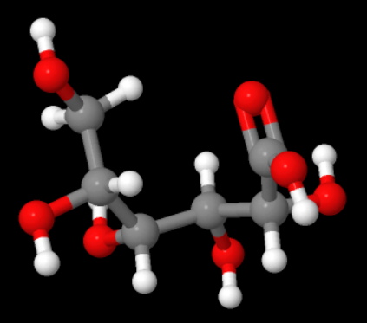
Figure S1. Structure of gluconic acid
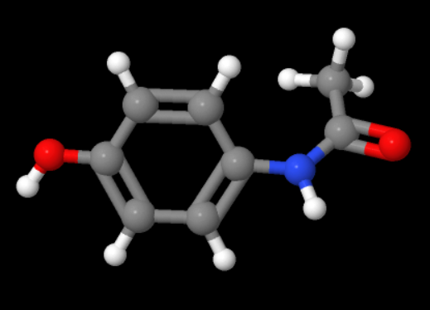
Figure S2. 1-hydroxy-4-acetaminobenzene (paracetamol)
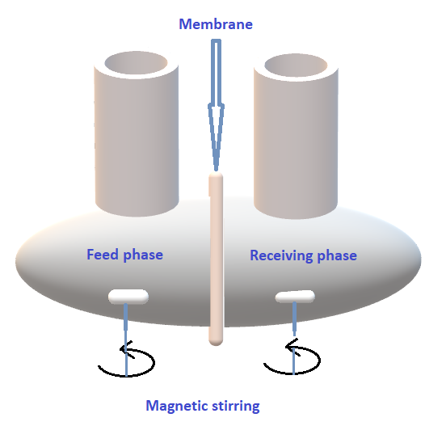
Figure S3. Representation of the facilitated extraction cell
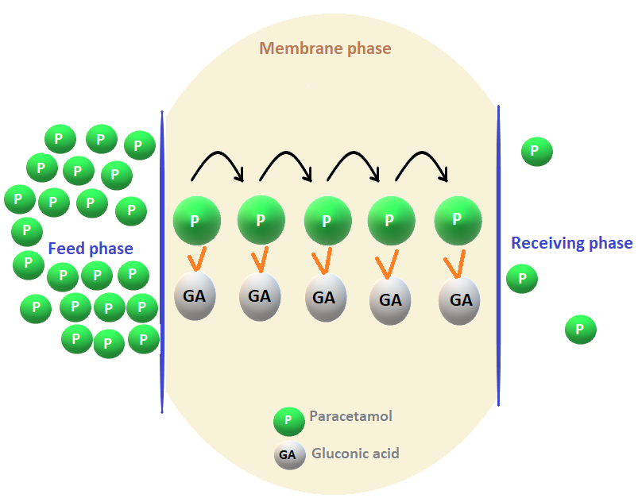
Figure S4. Mechanism of successive jumps on fixed sites during the facilitated extraction process followed for extracting paracetamol through the PIM-GA membrane
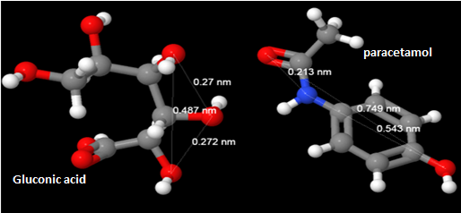
Figure S5. Possible interaction sites between paracetamol and gluconic acid
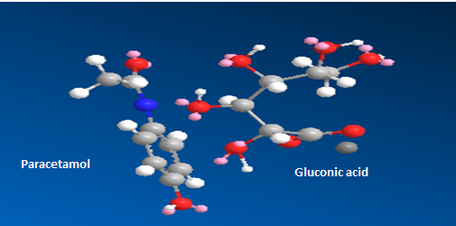
Figure S6. Interaction sites between paracetamol and gluconic acid (Chemdrew)

