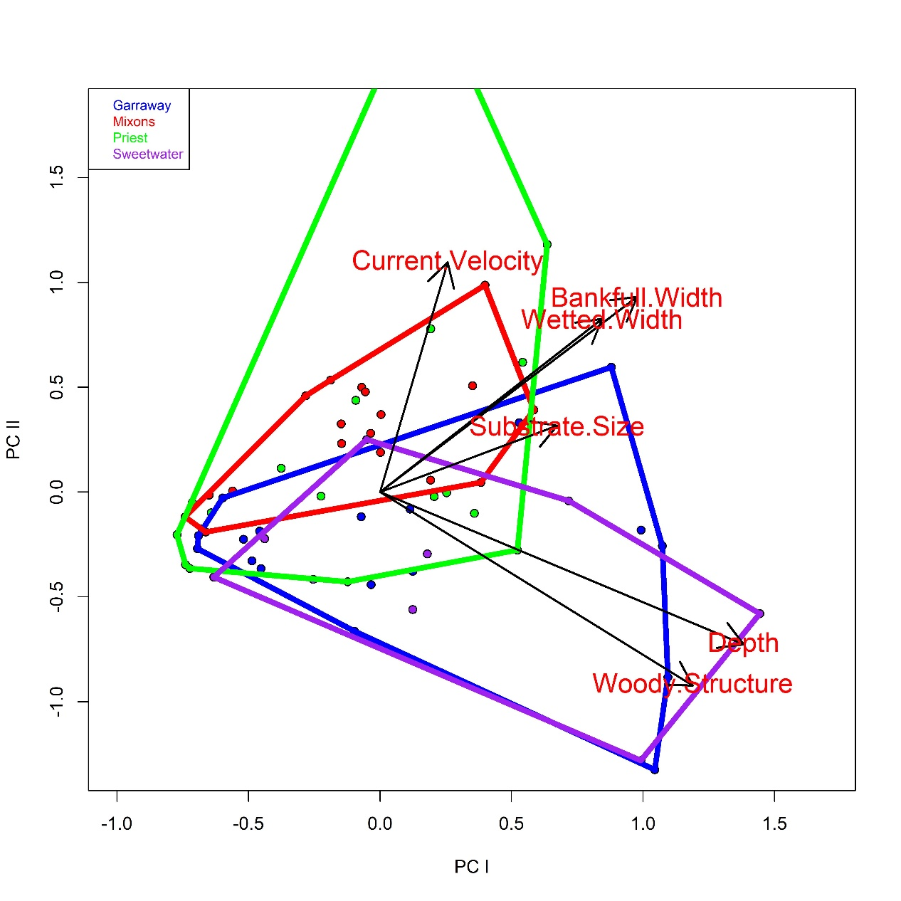

Figure S1. Principal component analysis (PCA) of in-stream habitat variable absolute mean differences for PC1 and PC2 axes. Arrows end at centroids for environmental variables.