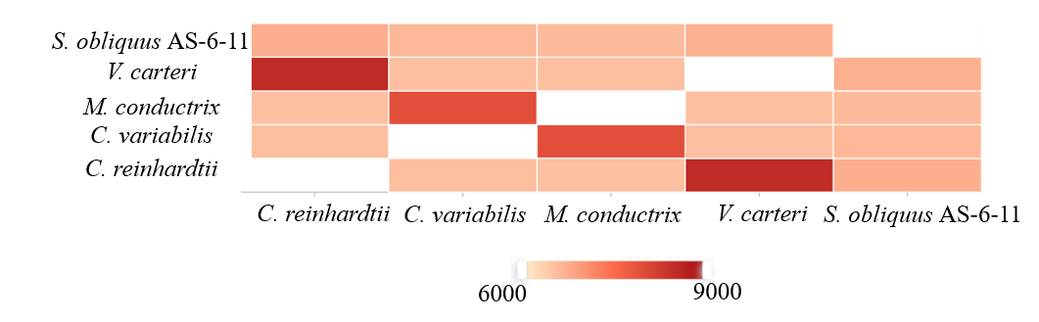
Fig. S1 The pairwise heatmap of overlapping cluster numbers between the pair-wise genomes

