Information and instructions for Patients

Medications

There are 3 medications
Probiotic / Placebo

How many? Dissolve 2 scoops (1/2 teaspoon) of powder in 20ml of warm water, gargle for 30 seconds then swallow.
How often? Four times a day, 4-6 hours apart
How long for? Fourteen (14) days

Paracetamol

How many? Two tablets (1 gram)
How often? Every six (6) hours, Maximum of 8 tablets a day
How long for? Ten (10) days
You can stop taking this if there is no pain

Endone

How many? One - two tablet (5mg)
How often? Endone is a strong pain killer. Take it only if your pain is not controlled with regular Paracetamol and powdered gargle.
Take 4- 6 hours apart
Maximum dose per 24 hours is four tablets (20mg)

The Pain Diary

The post op day is the number of days after you have had your tonsillectomy. For example –
January 1st | Day of Surgery
January 2nd | Post-op Day 1
January 3rd | Post-op Day 2
January 4th | Post-op Day 3

Please complete the diary at the end of each day (just before you go to bed):
Record all pain scores based on pain experienced during dinner. There are 3 types of pain you will need to record:
1 | Rest | The level of pain you experience when resting
2 | Drink | The level of pain you experience when drinking
3 | Eat | The level of pain you experience when eating
Record the name and dose of any other medications that you are taking
Record how many times you have used the gargle that day
Record how many paracetamol tablets you took that day
Record how many endone tablets you took that day

List any side effects using the following codes
V | Vomiting
N | Nausea
D | Diarrhoea
C | Constipation
B | Bleeding
D | Drowsy
H | Bad breath

Make a note of any other issues that arise relating to your post tonsillectomy period such as visits to your GP or the ED department for bleeding
Record the day you stopped taking Probiotic/Placebo if it is less than 7 days post-surgery
Record the day you stopped taking Paracetamol if it is less than 10 days post-surgery

Your review with your surgeon will be
Post-op Day 5-7 via phone
Post-op Day 14 in person at Frankston Hospital
Post-op Day 28 in person at Frankston Hospital

Post Tonsillectomy Diary Date of surgery:

Post Op  Day | Pain Score During  Dinner (0-10) |  |  | No of Endone  taken / day | No of paracetamol taken/day | No. of gargles used | Side Effects  (N/V/C/D/B) | Other  Medications
 | Rest | Drink | Eating
Example | 5 | 8 | 8 | 3 | 8 | 3 | N,C | 1 Maxolon
1
2
3
4
5
6
7
8
9
10
11
12
13
14
Day & Date when there is no pain on drinking |  |  |  |  | E.g.: Day 7, 8/1/13
Day & Date when there is no pain on eating
Day & Date when you are pain free
Day & Date when you return to school/work

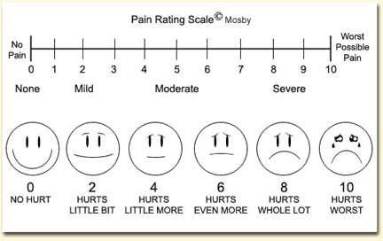
*Should you have any queries, please call Frankston Hospital 03-9784 7777 and ask get the operator to put you through to Michael Nasserallah, ENT Registrar.

