Prospects on the nano-plastic particles internalization and induction of cellular response in human keratinocytes

Ponnusamy Manogaran Gopinathª, Krishna Sundar Twayana^{b}, Palaniyandi Ravanan*^{b,c}, John Thomasª, Amitava Mukherjeeª & Natarajan Chandrasekaran*ª
ªCentre for Nanobiotechnology, Vellore Institute of Technology (VIT), Vellore – 632 014, Tamil Nadu, India
^{b}Apoptosis and Cell Survival Research Lab, Department of Biosciences, School of Biosciences and Technology, VIT University, Vellore – 632 014, Tamil Nadu, India
^{c}Department of Microbiology, School of Life Sciences, Central University of Tamil Nadu
Thiruvarur -610 104, Tamil Nadu, India

* Corresponding authors
Dr. N. Chandrasekaran
Centre for Nanobiotechnology, Vellore Institute of Technology (VIT), Vellore, Tamil Nadu
Tel-: +91 416 2202624; fax: +91 416 2243092
E-mail address: nchandrasekaran@vit.ac.in, nchandra40@hotmail.com
Dr. P. Ravanan
Department of Microbiology, School of Life Sciences, Central University of Tamil Nadu
Thiruvarur – 610 104, Tamil Nadu.
E-mail address: ravanan@cutn.ac.in
Figure S1. Figure 1. Characterization NPs isolated from cosmetics. (a) Scanning Electron Micrograph of mNPs, (b) wNPs, and (c) FT-Raman spectra of the mNPs and wNPs.

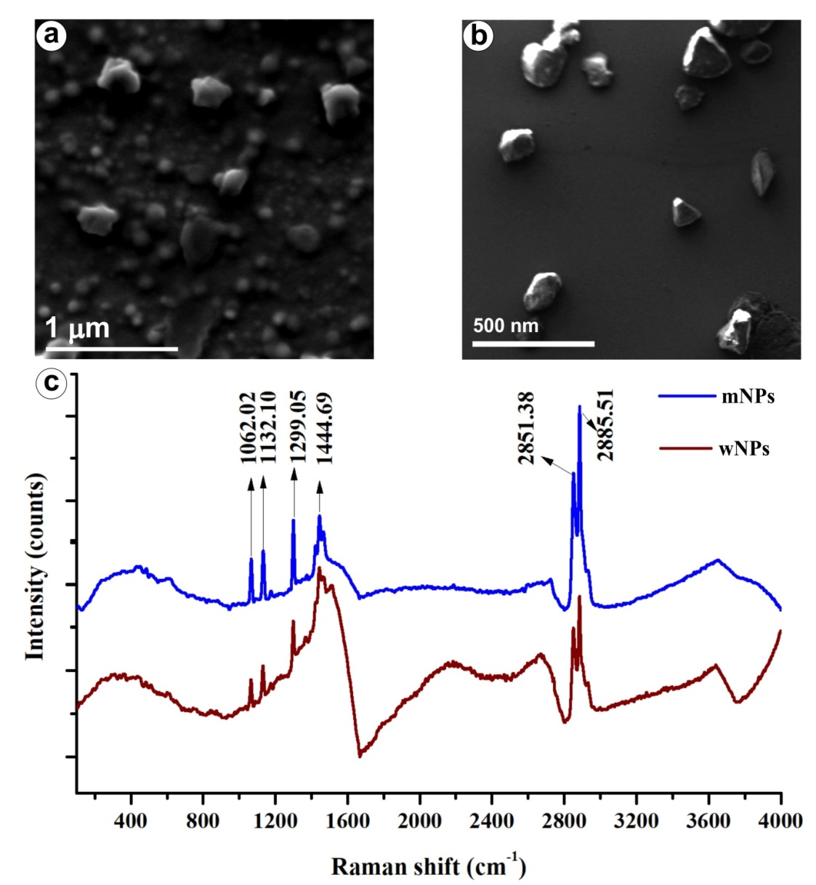

Figure S2. Dynamic light scattering size distribution analysis of NPs suspended in the cell culture medium for 24 hrs. (a) The size distribution of mNPs, (b) Size distribution of wNPs
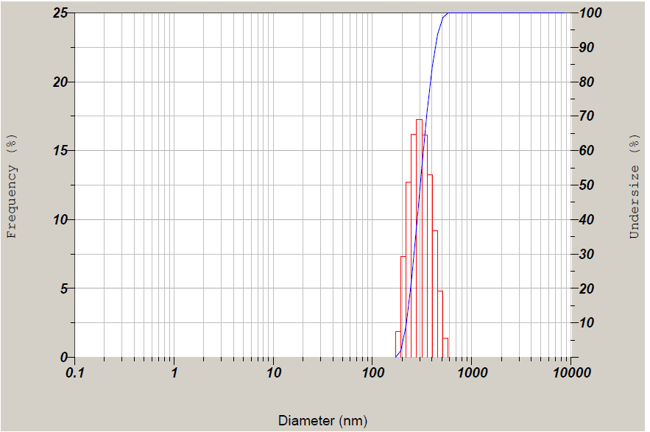
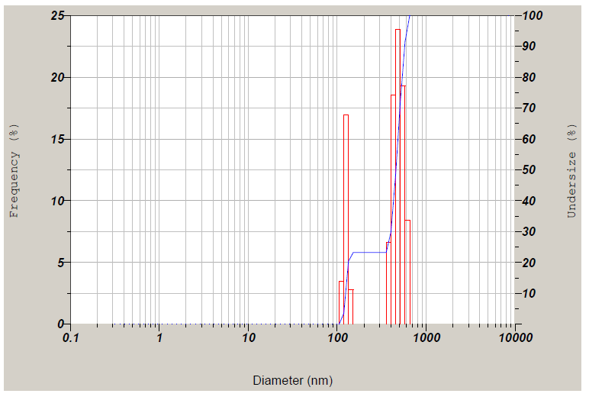
a
b

Table S1. Mean MTT values of three independent experiments of the keratinocytes cells exposed to different nanoplastics particles for 24, 48, 72, 96, 120, and 144 hrs.
Sample | Time | Concentration
 |  | 0µg/ml | 25µg/ml | 50µg/ml | 100µg/ml | 250µg/ml | 500µg/ml
PSNPs | 24 hrs | 0.456 | 0.418 | 0.403 | 0.428 | 0.435 | 0.425
 |  | 0.423 | 0.454 | 0.436 | 0.462 | 0.394 | 0.388
 |  | 0.401 | 0.391 | 0.375 | 0.406 | 0.418 | 0.367
 | 48 hrs | 0.818 | 0.732 | 0.828 | 0.756 | 0.701 | 0.774
 |  | 0.687 | 0.815 | 0.884 | 0.838 | 0.921 | 0.839
 |  | 0.747 | 0.829 | 0.782 | 0.805 | 0.855 | 0.818
 | 72 hrs | 1.518 | 1.797 | 1.689 | 1.742 | 1.667 | 1.755
 |  | 1.465 | 1.796 | 1.874 | 1.564 | 1.524 | 1.629
 |  | 1.578 | 1.615 | 1.658 | 1.81 | 1.84 | 1.642
 | 96 hrs | 2.22 | 2.585 | 2.714 | 3.041 | 3.037 | 2.371
 |  | 2.674 | 3.138 | 2.976 | 2.724 | 2.569 | 2.286
 |  | 2.499 | 3.024 | 3.286 | 3.526 | 2.487 | 2.91
 | 120 hrs | 3.468 | 4.59 | 3.466 | 3.43 | 3.522 | 3.44
 |  | 3.252 | 3.366 | 3.78 | 3.656 | 3.054 | 3.605
 |  | 3.693 | 3.486 | 3.428 | 3.097 | 2.92 | 3.608
 | 144 hrs | 5.38 | 6.074 | 4.742 | 6.114 | 5.64 | 6.794
 |  | 5.448 | 5.138 | 4.572 | 4.9 | 4.878 | 5.28
 |  | 5.056 | 4.974 | 5.82 | 4.118 | 5.416 | 6.368
mNPs | Concentration
 |  | 0µg/ml | 25µg/ml | 50µg/ml | 100µg/ml | 250µg/ml | 500µg/ml
 | 24 hrs | 0.456 | 0.401 | 0.384 | 0.394 | 0.329 | 0.270
 |  | 0.423 | 0.393 | 0.437 | 0.403 | 0.289 | 0.229
 |  | 0.401 | 0.389 | 0.406 | 0.433 | 0.301 | 0.209
 | 48 hrs | 0.818 | 0.77 | 0.888 | 0.716 | 0.417 | 0.075
 |  | 0.687 | 0.838 | 0.801 | 0.742 | 0.441 | 0.076
 |  | 0.747 | 0.794 | 0.783 | 0.679 | 0.468 | 0.078
 | 72 hrs | 1.518 | 1.65 | 1.555 | 1.333 | 0.766 | 0.093
 |  | 1.465 | 1.552 | 1.52 | 1.223 | 0.807 | 0.101
 |  | 1.578 | 1.502 | 1.483 | 1.416 | 0.677 | 0.076
 | 96 hrs | 2.22 | 2.558 | 2.921 | 2.3 | 1.189 | 0.095
 |  | 2.674 | 2.987 | 3.146 | 2.38 | 1.141 | 0.098
 |  | 2.499 | 2.875 | 3.19 | 1.808 | 1.142 | 0.095
 | 120 hrs | 3.468 | 3.168 | 3.095 | 2.668 | 1.81 | 0.086
 |  | 3.252 | 3.19 | 3.534 | 2.759 | 1.742 | 0.094
 |  | 3.693 | 3.444 | 2.912 | 2.797 | 1.66 | 0.086
 | 144 hrs | 5.38 | 6.666 | 4.62 | 5.83 | 3.84 | 0.146
 |  | 5.448 | 5.626 | 5.176 | 5.316 | 4.182 | 0.156
 |  | 5.056 | 6.224 | 4.706 | 4.56 | 4.184 | 0.148
wNPs | Concentration
 |  | 0µg/ml | 5µg/ml | 10µg/ml | 50µg/ml | 100µg/ml | 250µg/ml
 | 24 hrs | 0.456 | 0.410 | 0.454 | 0.407 | 0.396 | 0.352
 |  | 0.423 | 0.455 | 0.420 | 0.421 | 0.400 | 0.340
 |  | 0.401 | 0.394 | 0.397 | 0.439 | 0.383 | 0.343
 | 48 hrs | 0.818 | 0.781 | 0.95 | 0.723 | 0.629 | 0.417
 |  | 0.687 | 0.78 | 0.885 | 0.763 | 0.605 | 0.455
 |  | 0.747 | 0.8 | 0.805 | 0.694 | 0.668 | 0.43
 | 72 hrs | 1.518 | 1.433 | 1.621 | 1.372 | 0.872 | 0.503
 |  | 1.465 | 1.578 | 1.905 | 1.475 | 1.12 | 0.651
 |  | 1.578 | 1.627 | 1.677 | 1.543 | 1.155 | 0.635
 | 96 hrs | 2.22 | 2.775 | 3.118 | 2.358 | 1.655 | 0.454
 |  | 2.674 | 2.124 | 3.265 | 3.121 | 1.678 | 0.754
 |  | 2.499 | 2.374 | 2.479 | 2.483 | 1.865 | 0.662
 | 120 hrs | 3.468 | 3.416 | 3.172 | 3.156 | 2.724 | 0.637
 |  | 3.252 | 3.464 | 3.037 | 3.137 | 2.555 | 1.07
 |  | 3.693 | 3.311 | 2.861 | 3.465 | 3.013 | 1.18
 | 144 hrs | 5.38 | 6.25 | 5.276 | 4.97 | 4.104 | 0.72
 |  | 5.448 | 6.018 | 5.054 | 5.028 | 4.978 | 1.774
 |  | 5.056 | 6.744 | 5.89 | 5.784 | 4.834 | 1.548
H₂O₂ | Concentration
 |  | 0µM | 25µM | 50µM | 100µM | 250µM | 500µM
 | 24 hrs | 0.456 | 0.39 | 0.362 | 0.394 | 0.318 | 0.303
 |  | 0.423 | 0.371 | 0.38 | 0.39 | 0.329 | 0.31
 |  | 0.401 | 0.387 | 0.339 | 0.36 | 0.335 | 0.294
 | 48 hrs | 0.818 | 0.788 | 0.7 | 0.812 | 0.519 | 0.463
 |  | 0.687 | 0.726 | 0.801 | 0.735 | 0.599 | 0.393
 |  | 0.747 | 0.717 | 0.689 | 0.729 | 0.557 | 0.393
 | 72 hrs | 1.518 | 1.407 | 1.585 | 0.851 | 0.637 | 0.572
 |  | 1.465 | 1.424 | 1.382 | 0.861 | 0.612 | 0.567
 |  | 1.578 | 1.577 | 1.329 | 0.978 | 0.698 | 0.552
 | 96 hrs | 2.22 | 2.142 | 2.671 | 1.587 | 1.021 | 0.517
 |  | 2.674 | 2.59 | 2.352 | 1.599 | 0.75 | 0.704
 |  | 2.499 | 2.688 | 2.39 | 1.946 | 0.697 | 0.618
 | 120 hrs | 3.468 | 3.259 | 2.5 | 1.942 | 1.007 | 0.598
 |  | 3.252 | 3.242 | 2.451 | 2.338 | 1.194 | 0.576
 |  | 3.693 | 2.451 | 3.073 | 2.238 | 1.236 | 0.458
 | 144 hrs | 5.38 | 4.794 | 5.468 | 4.754 | 2.926 | 0.756
 |  | 5.448 | 3.874 | 5.3 | 4.434 | 2.466 | 0.684
 |  | 5.056 | 4.778 | 4.748 | 4.684 | 2.938 | 0.592

Figure S3. Intracellular ROS measured by DCFH2-DA staining of keratinocytes under fluorescence microscope. (a) control, (b) PSNPs (100 µg mL⁻¹), (c) styrene (100 µg mL⁻¹), (d) mNPs (100 µg mL⁻¹), (e) wNPs (100 µg mL⁻¹) and (f) H₂O₂ (100 µM). Scale bar - 125 µm.
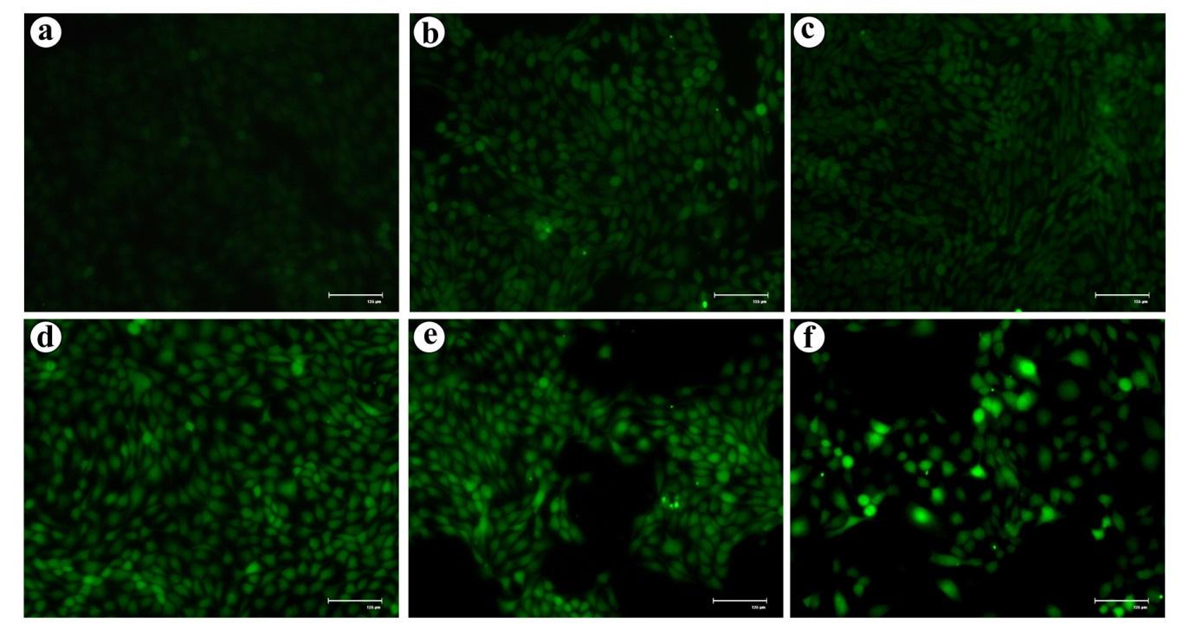

Figure S4. NPs mediated induction of cellular senescence in the HaCaT cells. (a) control, (b& c) H₂O₂ 10& 50 µM, (d-f) PSNPs 10, 100 & 500 µg/mL, (g-i) styrene 10, 100 & 500 µg/mL, ( j-l) mNPs 10, 50 & 100 µg/mL and (m-o) wNPs 10, 50 & 100 µg/mL of, respectively. Scale bar - 60 µm.
