Additional file

Table S1. Identification of species from OTUs using BLAST without a 1% sequence threshold for accepting a species. The top five species represent 97% of the reads. Nematodes were identified in 156 (99%) out of 158 samples. The most common species was Haemonchus contortus, which was identified in 135 (85%) of the positive samples. The ITS2 fragments varied in length from 266 to 512 bp.
Best species match from BLAST search | Query cover | Identity | Number of samples | ITS2 OTU Sequence length (bp)
Chabertia ovina | 100 | 100 | 48 | 283
Haemonchus contortus | 100 | 100 | 135 | 281
Teladorsagia circumcincta | 100 | 99 | 97 | 296
Trichostrongylus vitrinus | 100 | 100 | 57 | 288
Oesophagostomum venulosum | 99 | 100 | 32 | 308
Bunostomum trigonocephalum | 100 | 100 | 3 | 281
Cooperia curticei | 100 | 99 | 1 | 292
Cooperia oncophora | 100 | 100 | 10 | 291
Coronocyclus coronatus | 100 | 99 | 2 | 281
Coronocyclus labratus | 100 | 100 | 32 | 367
Craterostomum acuticaudatum | 86 | 100 | 1 | 370
Cylicocyclus nassatus | 100 | 99 | 24 | 370
Cylicocyclus ultrajectinus | 87 | 100 | 1 | 402
Cylicostephanus minutus | 99 | 100 | 5 | 266
Cystocaulus ocreatus | 100 | 99 | 5 | 418
Dictyocaulus viviparus | 97 | 97 | 1 | 512
Muellerius capillaris | 100 | 100 | 6 | 455
Nematodirus spathiger | 100 | 99 | 9 | 280
Ostertagia leptospicularis | 100 | 99 | 5 | 289
Ostertagia ostertagi | 100 | 100 | 5 | 288
Protostrongylus hobmaieri | 95 | 97 | 3 | 400
Varestrongylus eleguneniensis | 94 | 100 | 3 | 411
Strongyloides fuelleborni fuelleborni | 100 | 90 | 2 | 360
Trichostrongylus axei | 100 | 93 | 1 | 290
Trichostrongylus retortaeformis | 100 | 98 | 2 | 288
Triodontophorus serratus | 86 | 100 | 1 | 384

Table S2. Output from MCMCglmm testing of the impact of each of the three anthelmintic drug treatments (IVM=ivermectin, ABZ=albendazole, LEV=levamisole) on species richness and inverse Simpson’s diversity index (see also Fig 4G-4L) for farms sampled before and after anthelmintic treatment without 1% threshold.

Post- and pre-treatment | Posterior mean | Lower 95% CI | Upper 95%Ci | Effective sample size | pMCMC¹
Species richness IVM | 0.92261 | 0.01674 | 1.76027 | 10819 | 0.0366* | Fig S4G
Species richness ABZ | 2.1461 | 1.0375 | 3.2327 | 10691 | 0.0008*** | Fig S4H
Species richness LEV | 0.994394 | -1.699608 | 3.847177 | 9560 | 0.4242 | Fig S4I
Inverse Simpson IVM | 0.20262 | -0.06626 | 0.47498 | 10000 | 0.1320 | Fig S4J
Inverse Simpson BZ | 0.2544 | -0.08311 | 0.60872 | 10000 | 0.1430 | Fig S4K
Inverse Simpson LEV | -0.2207 | -0.9139 | 0.4719 | 10000 | 0.4858 | Fig S4L
¹Statistically significant fixed effects are marked with * and ***
Prior settings: | R (V=2, nu =0.2); G (V=2, nu = 0.02)
Run settings: | Burn-in = 50,000; Iterations = 100,000; Thinning interval = 10

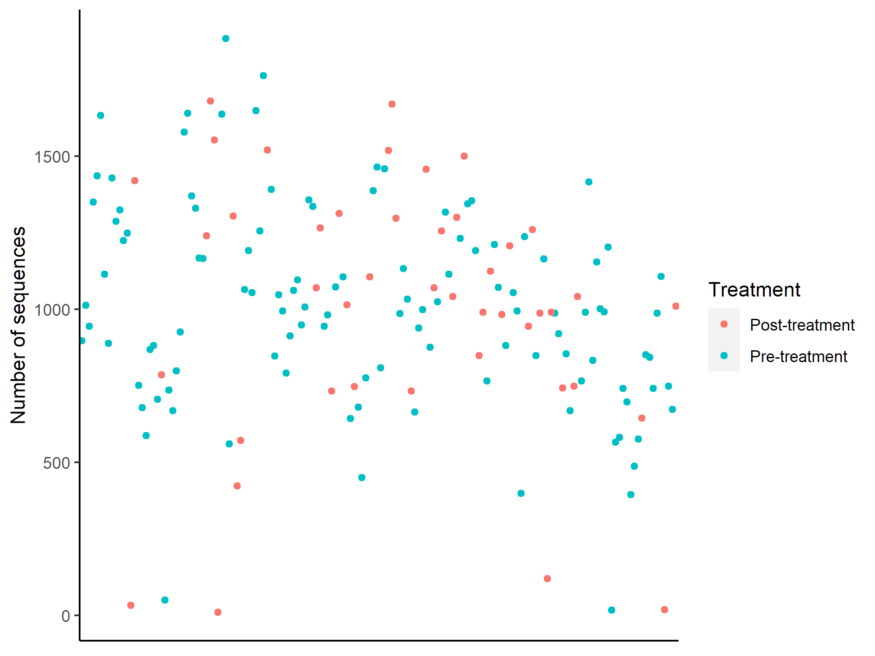
Figure S1. Number of sequences from the PacBio sequencing per sample divided on pre- and post treatment.

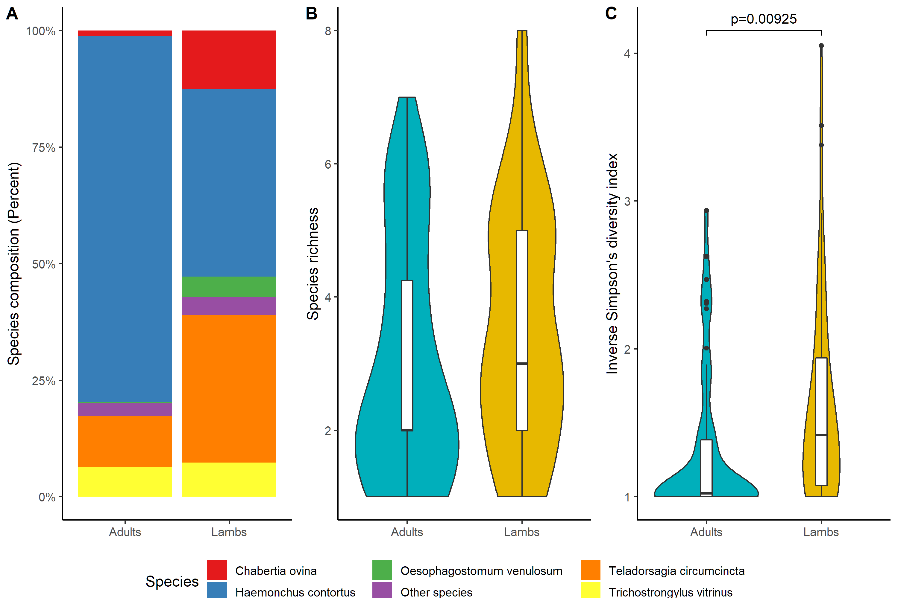Figure S2. A) Nemabiome composition for adults and lambs without using 1% threshold for accepting a species. No difference in nematode species richness (B), but adults were dominated by a few species compared to lambs (C).

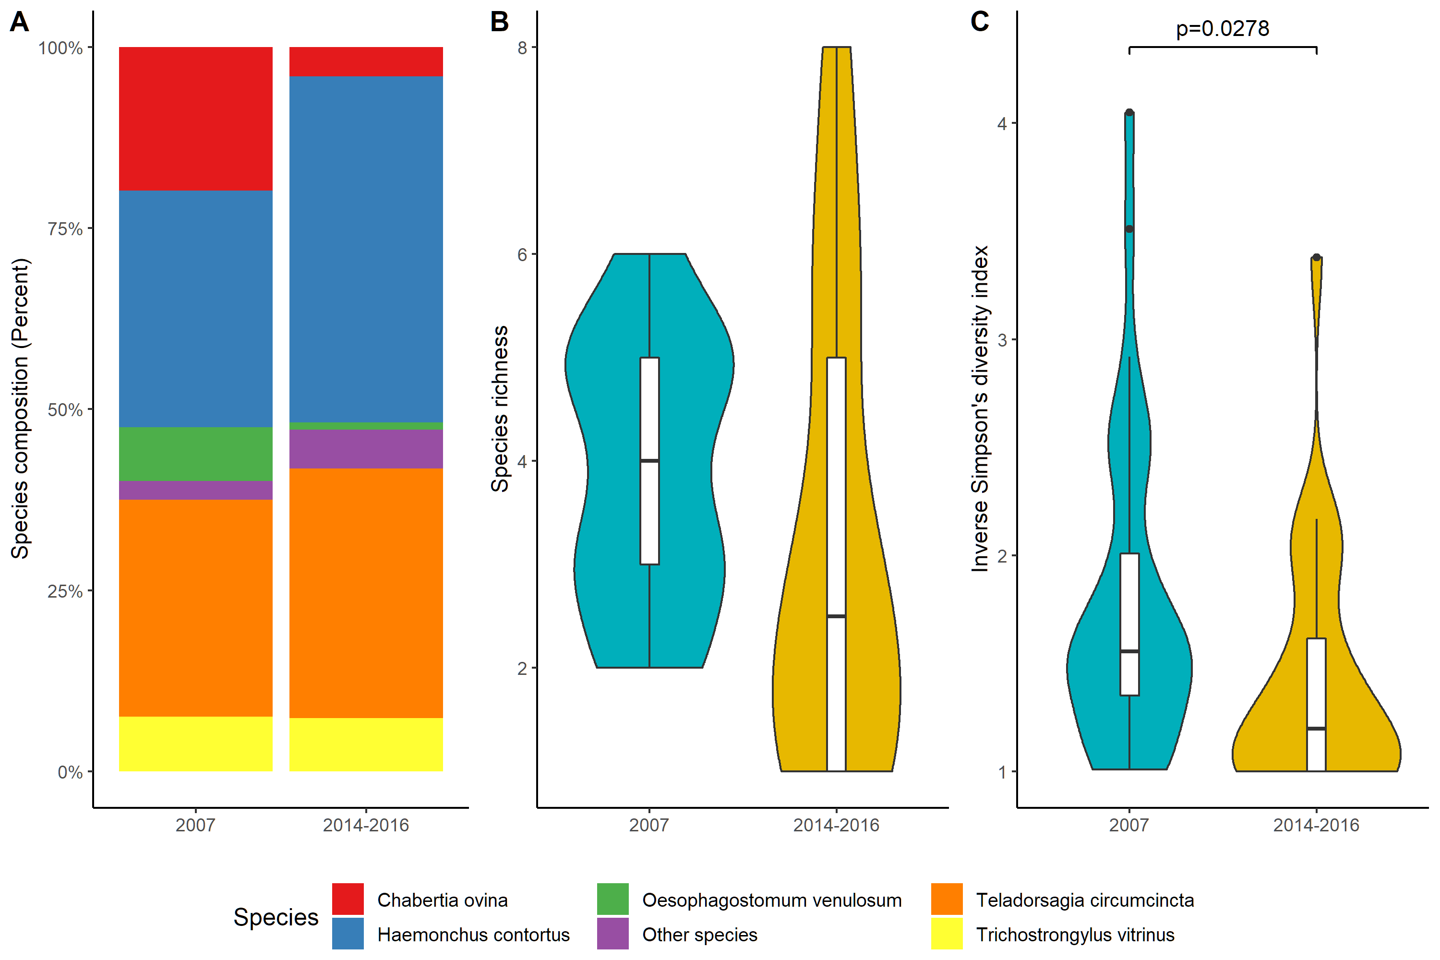

Figure S3. A) Nemabiome composition for lambs for two periods using data without 1% threshold for accepting a species. B) Species richness and C) Inverse Simpson´s diversity index for each period.

Figure S4. Nemabiome composition (A-C), EPG (D-F) and diversity indices; species richness (G-I) without a 1% threshold. The shape of the violin plots in panel G indicate that anthelmintic treatment will have a larger effect for individuals with higher species richness prior to treatment. Inverse Simpson´s index (J-L) prior and after anthelmintic treatment, for ivermectin (n=25) in left column, albendazole (n=14) in middle column and levamisole (n=5) in right column.

