Supplementary data

Deciphering the complex circulating immune cell microenvironment in chronic lymphocytic leukemia using patient similarity networks

File summary
File contents 6 Tables (S1-S2 Used surface markers; S3 Correlation analysis; S4-S6 Activation of immune cells in patients subgroups), 2 Figures (S1 Trend analysis for activation markers on immune cells across clusters; S2 comparative analysis), Comparison of immune cells activation during various treatment regimens, and Description of trends calculation based on network layout.

Table S1. List of surface markers used to characterise the immune populations.

Immune population | Combination of the markers
CLL cells | CD5/CD19/CD20/CD27/CD38/CD49d/HLA-DR
Classical/intermediate/non-classical monocytes | CD11b/CD14/CD16/CD64/HLA-DR
Neutrophils | CD11b/CD15/CD16/CD54/CD62L/CD64
CD4+ lymphocytes | CD3/CD4/HLA-DR
CD8+ lymphocytes | CD3/CD8/HLA-DR
Treg lymphocytes | CD3/CD4/CD25/CD127
NK cells | CD3/CD16/CD56/CD69/HLA-DR

Table S2. List of surface markers with relevant clone and fluorochrome (conjugate).

Name | Clone | Conjugate
CD3 | OKT3 | FITC
CD4 | RPA-T4 | APC-Cy7
CD5 | UCHT2 | PerCP-Cy5.5
CD8 | SK1 | PE-Cy7
CD11b | ICRF44 | PerCP-Cy5.5
CD14 | HCD14 | FITC
CD15 | W6D3 | PE-Cy7
CD16 | 3G8 | PE
CD19 | SJ25C1 | APC-Cy7
CD20 | 2H7 | PE
CD25 | M-A251 | PE
CD27 | M-T271 | FITC
CD38 | HB-7 | PE-Cy7
CD49d | 9F10 | APC
CD54 | HA58 | FITC
CD62L | DREG-56 | APC
CD64 | 10.1 | APC-Cy7
CD69 | FN50 | APC
CD86 | IT2.2 | PE
CD127 | A019D5 | PerCP-Cy5.5
HLA-DR | L243 | APC
CD3/(CD16+CD56) | UCHT1/3G8+MEM-188 | FITC/PE

Table S3. Correlations between absolute numbers of CLL cells and expression of activation markers on immune cell populations or percentages of immune cell subpopulations.
Populations/markers correlated with absolute number of CLL cells | r_{s} value | P value
Classical monocytes (MON)
% of MON | -0.05 | 0.480
HLA-DR | -0.76 | < 0.001
CD64 | -0.39 | < 0.001
CD11b | -0.11 | 0.120
Intermediate MON
% of MON | -0.01 | 0.880
HLA-DR | -0.74 | < 0.001
CD64 | -0.52 | < 0.001
CD11b | -0.07 | 0.330
Non-classical MON
% of MON | 0.11 | 0.120
HLA-DR | -0.78 | < 0.001
CD64 | -0.13 | 0.086
CD11b | 0.18 | 0.014
NEU
CD64 | -0.22 | 0.036
CD54 | 0.10 | 0.310
CD11b | -0.08 | 0.400
CD62L | -0.57 | < 0.001
NK cells
HLA-DR | -0.11 | 0.270
CD69 | -0.33 | < 0.001
T cells
CD4+/CD8+ ratio | 0.22 | < 0.001
HLA-DR on CD4+ cells | -0.51 | < 0.001
HLA-DR on CD8+ cells | -0.60 | < 0.001
% Treg cells of CD4+ cells | 0.31 | < 0.001

Table S4. Comparison of immune subset percentages, cell counts and activation markers expressed on immune cells in untreated CLL patients and CLL patients after the immunochemotherapy treatment with the same CLL cell counts (20-80x10⁹/L).
Populations/markers | Untreated  Mean (CI) | Chemotherapy Mean (CI) | FC | P value
CLL cell count [x10⁹/L] | 44.0 (37.5-50.6) | 42.2 (32.3-51.9) | -0.07 | 0.683
Classical monocytes (MON)
% of MON | 85.3 (82.6-88.0) | 82.6 (77.9-87.3) | -0.04 | 0.257
Cell count [x10⁹/L] | 0.46 (0.38-0.54) | 0.45 (0.30-0.60) | -0.02 | 0.880
HLA-DR | 122 (101-142) | 172 (130-215) | 0.57 | 0.032
CD64 | 229 (209-249) | 277 (221-333) | 0.20 | 0.044
CD11b | 544 (462-625) | 604 (513-694) | 0.10 | 0.228
Intermediate MON
% of MON | 5.32 (4.23-6.41) | 6.61 (5.14-8.08) | 0.36 | 0.130
Cell count [x10⁹/L] | 0.03 (0.02-0.03) | 0.03 (0.02-0.05) | 0.31 | 0.103
HLA-DR | 792 (554-1031) | 1034 (645-1423) | 0.24 | 0.133
CD64 | 200 (174-227) | 258 (191-326) | 0.19 | 0.061
CD11b | 444 (373-515) | 573 (485-661) | 0.35 | 0.050
Non-classical MON
% of MON | 9.38 (7.36-11.4) | 10.8 (6.32-15.2) | 0.21 | 0.645
Cell count [x10⁹/L] | 0.04 (0.03-0.05) | 0.05 (0.03-0.06) | 0.17 | 0.250
HLA-DR | 285 (222-348) | 519 (304-734) | 0.38 | 0.030
CD64 | 146 (135-158) | 170 (133-208) | 0.01 | 0.615
CD11b | 89.9 (77.9-102) | 116 (94.6-138) | 0.19 | 0.041
NEU
Cell count [x10⁹/L] | 5.38 (4.33-6.43) | 4.26 (3.47-5.05) | -0.21 | 0.335
CD64 | 69.5 (58.9-80.1) | 80.9 (74.0-87.8) | 0.04 | 0.162
CD54 | 20.4 (17.4-23.5) | 19.0 (16.8-21.2) | -0.10 | 0.708
CD11b | 178 (124-232) | 159 (123-196) | -0.18 | 0.615
CD62 | 275 (201-350) | 306 (139-472) | 0.03 | 0.965
NK cells
Cell count [x10⁹/L] | 0.48 (0.33-0.63) | 0.34 (0.24-0.43) | -0.30 | 0.254
HLA-DR | 83.8 (5.17-173) | 42.7 (6.55-78.8) | -0.15 | 0.958
CD69 | 29.1 (23.5-34.7) | 25.1 (21.9-28.3) | -0.02 | 0.792
T cells
Cell count [x10⁹/L] | 2.89 (2.41-3.36) | 2.75 (1.90-3.60) | -0.05 | 0.660
CD4+/CD8+ ratio | 2.02 (1.57-2.47) | 1.04 (0.75-1.34) | -0.31 | 0.008
HLA-DR on CD4+ cells | 19.2 (17.7-20.7) | 27.8 (22.5-33.1) | 0.25 | < 0.001
HLA-DR on CD8+ cells | 25.2 (22.0-28.4) | 36.1 (27.2-45.1) | 0.12 | 0.013
% Treg cells of CD4+ cells | 10.7 (9.19-12.2) | 10.7 (8.39-13.0) | 0.01 | 0.949
Cell count [x10⁹/L] | 0.14 (0.10-0.18) | 0.09 (0.07-0.12) | -0.33 | 0.278

Table S5. Comparison of immune subset percentages and activation markers expressed on immune cells in CLL patients after the immunochemotherapy treatment and patients on novel therapy with the equal CLL cell counts (<10.0x10⁹/L).

Populations/markers | Chemotherapy Mean (CI) | Novel drugs Mean (CI) | FC | P value
CLL cell count [x10⁹/L] | 2.21 (0.96-3.46) | 1.37 (0.85-1.89) | -0.32 | 0.389
Classical monocytes (MON)
% of MON | 77.4 (71.8-83.0) | 82.2 (79.1-85.3) | 0.07 | 0.038
Absolute count [x10⁹/L] | 0.27 (0.19-0.35) | 0.33 (0.28-0.39) | 0.23 | 0.212
HLA-DR | 274 (211-337) | 357 (302-411) | 0.32 | 0.099
CD64 | 338 (287-390) | 352 (315-389) | -0.06 | 0.914
CD11b | 689 (557-820) | 744 (656-833) | 0.11 | 0.503
Intermediate MON
% of MON | 10.4 (7.94-12.9) | 8.84 (7.37-10.3) | -0.34 | 0.207
Cell count [x10⁹/L] | 0.03 (0.02-0.04) | 0.04 (0.03-0.04) | 0.23 | 0.666
HLA-DR | 1517 (1042-1992) | 1998 (1756-2240) | 0.50 | 0.012
CD64 | 313 (253-373) | 329 (296-632) | 0.12 | 0.379
CD11b | 580 (468-692) | 597 (536-658) | 0.11 | 0.532
Non-classical MON
% of MON | 12.2 (8.25-16.1) | 8.03 (6.36-9.70) | -0.23 | 0.046
Cell count [x10⁹/L] | 0.03 (0.02-0.04) | 0.03 (0.02-0.03) | -0.17 | 0.419
HLA-DR | 778 (510-1045) | 1011 (823-1198) | 0.53 | 0.028
CD64 | 162 (144-180) | 157 (147-167) | -0.04 | 0.416
CD11b | 108 (77.3-139) | 116 (103-129) | 0.33 | 0.093
NEU
Cell count [x10⁹/L] | 3.02 (2.24-3.79) | 3.05 (2.59-3.51) | 0.01 | 0.907
CD64 | 89.1 (77.0-101) | 95.6 (84.3-107) | 0.02 | 0.439
CD54 | 18.5 (15.9-21.2) | 21.0 (18.3-23.8) | 0.10 | 0.225
CD11b | 145 (96.1-194) | 179 (144-214) | 0.12 | 0.247
CD62L | 452 (278-626) | 548 (449-648) | 0.01 | 0.288
NK cells
Cell count [x10⁹/L] | 0.17 (0.12-0.21) | 0.17 (0.12-0.22) | 0.03 | 0.577
HLA-DR | 62.4 (34.2-90.5) | 10.8 (31.6-110) | -0.27 | 0.267
CD69 | 46.8 (30.9-62.0) | 35.3 (30.3-40.3) | -0.25 | 0.538
T cells
Cell count [x10⁹/L] | 1.34 (0.95-1.76) | 1.64 (1.27-2.00) | 0.21 | 0.496
CD4+/CD8+ ratio | 1.32 (0.79-1.85) | 1.05 (0.80-1.30) | -0.23 | 0.317
HLA-DR on CD4+ cells | 29.6 (24.5-34.6) | 31.4 (26.5-36.3) | -0.06 | 0.701
HLA-DR on CD8+ cells | 45.2 (36.9-53.4) | 48.1 (41.9-54.3) | 0.13 | 0.629
% Treg cells of CD4+ cells | 12.0 (9.23-14.8) | 6.70 (5.50-7.89) | -0.45 | < 0.001
Cell count [x10⁹/L] | 0.07 (0.04-0.11) | 0.04 (0.03-0.05) | -0.43 | 0.062

Table S6. Comparison of immune subset percentages and activation markers expressed on immune cells in CLL patients treated with ibrutinib or idelalisib.

Populations/markers | ibrutinib  Mean (CI) | Idelalisib  Mean (CI) | FC | P value
CLL cell count [x10⁹/L] | 4.98 (2.23-7.73) | 2.52 (0.46-4.58) | -0.12 | 0.324
Classical monocytes (MON)
% of MON | 83.1 (79.1-87.0) | 80.5 (76.6-84.4) | -0.04 | 0.065
Cell count [x10⁹/L] | 0.35 (0.27-0.44) | 0.29 (0.20-0.38) | -0.18 | 0.402
HLA-DR | 339 (270-408) | 274 (289-459) | 0.08 | 0.287
CD64 | 339 (300-379) | 408 (331-486) | 0.33 | 0.118
CD11b | 753 (674-832) | 762 (551-974) | 0.03 | 0.936
Intermediate MON
% of MON | 7.79 (6.35-9.23) | 11.3 (8.71-13.9) | 0.92 | 0.002
Cell count [x10⁹/L] | 0.03 (0.02-0.04) | 0.04 (0.02-0.07) | 0.29 | 0.568
HLA-DR | 1676 (1372-1980) | 2163 (1788-2537) | 0.51 | 0.007
CD64 | 308 (269-348) | 368 (306-430) | 0.29 | 0.018
CD11b | 600 (533-667) | 590 (471-709) | -0.02 | 0.857
Non-classical MON
% of MON | 7.10 (5.43-8.77) | 8.24 (5.71-10.8) | -0.01 | 0.375
Cell count [x10⁹/L] | 0.03 (0.02-0.03) | 0.03 (0.02-0.04) | 0.01 | 0.878
HLA-DR | 949 (698-1201) | 931 (803-1059) | 0.12 | 0.364
CD64 | 153 (141-165) | 168 (149-187) | 0.10 | 0.087
CD11b | 125 (109-141) | 99.7 (86.1-113) | -0.14 | 0.075
NEU
Cell count [x10⁹/L] | 3.19 (2.65-3.73) | 2.50 (1.58-3.43) | -0.21 | 0.069
CD64 | 96.0 (82.6-109) | 95.7 (73.7-118) | -0.06 | 0.871
CD54 | 21.5 (17.2-25.9) | 21.3 (18.2-24.3) | 0.15 | 0.258
CD11b | 163 (132-193) | 179 (94.7-263) | 0.17 | 0.910
CD62L | 519 (390-648) | 547 (372-721) | 0.41 | 0.377
NK cells
Cell count [x10⁹/L] | 0.14 (0.11-0.18) | 0.20 (0.11-0.29) | 0.38 | 0.444
HLA-DR | 47.2 (27.6-66.8) | 82.2 (0.79-165) | 0.05 | 0.685
CD69 | 38.0 (28.7-47.3) | 45.4 (16.8-74.0) | -0.09 | 0.904
T cells
Cell count [x10⁹/L] | 1.61 (1.13-2.09) | 1.97 (1.12-2.82) | 0.22 | 0.299
CD4+/CD8+ ratio | 0.92 (0.75-1.09) | 0.96 (0.37-1.55) | -0.36 | 0.255
HLA-DR on CD4+ cells | 30.7 (25.7-35.7) | 30.8 (21.0-40.6) | -0.04 | 0.618
HLA-DR on CD8+ cells | 45.8 (37.8-53.9) | 47.7 (37.9-57.5) | 0.15 | 0.488
% Treg cells of CD4+ cells | 7.50 (6.07-8.93) | 6.80 (4.12-9.48) | -0.22 | 0.256
Cell count [x10⁹/L] | 0.05 (0.03-0.06) | 0.03 (0.02-0.05) | -0.27 | 0.146

Description of trends based on network layout
Network layouts in Fig. 3 can also be interpreted as the ordering of individual vertices (patients) in vertical (from bottom to top on the y-axis) and horizontal (from left to right on the x-axis) direction. We utilised the horizontal ordering to create scatter plots (Fig. S1) for each attribute. Subsequently, we interpolated the relationship between normalised attribute values and the order of individual patients from left to right in the network layout by a linear trend. The trend illustrates a correlation between patient placement in the network and a selected attribute.

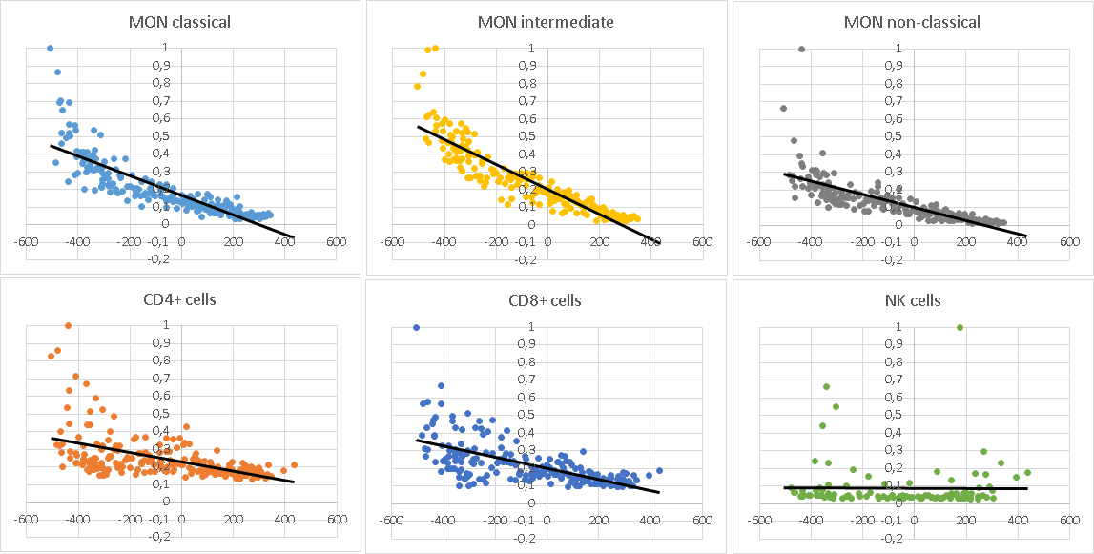
Figure S1. Trend analysis of HLA-DR expression on monocyte subsets (MON), CD4+ lymphocytes, CD8+ lymphocytes, and NK cells in CLL patients across clusters in the patient similarity network layout (Figure 3). Each dot represents the value of an individual patient. Values of all parameters were normalised to a maximum of 1. Individual lines then show the linear trend of each parameter.

Regardless of CLL cell count, the activation of circulating immune cells is dependent on the treatment regimen
To recognise the differences in circulating cells between the groups of patients with different treatment regimens, we compared studied parameters in patients with the comparable levels of CLL cells to reduce the impact of “CLL cell number” on studied parameters. We compared untreated patients (n=36) with treated patients with chemotherapy in the past (n=18) with CLL cell count from 20.0 to 80.0x10⁹ CLL cells/L and previously treated patients with immunochemotherapy (n=22) with patients treated with the novel drugs (n=53) with CLL cell count less than 10.0x10⁹ CLL cells /L. The untreated patient group was not compared with the group of patients treated with novel drugs because CLL cell number in both groups was mostly incomparable.
Comparison of treatment-naïve patients with the patients after chemotherapy (Table S4) revealed higher activation of immune cells in patients after chemotherapy. Particularly, the expression of HLA-DR on CD4+ (P<0.001) and CD8+ lymphocytes (P=0.013), classical (P=0.032) and non-classical (P=0.030) subsets of monocytes, as well as expression of CD64 on classical monocytes (P=0.044) and CD11b on non-classical monocytes (P=0.041) were lower in the untreated group. CD4+/CD8+ ratio was found to be higher in untreated patients (P=0.008).
When we compared the patients with passed chemotherapy treatment with the patients on novel drug therapy, higher activation of immune cells was observed in patients treated with novel drugs (Table S5).

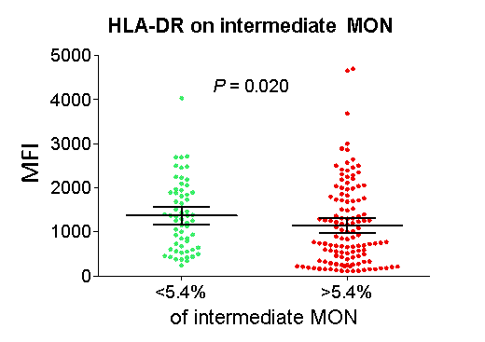
Figure S2. Difference in HLA-DR expression on intermediate monocytes (MON) between CLL patients with lower and higher numbers of intermediate monocytes (cut-off 5.4%).

