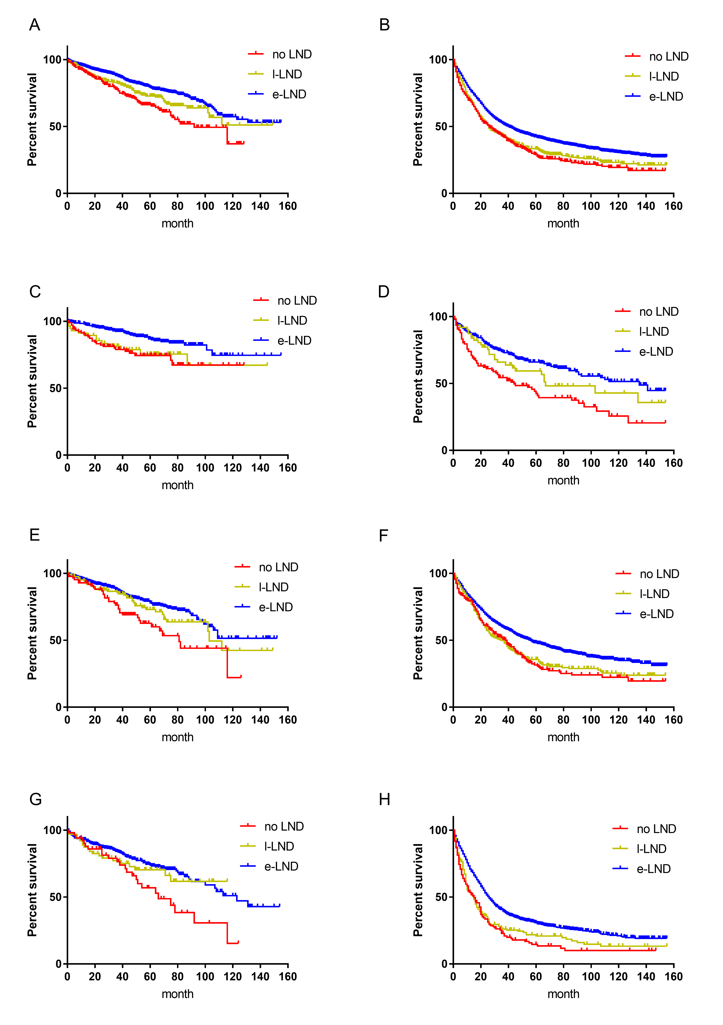
Figure S1. Kaplan-Meier plots depicting overall survival (OS) for all stage(A), pT1 and pT2(C), pT3(E) and pT4(G) after stratification according to lymph node dissection in neuroendocrine small intestine tumor patients. Kaplan-Meier plots depicting overall survival (OS) for all stage(B), pT1 and pT2(D), pT3(F) and pT4(H) after stratification according to lymph node dissection non-neuroendocrine small intestine tumor patients.
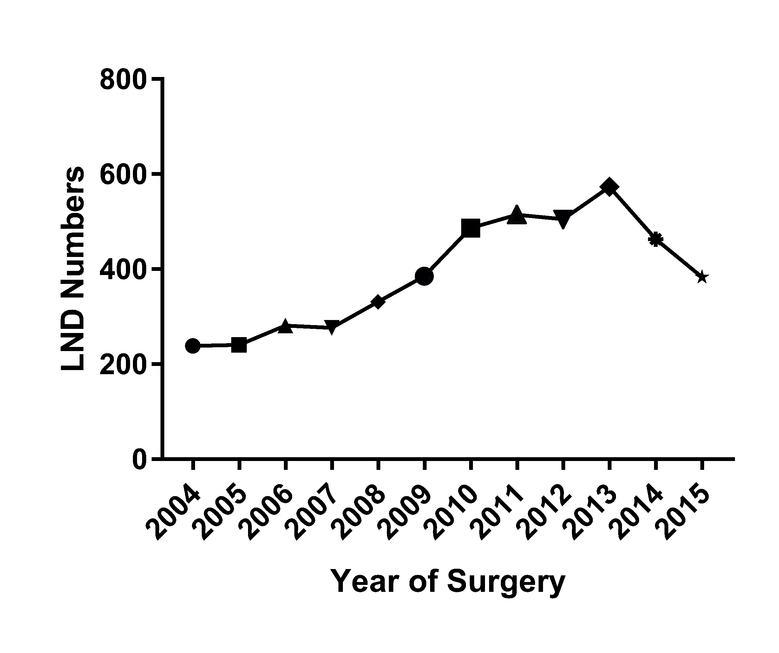
Figure S2. Numbers of LND patients from 2004 to 2015.
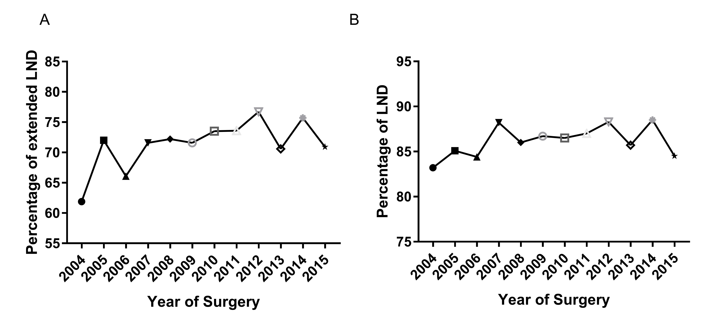Figure S3. A. Trend of extended LND rate from 2004 to 2015. B. Trend of LND rate from 2004 to 2015.

