Supporting Information
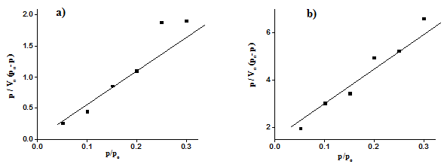
Fig. S1: BET plot for a) GA-g-PCHPMA b) GA-g-PCHPMA/Fe₃O₄
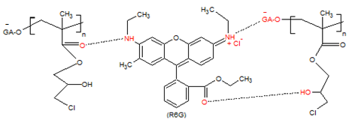
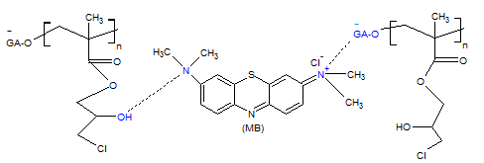
Fig. S2: Proposed mechanism for the adsorption of MB and R6G on the adsorbent GA-g-PCHPMA
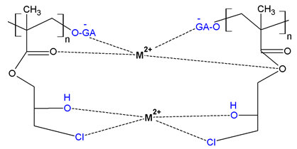
Fig. S3: Proposed mechanism for the adsorption of divalent metal ions (Cu(II) and Hg(II)) on the adsorbent GA-g-PCHPMA
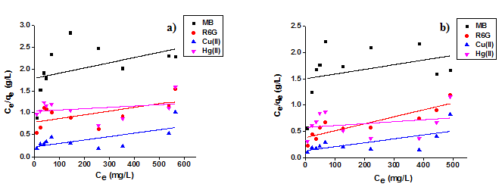
Fig. S4: Langmuir isotherm model fit for the adsorption of dyes and metal ions on a) GA–g–PCHPMA and b) GA–g–PCHPMA/Fe₃O₄
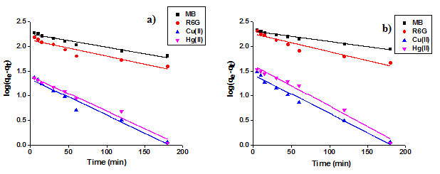
Fig. S5: Pseudo first order kinetic plot for adsorption of dyes and metal ions on a) GA–g–PCHPMA b) GA–g–PCHPMA/Fe₃O₄

