Synthesis
Supplementary file -3
Subgroup assessment for Virological Clearance using inverse variance method used and showed no significant changes. (Day 7: RR 1.49, 95% CI 0.71 to 3.13; participants = 99; studies = 2; I² = 55%; Day 14: RR 1.03, 95% CI 0.64 to 1.67; participants = 99; studies = 2; I² = 80%)
Figure 1: Forest plot of Sensitivity assessment for Virological Clearance using inverse variance method.
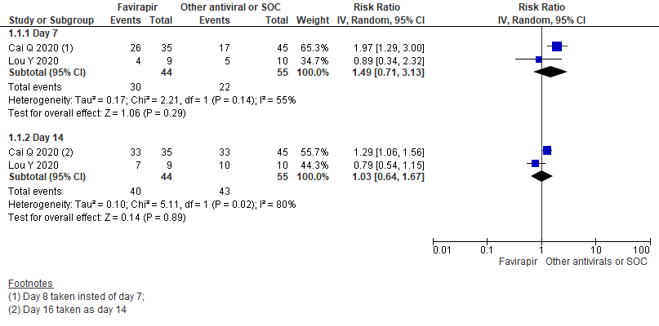
Clinical improvement on 7th day among two randomized controlled trial excluding non-randomized study by Cai Q et al. (RR 1.11, 95% CI 0.89 to 1.39; participants = 246; studies = 3; I² = 0%) (RD 0.06, 95% CI -0.06 to 0.18; participants = 246; studies = 3; I² = 0%)

Figure 2: Forest plot for risk ratios and risk differences regarding FVP in addition to SOC effectiveness for clinical improvement compared with other antivirals or SOC after exclusion of Cai Q et al.
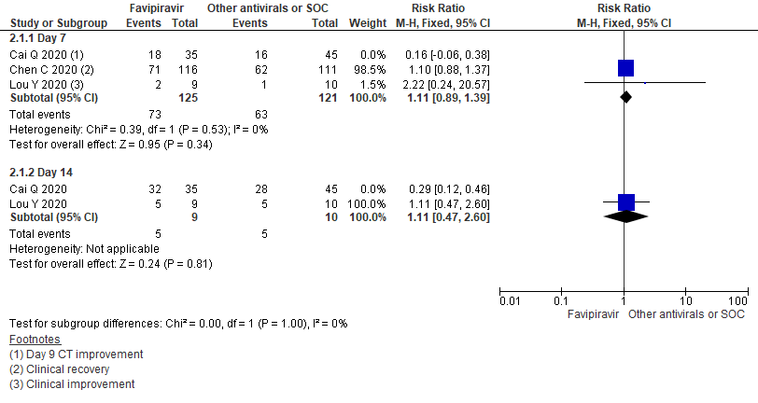
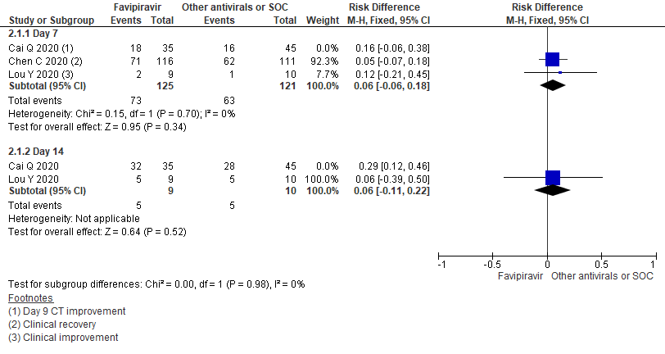
Duration to convert Negative RT-PCR: sensitivity assessment using random effect model (MD -2.16, 95% CI -13.28 to 8.97; participants = 99; studies = 2; I² = 45%)
Figure 3: Forest plot of Favipiravir in addition to standard of care or other anti-virals on Negative conversion of RT-PCR
