Supplemental Materials
Figures S1 to S9
Tables S1 to S7
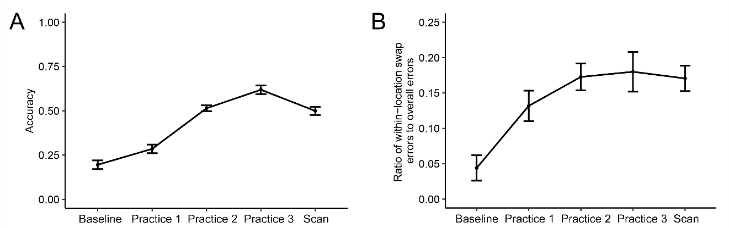
Fig. S1. Behavioral performance across sessions.
(A) Accuracy across sessions. Accuracy improved dramatically across sessions (F (3.43, 95.97) = 60.04, P < 0.0001, η² = 0.50). Post-hoc t-tests (Tukey HSD) revealed that the performance was significantly better during the fMRI scan than at the baseline (t (28) = 8.41, P < 0.001, Cohen’s d = 1.56) and during the first practice session (t (28) = 6.12, P < 0.001, Cohen’s d = 1.14). (B) Ratio of within-location swap errors to all errors across sessions. The ratio improved across sessions (F (3.09, 86.50) = 7.14, P = 0.0002, η² = 0.14). Error bars indicate averaged within-subject errors.
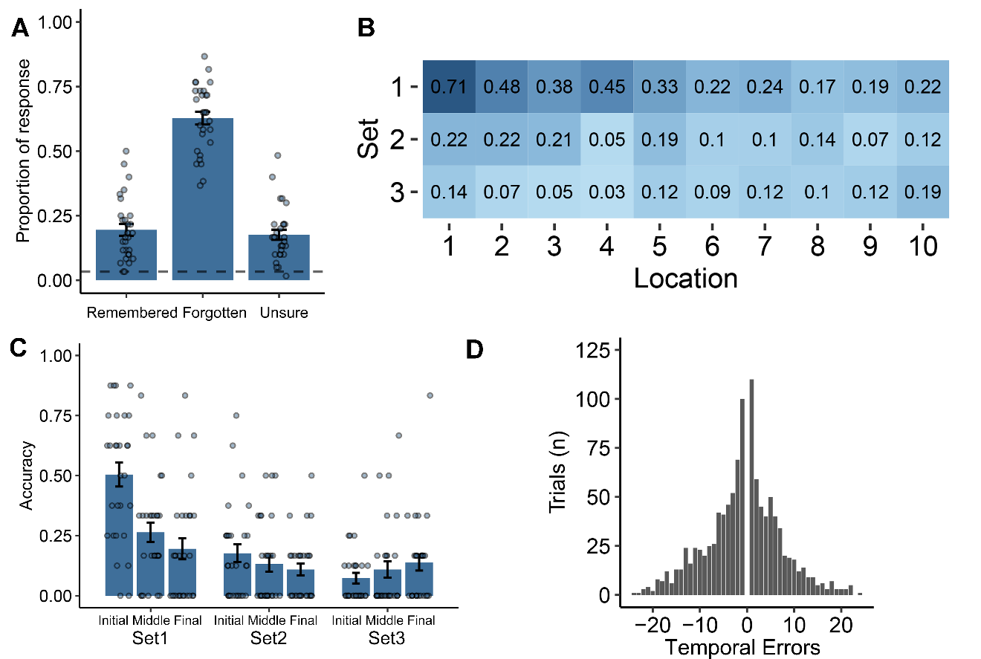 Fig. S2. Behavioral results in the baseline session.
(A) Proportions of remembered, forgotten, and unsure trials in the baseline session. The dashed line shows the chance level (3.33%). (B) Mean accuracy for each location. (C) Mean accuracy for each set. (D) Pattern of errors. Each dot represents one subject and the bars represent group means. Error bars indicate averaged within-subject errors.

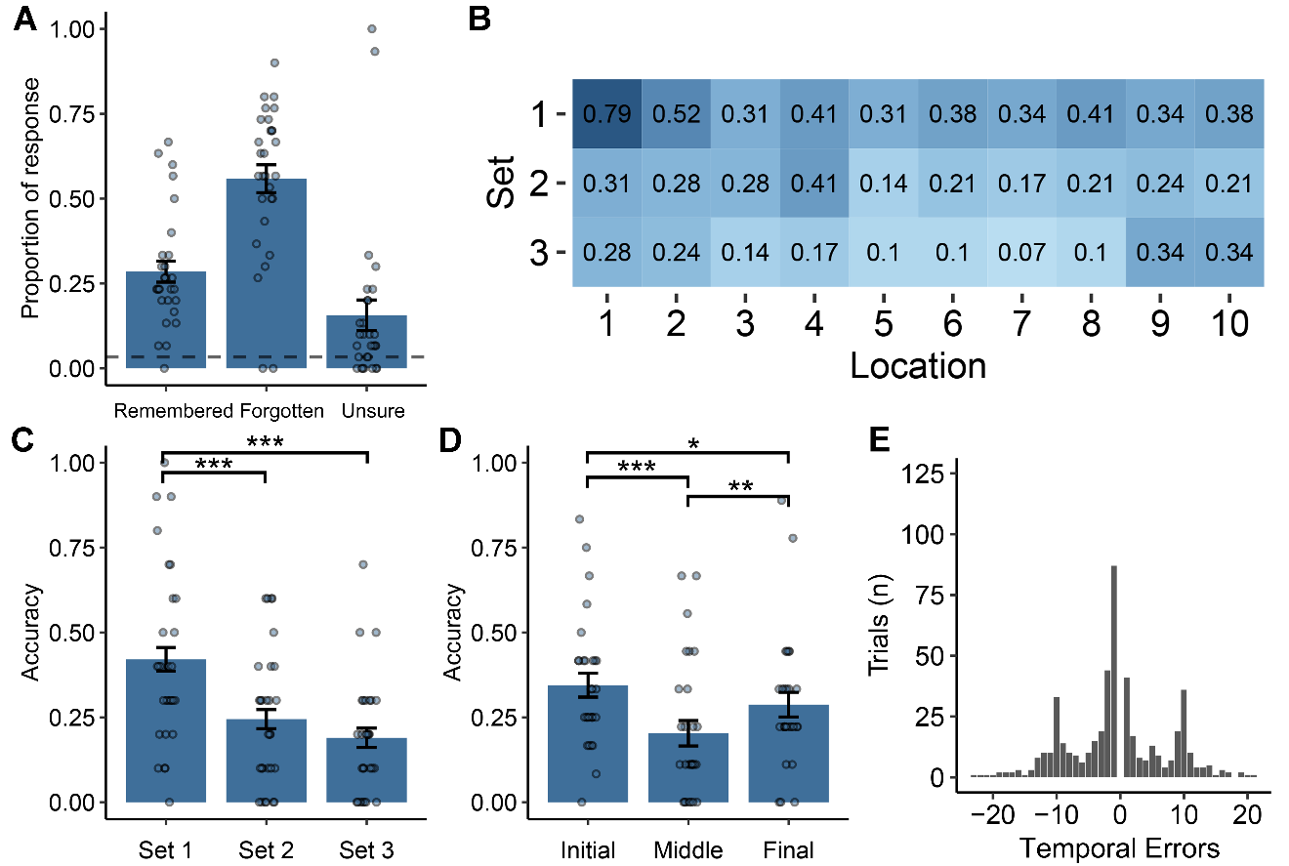
Fig. S3. Behavioral results in the first practice session.
(A) Proportions of remembered, forgotten and unsure trials in the first practice session. The dashed line shows the chance level (3.33%). (B) Mean accuracy for each location. No interaction between set and location was found (F (3.49, 97.76) = 1.58, P = 0.19). (C) Mean accuracy for each set. There was a significant fan effect (F (1.82, 50.86) = 14.26, P < 0.0001, η² = 0.11), with planned post-hoc t-tests indicating decreased performance from set 1 than to set 2 (t (28) = 3.71, P < 0.001, Cohen’s d = 0.71) and set 3 (t (28) = 4.69, P < 0.001, Cohen’s d = 0.92), but no difference between set 2 and set 3 (t (28) = 1.35, P = 0.095). (D) Mean accuracy as a function of serial position of the locations. Recency and primacy effects were found according to the position of the 10 locations (F (1.91, 53.37) = 9.83, P = 0.0003, η² = 0.04; Planned post-hoc t-tests: initial vs. middle, t (28) = 4.03, P < 0.001, Cohen’s d = 0.75; initial vs. final, t (28) = 1.80, P = 0.042, Cohen’s d = 0.33; final vs. middle, t (28) = 2.91, P = 0.004, Cohen’s d = 0.54). (E) Pattern of errors. Each dot represents one subject and the bars represent group means. Error bars indicate averaged within-subject errors. * P < 0.05. ** P < 0.01. *** P < 0.001.

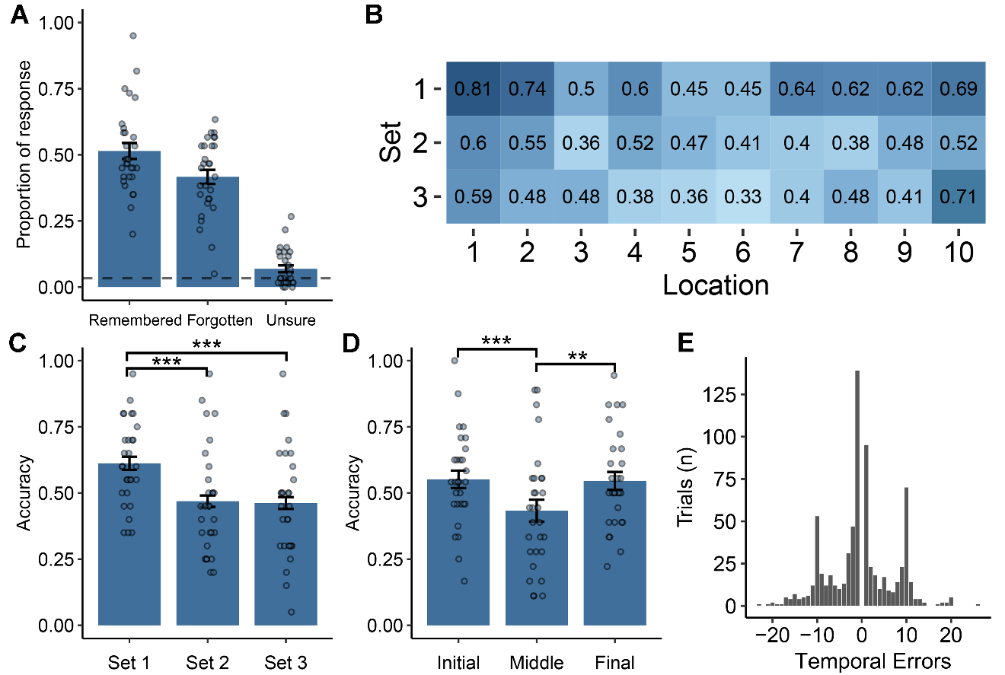
Fig. S4. Behavioral results in the second practice session.
(A) Proportions of remembered, forgotten and unsure trials in the second practice session. The dashed line shows the chance level (3.33%). (B) Mean accuracy for each location. No interaction between set and location was found (F (3.33, 93.38) = 1.06, P = 0.375). (C) Mean accuracy for each set. There was a significant fan effect (F (1.97, 55.11) = 12.96, P < 0.0001, η² = 0.07), with planned post-hoc t-tests indicating decreased performance from set 1 than to set 2 (t (28) = 4.19, P < 0.001, Cohen’s d = 0.80) and set 3 (t (28) = 4.36, P < 0.001, Cohen’s d = 0.81), but no difference between set 2 and set 3 (t (28) = 0.16, P = 0.438). (D) Mean accuracy as a function of serial position of the locations. Recency and primacy effects were found according to the position of the 10 locations (F (1.96, 54.84) = 7.57, P = 0.001, η² = 0.04; Planned post-hoc t-tests: initial vs. middle, t (28) = 3.45, P < 0.001, Cohen’s d = 0.64; initial vs. final, t (28) = 0.18, P = 0.430; final vs. middle, t (28) = 3.10, P = 0.002, Cohen’s d = 0.57). (E) Pattern of errors. Each dot represents one subject and the bars represent group means. Error bars indicate averaged within-subject errors. ** P < 0.01. *** P < 0.001.

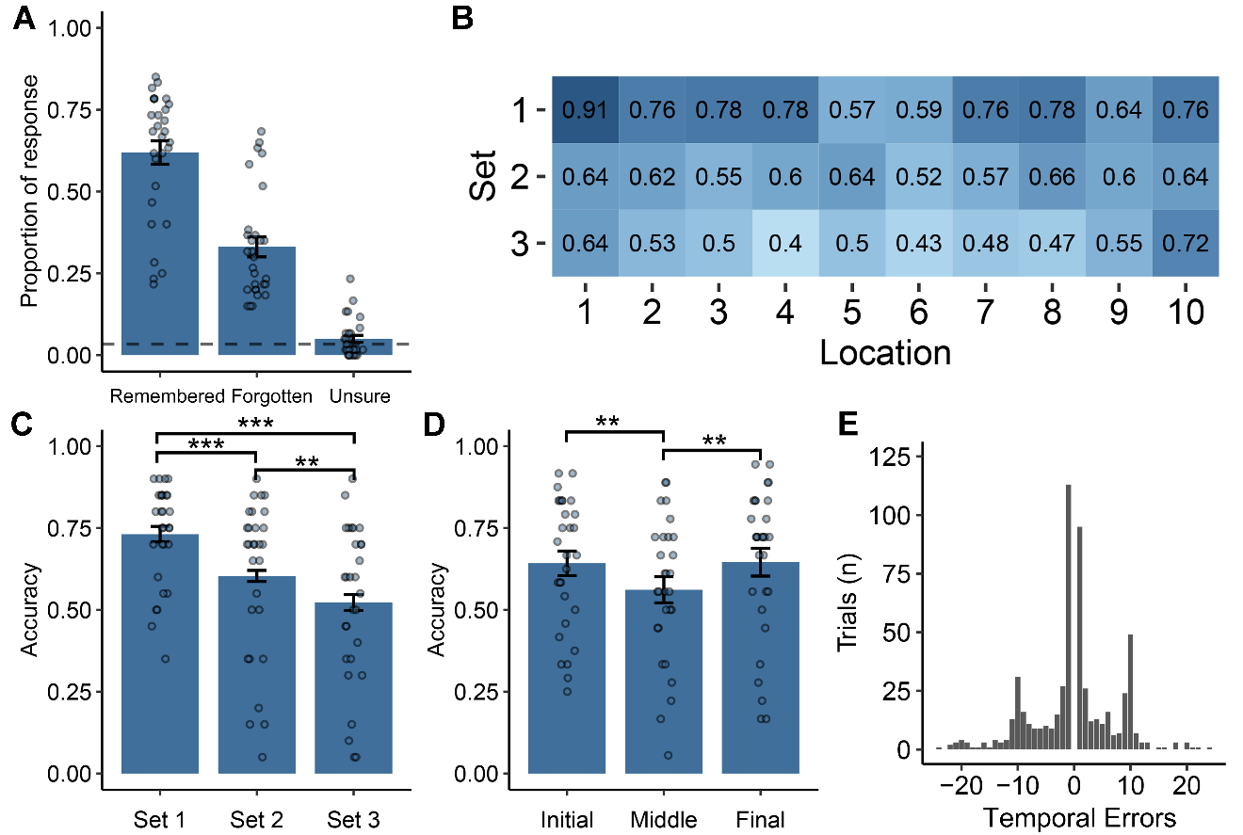
Fig. S5. Behavioral results in the third practice session.
(A) Proportions of remembered, forgotten and unsure trials in the third practice session. The dashed line shows the chance level (3.33%). (B) Mean accuracy for each locus. No interaction between set and location was found (F (2.84, 79.51) = 2.22, P = 0.096). (C) Mean accuracy for each set. There was a significant fan effect (F (1.75, 48.95) = 20.48, P < 0.0001, η² = 0.09), with planned post-hoc t-tests indicating decreased accuracy from set 1 to set 2 (t (28) = 4.34, P < 0.001, Cohen’s d = 0.87) and set 3 (t (28) = 5.42, P < 0.001, Cohen’s d = 1.06), and from set 2 to set 3 (t (28) = 2.77, P = 0.005, Cohen’s d = 0.54). (D) Mean accuracy as a function of serial position of the locations. Recency and primacy effects were found according to the position of the 10 locations (F (1.90, 53.13) = 4.70, P = 0.015, η² = 0.02; Planned post-hoc t-tests: initial vs. middle, t (28) = 2.93, P = 0.003, Cohen’s d = 0.54; initial vs. final, t (28) = -0.11, P = 0.542; final vs. middle, t (28) = 2.48, P = 0.009, Cohen’s d = 0.46). (E) Pattern of errors. Each dot represents one subject and the bars represent group means. Error bars indicate averaged within-subject errors. ** P < 0.01. *** P < 0.001.

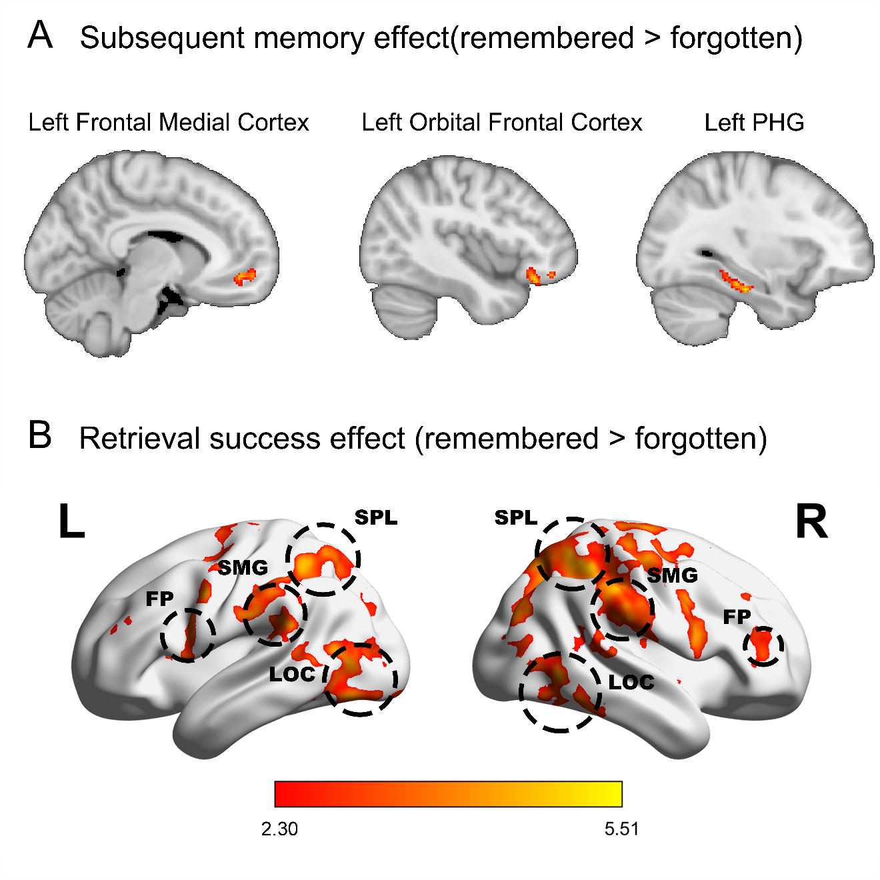
Fig. S6. Whole-brain univariate analysis.
(A) Subsequent memory effect (remembered > forgotten). (B) Retrieval success effect (remembered > forgotten). Images were thresholded using cluster detection statistics, with a height threshold of z > 2.3 and a cluster probability of P < 0.05, corrected for multiple comparisons across the whole brain using Gaussian Random Field Theory. The images were visualized with the BrainNet Viewer ⁷⁸.
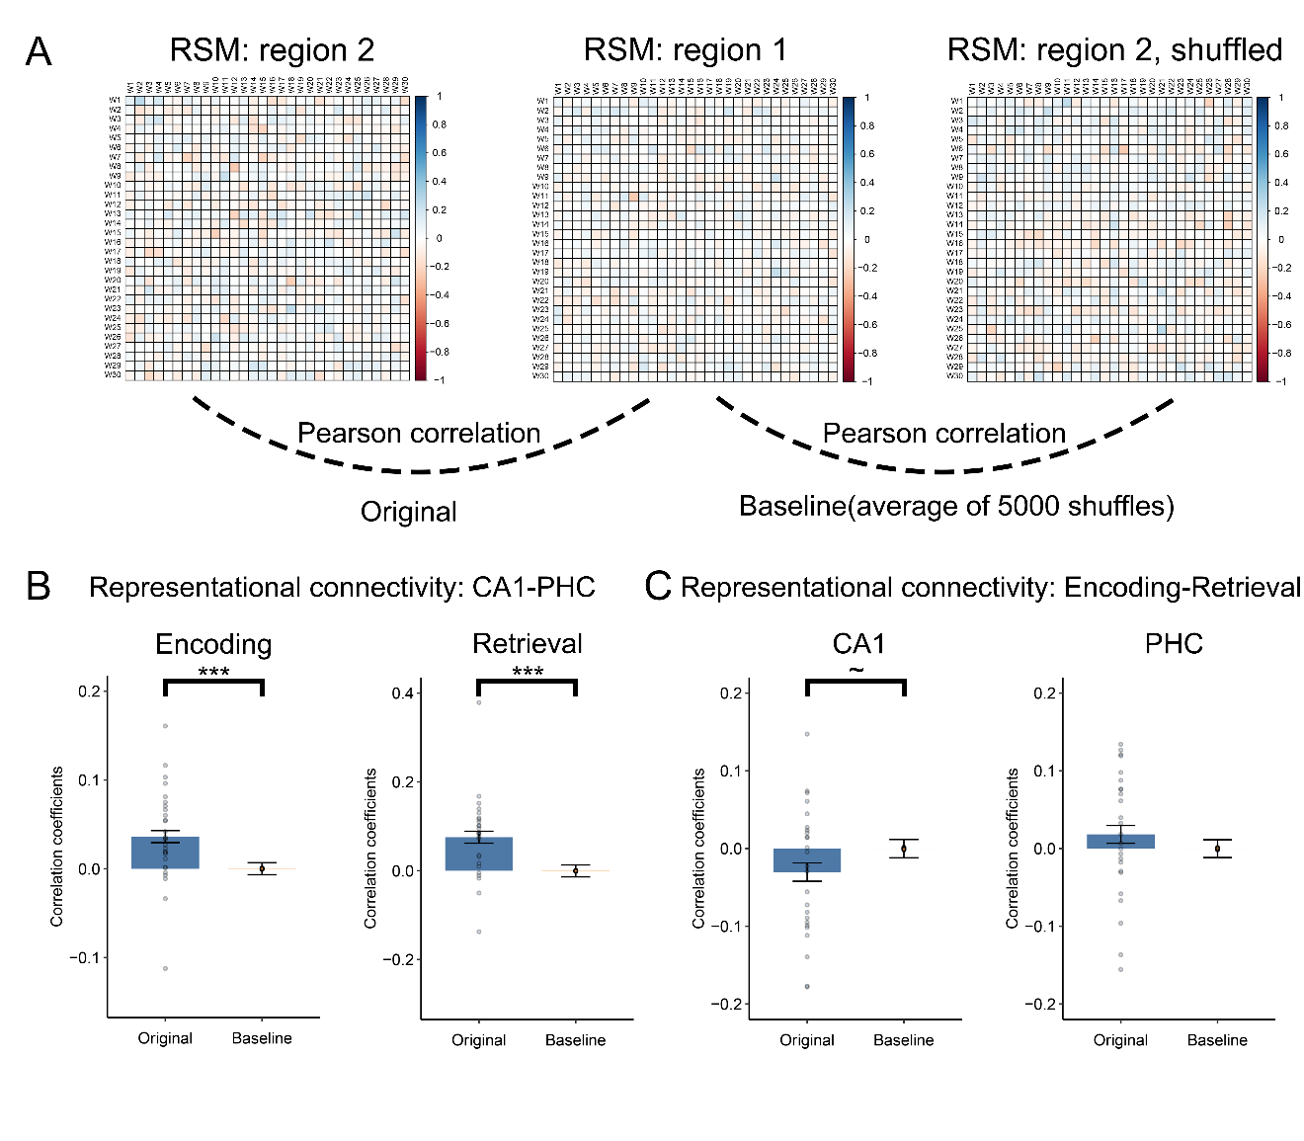
Fig. S7. Representational connectivity analysis.
(A) We correlated the cross-run representational similarity matrix (RSMs) (30 x 30) from different regions within processing stage (e.g., CA1 and PHC) or from different processing stage of the same region (e.g., CA1 encoding and CA1 retrieval). The group-level significance was determined by non-parametric permutations. (B) Representational connectivity between CA1 and PHC during encoding and retrieval. (C) Representational connectivity between encoding and retrieval for CA1 and PHC. Each dot represents one subject and the bars represent group means. Error bars indicate averaged within-subject errors. *** P < 0.001. ~ P < 0.10.

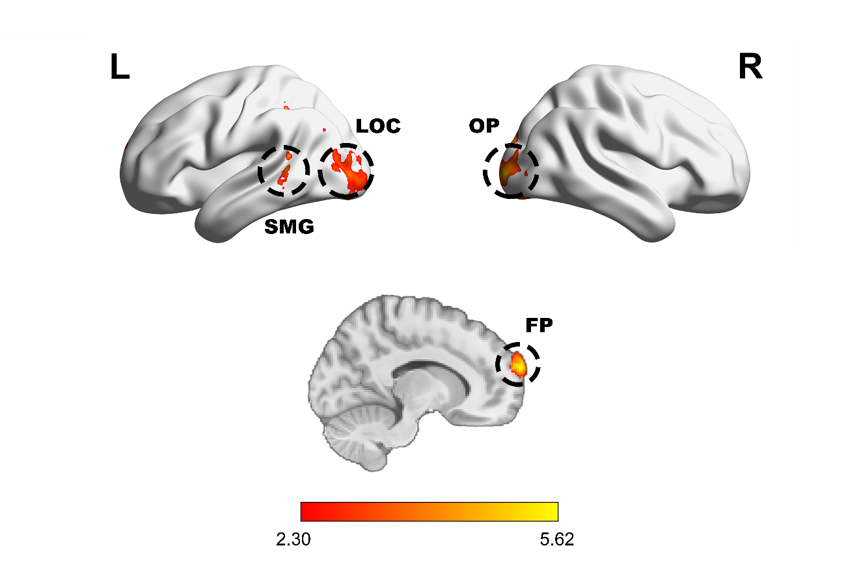
Fig. S8. Brain regions showing the location distance effect during encoding.
Regions showing greater representational similarity for near-distance pairs than far-distance pairs were overlaid onto surface brain. The significance of the derived statistical map was determined by the threshold-free cluster enhancement (TFCE) algorithm with P < 0.05 (whole brain FWE corrected) ⁷⁵. The top panel was visualized with the BrainNet Viewer ⁷⁸.
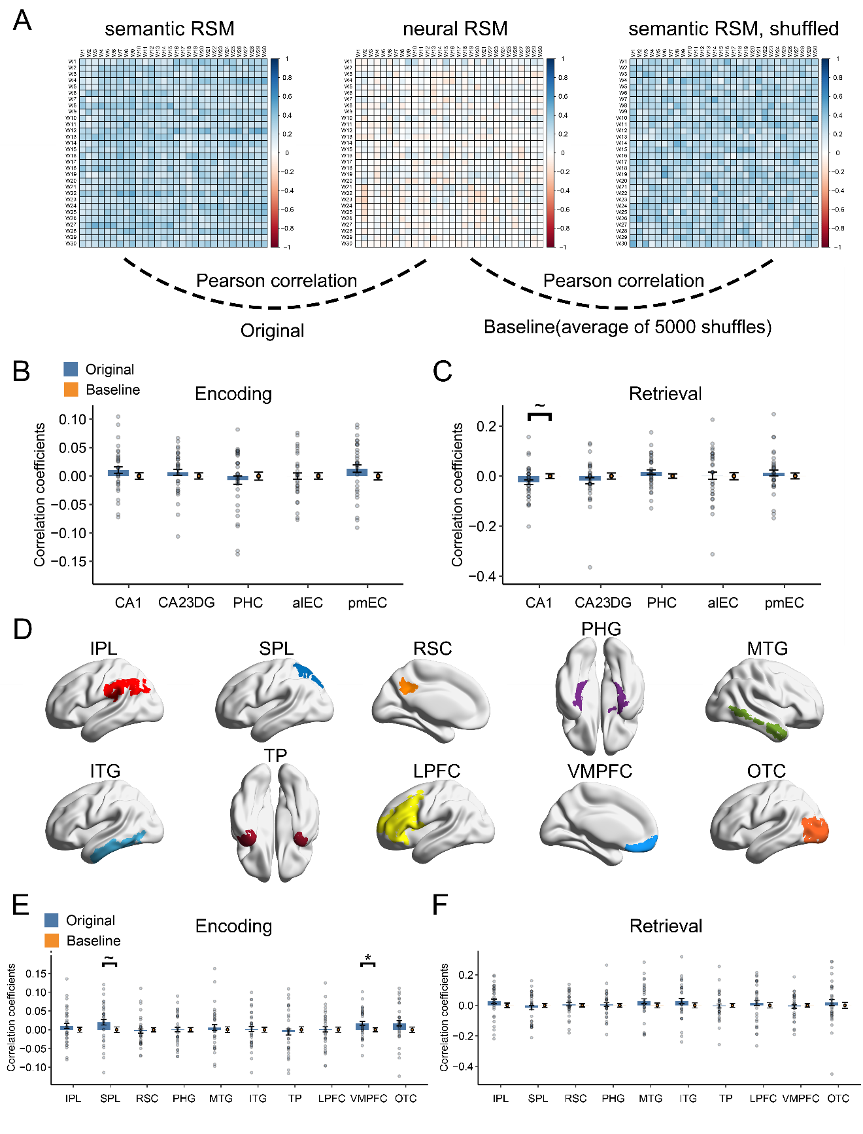

Fig. S9. Representation of semantic information in hippocampal subfields and cortical regions.
(A) Semantic representation was examined by correlating the semantic similarity matrix with the neural similarity matrix (cross-run, 30 x 30). The group-level significance was determined by non-parametric permutations. No significant semantic representation was found in the hippocampal subfields during (B) encoding or (C) retrieval. (D) Location of the pre-defined anatomic cortical surface ROIs from one subject. Please note that the ROIs were coregistered to MNI space for better display, and the analysis was conducted in subjects’ native space. Semantic representation in cortical region during (E) encoding or (F) retrieval. The VMPFC showed significant semantic representations during encoding. Each dot represents one subject and the bars represent group means. Error bars indicate averaged within-subject errors. * P < 0.05 uncorrected. ~ P < 0.10 uncorrected.

Table S1. Regions showing greater activation for remembered than forgotten trials during encoding.
Region | Coordinates
 | x | y | z | Z
Left Frontal Medial Cortex | -1 | 45 | -19 | 3.36
Left Orbital Frontal Cortex | -41 | 30 | -18 | 3.18
Left Parahippocampal Gyrus | -31 | -24 | -23 | 3.44

Table S2. Regions showing greater activation for remembered than forgotten trials during retrieval.
Region | Coordinates
 | x | y | z | Z
Left Supramarginal Gyrus | -47 | -45 | 51 | 4.71
Right Supramarginal Gyrus | 57 | -30 | 54 | 5.07
Left Superior Parietal Lobule | -36 | -54 | 59 | 5.07
Right Superior Parietal Lobule | 41 | -51 | 61 | 5.18
Left Frontal Pole | -39 | 46 | 29 | 3.82
Right Frontal Pole | 47 | 40 | 21 | 4.23
Left Lateral Occipital Cortex | -53 | -69 | -3 | 4.06
Right Lateral Occipital Cortex | 57 | -62 | -5 | 4.34

Table S3. Numbers of same-location and near-distance pairs for each subject.
Subject | Numbers of pairs in  same location | Numbers of pairs in  near distance
1 | 46 | 89
2 | 13 | 26
3 | 32 | 48
4 | 27 | 40
5 | 26 | 49
6 | 39 | 74
7 | 41 | 67
8 | 16 | 23
9* | 7 | 8
10 | 22 | 38
11 | 10 | 14
12 | 42 | 70
13* | 3 | 7
14 | 19 | 22
15 | 27 | 46
16 | 20 | 28
17 | 25 | 46
18* | 7 | 13
19 | 44 | 88
20 | 20 | 35
21 | 38 | 67
22 | 30 | 42
23* | 2 | 4
24 | 25 | 49
25 | 18 | 28
26 | 57 | 95
27 | 21 | 40
28 | 25 | 31
29 | 16 | 27
*. They were excluded in this analysis due to fewer than 10 trials in any condition.

Table S4. Regions showing greater pattern similarity for near-distance than far-distance pairs during encoding.
Region | Coordinates
 | x | y | z | Z
Right Occipital Pole | 27 | -103 | 4 | 5.62
Left Lateral Occipital Cortex | -37 | -73 | 4 | 5.55
Right Lateral Occipital Cortex | 16 | -62 | 61 | 5.25
Left Supramarginal Gyrus | -51 | -47 | 15 | 4.95
Left Frontal Pole | -13 | 70 | 21 | 5.37

Table S5. Numbers of within-boundary and cross-boundary pairs in each temporal distance for each subject.
Temporal Distance | Numbers of  within-boundary pairs | Numbers of  cross-boundary pairs
1 | 54 | 4
2 | 48 | 8
3 | 42 | 12
4 | 36 | 16
5 | 30 | 20
6 | 24 | 24
7 | 18 | 28
8 | 12 | 32
9 | 6 | 36
Sum | 108 | 88
Note: The temporal distance in bold type was chosen for the analysis and the sum only includes these four distances.

Table S6. Overall numbers of pairs and the percentage of subjects with correct pairs in each temporal distance.
Temporal Distance during retrieval (TDr) | Number of pairs  (both short- and long-distance pairs) | Percent of subjects
1 | 58 | 86.21%
2 | 56 | 68.97%
3 | 54 | 58.62%
4 | 52 | 72.41%
5 | 50 | 75.86%
6 | 48 | 65.52%
7 | 46 | 72.41%
8 | 44 | 62.07%
9 | 42 | 75.86%
10 | 40 | 82.76%
11 | 38 | 65.52%
12 | 36 | 75.86%
13 | 34 | 48.28%
14 | 32 | 62.07%
15 | 30 | 58.62%
16 | 28 | 51.72%
17 | 26 | 55.17%
18 | 24 | 58.62%
19 | 22 | 34.48%
20 | 20 | 44.83%
21 | 18 | 41.38%
22 | 16 | 24.14%
23 | 14 | 41.38%
24 | 12 | 17.24%
25 | 10 | 20.69%
26 | 8 | 0.00%
27 | 6 | 6.90%
28 | 4 | 0.00%
29 | 2 | 0.00%
Note: The temporal distances in bold type were chosen for the analysis.

Table S7. Numbers of short- and long-distance pairs for each subject.
Subject | Numbers of pairs in  short distance | Numbers of pairs in  long distance
1 | 76 | 68
2 | 16 | 17
3 | 30 | 33
4 | 28 | 26
5 | 29 | 23
6 | 72 | 66
7 | 60 | 44
8 | 19 | 17
9* | 3 | 3
10 | 28 | 31
11* | 10 | 8
12 | 69 | 60
13* | 6 | 4
14 | 22 | 19
15 | 36 | 28
16 | 23 | 24
17 | 33 | 36
18 | 10 | 11
19 | 72 | 65
20 | 26 | 20
21 | 56 | 60
22 | 36 | 40
23* | 7 | 8
24 | 29 | 29
25 | 13 | 19
26 | 99 | 90
27 | 37 | 30
28 | 28 | 24
29** | 16 | 14
*. They were excluded in this analysis due to fewer than 10 trials in any condition.
**. This subject was excluded in this analysis as an outlier, i.e., 2.5 SDs above the mean.

