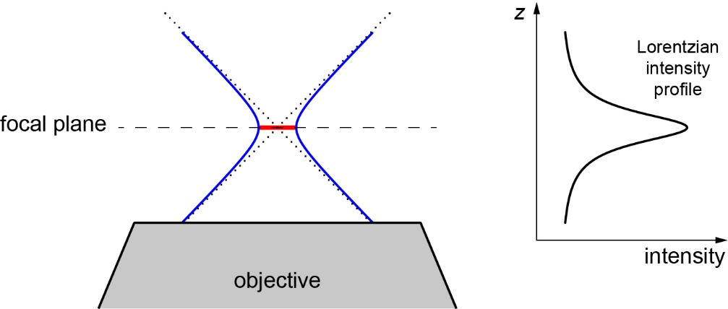

Figure S1. Focused beam profiles.
Focused beams are hyperboloid in the axial direction. Asymptotes indicated by dotted lines. Waist diameter indicated by red line on focal plane (dotted line). Corresponding intensity profile indicated to right of beam profile.

