**SUPPLEMENTARY MATERIAL**

**Fig. S1 a.** Spatial distribution of glaciers in the Upper Indus River Basin.

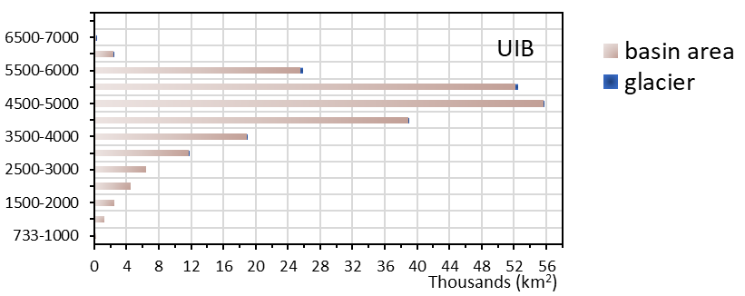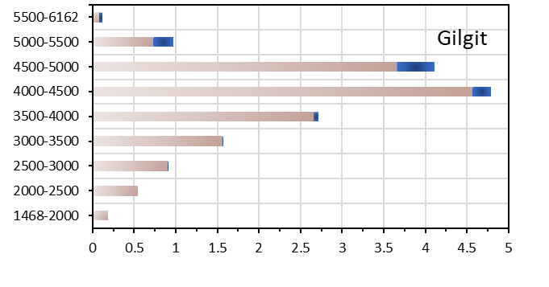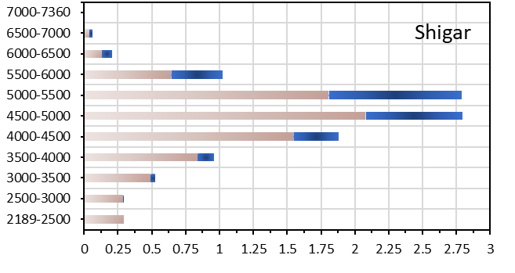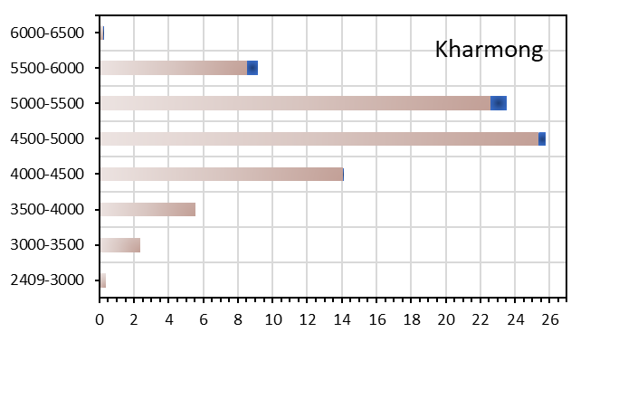

**Fig. S1 b**. Distribution of basin and glacier areas along elevations in the Upper Indus River Basin and subbasins.

Elevation (m)

Elevation (m)

Elevation (m)

Elevation (m)



**Fig. S2.** Observed monthly average discharge at Bisham Qila (1980-2005).



**Fig. S3.** Percentage of exceedance of daily discharge at Bisham Qila (1980–2005).



**Fig. S4.** Average monthly temperature and precipitation in the Upper Indus River Basin (1980–2005).



**Fig. S5.** Average of glacier area change in the Upper Indus River Basin according to GCMs used by Huss and Hock (2015).



**Fig. S6.** Validation results of hydrological model at Gilgit (1980–2005).



**Fig. S7.** Validation results of hydrological model at Shigar (1985–1998).



**Fig. S8.** Validation results of hydrological model at Kharmong (1982–2003).



**Fig. S9.** Change in (a) temperature and (b) precipitation across the Upper Indus River Basin according to MRI-AGCM. Change in (c) temperature and (d) precipitation on a monthly basis.