Supplementary Materials for

Efficient solar-driven steam generation enabled by an ultra-black paint
Xiaojie Liu¹, Yanpei Tian¹, Fangqi Chen¹, Ralph Ahlgren²,
Yiting Zheng³, Ming Su³, Gang Xiao⁴, Yi Zheng^{1,5*}
¹ Department of Mechanical and Industrial Engineering, Northeastern University, Boston, MA 02115, USA
² Soleeva Energy, Inc. San Jose, CA 95131, USA
³ Department of Chemical Engineering, Northeastern University, Boston, MA 02115, USA
⁴ Department of Physics, Brown University, Providence, RI 02912, USA
⁵ Department of Electrical and Computer Engineering, Northeastern University, Boston, MA 02115, USA
Correspondence to: y.zheng@northeastern.edu

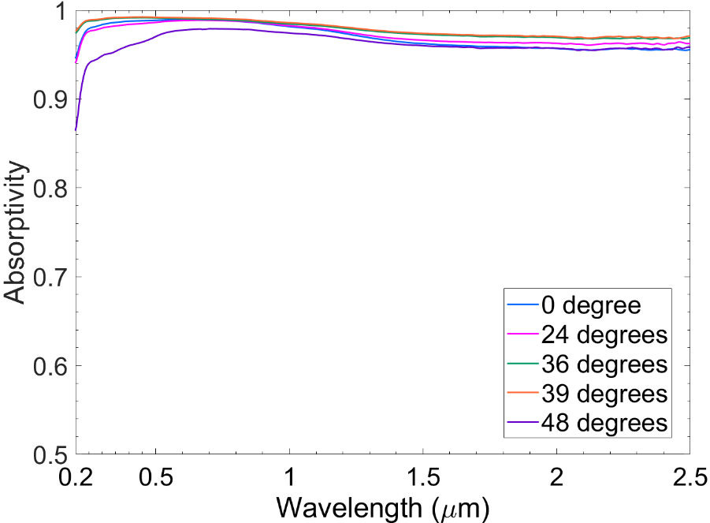
Figure S1. Absorptivity spectra of the absorber layer measured by a PTFE based integration sphere with different incident angles of 0°, 24°, 36°, 39°, and 48° and normalized by a PTFE based reference.
Figure S1 shows the hemispherical absorptivity of the absorber layer at various incident angles. It can be seen that the absorptivity of the absorber scarcely changes even near 75°, and it demonstrates that the fabricated absorber has an angular-independent hemispherical absorptivity and it enables the absorber latitude-insensitive and time-insensitive. This shows that the absorber has the great potential and less requirements to work all day.

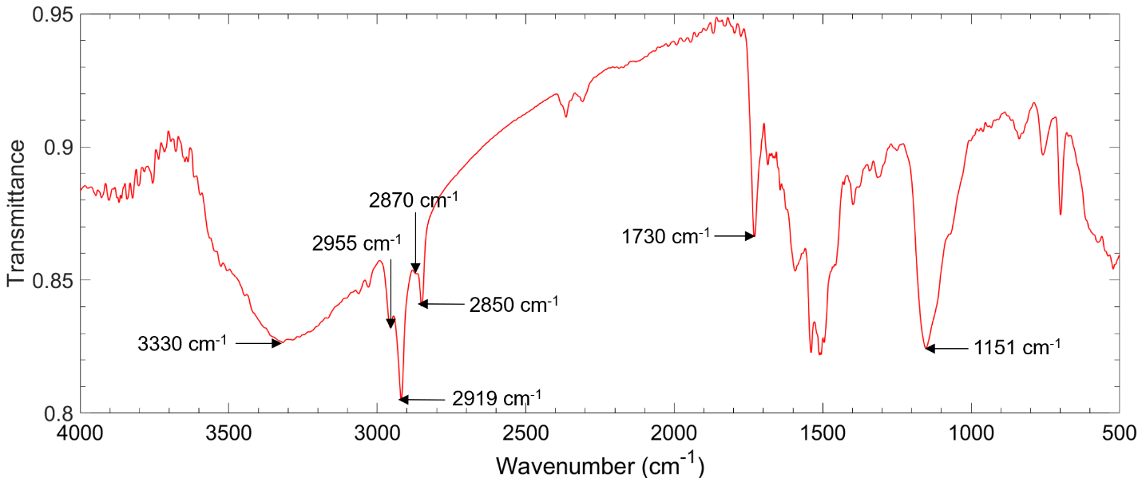
Figure S2. FTIR transmittance spectrum of the Black 3.0 paint hydraulic pressed with KBr powder showing corresponding wavenumber of functional groups.
Figure S2 shows the relations between the functional groups and the absorption peaks. The absorption peak at 3330 cm⁻¹ is due to the –OH group. The two peaks at 2955 cm⁻¹ and 2871 cm⁻¹ result from the asymmetric and symmetric stretching vibrations of CH₃ group, respectively. The asymmetric and symmetric stretching vibrations of CH₂ group cause the absorption peaks at 2919 cm⁻¹ and 2850 cm⁻¹. The sharp absorption peak at 1730 cm⁻¹ is due to the stretching vibrations of C=O and the stretching vibration C–O–C gives rise to the peak at 1151 cm⁻¹.

Calculation process
(a) Evaporation efficiency
The evaporation efficiency in the lab experiments is calculated from the equation: $η_{evap}={\dot{m}h_{fg}}/{Q_{s}}$, where $\dot{m}$ is water evaporation rate for the evaporation device, $h_{fg}$ is the total enthalpy of vaporization of water, and $Q_{s}$ is power density of the incoming light illumination. However, in the previous literature, the detailed values for $h_{fg}$ are determined in two main methods. One is to regard it as the total enthalpy of sensible heat and phase change enthalpy, as shown in the text [1-5]. The other one takes it as a constant value of around 2260 kJ kg⁻¹ [6-9].
In the first method, total enthalpy is composed of the sensible heat $c×\left(T-T_{0}\right)$ and the temperature-dependent enthalpy of vaporization ${Δh}_{fg}$ (i.e., $h_{fg}=c×\left(T-T_{0}\right)+ {Δh}_{fg}$). In the lab experiments, specific heat capacity of water, $c$, at the temperature of 50 °C is 4.1815 kJ kg⁻¹ K⁻¹, $T$ is the temperature measured by the IR camera, and the initial temperature of water, $T_{0}$, is 21 °C. The value of ${Δh}_{fg}$ which highly depends on the temperature is 2382.7 kJ kg⁻¹ at 50 °C. The calculated evaporation efficiency is 172.5 % based on the first method. Another one is based on the constant value of the $h_{fg}$ (2260 kJ kg⁻¹) and the corresponding evaporation efficiency is 155.69 %.
(b) Photothermal efficiency
The photothermal efficiency $η_{pt}$ of an absorber can be calculated using the equation $η_{pt}=\dot{m}h_{fg}^{'}/Q_{s}$, where $\dot{m}$ is water evaporation rate, $h_{fg}^{'}$ is the vaporization enthalpy of the water in an absorber, and $Q_{s}$ refers to power density of the incoming light illumination. However, according to the water cluster theory in Zhao et al.’s work, the vaporization enthalpy of water in the porous structure is smaller than that of pure bulk water [10]. To get the equivalent vaporization enthalpy ($h_{fg}^{'}$) of water in the porous absorber in this study, the repeated control experiments are conducted following the instruction of [10]. Two 100 ml graduated polypropylene beakers which are cut top opening part off to the 90 ml tick mark to keep complete circular openings are served as containers for the pure water and the absorber layer. The absorber layer is placed on the PVC foam fully fixed at the opening of the beaker and the cotton wipe strips act as water channel supplying water to the absorber layer through a slot cut in the center of PVC foam. These two beakers are synchronously placed on a polystyrene (PS) foam avoiding the heat loss and covered with a cardboard box creating a dark environment under the same ambient temperature and pressure. The control experiments are repeated 4 times and each time lasts over 17 hours (overnight). The experiments data and results are presented in Table S1.
Test | Evaporation rate (kg m⁻² h⁻¹) |  | Water initial temperature (℃) |  | Ambient temperature (℃) | Evaporation rate ratio (water/sample)
 | With sample | Pure water | With sample | Pure water
1  2  3  4 | 0.138  0.133  0.116  0.119 | 0.0795  0.0755  0.067  0.0672 | 27.8  24.6  22.2  24.1 | 27.2  24.4  23.9  23.8 | 24 - 27  23 - 24  23.6 - 24  23 - 24.7 | 0.576  0.568  0.578  0.565

The equivalent vaporization enthalpy $h_{fg}^{'}$ can be estimated using the following formula:
$$h_{fg}^{'}=\frac{{\dot{m}}_{water}}{{\dot{m}}_{BCP}}h_{fg}$$
where ${\dot{m}}_{water}$ is the evaporation rate of pure water, $h_{fg}$ is vaporization enthalpy of pure water, and ${\dot{m}}_{BCP}$ is evaporation rate of absorber layer. Taking the Test 3 as an example, the equivalent vaporization enthalpy $h_{fg}^{'}$ is 1377.2 kJ kg⁻¹, which is greatly reduced owing to the greatly increased effective surface for evaporation process in the absorber layer enabled by its porous structure. To obtain the photothermal efficiency $η_{pt}$with the equivalent vaporization enthalpy $h_{fg}^{'}$, a solar illumination experiment with the same absorber layer is conducted (2.34 kg m⁻² h⁻¹) after finishing the dark environment experiments. Using the equivalent vaporization enthalpy $h_{fg}^{'}$ and the net evaporation rate (subtract the evaporation rate in the dark environment), the photothermal efficiency $η_{pt}$ is calculated to be 85.1%.

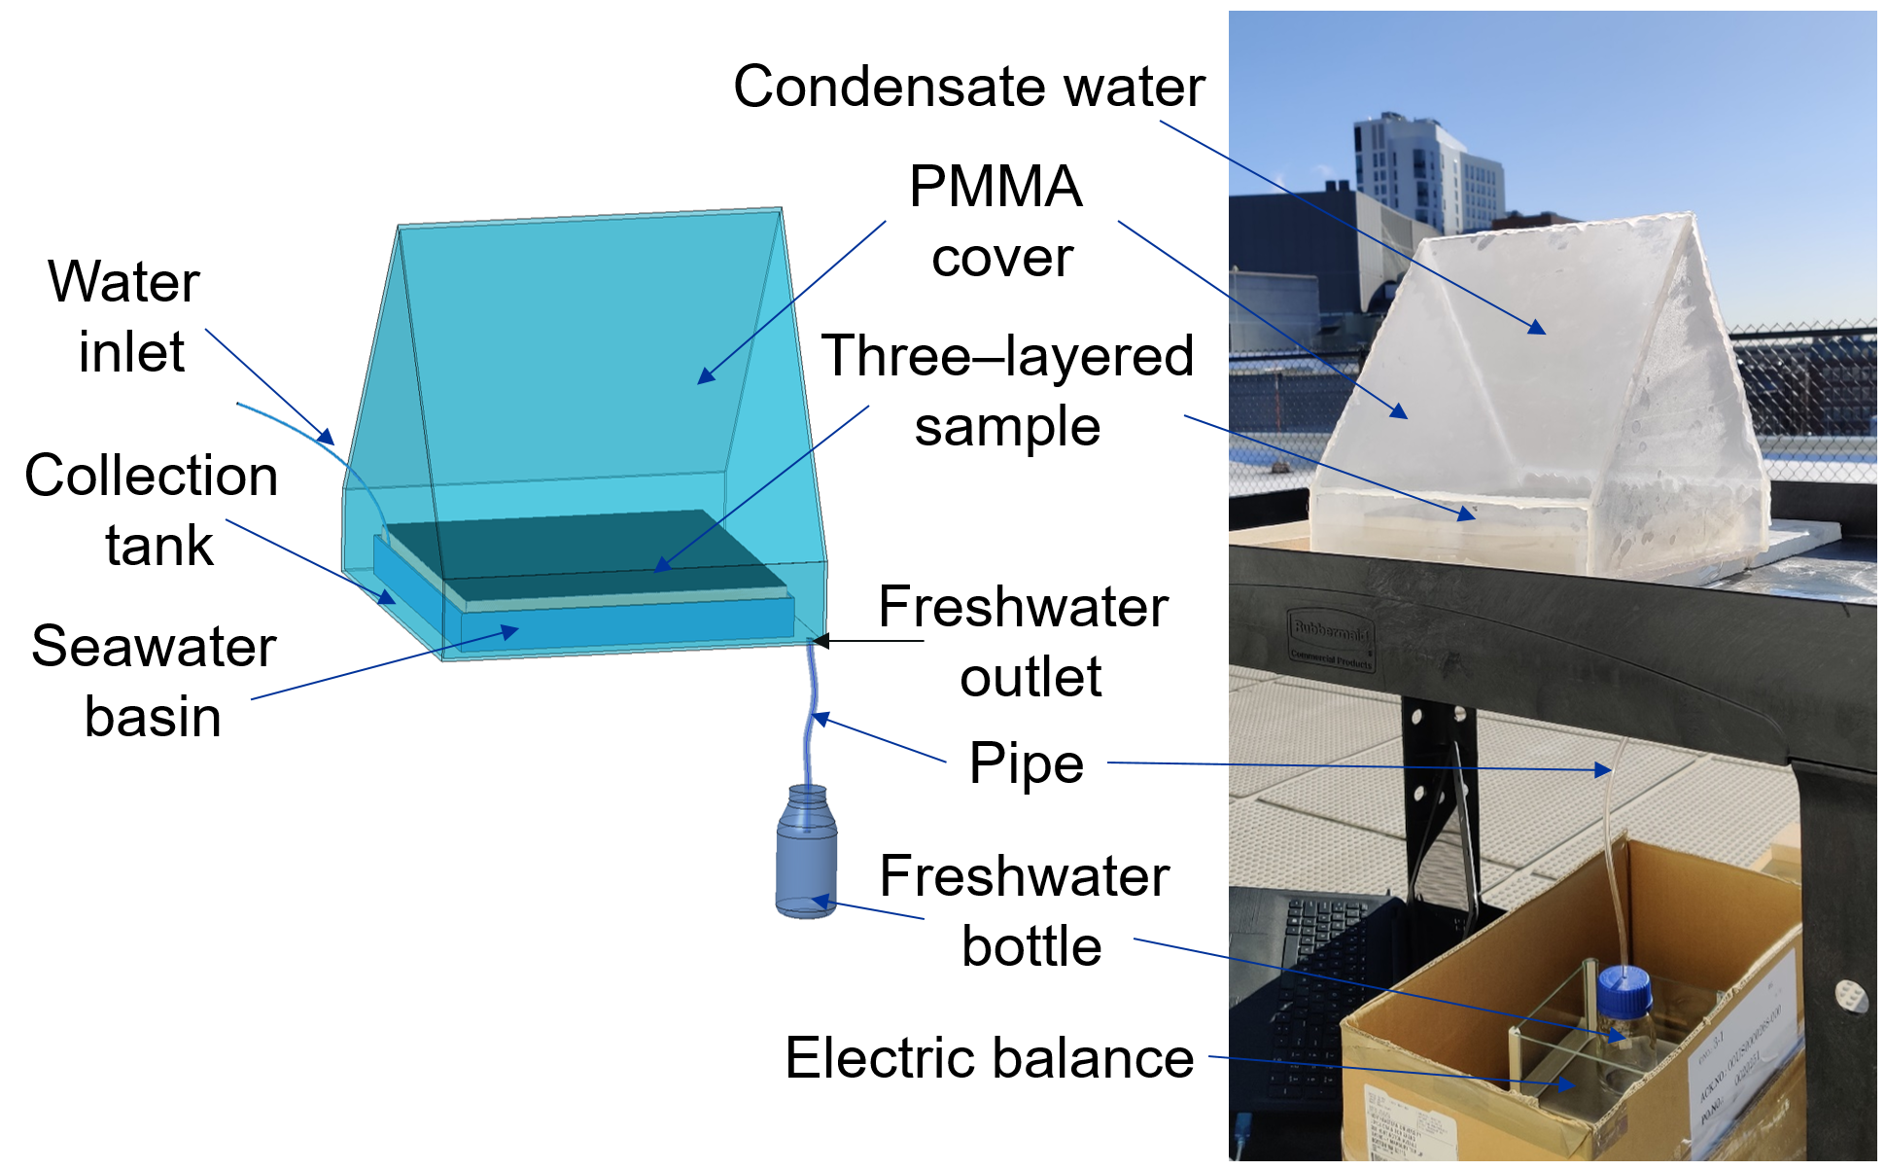
Figure S3. Three-dimensional model and photograph of the evaporation system in the rooftop experiments. Prototype of the entire is made of PMMA board including the 1/8-inch-thick bottom (McMaster-Carr, #8560K259) and 1/16-inch-thick chamber (SOURCEONE.ORG, L12’’ 𝗑 W12’’ 𝗑 H1/16’’) and sealed with hot glue sticks. The evaporation device with the dimension of 24 cm 𝗑 24 cm is floated in the water basin with a depth of 13 mm. During the evaporation process, the generated steam condenses on the interior surface of the cover forming the condensate and eventually drips into collection tank. The outlet of the prototype with the diameter of 6 mm is connected to a bottle placed on an electric balance through a plastic tube.

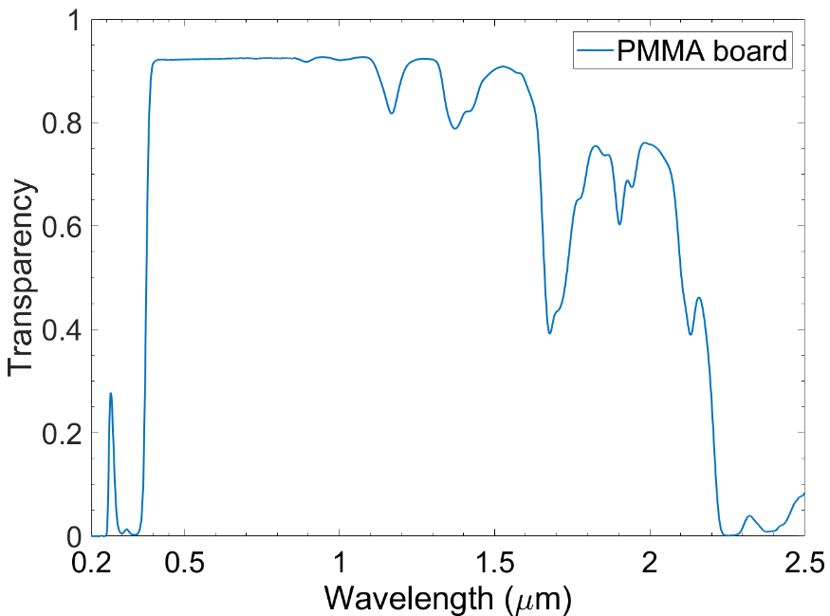
Figure S4. Transparency spectrum of the PMMA board used in the outdoor experiments serving as the cover of the evaporation system.

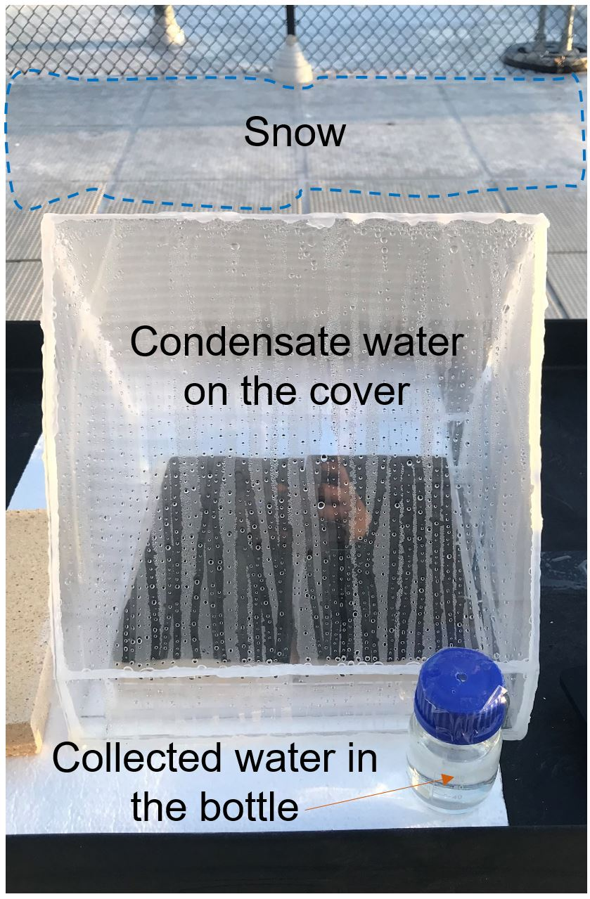
Figure S5. The photograph of the termination state of the evaporation system in the rooftop experiments in the Day 1 in Boston, MA, USA in winter (January 2020).

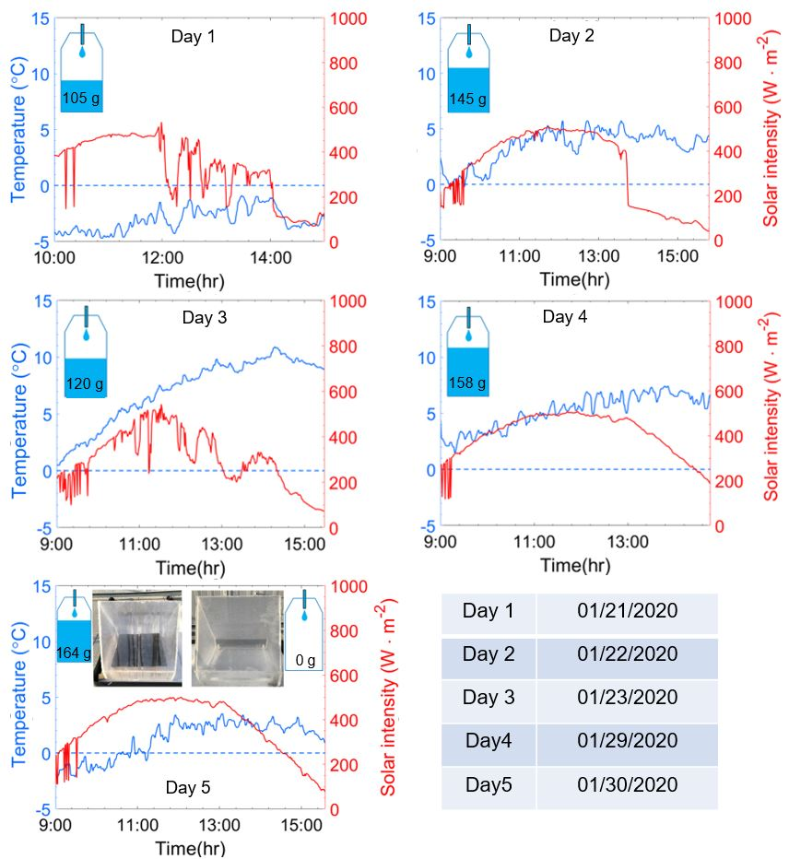
Figure S6. The solar intensity (red curve) and the ambient temperature (blue curve) changes over time for five days in January in Boston, MA, USA.

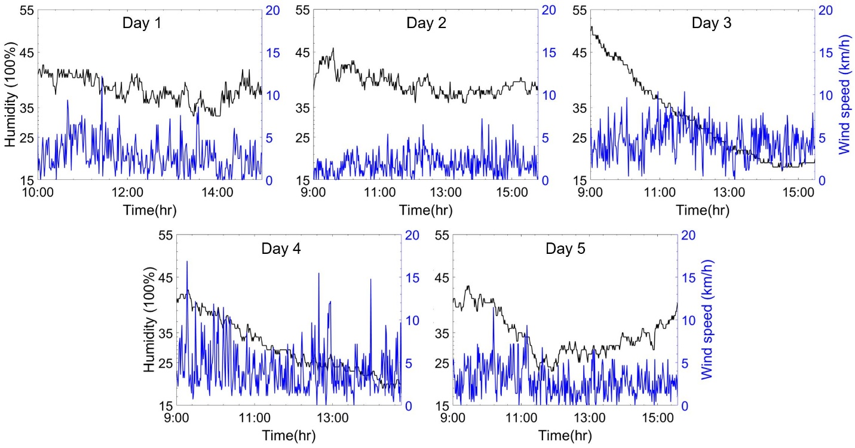
Figure S7. The ambient humidity and wind speed in the rooftop experiments.
Figures S6 and S7 show the varying solar intensity, the ambient temperature, the humidity and the wind speed in the rooftop experiments measured by the Smart Weather Station (Ambient Weather, WS-2000). The weight of the collected drinkable water is recorded at the end of each experiment.

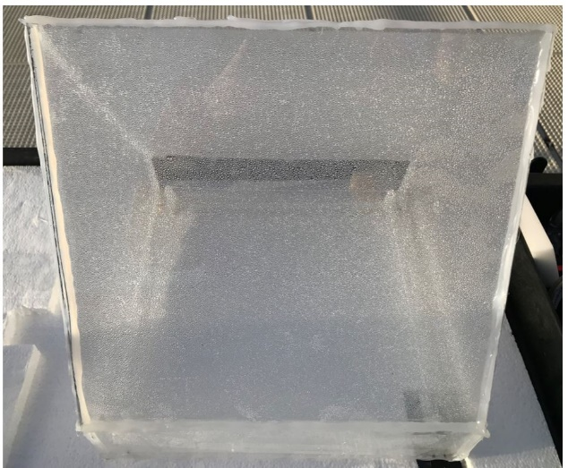
Figure S8. The photograph of the termination state of the control group in the rooftop experiments in the Day 5. At the end of the experiment, the condensed water droplets densely appeared on the cover without forming water dripping flow.

Cost analysis
In this work, the evaporation device is fabricated with low-cost commercial materials, including Black 3.0 paint, MF, all-cotton wipe, and PVC foam. The retail costs of the materials and the amounts required for an evaporation device of an area of 1 m² are listed in Table S2.
Table S2. Summary for material cost
Material | Unit Cost | Amount | Total Cost
Black 3.0 paint | $0.146/ml | 927 ml | $135
Melamine foam | $10/m² | 1 m² | $10
Cotton wipe | $2.99/m² | 1 m² | $2.99
PVC foam | $58.7/m² | 1 m² | $58.7
Total | -- | -- | $206.69

According to the material cost analysis, the estimated cost per unit for an evaporation device is $206.69/m². Here, we also recommend using the closed-pore PS foam with a low thermal conductivity of 0.02 W m⁻¹ K⁻¹ as a substitute for PVC foam serving as the thermal barrier in the evaporation device. The unit cost for the PS foam (Owens Corning, Foamular 250) is $6.57/m², which reduces the total price to $154.56/m².

References
- Li, Chenwei, et al. "Scalable and robust bilayer polymer foams for highly efficient and stable solar desalination." Nano Energy 60 (2019): 841-849.
- Li, Xiuqiang, et al. "Graphene oxide-based efficient and scalable solar desalination under one sun with a confined 2D water path." Proceedings of the National Academy of Sciences 113.49 (2016): 13953-13958.
- Ni, George, et al. "A salt-rejecting floating solar still for low-cost desalination." Energy & Environmental Science 11.6 (2018): 1510-1519.
- Ghasemi, Hadi, et al. "Solar steam generation by heat localization." Nature communications 5 (2014): 4449.
- Wang, Gang, et al. "Reusable reduced graphene oxide based double-layer system modified by polyethylenimine for solar steam generation." Carbon 114 (2017): 117-124.
- Shi, Le, et al. "Rational design of a bi-layered reduced graphene oxide film on polystyrene foam for solar-driven interfacial water evaporation." Journal of Materials Chemistry A 5.31 (2017): 16212-16219.
- Zhao, Xing, et al. "Macroporous three-dimensional MXene architectures for highly efficient solar steam generation." Journal of Materials Chemistry A 7.17 (2019): 10446-10455.
- Zhang, Lianbin, et al. "Hydrophobic light‐to‐heat conversion membranes with self‐healing ability for interfacial solar heating." Advanced Materials 27.33 (2015): 4889-4894.
- Wang, Yuchao, Lianbin Zhang, and Peng Wang. "Self-floating carbon nanotube membrane on macroporous silica substrate for highly efficient solar-driven interfacial water evaporation." ACS Sustainable Chemistry & Engineering 4.3 (2016): 1223-1230.
- Zhao, Fei, et al. "Highly efficient solar vapour generation via hierarchically nanostructured gels." Nature nanotechnology 13.6 (2018): 489-495.

