Appendices

Appendix A: Sample Allocation and Distribution of Inpatients by Ward at Juba Teaching Hospital (2016)
Medical Ward |  |  |  | Surgical Ward
Month | Admission | Proportion | Sample size | Month | Admission | Proportion | Sample size
Jan | * |  |  | Jan | *
Feb | 10,541 | 34% | 112 | Feb | 1,293 | 14% | 14
Mar | 3,214 | 10% | 34 | Mar | 2,376 | 25% | 25
Apr | 2,375 | 8% | 25 | Apr | 931 | 10% | 10
May | 1,050 | 3% | 11 | May | 240 | 3% | 3
Jun | 3,176 | 10% | 34 | Jun | 1,517 | 16% | 16
Jul | 1,274 | 4% | 14 | Jul | 179 | 2% | 2
Aug | 2,349 | 8% | 25 | Aug | 454 | 5% | 5
Sep | 1,193 | 4% | 13 | Sep | 243 | 3% | 3
Oct | 1,906 | 6% | 20 | Oct | 693 | 7% | 7
Nov | 778 | 3% | 8 | Nov | 184 | 2% | 2
Dec | 3,061 | 10% | 32 | Dec | 1,224 | 13% | 13
Total | 30,917 | 100% | 328 |  | 9,334 | 100% | 100
Note: * No records available for this month

Appendix B: Criteria Proposed by Baktygul et al. 2011 [18]
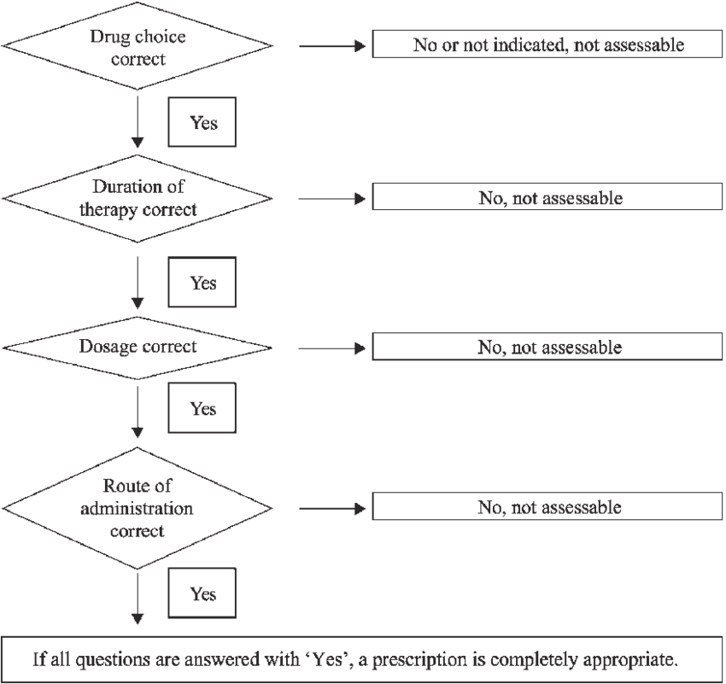

Appendix C: Data Collection Form
 | Antibiotic Use at Juba Teaching Hospital
 |  |  | Section A: Identification Information
A. Name of data collector:___________________ |  |  |  |  |  | B. Code No.:_____________
C. Form unique number:___________ |  |  |  |  | D. Date of data collection: ___/___/20___
 |  |  | Section B: Demographic and Clinical Information
Q No. |  | Questions and filters |  |  | Coding categories |  |  |  |  | Skips
101 |  | Age |  |  | 0–5 years ………………..1
 |  |  |  |  | 6–17 years ………………2
 |  |  |  |  | ≥18 years …………………3
102 |  | Sex |  |  | Male ………………………..1
 |  |  |  |  | Female …………………….2
103 |  | Occupation |  |  | Businessman …………..1
 |  |  |  |  | Teacher …………………...2
104 |  | Diagnosis |  |  | Respiratory tract disease……….........1
 |  |  |  |  | Genitourinary tract disease……........2
 |  |  |  |  | Gastrointestinal tract disease..........3
 |  |  |  |  | Pregnancy & childbirth illness……….4
 |  |  |  |  | Consequence of external cause…....5
 |  |  |  |  | Circulatory system disease…............6
 |  |  |  |  | Infectious & parasitic disease….......7
 |  |  |  |  | Others…………………………...........8
105 |  | Length of hospital stay |  |  | 0–7 days.......1
 |  |  |  |  | 8–14 days......2
 |  |  |  |  | ≥15 days.........3
106 |  | Ward |  |  | Medical …………………..1
 |  |  |  |  | Surgical …………………..2

 |  | Section C: Antibiotic Prescription Pattern
201 | Antibiotic(s) prescribed (Please state medicine name as indicated in the patient file) |  |  | Metronidazole ……….. A =  Ampicillin ………………. B = 2
202 | Number of antibiotic(s) |  |  | One …………………………1
 | prescribed |  |  | Two …………………………2
 |  |  |  | Three ………………………3
 |  |  |  | Four ………………………..4
 |  |  |  | Five …………………………5
203 | Dosage method |  |  | Tablet ……………………..1
 |  |  |  | Capsule …………………..2
 |  |  |  | Injection soln ………....3
 |  |  |  | Susp/ syrup ……………..4
 |  |  |  | Ointment ………….…….5
 |  |  |  | Other ………………………6
204 | Duration of therapy |  |  | 0–7 days …………………1
 |  |  |  | 8–14 days ……………….2
 |  |  |  | ≥15 days …………………3
205 | Route of administration |  |  | Oral ………………………..1
 |  |  |  | Intramuscular …………2
 |  |  |  | Intravenous ……………3
 |  |  |  | Intra-bone ………………4
 |  |  |  | Topical ……………………5
 |  |  |  | Other ……………………..6
 |  | Section D: Quality Assessment for Antibiotic Use
301 | Drug choice correct: |  |  | Yes …………………………..1
 |  |  |  | No ……………………………2
302 | Duration of therapy correct: |  |  | Yes ………………………….1
 |  |  |  | No …………………………..2
303 | Given dosage correct: |  |  | Yes …………………………..1
 |  |  |  | No ……………………………2
304 | Correct route of administration: |  |  | Yes …………………………..1
 |  |  |  | No ……………………………2

 |  | Section E: Appropriateness of Antibiotics Use
401 | The prescribed antibiotic(s) are: |  | Appropriately used ………...1
 |  |  | Not appropriately used…….2
402 | Antibiotics are indicated for treatment according to national guidelines: |  | Yes ………………………….1
 |  |  | No …………………………..2

