Supplementary Material

Supplementary Figures
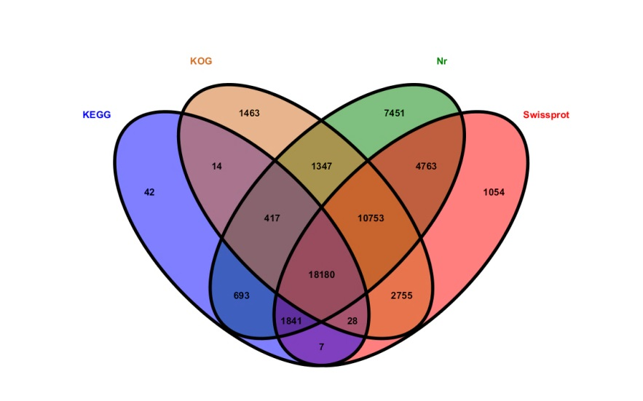
(A)
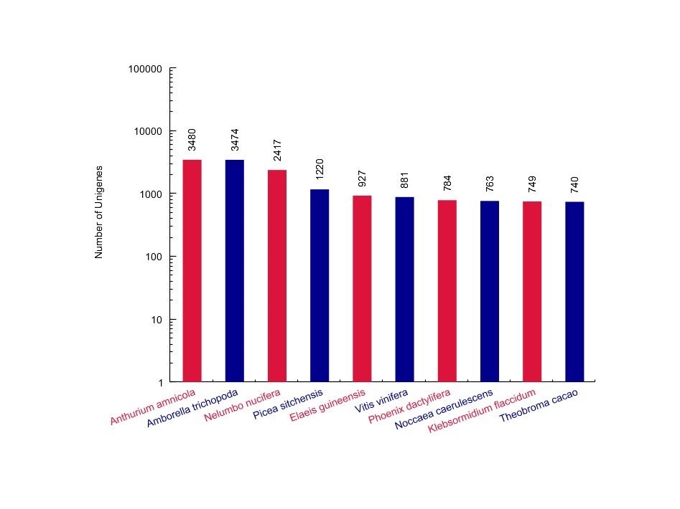
(B)
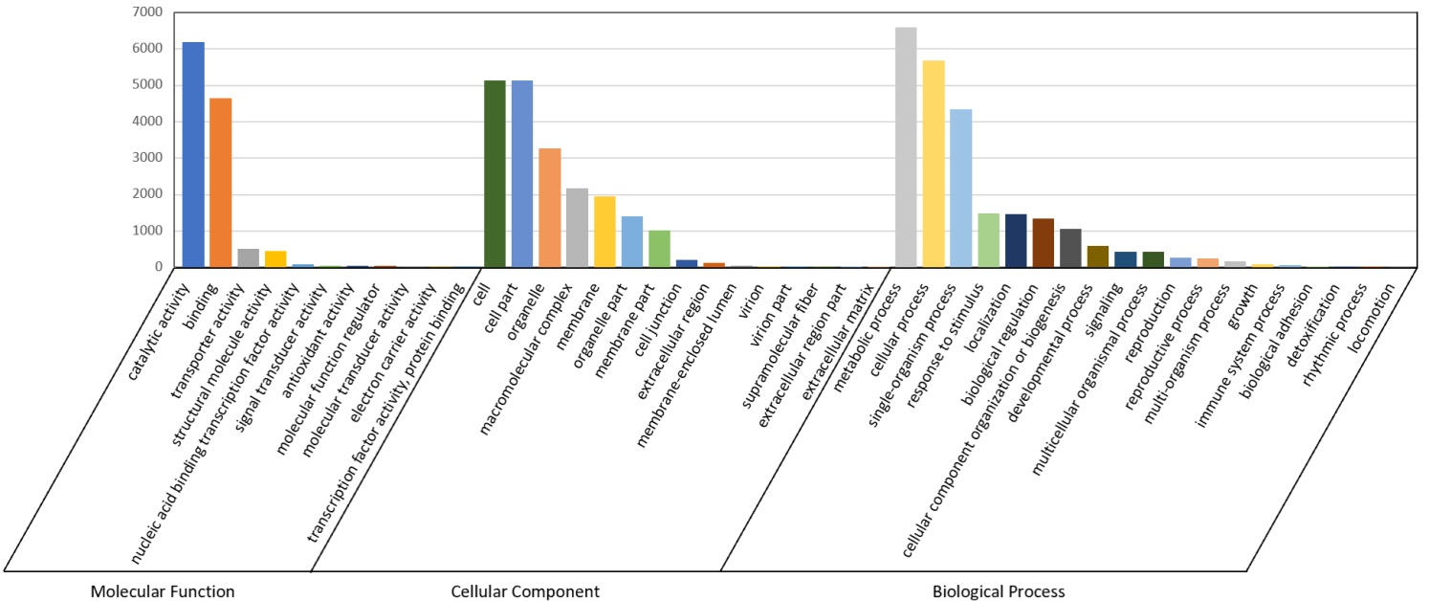
(C)
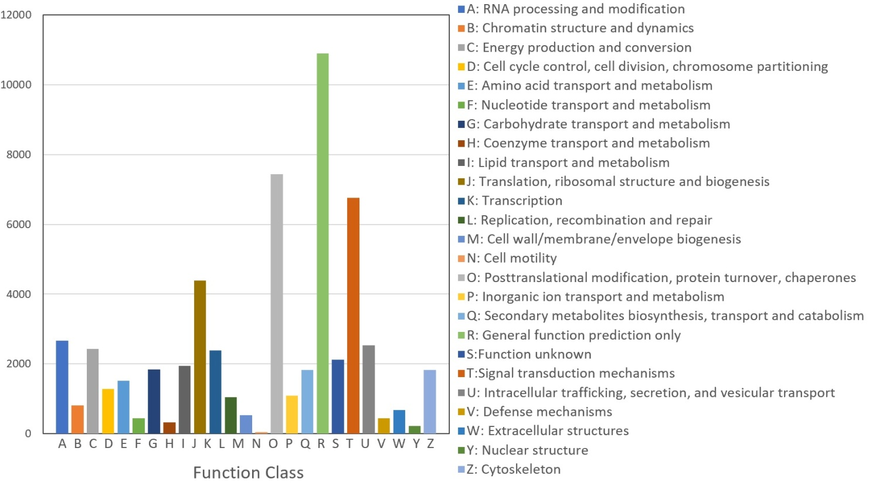
(D)
Supplementary Figure 1 Venn diagram of Unigenes annotated in the Nr, SwissProt, KOG and KEGG database (A); Nr Database annotated statistical chart of homologous species (B);GO Functional classification(C);KOG function classification of Unigenes in Chinese fir transcriptome(D).

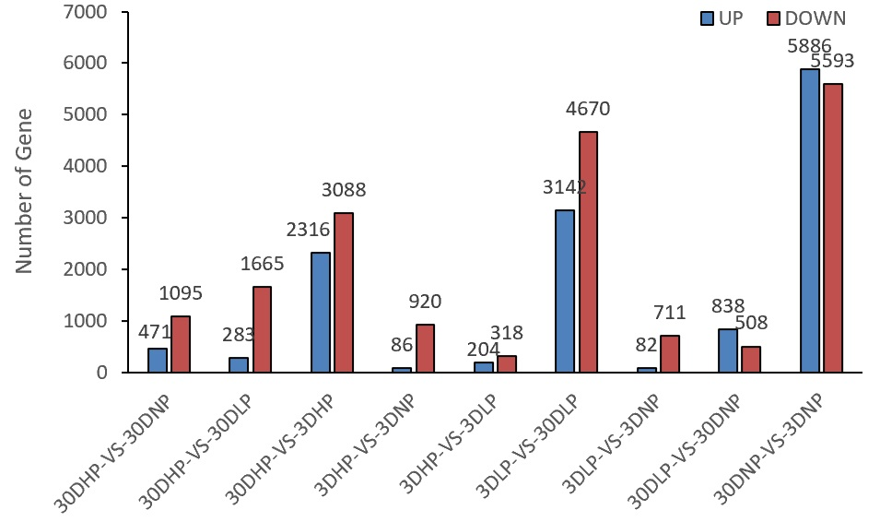
Supplementary Figure 2 Statistical histogram of differentially expressed genes between groups (A).

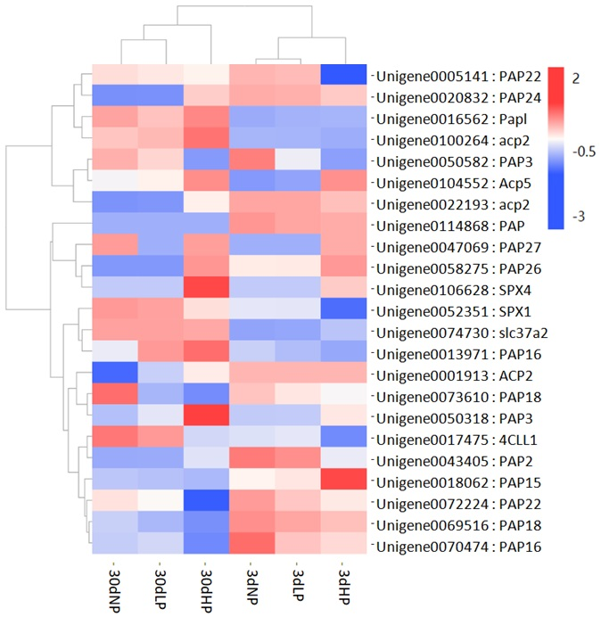
(A)
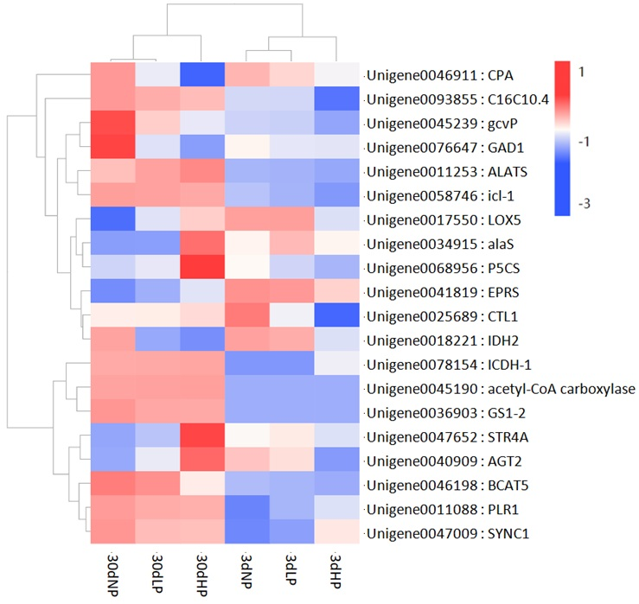
(B)
Supplementary Figure 3 Expression thermography of PAP, ACP and SPX genes in phosphorus response genes (A); Thermograms of key genes for organic acid synthesis and metabolism (B).

