Lack of Tocilizumab effect on mortality in COVID19 patients
Gregory E Holt¹, Mayank Batra¹, Mukunthan Murthi¹, Shweta Kambali¹, Kayo Santos¹, Maria Virginia Perez Bastidas¹, Huda Asif¹, Sara Hadadi¹, Sixto Arias¹, and Mehdi Mirsaeidi¹
¹Division of Pulmonary and Critical Care, University of Miami, Miami, FL, USA

Table 1. Sociodemographic and clinical variables of subjects with COVID19

Demographics (N = 62) | Survived N(%) | Did not Survive N(%) | P-Value
Age, mean (SD) (years) | 60.33(12.5) | 74.16(11.4) | <0.001
Age≥ 75 (N = 15) | 5 (11.6) | 10 (52.6) | 0.001
Male (N = 44) | 30 (69.8) | 14 (73.7) | 0.754
Hispanics (N=34) | 23(56.1) | 11(64.7) | 0.545
White (N = 33) | 20(51.3) | 13(76.5) | 0.085
Black (N = 15) | 13(33.3) | 2(11.8) | 0.109
Asian (N = 2) | 1(2.6) | 1(5.9) | 0.55
More than one race (N = 6) | 5(12.8) | 1(5.9) | 0.452
Tobacco cigarette use (N = 39) | 27(62.8 | 12(63.2) | 0.978
Vaping (N = 51) | 37(86) | 14(73.7) | 0.247
Alcohol (N = 50) | 35(81.4) | 15(78.9) | 0.822
Marijuana (N = 49) | 32(74.4) | 17(89.5) | 0.194
Symptoms at or after 48 hours of hospital admission
Temperature >=100º F (N = 26) | 18(41.9) | 8(42.1) | 0.986
Cough (N = 44) | 32(76.2) | 12(66.7) | 0.447
Sore throat (N = 2) | 1(2.4) | 1(5.6) | 0.553
Rhinorrhea (N = 4) | 3(7.3) | 1(6.3) | 0.887
Dyspnea (N = 43) | 30(69.8) | 13(68.4) | 0.916
Fever (N =42) | 29(67.4) | 13(72.2) | 0.713
Chills (N = 21) | 13(31) | 8(44.4) | 0.318
Myalgias (N = 16) | 10(24.4) | 6(33.3) | 0.478
Abdominal pain (N = 5) | 4(9.8) | 1(5.9) | 0.636
Diarrhea (N = 5) | 3(7.3) | 2(11.1) | 0.632
Nausea/vomiting (N = 7) | 5(12.2) | 2(11.8) | 0.963
Altered mental status (N = 8) | 3(7.1 | 5(29.4) | 0.035
Pre-admission oxygen use (N = 5) | 1(2.4) | 4(21.1) | 0.039
Inhaled steroid use (N = 6) | 4(9.5) | 2(11.1) | 0.851
qSOFA, mean (SD) | 0.4(0.5) | 0.7(0.7) | 0.145
Medications prior to hospital admission
Prednisone | 6(14.3) | 2(11.1) | 0.741
ACE inhibitors | 4(9.5) | 3(17.6) | 0.389
Angiotensin Receptor Blockers | 7(16.7) | 3(17.6) | 0.928
Statins | 10(23.8) | 7(41.2) | 0.187
Emergency Room visit within 12 months | 10(24.4) | 4(22.2) | 0.857
Hospital admission within last 12 months | 11(26.8) | 5(27.8) | 0.94
Nursing home/long term care facility residents | 5(11.9) | 9(47.4) | 0.004
Findings at Chest X-Ray or CT images obtained while in hospital
Ground glass opacities | 9(22.0) | 5(26.3) | 0.71
Consolidations | 10(24.4) | 8(42.1) | 0.168
Pleural effusions | 5(12.2) | 5(26.3) | 0.181
Bilateral infiltrates | 27(65.9) | 19(31.7) | 0.552
Comorbidities
Chronic Obstructive Pulmonary Disease | 4(9.5) | 1(5.3) | 0.58
Supportive oxygen before admission | 16(42.1 | 13(68.4) | 0.066
Congestive Heart Failure | 1(2.4) | 2(10.5) | 0.211
Atrial fibrillation | 4(9.5) | 2(10.5) | 0.903
Hypertension | 23(54.8) | 14(73.7) | 0.167
Stroke | 4(9.5) | 2(10.5) | 0.903
Dementia | 2(4.8) | 1(5.3) | 0.933
Chronic Renal Failure | 2(4.8) | 1(5.3) | 0.933
Diabetes Mellitus | 10(23.8) | 13(68.4) | 0.02
Lymphoma | 2(4.8) | 1(5.3) | 0.933
Solid tumor | 1(2.4) | 4(21.1) | 0.039
Laboratory findings at or within 48 hours of admission to hospital
Procalcitonin ≥ 1.15 ng/mL | 7(16.3 | 5(26.3) | 0.36
Fibrinogen ≥ 649 mg/dL | 2(4.7) | 1(5.3) | 0.918
IL-6 > 580 pg/mL | 1(2.3) | 4(21.1) | 0.037
IL-6 > 580pg/mL, mean (SD) | 177.9(227.6) | 1384.2(1234.7) | 0.028
Ferritin > 1631ng/mL | 6(14.0) | 7(36.8) | 0.048
C-Reactive Protein ≥ 21 | 7(16.3) | 6(31.6) | 0.179
Mechanical ventilation use | 21(65.6) | 15(83.3) | 0.19
Positive blood culture obtained after tocilizumab | 5(16.1) | 2(11.8) | 0.683
Medications for COVID19
Tocilizumab | 22(51.2) | 10(52.6) | 0.915
Tocilizumab administration post-admission, mean (SD) (days) | 2.6(1.7) | 5.2(9.4) | 0.414
Tocilizumab for more than 4 days | 6(14.0) | 2(10.5) | 0.711
Chloroquine/Hydroxychloroquine | 31(72.1 | 15(32.6) | 0.571
Macrolides | 33(76.7) | 16(84.2) | 0.508
Steroids | 26(60.5) | 10(52.6) | 0.565
Outcome
Hospital stay duration, mean (SD) day | 25.4(17.1) | 16.4(13.2) | 0.046
ICU stay duration, mean (SD) day | 11.4(15.6) | 10.5(11.0) | 0.833
Patient delay*, mean (SD) day | 5.3(4.8) | 3.9 (3.2) | 0.394
Physician delay**, mean (SD) day | 5.3(5.3) | 4.0(4.0) | 0.437
Readmission | 3(7.0) | 1(5.3) | 0.801
ICU admission | 29(67.4) | 17(89.5) | 0.083

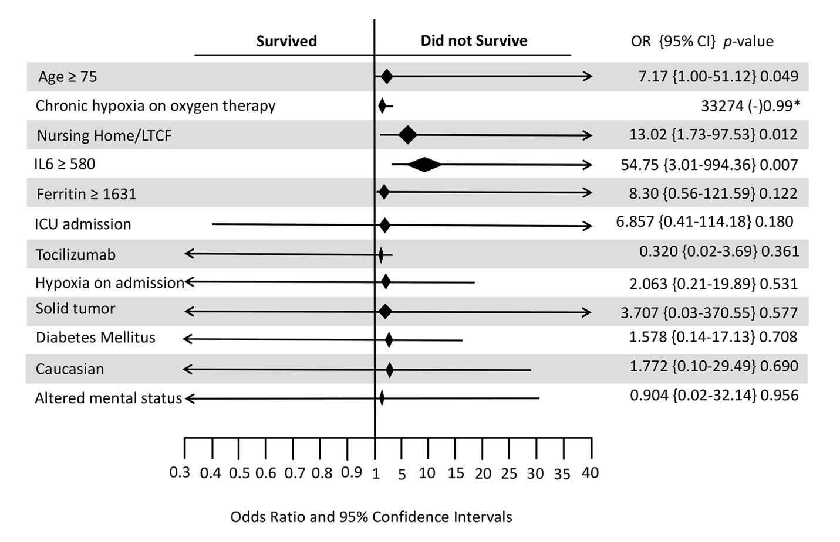
Figure 1. Forest plot showing the variables used in the multivariate model among COVID19 subjects. Hosmer lameshow score>0.05, IL6 and Ferritin units: pg/ml.

