Supplementary table 1：Model development of risk point
Effect |  | Score
Hemoglobin（g/L） | >120 | 63
Hemoglobin（g/L） | ≤120 | 0
NCT regimens | TEC | 0
NCT regimens | TCbH | 87
Ki67 | >60 | 100
Ki67 | ≤60 | 0
LVI | Absent | 85
LVI | Present | 0
Estrogen receptor | Negative | 79
Estrogen receptor | Positive | 0
Total Points | Probability of pCR
111 | 0.05
166 | 0.10
226 | 0.20
266 | 0.30
298 | 0.40
328 | 0.50
358 | 0.60
391 | 0.70
430 | 0.80

Abbreviations: NCT: Neoadjuvant chemotherapy; LVI: lymphovascular invasion

Supplementary table 2: Predictive values and sensitivity, specificity of the predicted probability at different cutoff values.
Predicted Probability | Sensitivity (%) | Specificity (%) | ppv(%) | npv(%) | index
0.100 | 93.3 | 34.2 | 34.7 | 93.2 | 27.5
0.108 | 93.3 | 35.0 | 35.0 | 93.3 | 28.3
0.117 | 93.3 | 39.2 | 36.5 | 94.0 | 32.5
0.126 | 93.3 | 40.8 | 37.2 | 94.2 | 34.2
0.204 | 91.1 | 42.5 | 37.3 | 92.7 | 33.6
0.208 | 82.2 | 53.3 | 39.8 | 88.9 | 35.6
0.223 | 80.0 | 57.5 | 41.4 | 88.5 | 37.5
0.238 | 73.3 | 65.8 | 44.6 | 86.8 | 39.2
0.254 | 66.7 | 68.3 | 44.1 | 84.5 | 35.0
0.262 | 66.7 | 69.2 | 44.8 | 84.7 | 35.8
0.296 | 62.2 | 73.3 | 46.7 | 83.8 | 35.6
0.320 | 62.2 | 77.5 | 50.9 | 84.5 | 39.7
0.456 | 60.0 | 78.3 | 50.9 | 83.9 | 38.3
0.499 | 33.3 | 90.8 | 57.7 | 78.4 | 24.2
0.505 | 20.0 | 98.3 | 81.8 | 76.6 | 18.3
0.526 | 20.0 | 99.2 | 90.0 | 76.8 | 19.2
0.765 | 20.0 | 100.0 | 100.0 | 76.9 | 20.0
Abbreviations: PPV: positive predictive value；NPV: negative predictive value

Supplementary table 3：The diagnostic odds ratio (DOR) of the nomogram at different cutoff values.
Predicted Probability | DOR (95% CI)
≥0.1 | 7.266(2.123-24.872)
≥0.2 | 7.576(2.551-22.502)
≥0.3 | 5.673(2.708-11.884)
≥0.4 | 5.423(2.593-11.341)
≥0.5 | 14.750(3.047-71.396)
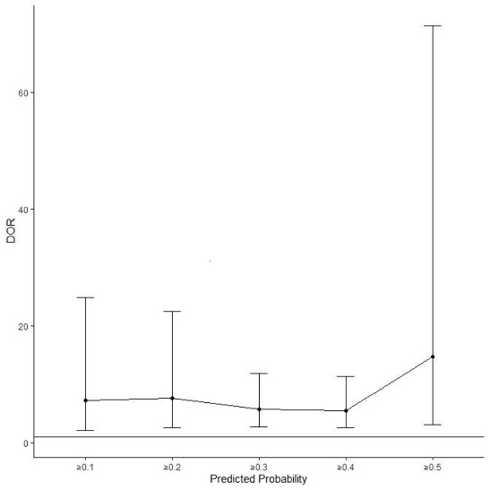

Supplementary table 4: Predictive values and sensitivity, specificity of the predicted probability at the optimal cutoff value.
 | The Optimal Cutoff | Sensitivity (%) | Specificity (%) | ppv(%) | npv(%)
 | 0.32 | 62.2 | 77.5 | 50.9 | 84.5
Abbreviations: PPV: positive predictive value；NPV: negative predictive value

