Supplementary Information

Simple and cost-effective microfabrication of flexible and stretchable electronics for wearable multi-functional electrophysiological monitoring
Chae Hyun Kim¹, Dong Hyeon Lee², Jiman Youn³, Hongje Lee⁴ and Joonsoo Jeong^{5,*}
¹Medical Research Institute, Pusan National University, Yangsan, 50612, Republic of Korea
²School of Mechanical Engineering, Pusan National University, Busan, 46241, Republic of Korea
³Information Convergence Engineering, Pusan National University, Yangsan, 50612, Republic of Korea
⁴Department of Nuclear Medicine, Dongnam Institution of Radiological and Medical Sciences, Busan, 46033, Republic of Korea
⁵School of Biomedical Convergence Engineering, Pusan National University, Yangsan, 50612, Republic of Korea
*Corresponding author: joonsoo_jeong@pusan.ac.kr

- Detailed fabrication procedures

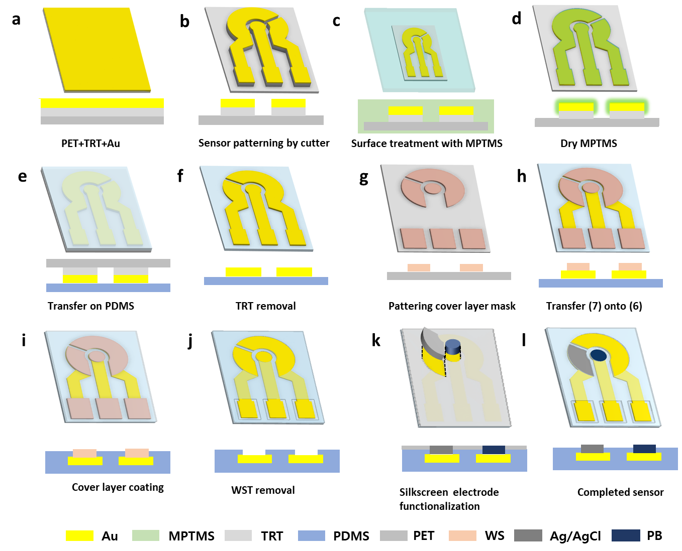
Figure S1. Schematic illustration of complete step-by-step fabrication process

Detailed description of the fabrication procedures is provided in the Methods section.
2. Calculation of “Fill factor”

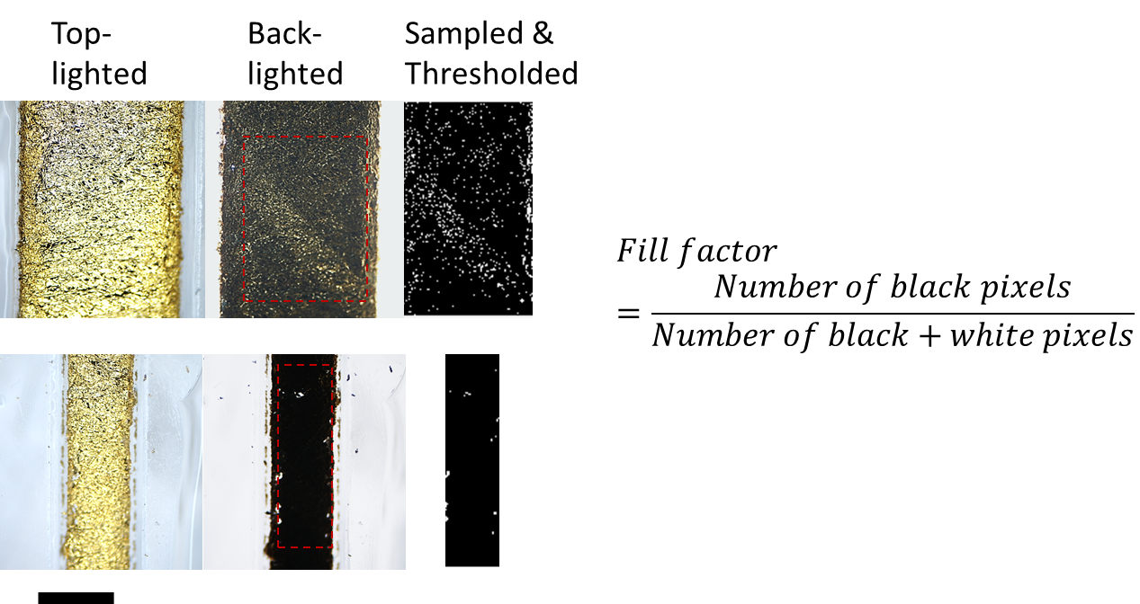
Figure S1. Calculation of “Fill factor” for quantification of the integrity of the patterned gold lines. (scale bar: 1 mm)

“Fill factor” was calculated as a quantified measure to assess the integrity of the fabricated gold lines by finding the number of voids which are seen as white pixels in the back-lighted ages. The original back-lighted images of the gold lines taken by stereoscopic microscope were first cropped to only contain the gold surfaces area and to trim the background area off the images. The cropped images were converted into black and white images of brightness value of 0 to 255, and threshold (>100) was applied to turn the BW images into binary images. The fill factor was then calculated by dividing (Number of all the pixels – Number of white pixels) by (Number of all the pixels).

