Declarations
Ethics approval and consent to participate
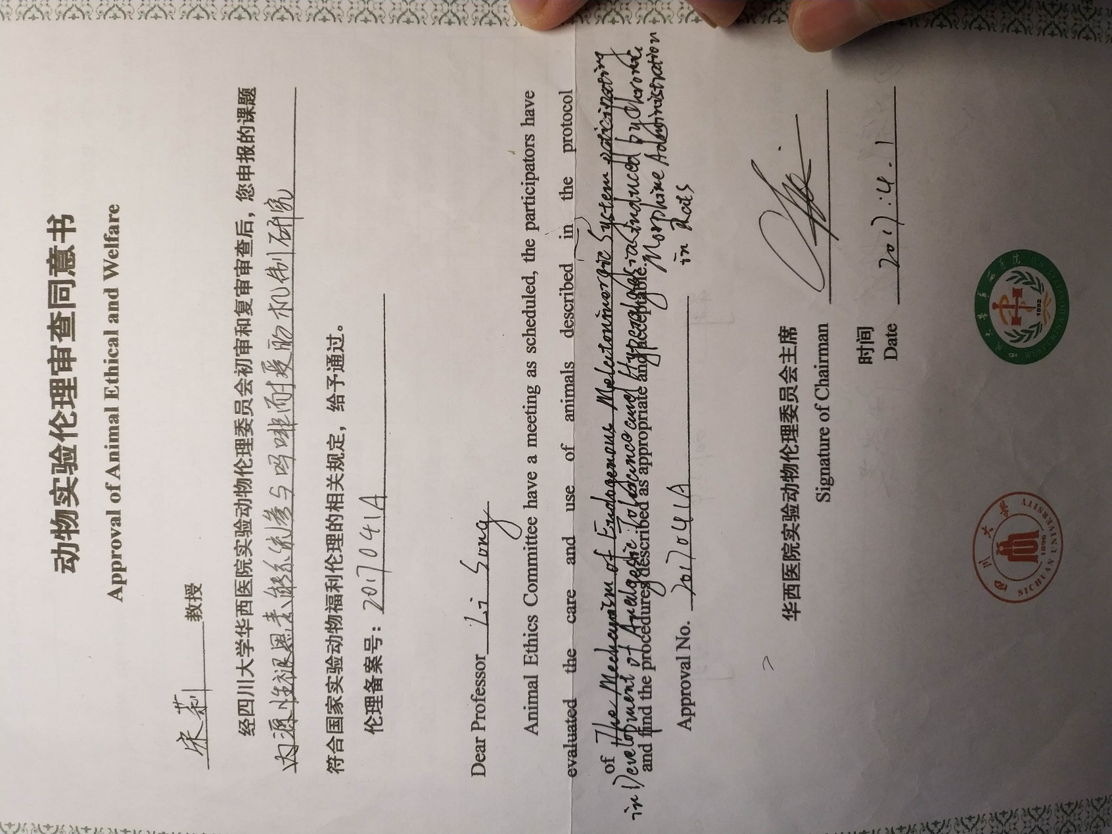
Consent for publication
Not applicable

Availability of data and materials
The datasets used and/or analysed during the current study are available from the corresponding author on reasonable request.

Competing interests
The authors declare that they have no competing interests

Funding
This study was fully fund by National Nature Science Foundation of China, grant number 81500956. and Science Foundation of Sichuan science and Technology Department, grant number 2015JY0264.

Authors' contributions
Song designed the study.
Fan performed all the experiment and collected the data.
Fan and Liang analyzed and interpreted the rat’s data and was major contributors in writing the manuscript.
Zheng contributed partly in writing the manuscript.
All authors read and approved the final manuscript.
Acknowledgements
Not applicable

Authors' information (optional)
None

