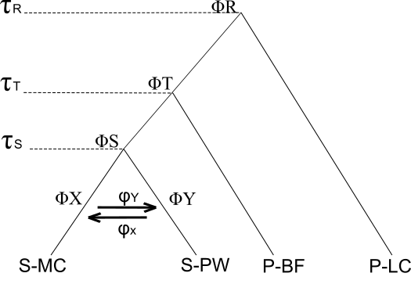
Model | T(S) | 95% SD | T(T) | 95% SD | T(R) | 95% SD | phi_X | phi_Y
Migration | 65,957 | 32,827-100,399 | 85,112 | 54,163-117,766 | 264,850 | 170,941-410,204 | 0.5284 | 0.4630
No Migration | 69,638 | 53,632-85,727 | 71,877 | 55,753-88,862 | 226,277 | 160,100-300,336

Supplement 3. A) Model M2 used for divergence time estimates using the Bayesian multispecies-coalescent-with-introgression (MSci) method as implemented in BPP (Flouri et al., 2018) and converted to absolute time in the BPPR statistical package (https://github.com/dosreislab/bppr). B) Posterior means of divergence time estimates (τ_{i}). for the model that includes bidirectional migration (M1) and for the model with no post-divergence migration (M2). Migration parameter estimates for model M2, ϕ_{Y} and ϕ_{X,} indicate the proportion of gene flow from S Y and S X, respectively, (i.e. the proportion of gene flow from XY is 1- ϕ_{Y}).

