Supplementary information
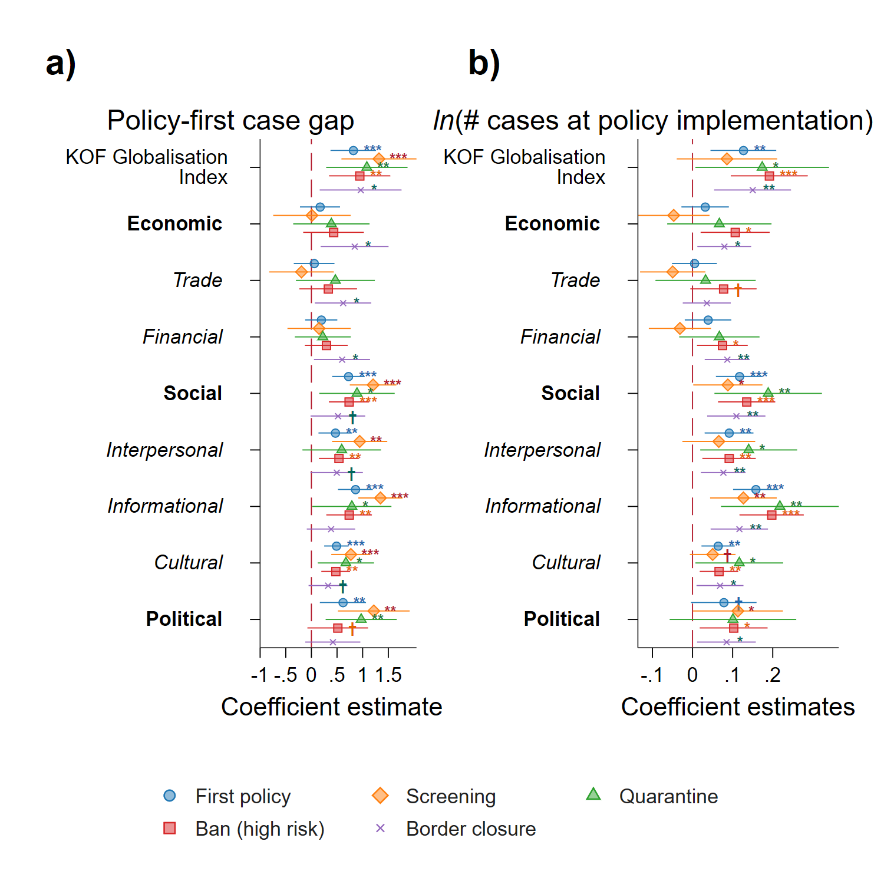
Fig. S1. Correlation between economic, social and political dimensions of globalisation indices with a) travel restriction policy implementation-first confirmed case gap and b) number of cases at restriction implementation. Coefficients estimates obtained using OLS with robust SEs, controlling for number of confirmed case at time of implementation, population density and economic risk rating. † p < .10; * p < .05; ** p < .01; *** p < .001.
Table S1. Robustness – Relationship between globalization and policy-first case time gap: Foreign international restriction policy weights using 2018 gross bilateral import and export
Dependent variable | Days between policy introduction and first case
 | Import |  |  |  |  |  | Export
Independent variable | First policy | Screening | Quarantine | Ban (high risk) | Border closure |  | First policy | Screening | Quarantine | Ban (high risk) | Border closure
KOF Globalization Index | 1.14*** | 0.91† | 1.11** | 1.33*** | 1.17** |  | 1.05*** | 0.91† | 1.10** | 1.12** | 1.22**
 | (0.224) | (0.454) | (0.365) | (0.312) | (0.398) |  | (0.211) | (0.449) | (0.342) | (0.330) | (0.414)
Case per 1,000 people in population | 0.018*** | 1.18 | 0.018*** | 0.029** | 0.12* |  | 0.019*** | 0.93 | 0.018*** | 0.034** | 0.11*
 | (0.00161) | (1.123) | (0.00177) | (0.00953) | (0.0462) |  | (0.00120) | (1.118) | (0.00163) | (0.0117) | (0.0480)
Democracy | -9.21† | -12.4 | 7.73 | -14.0* | -8.92† |  | -6.72 | -11.6 | 5.81 | -12.5† | -9.56†
 | (4.672) | (9.917) | (5.699) | (5.523) | (5.125) |  | (5.393) | (10.72) | (6.577) | (6.451) | (5.016)
Foreign international restriction policy | 16.2*** | 37.3*** | 35.1*** | 39.1*** | 17.7* |  | 16.8*** | 35.3*** | 36.8*** | 29.3*** | 25.5*
 | (1.603) | (8.011) | (5.299) | (6.925) | (8.184) |  | (1.633) | (8.867) | (5.152) | (7.653) | (11.89)
ln(Population density) | 2.19† | 5.08† | 4.08† | 4.10* | 3.45* |  | 3.54* | 7.05* | 5.35* | 5.74** | 2.94*
 | (1.269) | (2.702) | (2.099) | (1.771) | (1.332) |  | (1.355) | (2.806) | (2.065) | (2.005) | (1.379)
Economic risk rating | 0.23 | 0.90 | -0.17 | 0.12 | -0.33 |  | 0.45 | 0.93 | -0.032 | 0.45 | -0.47
 | (0.384) | (0.597) | (0.523) | (0.520) | (0.523) |  | (0.323) | (0.553) | (0.450) | (0.688) | (0.474)
Physicians per 1,000 people | -0.92 | 0.25 | -1.87 | -1.47 | -4.24† |  | -0.61 | 0.90 | -1.63 | -1.74 | -5.69*
 | (1.865) | (5.358) | (2.749) | (2.280) | (2.487) |  | (1.578) | (5.650) | (2.557) | (2.492) | (2.679)
Landlocked | -8.59* | -16.5* | -10.9 | -7.11 | -4.10 |  | -6.84† | -18.9* | -9.07 | -3.87 | -6.13†
 | (3.767) | (7.784) | (6.547) | (4.430) | (3.618) |  | (3.793) | (8.364) | (6.647) | (4.778) | (3.563)
Continent
Africa | (ref.) | (ref.) | (ref.) | (ref.) | (ref.) |  | (ref.) | (ref.) | (ref.) | (ref.) | (ref.)
America | 5.09 | 5.16 | -5.51 | 7.90 | 8.69 |  | 4.80 | 8.24 | -3.81 | 2.61 | 15.0*
 | (6.623) | (11.92) | (12.02) | (7.301) | (5.463) |  | (7.524) | (12.02) | (11.95) | (9.796) | (5.909)
Asia | 4.95 | -3.67 | 14.4 | -1.42 | 17.4** |  | 2.63 | -6.72 | 9.70 | -10.5 | 23.0***
 | (5.794) | (12.71) | (9.889) | (6.569) | (6.177) |  | (6.176) | (14.02) | (9.875) | (8.147) | (6.182)
Europe | 7.61 | 2.25 | 1.57 | -0.46 | 1.81 |  | 1.49 | -1.13 | 1.63 | -7.38 | 7.33
 | (9.243) | (15.75) | (11.74) | (9.840) | (7.951) |  | (9.036) | (15.52) | (12.10) | (13.09) | (8.056)
Pacific | -7.36 |  |  | -19.9† | 20.2† |  | -14.5 |  |  | -28.5* | 24.7*
 | (12.43) |  |  | (10.60) | (10.50) |  | (16.75) |  |  | (13.93) | (11.43)
ln(Area in sq. kms) | 5.02*** | 5.09* | 4.67** | 6.65*** | 6.08*** |  | 5.13*** | 5.00* | 5.50*** | 7.07*** | 5.64***
 | (1.006) | (1.874) | (1.480) | (1.409) | (1.069) |  | (0.981) | (1.911) | (1.472) | (1.676) | (1.145)
Constant | -183.8*** | -207.7*** | -163.2*** | -196.2*** | -135.3*** |  | -192.5*** | -214.8*** | -183.9*** | -194.8*** | -128.3***
 | (18.76) | (43.02) | (31.63) | (31.07) | (28.58) |  | (19.70) | (43.81) | (32.60) | (36.78) | (26.12)
N | 98 | 43 | 41 | 78 | 73 |  | 98 | 43 | 41 | 78 | 73
Prob. > F | 0.000 | 0.000 | 0.000 | 0.000 | 0.000 |  | 0.000 | 0.000 | 0.000 | 0.000 | 0.000
R² | 0.805 | 0.681 | 0.891 | 0.651 | 0.630 |  | 0.796 | 0.666 | 0.899 | 0.550 | 0.641
Notes: OLS estimates. Standard errors (robust) in parentheses. † p < .10; * p < .05; ** p < .01; *** p < .001.
Table S2. Robustness – Relationship between globalization and policy-first case time gap: Hospital beds and nurses and midwives as proxy for health system capacity
Dependent variable | Days between policy introduction and first case
 | Hospital beds (per 1,000 people) |  |  |  |  |  | Nurses and midwives (per 1,000 people)
Independent variable | First policy | Screening | Quarantine | Ban (high risk) | Border closure |  | First policy | Screening | Quarantine | Ban (high risk) | Border closure
KOF Globalization Index | 0.80*** | 0.94* | 1.09** | 0.89*** | 0.87* |  | 0.78*** | 0.67† | 1.11* | 0.85** | 0.86*
 | (0.204) | (0.389) | (0.387) | (0.258) | (0.361) |  | (0.220) | (0.391) | (0.424) | (0.289) | (0.409)
Case per 1,000 people in population | 0.022*** | 1.12* | 0.018*** | 0.048*** | 0.043† |  | 0.021*** | 1.19* | 0.019*** | 0.043** | 0.043†
 | (0.00166) | (0.525) | (0.00216) | (0.0119) | (0.0247) |  | (0.00136) | (0.441) | (0.00216) | (0.0140) | (0.0250)
Democracy | -12.4** | -22.6** | 5.55 | -16.5** | -8.99 |  | -12.1** | -20.9** | 4.17 | -16.2** | -8.96
 | (4.146) | (7.845) | (8.150) | (5.090) | (5.415) |  | (4.180) | (7.648) | (9.047) | (5.264) | (5.613)
Foreign international restriction policy | 13.4*** | 35.5*** | 29.9*** | 22.4*** | 7.41 |  | 13.3*** | 35.6*** | 28.5** | 22.4*** | 7.48
 | (1.625) | (7.811) | (7.653) | (5.991) | (8.994) |  | (1.683) | (6.883) | (8.094) | (5.946) | (9.011)
ln(Population density) | 3.59* | 6.94** | 4.39† | 7.09*** | 7.23*** |  | 3.73* | 7.25** | 4.02 | 7.07*** | 7.23***
 | (1.580) | (2.543) | (2.458) | (1.867) | (1.813) |  | (1.647) | (2.445) | (2.777) | (1.859) | (1.629)
Economic risk rating | 0.41 | 0.99 | -0.44 | 0.36 | 0.27 |  | 0.30 | 0.80 | -0.22 | 0.31 | 0.26
 | (0.338) | (0.627) | (0.645) | (0.442) | (0.465) |  | (0.352) | (0.563) | (0.605) | (0.448) | (0.455)
Health system capacity | 1.09 | 1.12 | -1.13 | 0.45 | 0.071 |  | 0.48 | 1.63† | -0.71 | 0.33 | 0.057
 | (0.671) | (1.269) | (1.022) | (0.793) | (1.398) |  | (0.507) | (0.851) | (0.692) | (0.601) | (0.771)
Landlocked | -10.4* | -20.6* | -15.2† | -4.66 | -2.61 |  | -9.62* | -22.5** | -16.8* | -4.40 | -2.57
 | (4.173) | (7.632) | (7.632) | (5.237) | (4.734) |  | (4.132) | (7.511) | (7.812) | (5.240) | (4.868)
Continent
Africa | (ref.) | (ref.) | (ref.) | (ref.) | (ref.) |  | (ref.) | (ref.) | (ref.) | (ref.) | (ref.)
America | 6.26 | 7.13 | -10.1 | -4.13 | 2.39 |  | 6.36 | 7.08 | -9.24 | -4.24 | 2.43
 | (5.423) | (8.984) | (12.95) | (5.497) | (5.694) |  | (5.454) | (9.205) | (13.10) | (5.438) | (5.723)
Asia | -4.25 | -7.86 | 18.0 | -11.6† | 6.56 |  | -2.63 | -7.06 | 16.5 | -10.8† | 6.64
 | (5.746) | (8.147) | (12.36) | (6.305) | (7.851) |  | (5.592) | (7.781) | (12.09) | (5.944) | (7.244)
Europe | 6.49 | 4.44 | 2.18 | -4.82 | -5.27 |  | 8.36 | 5.18 | 2.79 | -3.95 | -5.16
 | (7.149) | (8.274) | (14.72) | (8.271) | (10.31) |  | (7.537) | (8.577) | (15.08) | (8.059) | (9.114)
Pacific | -8.74 | 7.58 | -21.6* | -24.6** | 6.95 |  | -8.47 | 10.8 | -26.1** | -25.0** | 6.86
 | (11.07) | (8.372) | (8.551) | (8.189) | (9.562) |  | (11.22) | (7.942) | (9.377) | (8.382) | (9.664)
ln(Area in sq. kms) | 4.82*** | 5.86*** | 5.25*** | 7.43*** | 6.20*** |  | 4.93*** | 5.97*** | 5.47*** | 7.39*** | 6.19***
 | (1.157) | (1.640) | (1.343) | (1.601) | (1.197) |  | (1.167) | (1.621) | (1.372) | (1.671) | (1.246)
Constant | -164.5*** | -223.4*** | -154.3*** | -185.4*** | -151.8*** |  | -161.6*** | -206.3*** | -163.0*** | -181.2*** | -151.2***
 | (24.51) | (37.76) | (37.07) | (30.04) | (29.55) |  | (26.26) | (36.68) | (37.13) | (35.40) | (34.35)
N | 117 | 51 | 47 | 92 | 89 |  | 117 | 51 | 47 | 92 | 89
Prob. > F | 0.000 | . | . | 0.000 | 0.000 |  | 0.000 | . | . | 0.000 | 0.000
R² | 0.715 | 0.681 | 0.823 | 0.550 | 0.471 |  | 0.712 | 0.700 | 0.823 | 0.550 | 0.471
Notes: OLS estimates. Standard errors (robust) in parentheses. † p < .10; * p < .05; ** p < .01; *** p < .001.

