Supplementary Material

Table S1 Sequence characteristics obtained in stored cane stalks.
Sample ID | PE Reads | Raw Tags | Clean Tags | Effective Tags | AvgLen(bp) | GC(%) | Q20(%) | Q30(%) | Effective(%)
ck1 | 74,223 | 54,585 | 54,584 | 54,584 | 260 | 37.5 | 99.89 | 99.12 | 73.54
ck2 | 71,560 | 55,392 | 55,387 | 55,387 | 261 | 37.49 | 99.88 | 99.12 | 77.4
ck3 | 70,317 | 49,317 | 49,315 | 49,315 | 261 | 37.44 | 99.89 | 99.19 | 70.13
s12h30c1 | 73,821 | 71,693 | 71,693 | 71,693 | 254 | 44.33 | 99.89 | 99.14 | 97.12
s12h30c2 | 69,968 | 66,750 | 66,747 | 66,747 | 255 | 44.26 | 99.91 | 99.32 | 95.4
s12h30c3 | 72,116 | 63,756 | 63,756 | 63,756 | 258 | 39.19 | 99.9 | 99.2 | 88.41
s12h40c1 | 56,467 | 48,638 | 48,636 | 48,636 | 333 | 37.33 | 99.34 | 96.98 | 86.13
s12h40c2 | 55,252 | 41,283 | 41,281 | 41,281 | 357 | 37.22 | 99.18 | 96.34 | 74.71
s12h40c3 | 59,075 | 35,589 | 35,589 | 35,589 | 360 | 37.31 | 99.23 | 96.62 | 60.24
s60h30c1 | 74,617 | 71,293 | 71,291 | 71,291 | 268 | 43.82 | 99.76 | 98.63 | 95.54
s60h30c2 | 73,684 | 68,561 | 68,559 | 68,559 | 280 | 42.81 | 99.68 | 98.37 | 93.04
s60h30c3 | 72,162 | 64,696 | 64,695 | 64,695 | 257 | 43.69 | 99.87 | 99.05 | 89.65
s60h40c1 | 47,140 | 46,581 | 46,581 | 46,581 | 435 | 37.14 | 98.79 | 94.87 | 98.81
s60h40c2 | 44,949 | 44,415 | 44,411 | 44,411 | 435 | 37.11 | 98.76 | 94.64 | 98.8
s60h40c3 | 47,289 | 45,785 | 45,785 | 45,785 | 436 | 37.14 | 98.93 | 95.2 | 96.82
ck: before storage (n= 3); s12h30c: stored 12h in 30℃ (n =3); s12h40c: stored 12h in 40℃ (n =3); s60h30c: stored 60h in 30℃ (n =3); s60h40c: stored 60h in 40℃ (n =3).

Figure legends:

Fig S1. Sequence rarefaction curve
ck: before storage (n= 3); s12h30c: stored 12h in 30℃ (n =3); s12h40c: stored 12h in 40℃ (n =3); s60h30c: stored 60h in 30℃ (n =3); s60h40c: stored 60h in 40℃ (n =3).

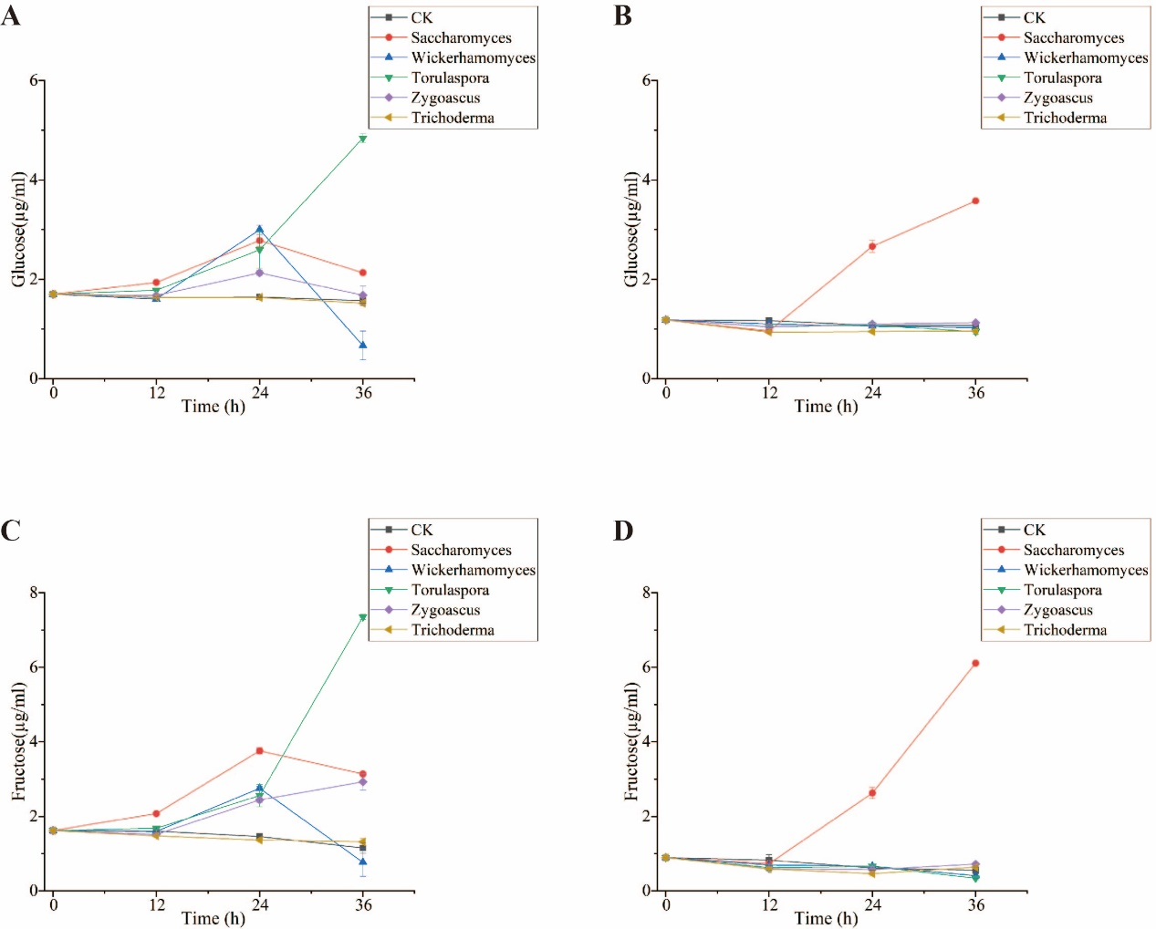
Fig S2. The glucose and fructose profiles in sucrose medium of isolated strains cultured at 30℃and 40℃.
(a) glucose at 30℃; (b) glucose at 40℃; (c) fructose at 30℃; (d) fructose at 40℃.
Data are presented as the mean ± standard deviation.

