**SUPPLEMENTARY DATA**

**Title:** Design and Antiproliferative and Antioxidant Activities of Furan-Based Thiosemicarbazides and 1,2,4-Triazoles: Their Structure–Activity Relationship and SwissADME Predictions

**Yusuf Sıcak**

*Department of Medicinal and Aromatic Plants, Köyceğiz Vocational School, Muğla Sıtkı Koçman University, Muğla, Turkey*

**🖂 Yusuf SICAK**

*Department of Medicinal and Aromatic Plants, Köyceğiz Vocational School, Muğla Sıtkı Koçman University, Muğla, Turkey*

*E-mail:* [yusufsicak@mu.edu.tr](mailto:yusufsicak@mu.edu.tr)

**Table S1.** Physicochemical properties, lipophilicity, solubility, pharmacokinetics, drug likeness and medicinal chemistry of thiosemicarbazide (1-12) and 1,2,4-triazole derivatives **(13-24)** predicted using SwissADME.

|  |  |  |  |  |  |  |
| --- | --- | --- | --- | --- | --- | --- |
| **Compounds** | **Physicochemical Properties** | **Lipophilicity** | **Water Solubility** | **Pharmacokinetics** | **Drug likeness** | **Medicinal Chemistry** |
| 1- | Formula: C12H11N3O2S  Molecular weight: 261.30 g/mol  Num. heavy atoms: 18  Num. arom. heavy atoms : 11  Fraction Csp3: 0.00  Num. rotatable bonds: 6  Num. H-bond acceptors: 2  Num. H-bond donors: 3  Molar Refractivity: 71.12  TPSA: 98.39 Å² | Log Po/w (iLOGP): 2.24  Log Po/w (XLOGP3): 2.09  Log Po/w (WLOGP): 1.72  Log Po/w (MLOGP): 0.97  Log Po/w (SILICOS-IT): 1.77  Consensus Log Po/w: 1.76 | Log S (ESOL): -2.83  Solubility: 3.84e-01 mg/ml ; 1.47e-03 mol/l  Class: Soluble  Log S (Ali): -3.79  Solubility: 4.28e-02 mg/ml ; 1.64e-04 mol/l  Class: Soluble  Log S (SILICOS-IT): -4.39  Solubility: 1.07e-02 mg/ml ; 4.10e-05 mol/l  Class: Moderately soluble | GI absorption: High  BBB permeant: No  P-gp substrate: No  CYP1A2 inhibitor: Yes  CYP2C19 inhibitor: Yes  CYP2C9 inhibitor: No  CYP2D6 inhibitor: No  CYP3A4 inhibitor: No  Log Kp (skin permeation): -6.41 cm/s | Lipinski: Yes  Ghose: Yes  Veber: Yes  Egan: Yes  Muegge: Yes  Bioavailability Score: 0.55 | PAINS: 0 alert  Brenk: 1 alert: thiocarbonyl_group  Leadlikeness: Yes  Synthetic accessibility: 2.71 |
| 2- | Formula: C12H10ClN3O2S  Molecular weight: 295.74 g/mol  Num. heavy atoms: 19  Num. arom. heavy atoms : 11  Fraction Csp3: 0.00  Num. rotatable bonds: 6  Num. H-bond acceptors: 2  Num. H-bond donors: 3  Molar Refractivity: 76.13  TPSA: 98.39 Å² | Log Po/w (iLOGP): 2.64  Log Po/w (XLOGP3): 2.72  Log Po/w (WLOGP): 2.37  Log Po/w (MLOGP): 1.51  Log Po/w (SILICOS-IT): 2.42  Consensus Log Po/w: 2.33 | Log S (ESOL): -3.42  Solubility: 1.13e-01 mg/ml ; 3.81e-04 mol/l  Class: Soluble  Log S (Ali): -4.44  Solubility: 1.07e-02 mg/ml ; 3.63e-05 mol/l  Class: Moderately soluble  Log S (SILICOS-IT): -4.99  Solubility: 3.02e-03 mg/ml ; 1.02e-05 mol/l  Class: Moderately soluble | GI absorption: High  BBB permeant: No  P-gp substrate: No  CYP1A2 inhibitor: Yes  CYP2C19 inhibitor: Yes  CYP2C9 inhibitor: Yes  CYP2D6 inhibitor: No  CYP3A4 inhibitor: Yes  Log Kp (skin permeation): -6.17 cm/s | Lipinski: Yes  Ghose: Yes  Veber: Yes  Egan: Yes  Muegge: Yes  Bioavailability Score: 0.55 | PAINS: 0 alert  Brenk:1 alert: thiocarbonyl_group  Leadlikeness: Yes  Synthetic accessibility: 2.69 |
| 3- | Formula: C12H9Cl2N3O2S  Molecular weight: 330.19 g/mol  Num. heavy atoms: 20  Num. arom. heavy atoms: 11  Fraction Csp3: 0.00  Num. rotatable bonds: 6  Num. H-bond acceptors: 2  Num. H-bond donors: 3  Molar Refractivity: 81.14  TPSA: 98.39 Å² | Log Po/w (iLOGP): 2.79  Log Po/w (XLOGP3): 3.35  Log Po/w (WLOGP): 3.03  Log Po/w (MLOGP): 2.04  Log Po/w (SILICOS-IT): 3.07  Consensus Log Po/w: 2.85 | Log S (ESOL): -4.01  Solubility: 3.24e-02 mg/ml ; 9.80e-05 mol/l  Class: Moderately soluble  Log S (Ali): -5.09  Solubility: 2.66e-03 mg/ml ; 8.06e-06 mol/l  Class: Moderately soluble  Log S (SILICOS-IT): -5.59  Solubility: 8.51e-04 mg/ml ; 2.58e-06 mol/l  Class: Moderately soluble | GI absorption: High  BBB permeant: No  P-gp substrate: No  CYP1A2 inhibitor: Yes  CYP2C19 inhibitor: Yes  CYP2C9 inhibitor: Yes  CYP2D6 inhibitor: No  CYP3A4 inhibitor: Yes  Log Kp (skin permeation): -5.94 cm/s | Lipinski: Yes  Ghose: Yes  Veber: Yes  Egan: Yes  Muegge: Yes  Bioavailability Score: 0.55 | PAINS: 0 alert  Brenk: 1 alert: thiocarbonyl_group  Leadlikeness: Yes  Synthetic accessibility: 2.74 |
| 4- | Formula: C13H9ClF3N3O2S  Molecular weight: 363.74 g/mol  Num. heavy atoms: 23  Num. arom. heavy atoms : 11  Fraction Csp3: 0.08  Num. rotatable bonds: 7  Num. H-bond acceptors: 5  Num. H-bond donors: 3  Molar Refractivity: 81.14  TPSA: 98.39 Å² | Log Po/w (iLOGP): 2.42  Log Po/w (XLOGP3): 3.60  Log Po/w (WLOGP): 4.54  Log Po/w (MLOGP): 2.42  Log Po/w (SILICOS-IT): 3.52  Consensus Log Po/w: 3.30 | Log S (ESOL): -4.26  Solubility: 2.02e-02 mg/ml ; 5.56e-05 mol/l  Class: Moderately soluble  Log S (Ali): -5.35  Solubility: 1.61e-03 mg/ml ; 4.43e-06 mol/l  Class: Moderately soluble  Log S (SILICOS-IT): -5.84  Solubility: 5.28e-04 mg/ml ; 1.45e-06 mol/l  Class: Moderately soluble | GI absorption: High  BBB permeant: No  P-gp substrate: No  CYP1A2 inhibitor: Yes  CYP2C19 inhibitor: Yes  CYP2C9 inhibitor: Yes  CYP2D6 inhibitor: No  CYP3A4 inhibitor: Yes  Log Kp (skin permeation): -5.96 cm/s | Lipinski: Yes  Ghose: Yes  Veber: Yes  Egan: Yes  Muegge: Yes  Bioavailability Score: 0.55 | PAINS: 0 alert  Brenk: 1 alert: thiocarbonyl_group  Leadlikeness: No  Synthetic accessibility: 2.82 |
| 5- | Formula: C13H13N3O3S  Molecular weight: 291.33 g/mol  Num. heavy atoms: 20  Num. arom. heavy atoms : 11  Fraction Csp3: 0.08  Num. rotatable bonds: 7  Num. H-bond acceptors: 3  Num. H-bond donors: 3  Molar Refractivity: 77.62  TPSA: 107.62 Å² | Log Po/w (iLOGP): 2.76  Log Po/w (XLOGP3): 2.06  Log Po/w (WLOGP): 1.73  Log Po/w (MLOGP): 0.69  Log Po/w (SILICOS-IT): 1.81  Consensus Log Po/w: 1.81 | Log S (ESOL): -2.89  Solubility: 3.76e-01 mg/ml ; 1.29e-03 mol/l  Class: Soluble  Log S (Ali): -3.95  Solubility: 3.28e-02 mg/ml ; 1.12e-04 mol/l  Class: Soluble  Log S (SILICOS-IT): -4.50  Solubility: 9.11e-03 mg/ml ; 3.13e-05 mol/l  Class: Moderately soluble | GI absorption: High  BBB permeant: No  P-gp substrate: No  CYP1A2 inhibitor: Yes  CYP2C19 inhibitor: No  CYP2C9 inhibitor: Yes  CYP2D6 inhibitor: No  CYP3A4 inhibitor: No  Log Kp (skin permeation): -6.61 cm/s | Lipinski: Yes  Ghose: Yes  Veber: Yes  Egan: Yes  Muegge: Yes  Bioavailability Score: 0.55 | PAINS: 0 alert  Brenk: 1 alert: thiocarbonyl_group  Leadlikeness: Yes  Synthetic accessibility: 2.83 |
| 6- | Formula: C14H15N3O4S  Molecular weight: 321.35 g/mol  Num. heavy atoms: 22  Num. arom. heavy atoms : 11  Fraction Csp3: 0.14  Num. rotatable bonds: 8  Num. H-bond acceptors: 4  Num. H-bond donors: 3  Molar Refractivity: 84.11  TPSA: 116.85 Å² | Log Po/w (iLOGP): 2.88  Log Po/w (XLOGP3): 2.04  Log Po/w (WLOGP): 1.74  Log Po/w (MLOGP): 0.43  Log Po/w (SILICOS-IT): 1.88  Consensus Log Po/w: 1.79 | Log S (ESOL): -2.96  Solubility: 3.53e-01 mg/ml ; 1.10e-03 mol/l  Class: Soluble  Log S (Ali): -4.12  Solubility: 2.43e-02 mg/ml ; 7.55e-05 mol/l  Class: Moderately soluble  Log S (SILICOS-IT): -4.62  Solubility: 7.74e-03 mg/ml ; 2.41e-05 mol/l  Class: Moderately soluble | GI absorption: High  BBB permeant: No  P-gp substrate: No  CYP1A2 inhibitor: Yes  CYP2C19 inhibitor: No  CYP2C9 inhibitor: Yes  CYP2D6 inhibitor: No  CYP3A4 inhibitor: No  Log Kp (skin permeation): -6.81 cm/s | Lipinski: Yes  Ghose: Yes  Veber: Yes  Egan: Yes  Muegge: Yes  Bioavailability Score: 0.55 | PAINS: 0 alert  Brenk: 1 alert: thiocarbonyl_group  Leadlikeness: No  Synthetic accessibility: 3.01 |
| 7- | Formula: C14H15N3O4S  Molecular weight: 321.35 g/mol  Num. heavy atoms: 22  Num. arom. heavy atoms: 11  Fraction Csp3: 0.14  Num. rotatable bonds: 8  Num. H-bond acceptors: 4  Num. H-bond donors: 3  Molar Refractivity: 84.11  TPSA: 116.85 Å² | Log Po/w (iLOGP): 3.21  Log Po/w (XLOGP3): 2.04  Log Po/w (WLOGP): 1.74  Log Po/w (MLOGP): 0.43  Log Po/w (SILICOS-IT): 1.88  Consensus Log Po/w: 1.86 | Log S (ESOL): -2.96  Solubility: 3.53e-01 mg/ml ; 1.10e-03 mol/l  Class: Soluble  Log S (Ali): -4.12  Solubility: 2.43e-02 mg/ml ; 7.55e-05 mol/l  Class: Moderately soluble  Log S (SILICOS-IT): -4.62  Solubility: 7.74e-03 mg/ml ; 2.41e-05 mol/l  Class: Moderately soluble | GI absorption: High  BBB permeant: No  P-gp substrate: No  CYP1A2 inhibitor: Yes  CYP2C19 inhibitor: No  CYP2C9 inhibitor: Yes  CYP2D6 inhibitor: No  CYP3A4 inhibitor: No  Log Kp (skin permeation): -6.81 cm/s | Lipinski: Yes  Ghose: Yes  Veber: Yes  Egan: Yes  Muegge: Yes  Bioavailability Score: 0.55 | PAINS: 0 alert  Brenk: 1 alert: thiocarbonyl_group  Leadlikeness: No  Synthetic accessibility: 3.05 |
| 8- | Formula: C14H15N3O4S  Molecular weight: 321.35 g/mol  Num. heavy atoms: 22  Num. arom. heavy atoms : 11  Fraction Csp3: 0.14  Num. rotatable bonds: 8  Num. H-bond acceptors: 4  Num. H-bond donors: 3  Molar Refractivity: 84.11  TPSA: 116.85 Å² | Log Po/w (iLOGP): 2.83  Log Po/w (XLOGP3): 2.04  Log Po/w (WLOGP): 1.74  Log Po/w (MLOGP): 0.43  Log Po/w (SILICOS-IT): 1.88  Consensus Log Po/w: 1.78 | Log S (ESOL): -2.96  Solubility: 3.53e-01 mg/ml ; 1.10e-03 mol/l  Class: Soluble  Log S (Ali): -4.12  Solubility: 2.43e-02 mg/ml ; 7.55e-05 mol/l  Class: Moderately soluble  Log S (SILICOS-IT): -4.62  Solubility: 7.74e-03 mg/ml ; 2.41e-05 mol/l  Class: Moderately soluble | GI absorption: High  BBB permeant: No  P-gp substrate: No  CYP1A2 inhibitor: No  CYP2C19 inhibitor: No  CYP2C9 inhibitor: Yes  CYP2D6 inhibitor: No  CYP3A4 inhibitor: No  Log Kp (skin permeation): -6.81 cm/s | Lipinski: Yes  Ghose: Yes  Veber: Yes  Egan: Yes  Muegge: Yes  Bioavailability Score: 0.55 | PAINS: 0 alert  Brenk: 1 alert: thiocarbonyl_group  Leadlikeness: No  Synthetic accessibility: 2.95 |
| 9- | Formula: C14H15N3O4S  Molecular weight: 321.35 g/mol  Num. heavy atoms: 22  Num. arom. heavy atoms : 11  Fraction Csp3: 0.14  Num. rotatable bonds: 8  Num. H-bond acceptors: 4  Num. H-bond donors: 3  Molar Refractivity: 84.11  TPSA: 116.85 Å² | Log Po/w (iLOGP): 2.97  Log Po/w (XLOGP3): 2.04  Log Po/w (WLOGP): 1.74  Log Po/w (MLOGP): 0.43  Log Po/w (SILICOS-IT): 1.88  Consensus Log Po/w: 1.81 | Log S (ESOL): -2.96  Solubility: 3.53e-01 mg/ml ; 1.10e-03 mol/l  Class: Soluble  Log S (Ali): -4.12  Solubility: 2.43e-02 mg/ml ; 7.55e-05 mol/l  Class: Moderately soluble  Log S (SILICOS-IT): -4.62  Solubility: 7.74e-03 mg/ml ; 2.41e-05 mol/l  Class: Moderately soluble | GI absorption: High  BBB permeant: No  P-gp substrate: No  CYP1A2 inhibitor: Yes  CYP2C19 inhibitor: No  CYP2C9 inhibitor: Yes  CYP2D6 inhibitor: No  CYP3A4 inhibitor: No  Log Kp (skin permeation): -6.81 cm/s | Lipinski: Yes  Ghose: Yes  Veber: Yes  Egan: Yes  Muegge: Yes  Bioavailability Score: 0.55 | PAINS: 0 alert  Brenk: 1 alert: thiocarbonyl_group  Leadlikeness: No  Synthetic accessibility: 2.97 |
| 10- | Formula: C15H17N3O5S  Molecular weight: 351.38 g/mol  Num. heavy atoms: 24  Num. arom. heavy atoms : 11  Fraction Csp3: 0.20  Num. rotatable bonds: 9  Num. H-bond acceptors: 5  Num. H-bond donors: 3  Molar Refractivity: 90.60  TPSA: 126.08 Å | Log Po/w (iLOGP): 3.05  Log Po/w (XLOGP3): 2.01  Log Po/w (WLOGP): 1.75  Log Po/w (MLOGP): 0.16  Log Po/w (SILICOS-IT): 1.95  Consensus Log Po/w: 1.78 | Log S (ESOL): -3.03  Solubility: 3.28e-01 mg/ml ; 9.33e-04 mol/l  Class: Soluble  Log S (Ali): -4.28  Solubility: 1.82e-02 mg/ml ; 5.19e-05 mol/l  Class: Moderately soluble  Log S (SILICOS-IT): -4.73  Solubility: 6.59e-03 mg/ml ; 1.87e-05 mol/l  Class: Moderately soluble | GI absorption: High  BBB permeant: No  P-gp substrate: Yes  CYP1A2 inhibitor: No  CYP2C19 inhibitor: No  CYP2C9 inhibitor: Yes  CYP2D6 inhibitor: No  CYP3A4 inhibitor: Yes  Log Kp (skin permeation): -7.02 cm/s | Lipinski: Yes  Ghose: Yes  Veber: Yes  Egan: Yes  Muegge: Yes  Bioavailability Score: 0.55 | PAINS: 0 alert  Brenk: 1 alert: thiocarbonyl_group  Leadlikeness: No  Synthetic accessibility: 3.13 |
| 11- | Formula: C14H16N4O2S  Molecular weight: 304.37 g/mol  Num. heavy atoms: 21  Num. arom. heavy atoms : 11  Fraction Csp3: 0.14  Num. rotatable bonds: 7  Num. H-bond acceptors: 2  Num. H-bond donors: 3  Molar Refractivity: 85.33  TPSA: 101.63 Å² | Log Po/w (iLOGP): 2.44  Log Po/w (XLOGP3): 2.22  Log Po/w (WLOGP): 1.79  Log Po/w (MLOGP): 0.96  Log Po/w (SILICOS-IT): 1.43  Consensus Log Po/w: 1.77 | Log S (ESOL): -3.05  Solubility: 2.70e-01 mg/ml ; 8.89e-04 mol/l  Class: Soluble  Log S (Ali): -3.99  Solubility: 3.12e-02 mg/ml ; 1.03e-04 mol/l  Class: Soluble  Log S (SILICOS-IT): -4.48  Solubility: 1.00e-02 mg/ml ; 3.30e-05 mol/l  Class: Moderately soluble | GI absorption: High  BBB permeant: No  P-gp substrate: No  CYP1A2 inhibitor: Yes  CYP2C19 inhibitor: No  CYP2C9 inhibitor: Yes  CYP2D6 inhibitor: No  CYP3A4 inhibitor: No  Log Kp (skin permeation): -6.58 cm/s | Lipinski: Yes  Ghose: Yes  Veber: Yes  Egan: Yes  Muegge: Yes  Bioavailability Score: 0.55 | PAINS: 1 alert: anil_di_alk_A  Brenk: 1 alert: thiocarbonyl_group  Leadlikeness: Yes  Synthetic accessibility: 2.97 |
| 12- | Formula: C16H20N4O2S  Molecular weight: 332.42 g/mol  Num. heavy atoms: 23  Num. arom. heavy atoms : 11  Fraction Csp3: 0.25  Num. rotatable bonds: 9  Num. H-bond acceptors: 2  Num. H-bond donors: 3  Molar Refractivity: 94.94  TPSA: 101.63 Å² | Log Po/w (iLOGP): 3.14  Log Po/w (XLOGP3): 2.95  Log Po/w (WLOGP): 2.57  Log Po/w (MLOGP): 1.46  Log Po/w (SILICOS-IT): 2.20  Consensus Log Po/w: 2.46 | Log S (ESOL): -3.52  Solubility: 1.01e-01 mg/ml ; 3.02e-04 mol/l  Class: Soluble  Log S (Ali): -4.75  Solubility: 5.96e-03 mg/ml ; 1.79e-05 mol/l  Class: Moderately soluble  Log S (SILICOS-IT): -5.28  Solubility: 1.76e-03 mg/ml ; 5.28e-06 mol/l  Class: Moderately soluble | GI absorption: High  BBB permeant: No  P-gp substrate: No  CYP1A2 inhibitor: No  CYP2C19 inhibitor: Yes  CYP2C9 inhibitor: Yes  CYP2D6 inhibitor: No  CYP3A4 inhibitor: Yes  Log Kp (skin permeation): -6.23 cm/s | Lipinski: Yes  Ghose: Yes  Veber: Yes  Egan: Yes  Muegge: Yes  Bioavailability Score: 0.55 | PAINS: 1 alert: anil_di_alk_A  Brenk: 1 alert: thiocarbonyl_group  Leadlikeness: No  Synthetic accessibility: 3.12 |
| 13 | Formula: C12H9N3OS  Molecular weight: 243.28 g/mol  Num. heavy atoms: 17  Num. arom. heavy atoms : 16  Fraction Csp3: 0.00  Num. rotatable bonds: 2  Num. H-bond acceptors: 2  Num. H-bond donors: 1  Molar Refractivity: 66.45  TPSA: 78.84 Å² | Log Po/w (iLOGP): 2.33  Log Po/w (XLOGP3): 2.59  Log Po/w (WLOGP): 3.19  Log Po/w (MLOGP): 1.68  Log Po/w (SILICOS-IT): 3.50  Consensus Log Po/w: 2.66 | Log S (ESOL): -3.54  Solubility: 6.94e-02 mg/ml ; 2.85e-04 mol/l  Class: Soluble  Log S (Ali): -3.89  Solubility: 3.10e-02 mg/ml ; 1.28e-04 mol/l  Class: Soluble  Log S (SILICOS-IT): -4.40  Solubility: 9.64e-03 mg/ml ; 3.96e-05 mol/l  Class: Moderately soluble | GI absorption: High  BBB permeant: Yes  P-gp substrate: No  CYP1A2 inhibitor: Yes  CYP2C19 inhibitor: Yes  CYP2C9 inhibitor: No  CYP2D6 inhibitor: No  CYP3A4 inhibitor: No  Log Kp (skin permeation): -5.95 cm/s | Lipinski: Yes  Ghose: Yes  Veber: Yes  Egan: Yes  Muegge: Yes  Bioavailability Score: 0.55 | PAINS: 0 alert  Brenk: 1 alert: thiocarbonyl_group  Leadlikeness: No  Synthetic accessibility: 2.53 |
| 14 | Formula: C12H8ClN3OS  Molecular weight: 277.73 g/mol  Num. heavy atoms: 18  Num. arom. heavy atoms : 16  Fraction Csp3: 0.00  Num. rotatable bonds: 2  Num. H-bond acceptors: 2  Num. H-bond donors: 1  Molar Refractivity: 71.46  TPSA: 78.84 Å² | Log Po/w (iLOGP): 2.57  Log Po/w (XLOGP3): 3.22  Log Po/w (WLOGP): 3.84  Log Po/w (MLOGP): 2.22  Log Po/w (SILICOS-IT): 4.12  Consensus Log Po/w: 3.20 | Log S (ESOL): -4.12  Solubility: 2.12e-02 mg/ml ; 7.65e-05 mol/l  Class: Moderately soluble  Log S (Ali): -4.55  Solubility: 7.86e-03 mg/ml ; 2.83e-05 mol/l  Class: Moderately soluble  Log S (SILICOS-IT): -5.01  Solubility: 2.71e-03 mg/ml ; 9.77e-06 mol/l  Class: Moderately soluble | GI absorption: High  BBB permeant: No  P-gp substrate: No  CYP1A2 inhibitor: Yes  CYP2C19 inhibitor: Yes  CYP2C9 inhibitor: Yes  CYP2D6 inhibitor: No  CYP3A4 inhibitor: No  Log Kp (skin permeation): -5.71 cm/s | Lipinski: Yes  Ghose: Yes  Veber: Yes  Egan: Yes  Muegge: Yes  Bioavailability Score: 0.55 | PAINS: 0 alert  Brenk: 1 alert: thiocarbonyl_group  Leadlikeness: No  Synthetic accessibility: 2.54 |
| 15 | Formula: C12H7Cl2N3OS  Molecular weight: 312.17 g/mol  Num. heavy atoms: 19  Num. arom. heavy atoms : 16  Fraction Csp3: 0.00  Num. rotatable bonds: 2  Num. H-bond acceptors: 2  Num. H-bond donors: 1  Molar Refractivity: 76.47  TPSA: 78.84 Å² | Log Po/w (iLOGP): 2.77  Log Po/w (XLOGP3): 3.85  Log Po/w (WLOGP): 4.50  Log Po/w (MLOGP): 2.75  Log Po/w (SILICOS-IT): 4.74  Consensus Log Po/w: 3.72 | Log S (ESOL): -4.69  Solubility: 6.34e-03 mg/ml ; 2.03e-05 mol/l  Class: Moderately soluble  Log S (Ali): -5.20  Solubility: 1.96e-03 mg/ml ; 6.28e-06 mol/l  Class: Moderately soluble  Log S (SILICOS-IT): -5.61  Solubility: 7.65e-04 mg/ml ; 2.45e-06 mol/l  Class: Moderately soluble | GI absorption: High  BBB permeant: No  P-gp substrate: No  CYP1A2 inhibitor: Yes  CYP2C19 inhibitor: Yes  CYP2C9 inhibitor: Yes  CYP2D6 inhibitor: No  CYP3A4 inhibitor: No  Log Kp (skin permeation): -5.47 cm/s | Lipinski: Yes  Ghose: Yes  Veber: Yes  Egan: Yes  Muegge: Yes  Bioavailability Score: 0.55 | PAINS: 0 alert  Brenk: 1 alert: thiocarbonyl_group  Leadlikeness: No  Synthetic accessibility: 2.66 |
| 16 | Formula: C13H7ClF3N3OS  Molecular weight: 345.73 g/mol  Num. heavy atoms: 22  Num. arom. heavy atoms: 16  Fraction Csp3: 0.08  Num. rotatable bonds: 3  Num. H-bond acceptors: 5  Num. H-bond donors: 1  Molar Refractivity: 76.46  TPSA: 78.84 Å² | Log Po/w (iLOGP): 2.69  Log Po/w (XLOGP3): 4.10  Log Po/w (WLOGP): 6.01  Log Po/w (MLOGP): 3.13  Log Po/w (SILICOS-IT): 5.12  Consensus Log Po/w: 4.21 | Log S (ESOL): -4.91  Solubility: 4.29e-03 mg/ml ; 1.24e-05 mol/l  Class: Moderately soluble  Log S (Ali): -5.46  Solubility: 1.19e-03 mg/ml ; 3.46e-06 mol/l  Class: Moderately soluble  Log S (SILICOS-IT): -5.86  Solubility: 4.75e-04 mg/ml ; 1.37e-06 mol/l  Class: Moderately soluble | GI absorption: High  BBB permeant: No  P-gp substrate: No  CYP1A2 inhibitor: Yes  CYP2C19 inhibitor: Yes  CYP2C9 inhibitor: Yes  CYP2D6 inhibitor: No  CYP3A4 inhibitor: No  Log Kp (skin permeation): -5.50 cm/s | Lipinski: Yes  Ghose: No  Veber: Yes  Egan: No  Muegge: Yes  Bioavailability Score: 0.55 | PAINS: 0 alert  Brenk: 1 alert: thiocarbonyl_group  Leadlikeness: No  Synthetic accessibility: 2.65 |
| 17 | Formula: C13H11N3O2S  Molecular weight: 273.31 g/mol  Num. heavy atoms: 19  Num. arom. heavy atoms 16  Fraction Csp3: 0.08  Num. rotatable bonds: 3  Num. H-bond acceptors: 3  Num. H-bond donors: 1  Molar Refractivity: 72.94  TPSA: 88.07 Å² | Log Po/w (iLOGP): 2.47  Log Po/w (XLOGP3): 2.56  Log Po/w (WLOGP): 3.20  Log Po/w (MLOGP): 1.39  Log Po/w (SILICOS-IT): 3.49  Consensus Log Po/w: 2.62 | Log S (ESOL): -3.57  Solubility: 7.31e-02 mg/ml ; 2.68e-04 mol/l  Class: Soluble  Log S (Ali): -4.06  Solubility: 2.40e-02 mg/ml ; 8.77e-05 mol/l  Class: Moderately soluble  Log S (SILICOS-IT): -4.52  Solubility: 8.20e-03 mg/ml ; 3.00e-05 mol/l  Class: Moderately soluble | GI absorption: High  BBB permeant: No  P-gp substrate: No  CYP1A2 inhibitor: Yes  CYP2C19 inhibitor: Yes  CYP2C9 inhibitor: Yes  CYP2D6 inhibitor: No  CYP3A4 inhibitor: No  Log Kp (skin permeation): -6.15 cm/s | Lipinski: Yes  Ghose: Yes  Veber: Yes  Egan: Yes  Muegge: Yes  Bioavailability Score: 0.55 | PAINS: 0 alert  Brenk: 1 alert: thiocarbonyl_group  Leadlikeness: Yes  Synthetic accessibility: 2.65 |
| 18 | Formula: C14H13N3O3S  Molecular weight: 303.34 g/mol  Num. heavy atoms: 21  Num. arom. heavy atoms: 16  Fraction Csp3: 0.14  Num. rotatable bonds: 4  Num. H-bond acceptors: 4  Num. H-bond donors: 1  Molar Refractivity: 79.43  TPSA: 97.30 Å² | Log Po/w (iLOGP): 2.85  Log Po/w (XLOGP3): 2.53  Log Po/w (WLOGP): 3.21  Log Po/w (MLOGP): 1.11  Log Po/w (SILICOS-IT): 3.50  Consensus Log Po/w: 2.64 | Log S (ESOL): -3.61  Solubility: 7.37e-02 mg/ml ; 2.43e-04 mol/l  Class: Soluble  Log S (Ali): -4.22  Solubility: 1.83e-02 mg/ml ; 6.03e-05 mol/l  Class: Moderately soluble  Log S (SILICOS-IT): -4.64  Solubility: 6.97e-03 mg/ml ; 2.30e-05 mol/l  Class: Moderately soluble | GI absorption: High  BBB permeant: No  P-gp substrate: No  CYP1A2 inhibitor: Yes  CYP2C19 inhibitor: Yes  CYP2C9 inhibitor: Yes  CYP2D6 inhibitor: No  CYP3A4 inhibitor: Yes  Log Kp (skin permeation): -6.35 cm/s | Lipinski: Yes  Ghose: Yes  Veber: Yes  Egan: Yes  Muegge: Yes  Bioavailability Score: 0.55 | PAINS: 0 alert  Brenk: 1 alert: thiocarbonyl_group  Leadlikeness: Yes  Synthetic accessibility: 2.83 |
| 19 | Formula: C14H13N3O3S  Molecular weight: 303.34 g/mol  Num. heavy atoms: 21  Num. arom. heavy atoms: 16  Fraction Csp3: 0.14  Num. rotatable bonds: 4  Num. H-bond acceptors: 4  Num. H-bond donors: 1  Molar Refractivity: 79.43  TPSA: 97.30 Å² | Log Po/w (iLOGP): 2.78  Log Po/w (XLOGP3): 2.53  Log Po/w (WLOGP): 3.21  Log Po/w (MLOGP): 1.11  Log Po/w (SILICOS-IT): 3.50  Consensus Log Po/w: 2.63 | Log S (ESOL): -3.61  Solubility: 7.37e-02 mg/ml ; 2.43e-04 mol/l  Class: Soluble  Log S (Ali): -4.22  Solubility: 1.83e-02 mg/ml ; 6.03e-05 mol/l  Class: Moderately soluble  Log S (SILICOS-IT): -4.64  Solubility: 6.97e-03 mg/ml ; 2.30e-05 mol/l  Class: Moderately soluble | GI absorption: High  BBB permeant: No  P-gp substrate: No  CYP1A2 inhibitor: Yes  CYP2C19 inhibitor: Yes  CYP2C9 inhibitor: Yes  CYP2D6 inhibitor: No  CYP3A4 inhibitor: Yes  Log Kp (skin permeation): -6.35 cm/s | Lipinski: Yes  Ghose: Yes  Veber: Yes  Egan: Yes  Muegge: Yes  Bioavailability Score: 0.55 | PAINS: 0 alert  Brenk: 1 alert: thiocarbonyl_group  Leadlikeness: Yes  Synthetic accessibility: 2.92 |
| 20 | Formula: C14H13N3O3S  Molecular weight: 303.34 g/mol  Num. heavy atoms: 21  Num. arom. heavy atoms : 16  Fraction Csp3: 0.14  Num. rotatable bonds: 4  Num. H-bond acceptors: 4  Num. H-bond donors: 1  Molar Refractivity: 79.43  TPSA: 97.30 Å² | Log Po/w (iLOGP): 2.76  Log Po/w (XLOGP3): 2.53  Log Po/w (WLOGP): 3.21  Log Po/w (MLOGP): 1.11  Log Po/w (SILICOS-IT): 3.50  Consensus Log Po/w: 2.62 | Log S (ESOL): -3.61  Solubility: 7.37e-02 mg/ml ; 2.43e-04 mol/l  Class: Soluble  Log S (Ali): -4.22  Solubility: 1.83e-02 mg/ml ; 6.03e-05 mol/l  Class: Moderately soluble  Log S (SILICOS-IT): -4.64  Solubility: 6.97e-03 mg/ml ; 2.30e-05 mol/l  Class: Moderately soluble | GI absorption: High  BBB permeant: No  P-gp substrate: No  CYP1A2 inhibitor: Yes  CYP2C19 inhibitor: Yes  CYP2C9 inhibitor: Yes  CYP2D6 inhibitor: No  CYP3A4 inhibitor: Yes  Log Kp (skin permeation): -6.35 cm/s | Lipinski: Yes  Ghose: Yes  Veber: Yes  Egan: Yes  Muegge: Yes  Bioavailability Score: 0.55 | PAINS: 0 alert  Brenk: 1 alert: thiocarbonyl_group  Leadlikeness: Yes  Synthetic accessibility: 2.88 |
| 21 | Formula: C14H13N3O3S  Molecular weight: 303.34 g/mol  Num. heavy atoms: 21  Num. arom. heavy atoms : 16  Fraction Csp3: 0.14  Num. rotatable bonds: 4  Num. H-bond acceptors: 4  Num. H-bond donors: 1  Molar Refractivity: 79.43  TPSA: 97.30 Å² | Log Po/w (iLOGP): 2.73  Log Po/w (XLOGP3): 2.53  Log Po/w (WLOGP): 3.21  Log Po/w (MLOGP): 1.11  Log Po/w (SILICOS-IT): 3.50  Consensus Log Po/w: 2.61 | Log S (ESOL): -3.61  Solubility: 7.37e-02 mg/ml ; 2.43e-04 mol/l  Class: Soluble  Log S (Ali): -4.22  Solubility: 1.83e-02 mg/ml ; 6.03e-05 mol/l  Class: Moderately soluble  Log S (SILICOS-IT): -4.64  Solubility: 6.97e-03 mg/ml ; 2.30e-05 mol/l  Class: Moderately soluble | GI absorption: High  BBB permeant: No  P-gp substrate: No  CYP1A2 inhibitor: Yes  CYP2C19 inhibitor: Yes  CYP2C9 inhibitor: Yes  CYP2D6 inhibitor: No  CYP3A4 inhibitor: Yes  Log Kp (skin permeation): -6.35 cm/s | Lipinski: Yes  Ghose: Yes  Veber: Yes  Egan: Yes  Muegge: Yes  Bioavailability Score: 0.55 | PAINS: 0 alert  Brenk: 1 alert: thiocarbonyl_group  Leadlikeness: Yes  Synthetic accessibility: 2.88 |
| 22 | Formula: C15H15N3O4S  Molecular weight: 333.36 g/mol  Num. heavy atoms: 23  Num. arom. heavy atoms : 16  Fraction Csp3: 0.20  Num. rotatable bonds: 5  Num. H-bond acceptors: 5  Num. H-bond donors: 1  Molar Refractivity: 85.93  TPSA: 106.53 Å² | Log Po/w (iLOGP): 2.90  Log Po/w (XLOGP3): 2.51  Log Po/w (WLOGP): 3.22  Log Po/w (MLOGP): 0.84  Log Po/w (SILICOS-IT): 3.54  Consensus Log Po/w: 2.60 | Log S (ESOL): -3.67  Solubility: 7.08e-02 mg/ml ; 2.12e-04 mol/l  Class: Soluble  Log S (Ali): -4.39  Solubility: 1.35e-02 mg/ml ; 4.05e-05 mol/l  Class: Moderately soluble  Log S (SILICOS-IT): -4.75  Solubility: 5.91e-03 mg/ml ; 1.77e-05 mol/l  Class: Moderately soluble | GI absorption: High  BBB permeant: No  P-gp substrate: No  CYP1A2 inhibitor: Yes  CYP2C19 inhibitor: Yes  CYP2C9 inhibitor: Yes  CYP2D6 inhibitor: No  CYP3A4 inhibitor: Yes  Log Kp (skin permeation): -6.55 cm/s | Lipinski: Yes  Ghose: Yes  Veber: Yes  Egan: Yes  Muegge: Yes  Bioavailability Score: 0.55 | PAINS: 0 alert  Brenk: 1 alert: thiocarbonyl_group  Leadlikeness: Yes  Synthetic accessibility: 3.05 |
| 23 | Formula: C14H14N4OS  Molecular weight: 286.35 g/mol  Num. heavy atoms: 20  Num. arom. heavy atoms: 16  Fraction Csp3: 0.14  Num. rotatable bonds: 3  Num. H-bond acceptors: 2  Num. H-bond donors: 1  Molar Refractivity: 80.66  TPSA: 82.08 Å² | Log Po/w (iLOGP): 2.47  Log Po/w (XLOGP3): 2.72  Log Po/w (WLOGP): 3.26  Log Po/w (MLOGP): 1.66  Log Po/w (SILICOS-IT): 3.08  Consensus Log Po/w: 2.64 | Log S (ESOL): -3.72  Solubility: 5.42e-02 mg/ml ; 1.89e-04 mol/l  Class: Soluble  Log S (Ali): -4.10  Solubility: 2.29e-02 mg/ml ; 7.99e-05 mol/l  Class: Moderately soluble  Log S (SILICOS-IT): -4.50  Solubility: 9.01e-03 mg/ml ; 3.15e-05 mol/l  Class: Moderately soluble | GI absorption: High  BBB permeant: No  P-gp substrate: No  CYP1A2 inhibitor: Yes  CYP2C19 inhibitor: Yes  CYP2C9 inhibitor: Yes  CYP2D6 inhibitor: No  CYP3A4 inhibitor: Yes  Log Kp (skin permeation): -6.12 cm/s | Lipinski: Yes  Ghose: Yes  Veber: Yes  Egan: Yes  Muegge: Yes  Bioavailability Score: 0.55 | PAINS: 1 alert: anil_di_alk_A  Brenk: 1 alert: thiocarbonyl_group  Leadlikeness: Yes  Synthetic accessibility: 2.75 |
| 24 | Formula: C16H18N4OS  Molecular weight: 314.41 g/mol  Num. heavy atoms: 22  Num. arom. heavy atoms : 16  Fraction Csp3: 0.25  Num. rotatable bonds: 5  Num. H-bond acceptors: 2  Num. H-bond donors: 1  Molar Refractivity: 90.27  TPSA: 82.08 Å² | Log Po/w (iLOGP): 3.11  Log Po/w (XLOGP3): 3.45  Log Po/w (WLOGP): 4.04  Log Po/w (MLOGP): 2.16  Log Po/w (SILICOS-IT): 3.81  Consensus Log Po/w: 3.31 | Log S (ESOL): -4.17  Solubility: 2.12e-02 mg/ml ; 6.75e-05 mol/l  Class: Moderately soluble  Log S (Ali): -4.85  Solubility: 4.39e-03 mg/ml ; 1.40e-05 mol/l  Class: Moderately soluble  Log S (SILICOS-IT): -5.30  Solubility: 1.58e-03 mg/ml ; 5.04e-06 mol/l  Class: Moderately soluble | GI absorption: High  BBB permeant: No  P-gp substrate: No  CYP1A2 inhibitor: Yes  CYP2C19 inhibitor: Yes  CYP2C9 inhibitor: Yes  CYP2D6 inhibitor: No  CYP3A4 inhibitor: Yes  Log Kp (skin permeation): -5.77 cm/s | Lipinski: Yes  Ghose: Yes  Veber: Yes  Egan: Yes  Muegge: Yes  Bioavailability Score: 0.55 | PAINS: 1 alert: anil_di_alk_A  Brenk: 1 alert: thiocarbonyl_group  Leadlikeness: Yes  Synthetic accessibility: 2.93 |



**Figure 1.** FT-IR spectrum of compound **1**

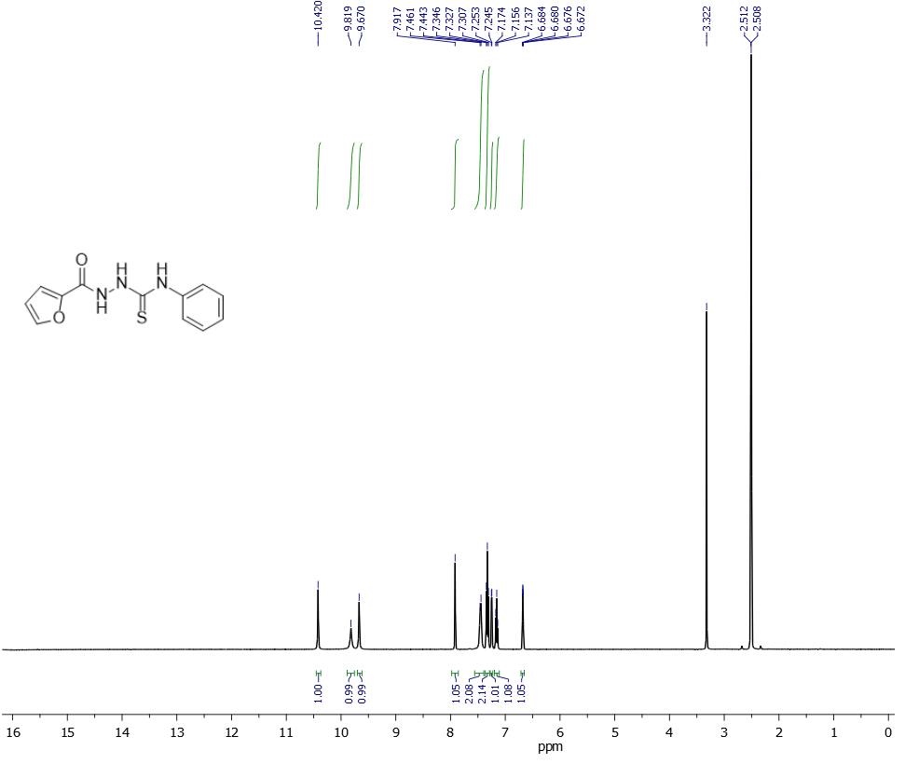

**Figure 2.** 1H NMR spectrum of compound **1**



**Figure 3.** FT-IR spectrum of compound **2**

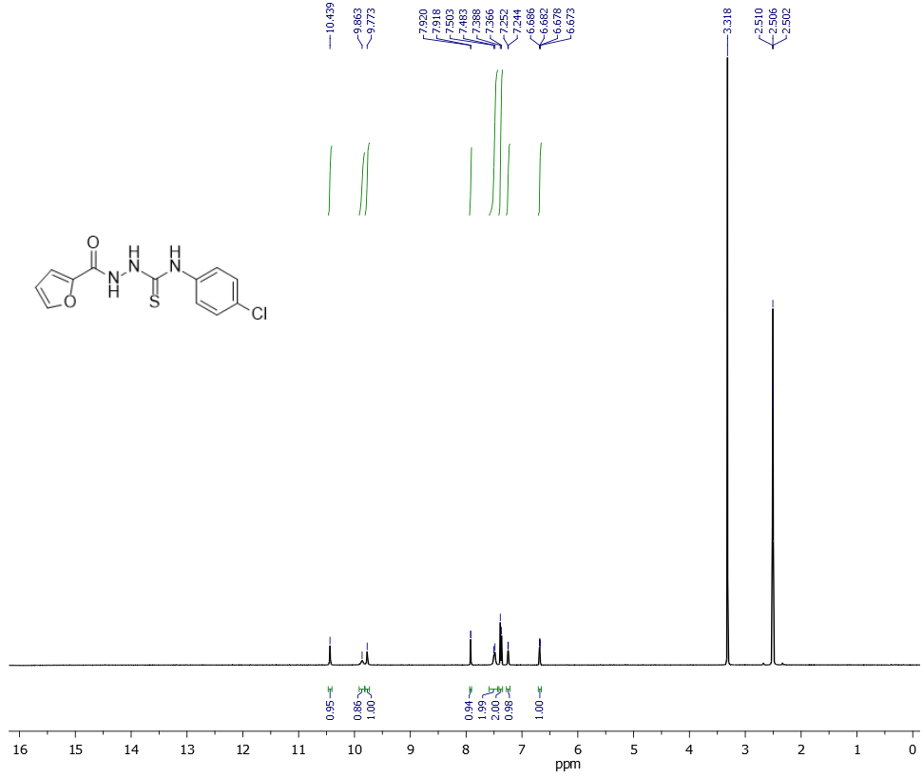

**Figure 4.** 1H NMR spectrum of compound **2**



**Figure 5**. FT-IR spectrum of compound **3**

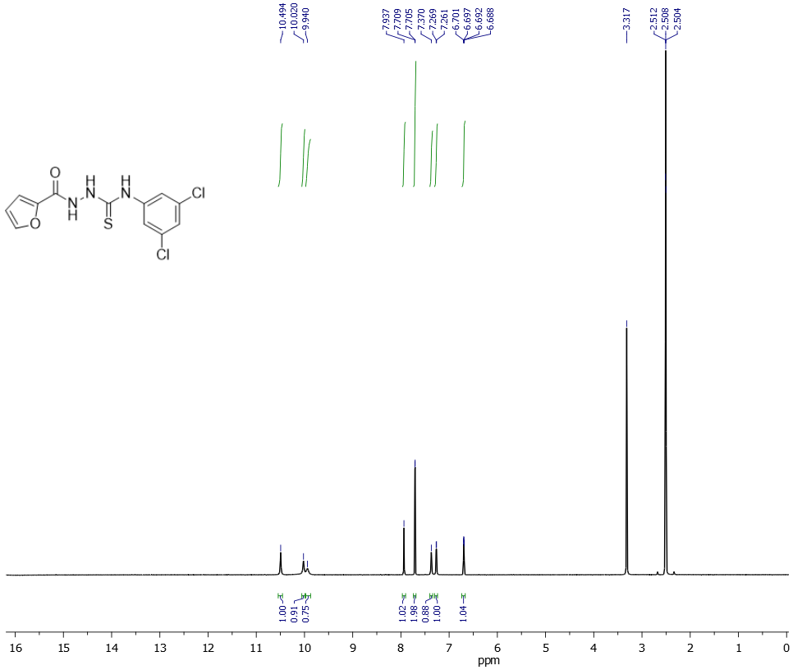

**Figure 6**. 1H NMR spectrum of compound **3**



**Figure 7**. FT-IR spectrum of compound **4**

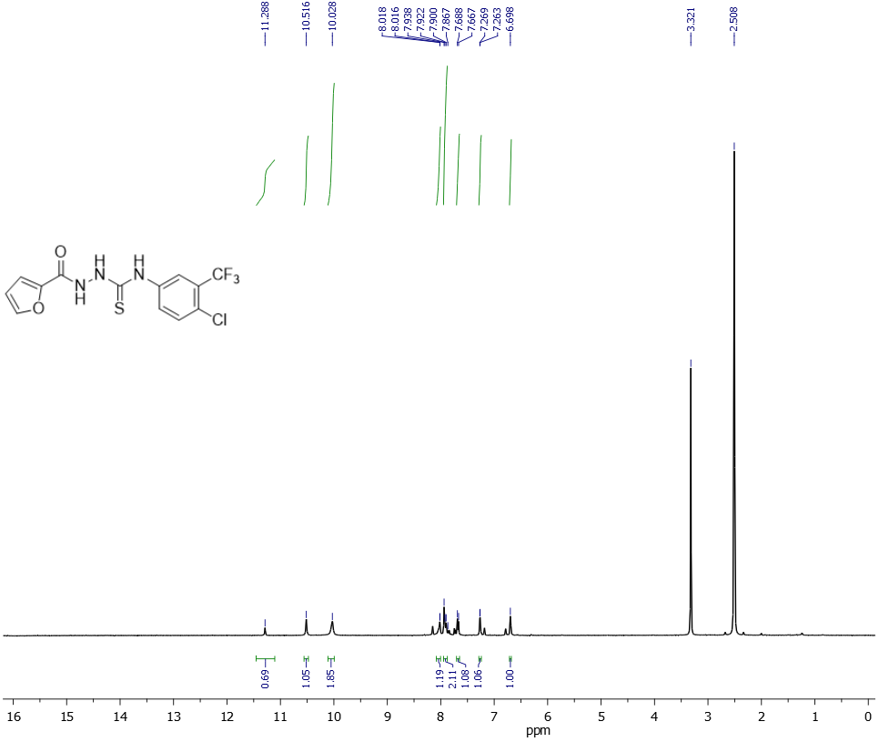 **Figure 8**. 1H NMR spectrum of compound **4**



**Figure 9**. FT-IR spectrum of compound **5**

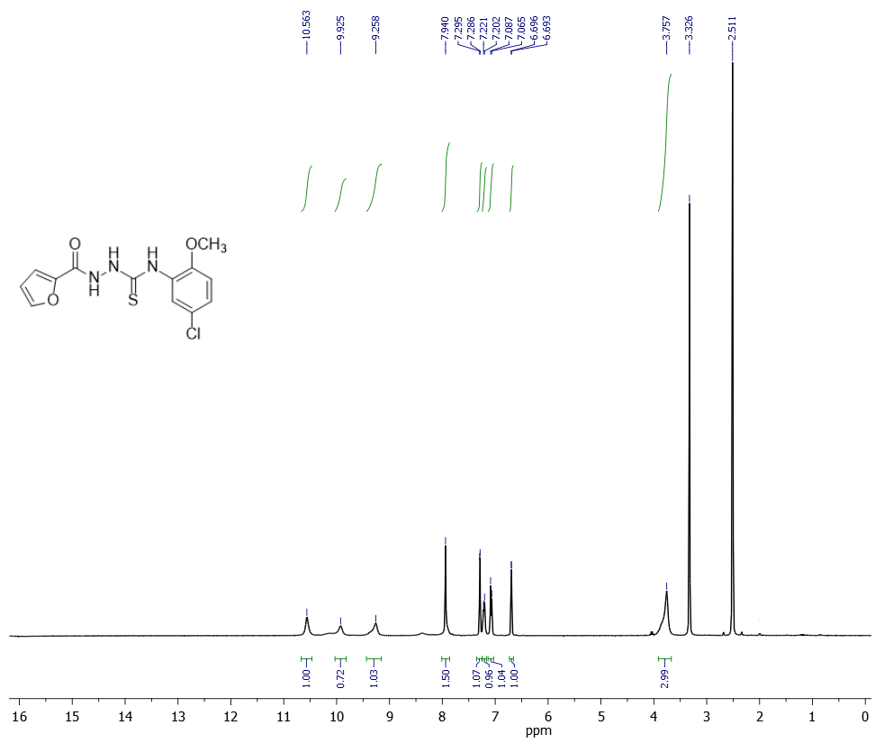

**Figure 10**. 1H NMR spectrum of compound **5**



**Figure 11**. FT-IR spectrum of compound **6**

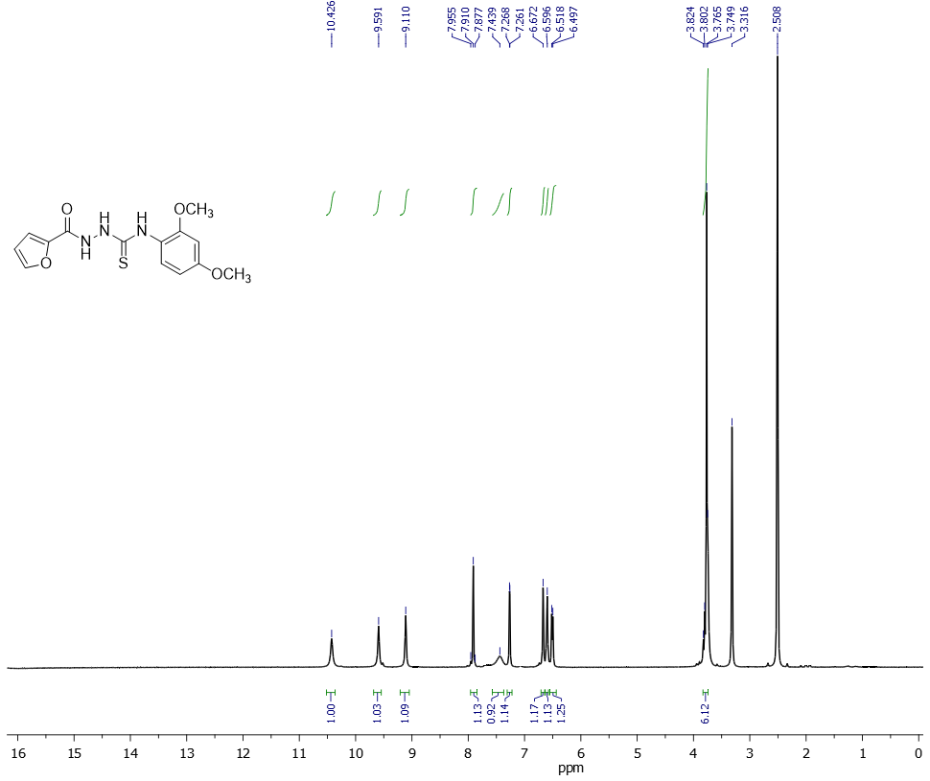

**Figure 12**. 1H NMR spectrum of compound **6**



**Figure 13**. FT-IR spectrum of compound **7**

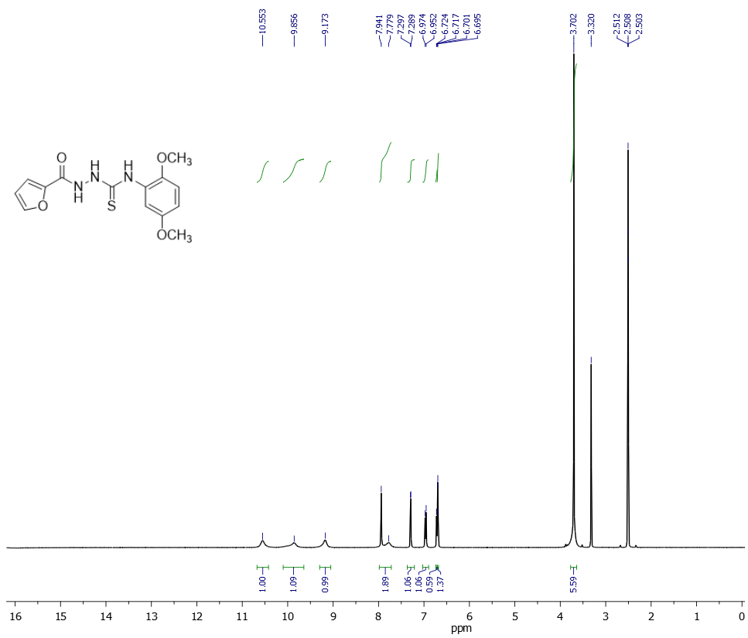

**Figure 14**. 1H NMR spectrum of compound **7**



**Figure 15**. FT-IR spectrum of compound **8**

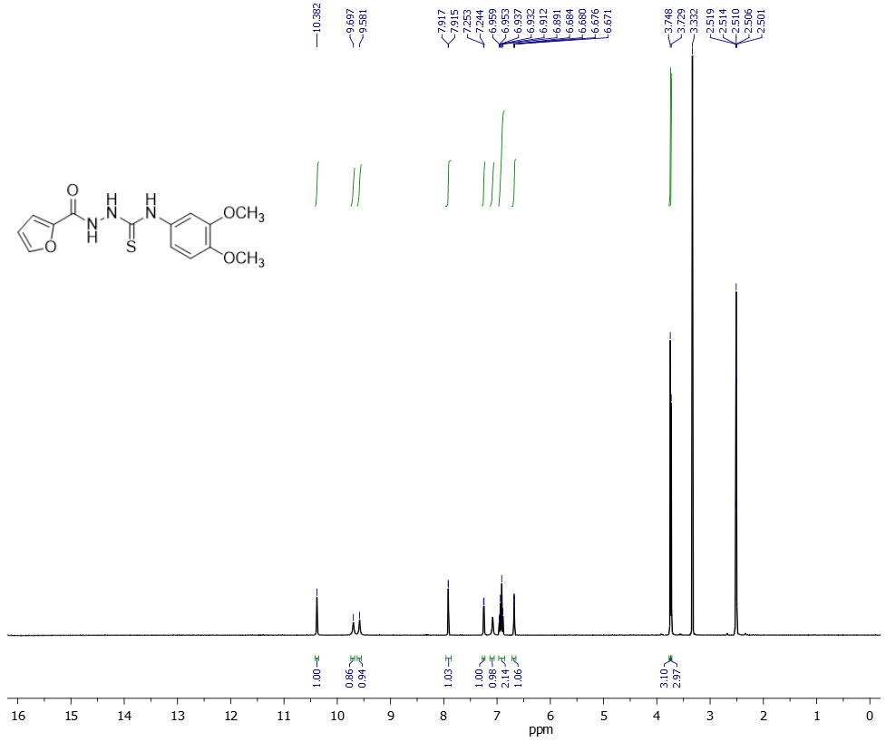

**Figure 16**. 1H NMR spectrum of compound **8**



**Figure 17**. FT-IR spectrum of compound **9**

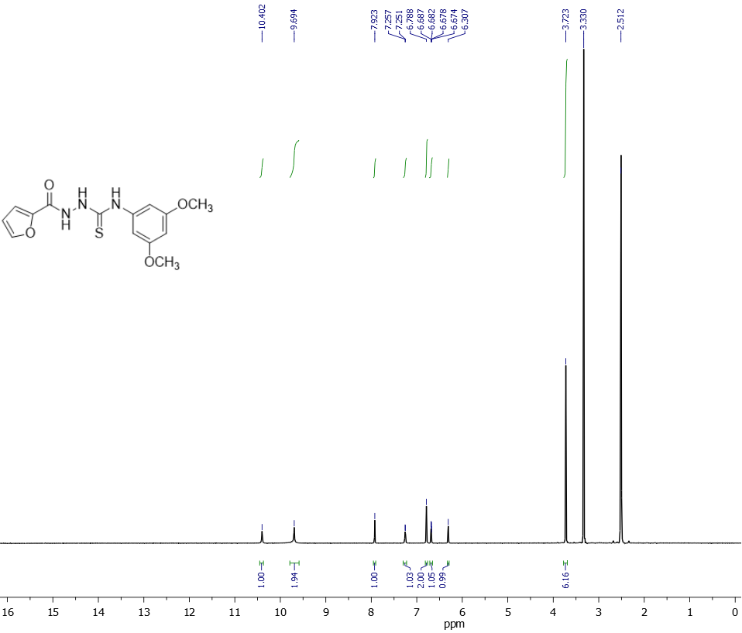

**Figure 18**. 1H NMR spectrum of compound **9**



**Figure 19**. FT-IR spectrum of compound **10**

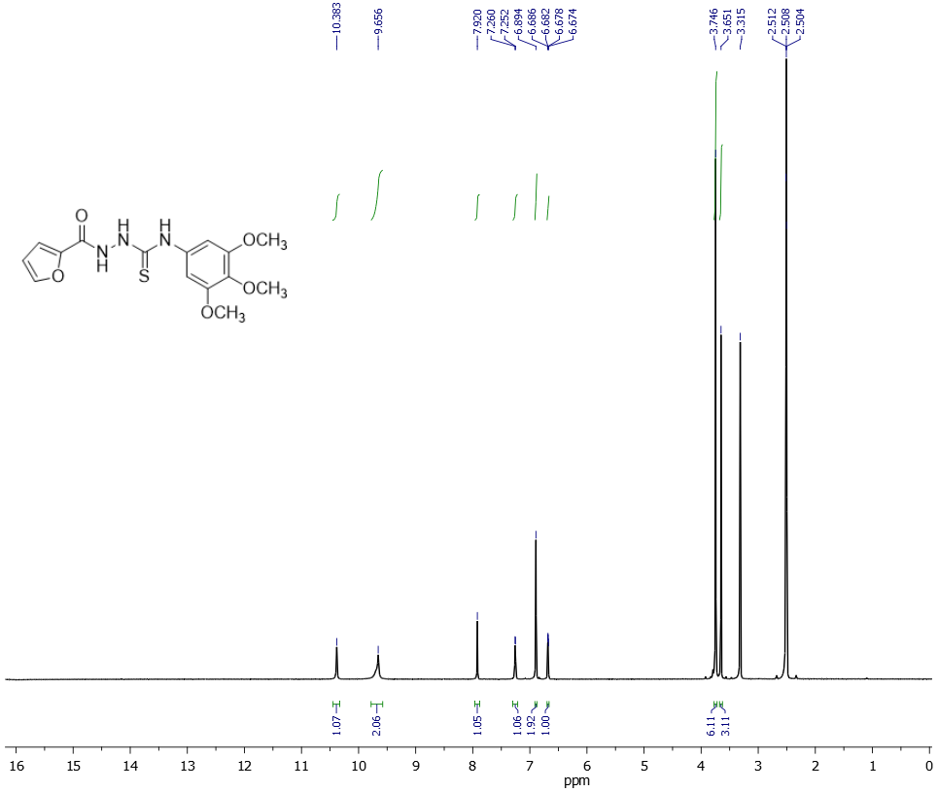

**Figure 20**. 1H NMR spectrum of compound **10**



**Figure 21**. FT-IR spectrum of compound **11**

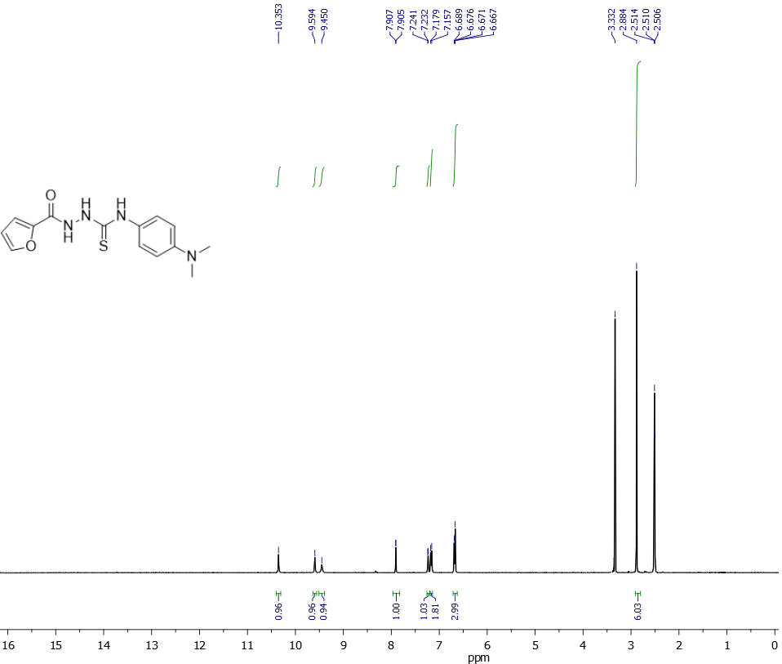

**Figure 22**. 1H NMR spectrum of compound **11**



**Figure 23**. FT-IR spectrum of compound **12**

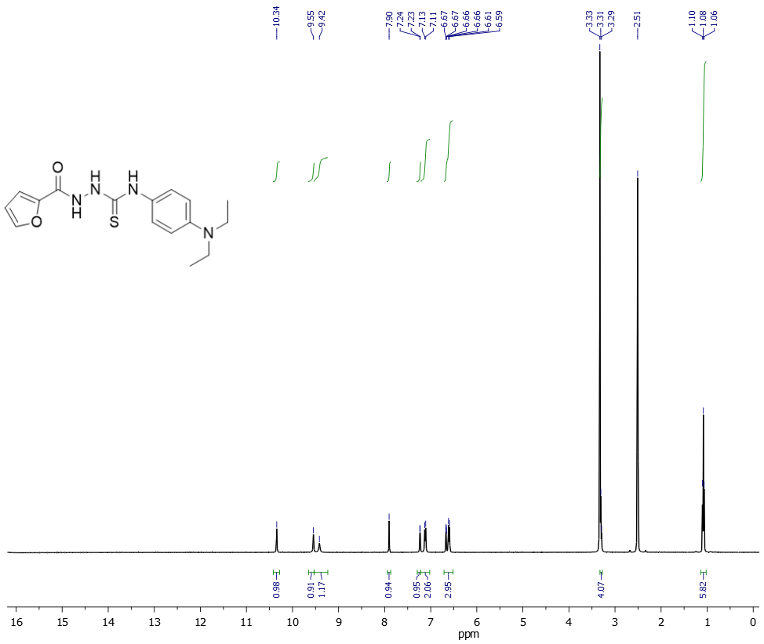

**Figure 24**. 1H NMR spectrum of compound **12**



**Figure 25**. FT-IR spectrum of compound **13**

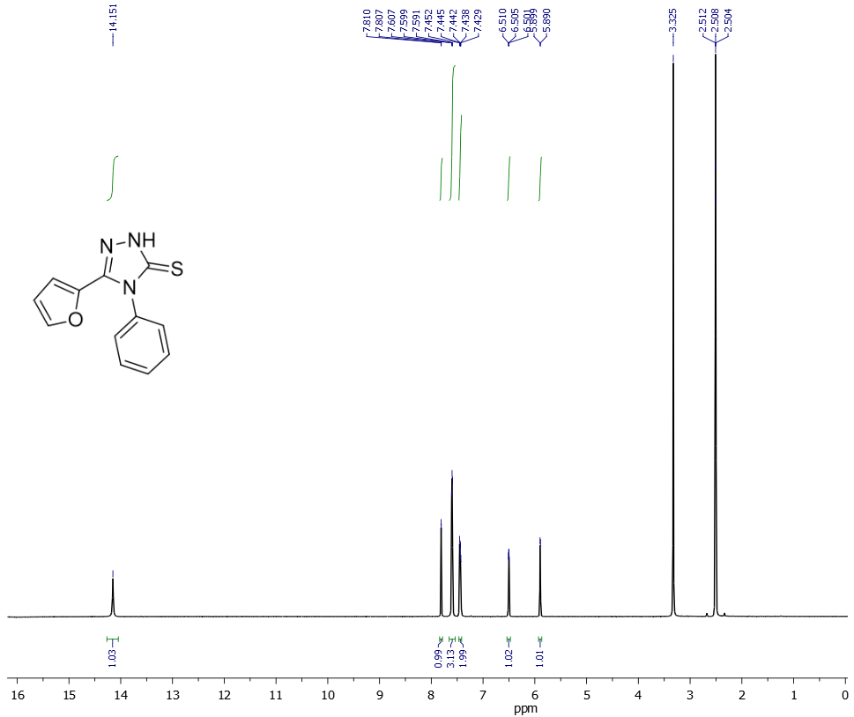

**Figure 26**. 1H NMR spectrum of compound 1**3**

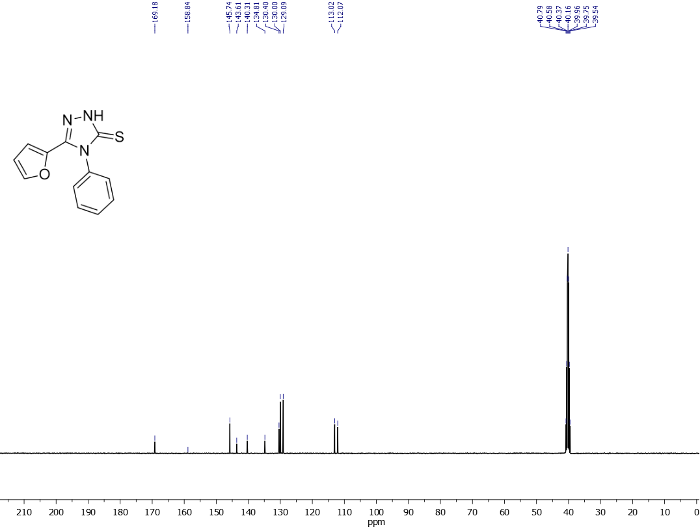

**Figure 27**. 13C NMR spectrum of compound 1**3**



**Figure 28**. FT-IR spectrum of compound **14**

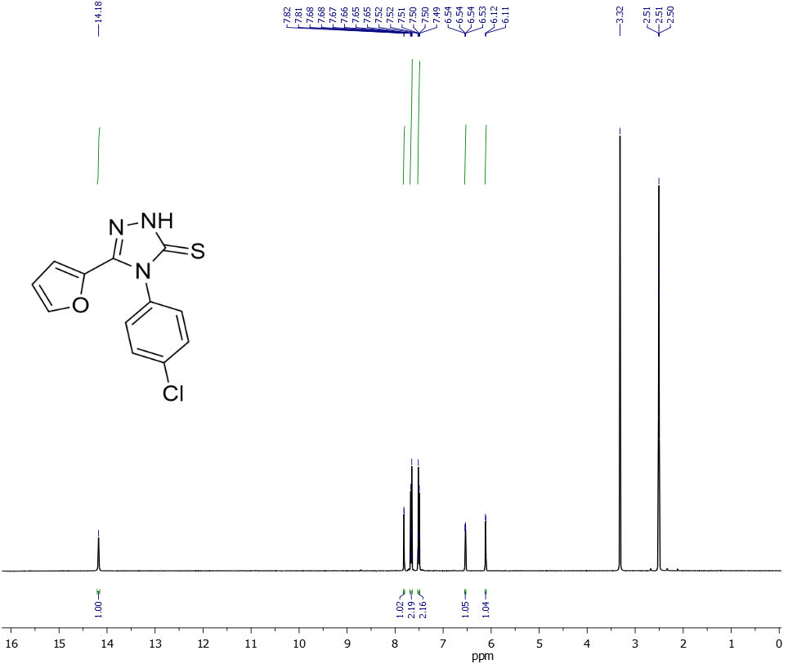

**Figure 29**. 1H NMR spectrum of compound **14**

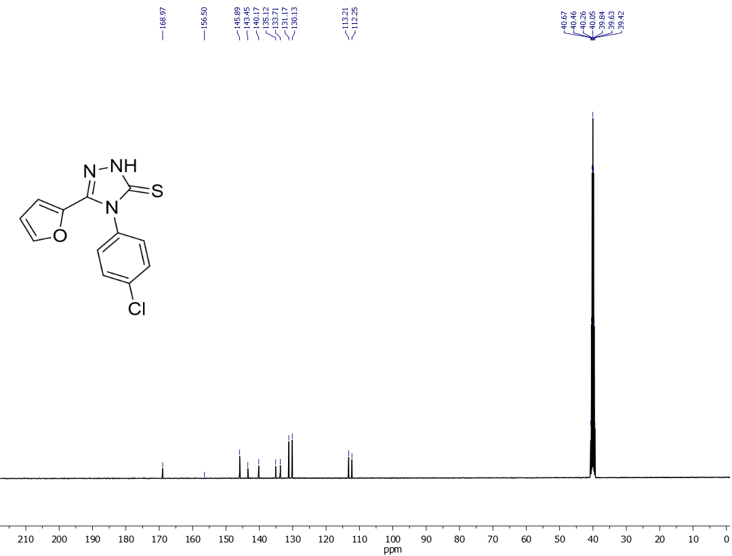

**Figure 30**. 13C NMR spectrum of compound **14**



**Figure 30**. FT-IR spectrum of compound **15**

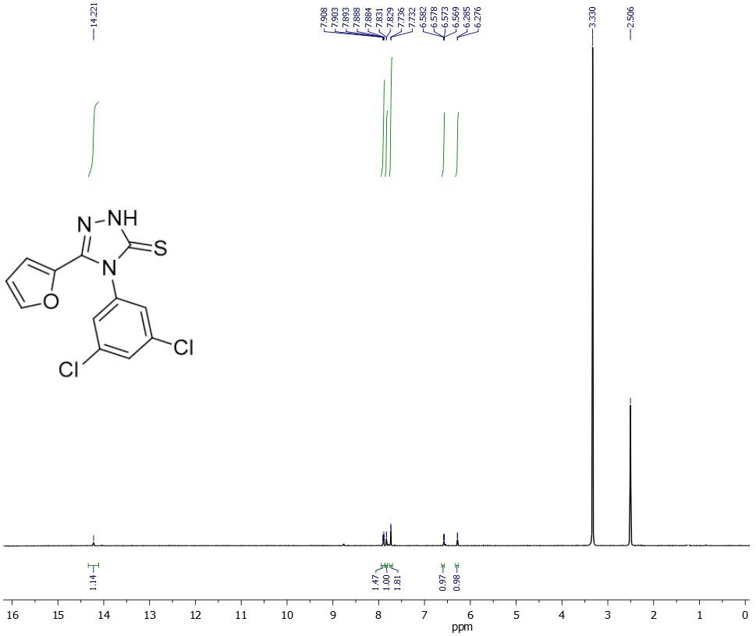

**Figure 31**. 1H NMR spectrum of compound **15**

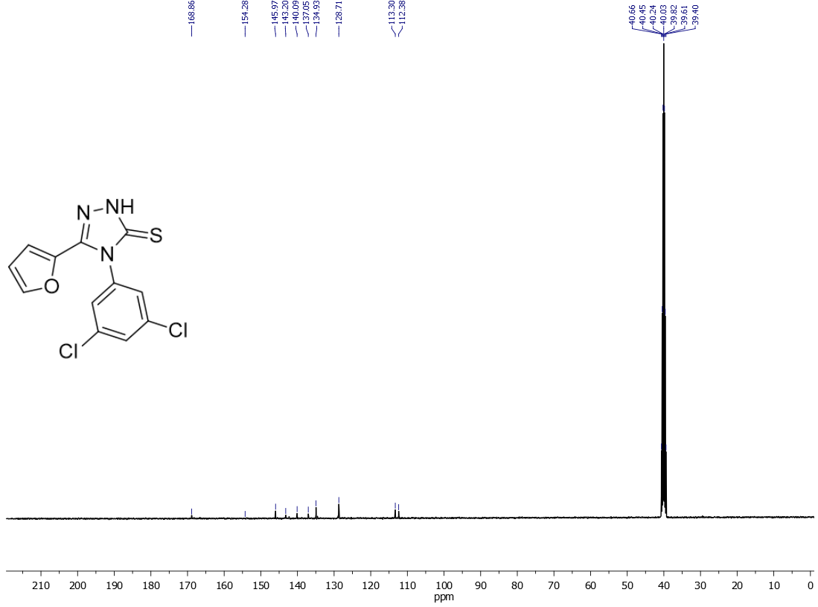

**Figure 32**. 13C NMR spectrum of compound **15**



**Figure 33**. FT-IR spectrum of compound **16**

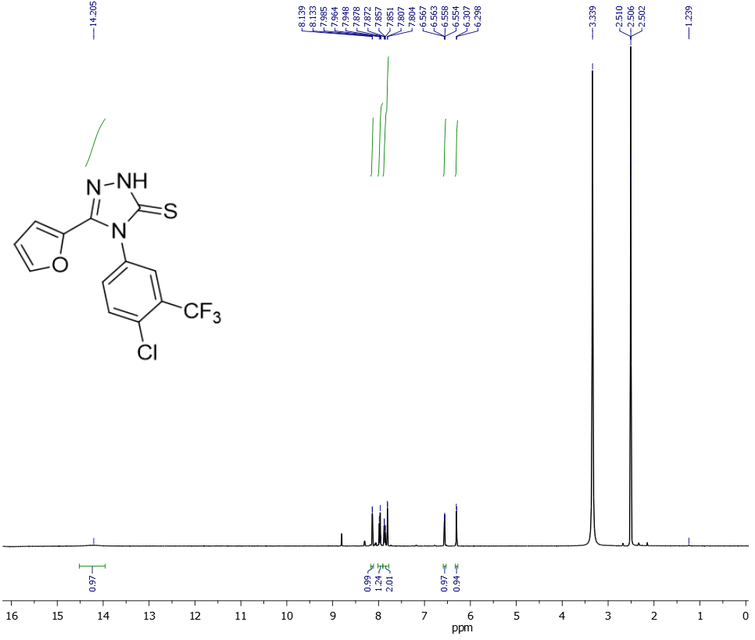

**Figure 34**. 1H NMR spectrum of compound **16**

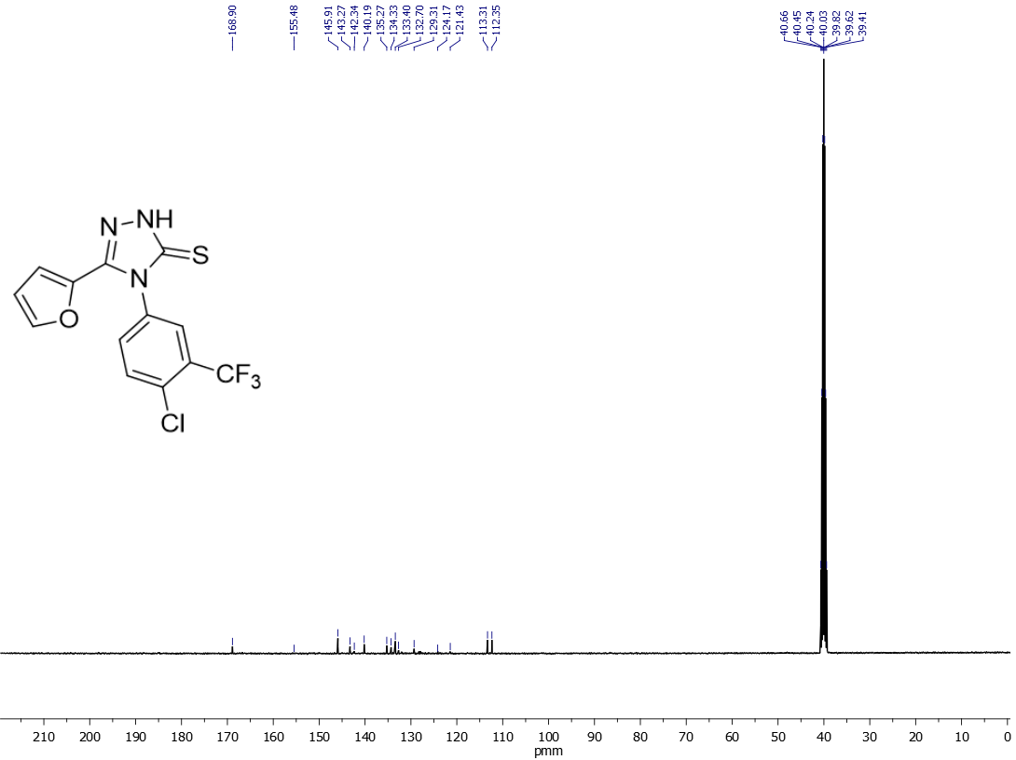

**Figure 34**. 13C NMR spectrum of compound **16**



**Figure 35**. FT-IR spectrum of compound **17**

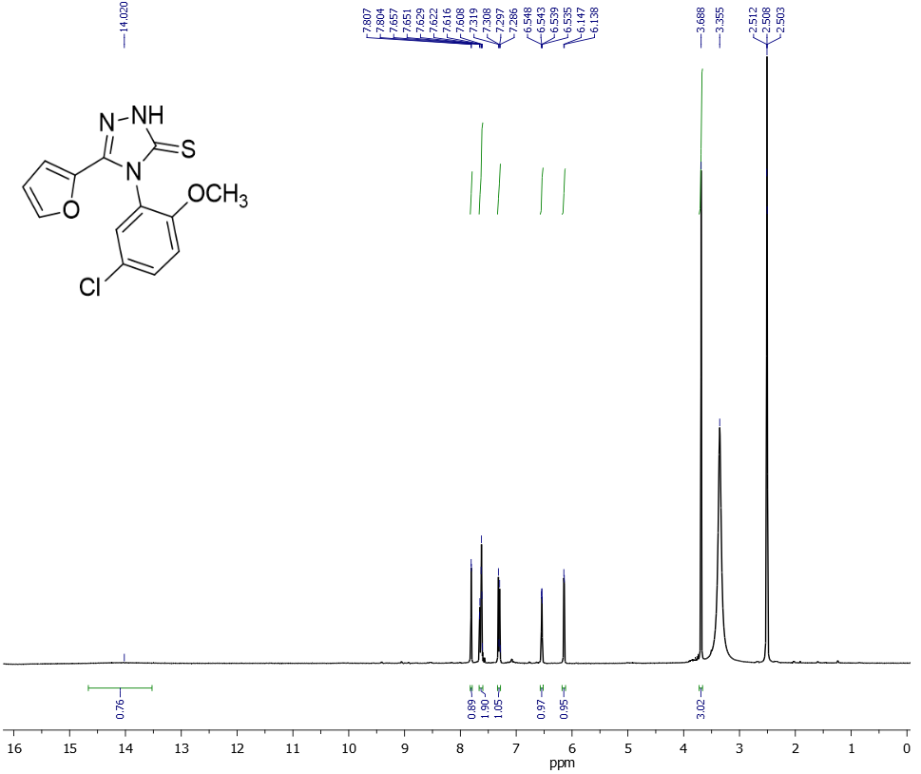

**Figure 36**. 1H NMR spectrum of compound **17**

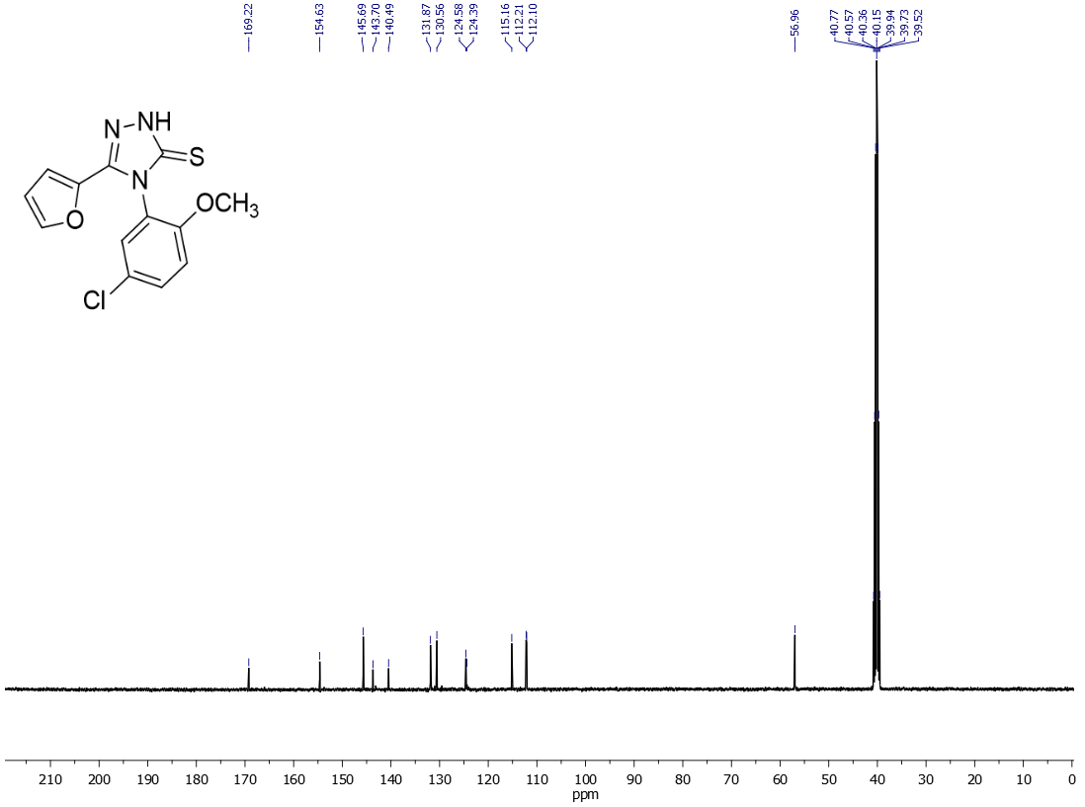

**Figure 37**. 13C NMR spectrum of compound **17**



**Figure 38**. FT-IR spectrum of compound **18**

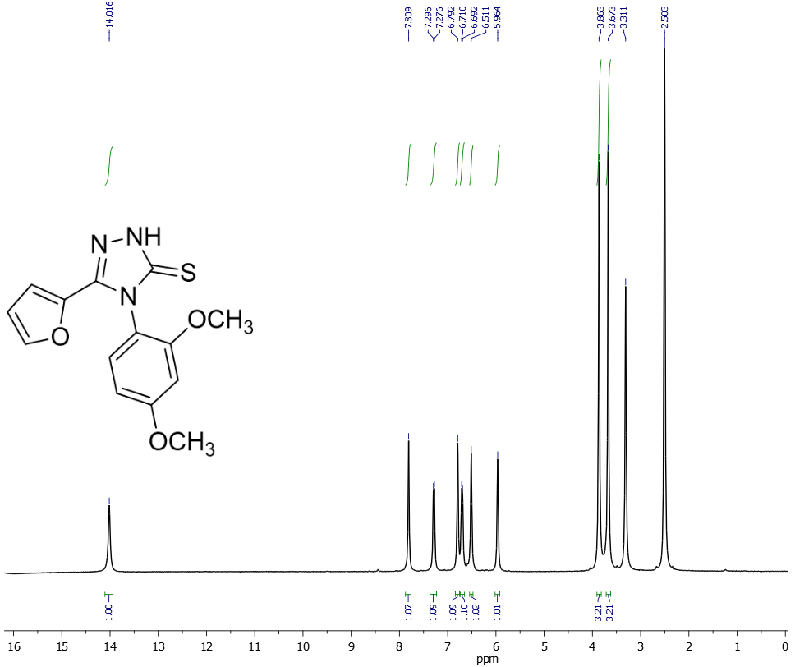

**Figure 39**. 1H NMR spectrum of compound **18**

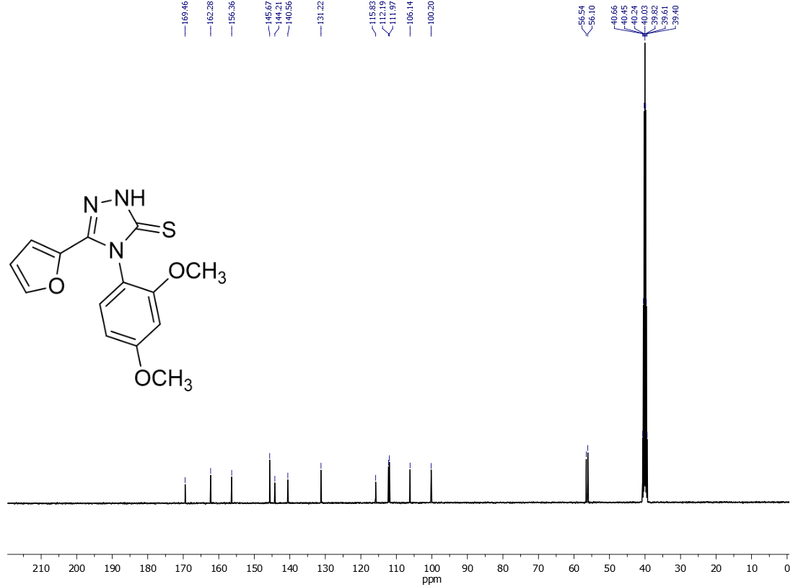

**Figure 40**. 13C NMR spectrum of compound **18**



**Figure 41**. FT-IR spectrum of compound **19**

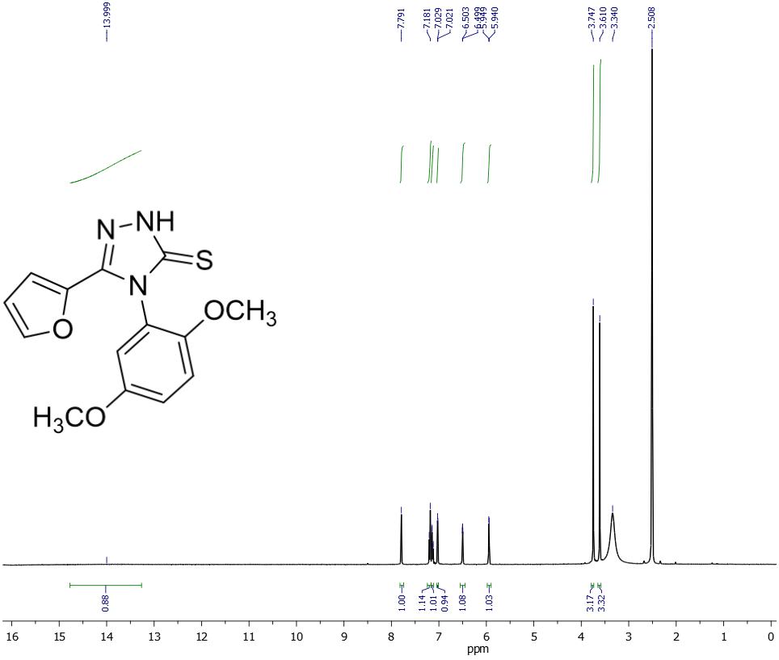

**Figure 42**. 1H NMR spectrum of compound **19**

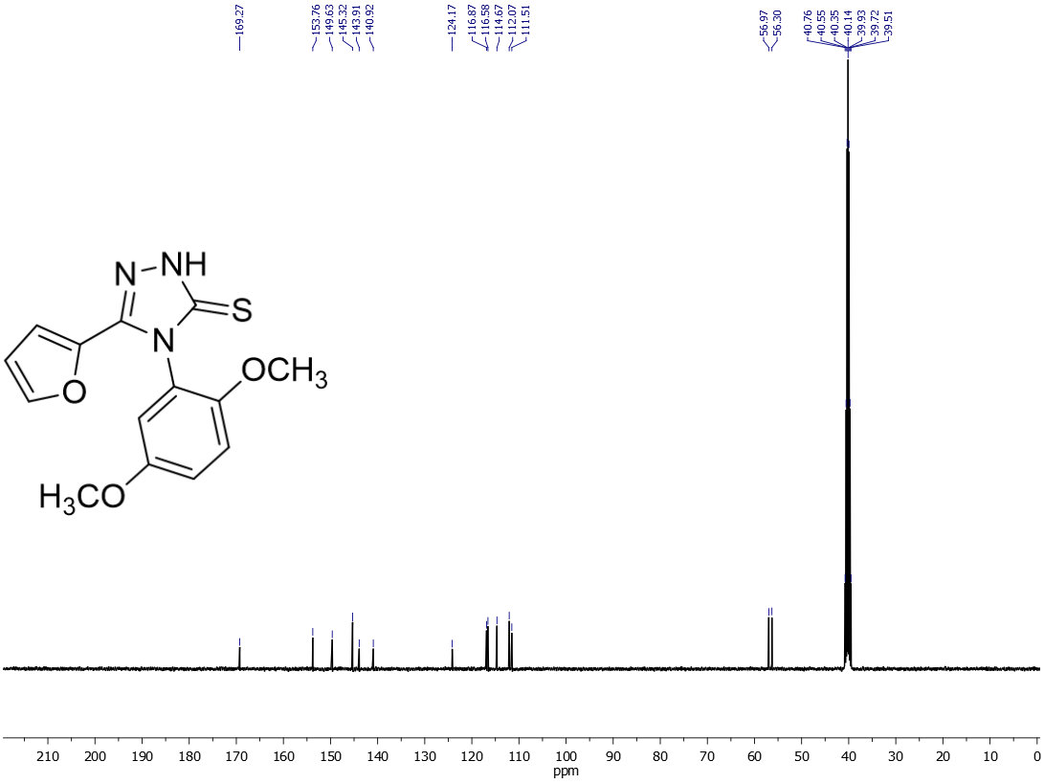

**Figure 42**. 13C NMR spectrum of compound **19**



**Figure 43**. FT-IR spectrum of compound **20**

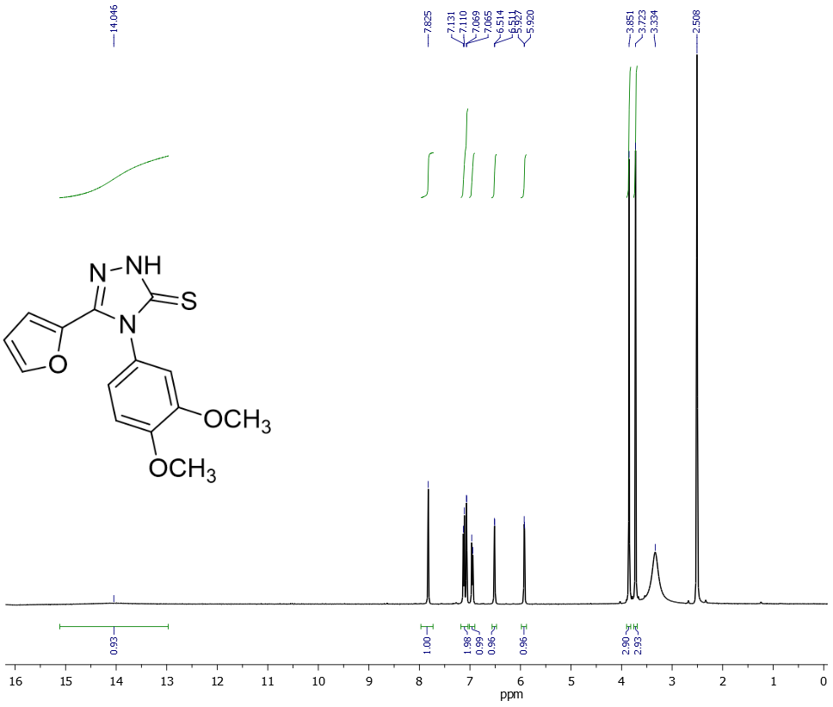

**Figure 44**. 1H NMR spectrum of compound **20**

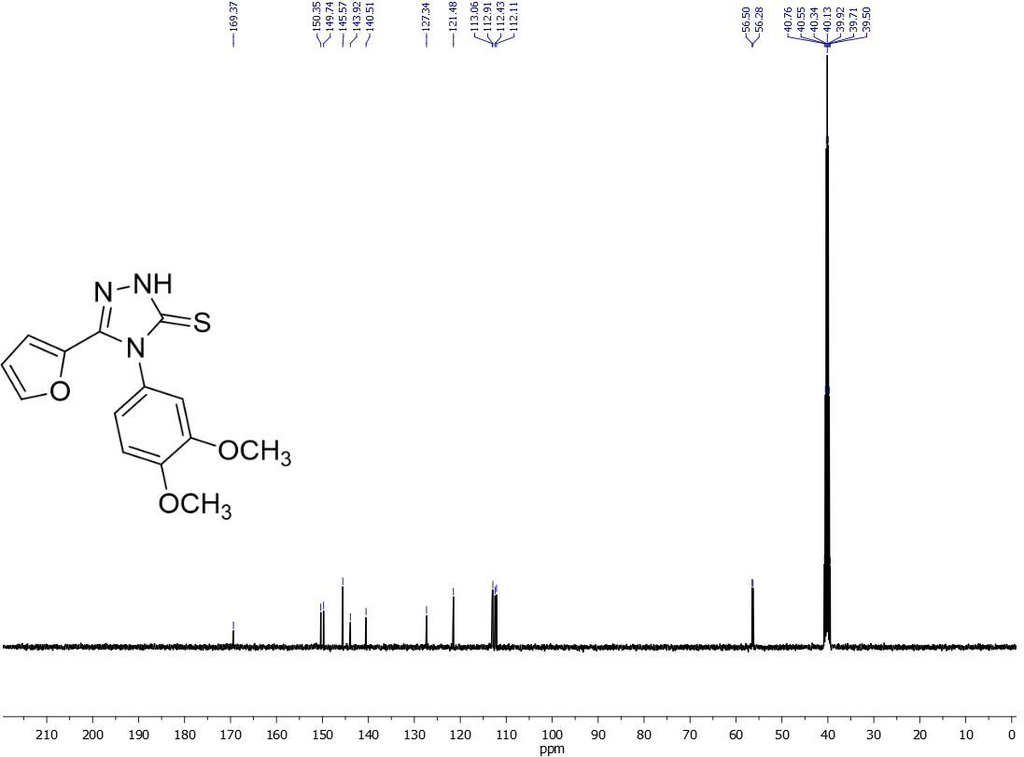

**Figure 45**. 13C NMR spectrum of compound **20**



**Figure 46**. FT-IR spectrum of compound **21**

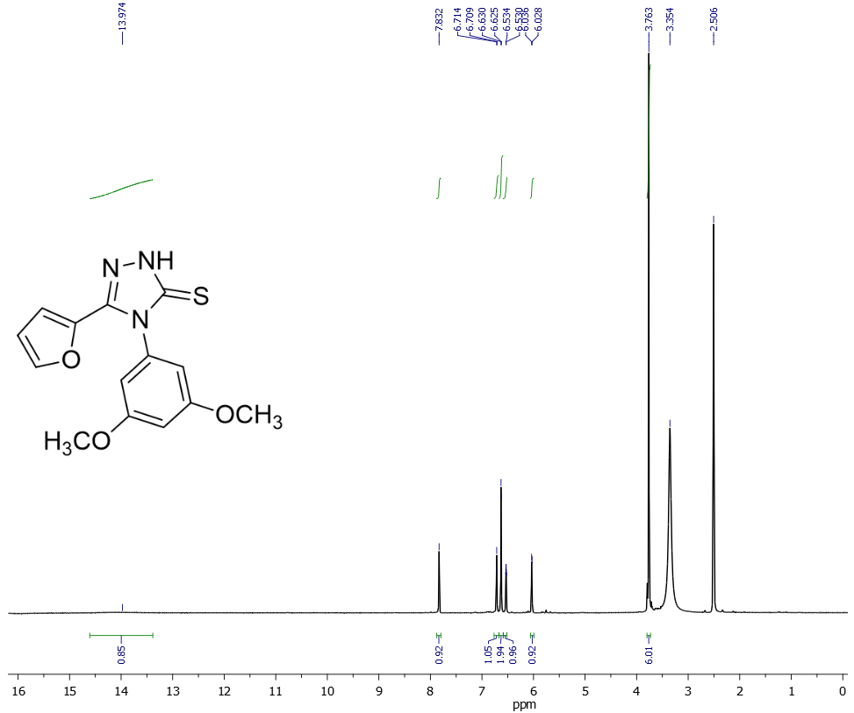

**Figure 47**. 1H NMR spectrum of compound **21**

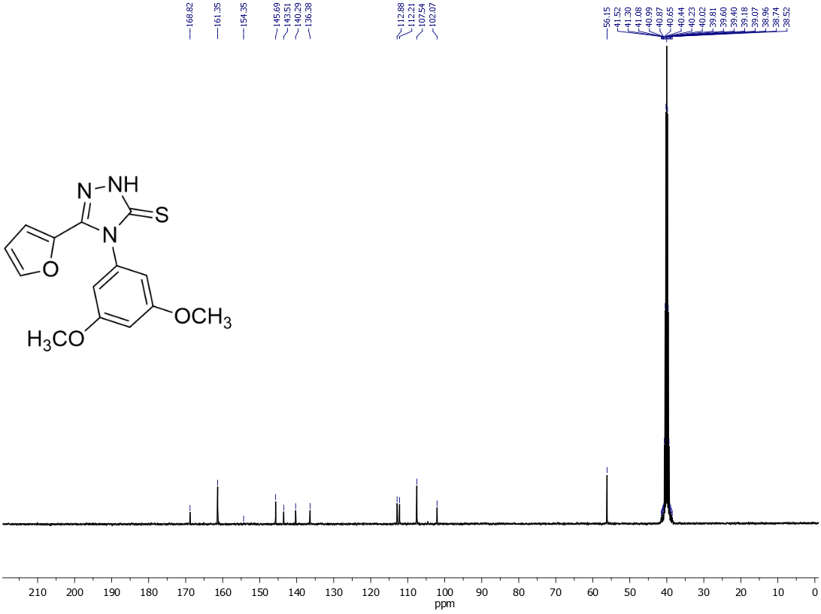

**Figure 48**. 13C NMR spectrum of compound **21**



**Figure 49**. FT-IR spectrum of compound **22**

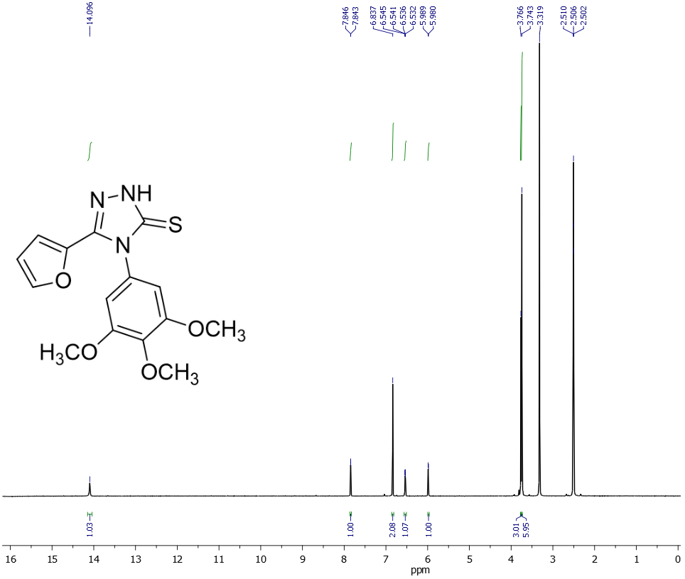

**Figure 50**. 1H NMR spectrum of compound **22**

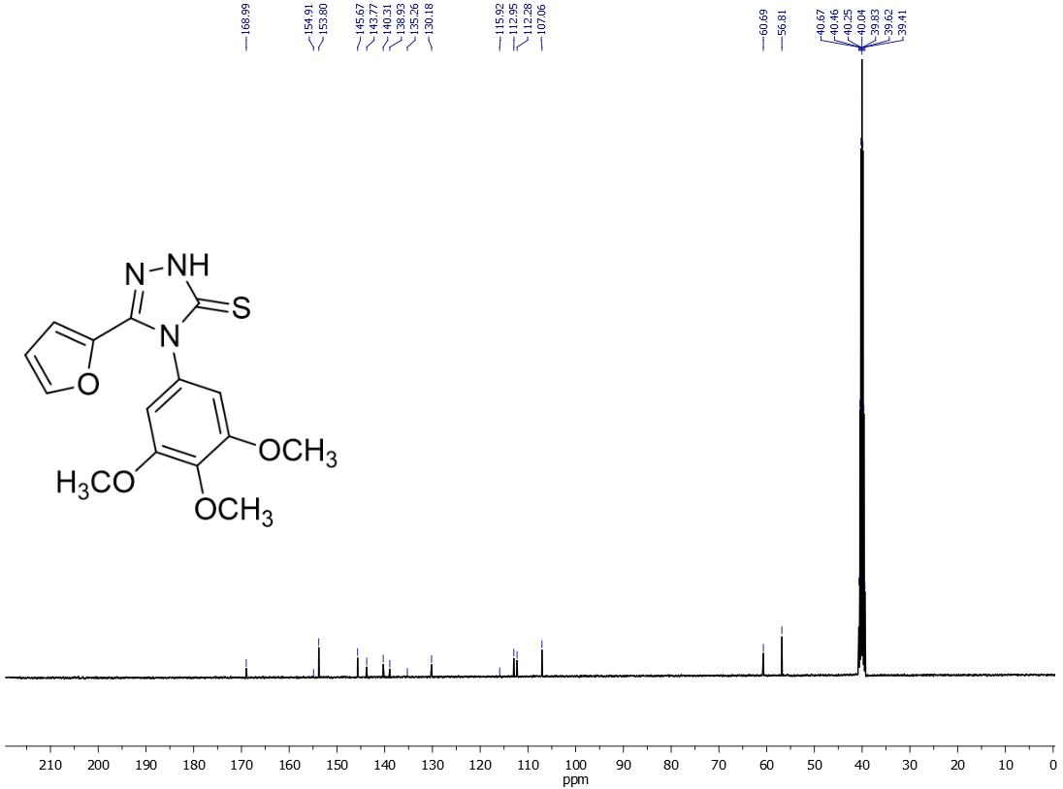

**Figure 51**. 13C NMR spectrum of compound **22**



**Figure** **52**. FT-IR spectrum of compound **23**

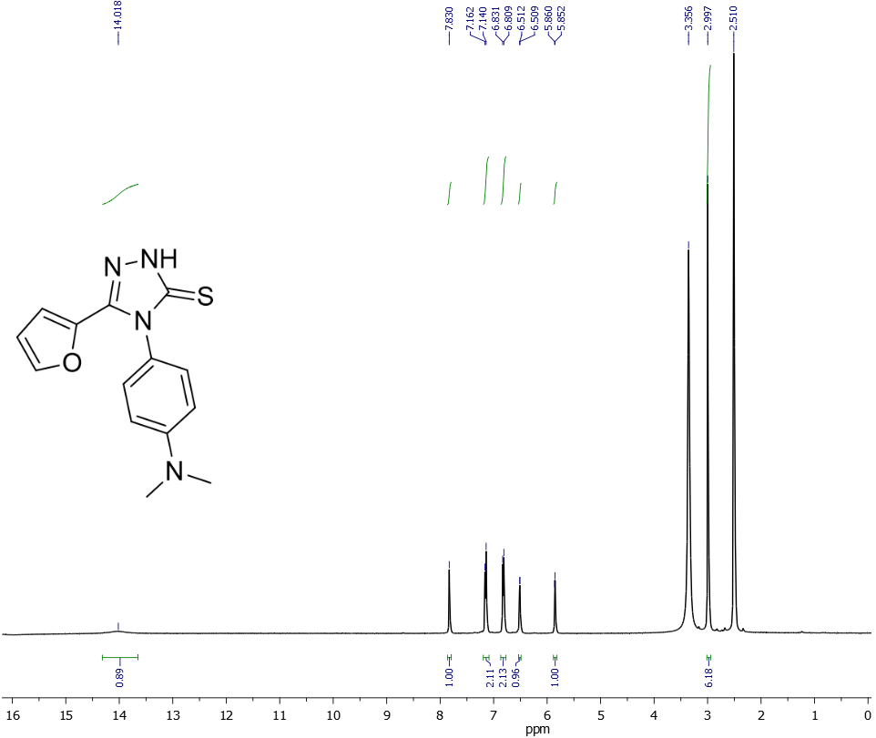

**Figure 53**. 1H NMR spectrum of compound **23**

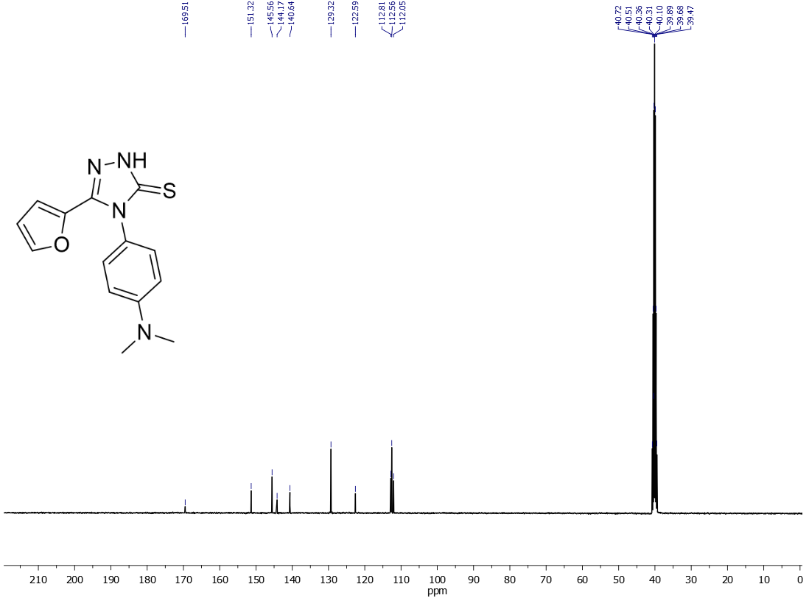

**Figure 54**. 13C NMR spectrum of compound **23**



**Figure 55.** FT-IR spectrum of compound **24**

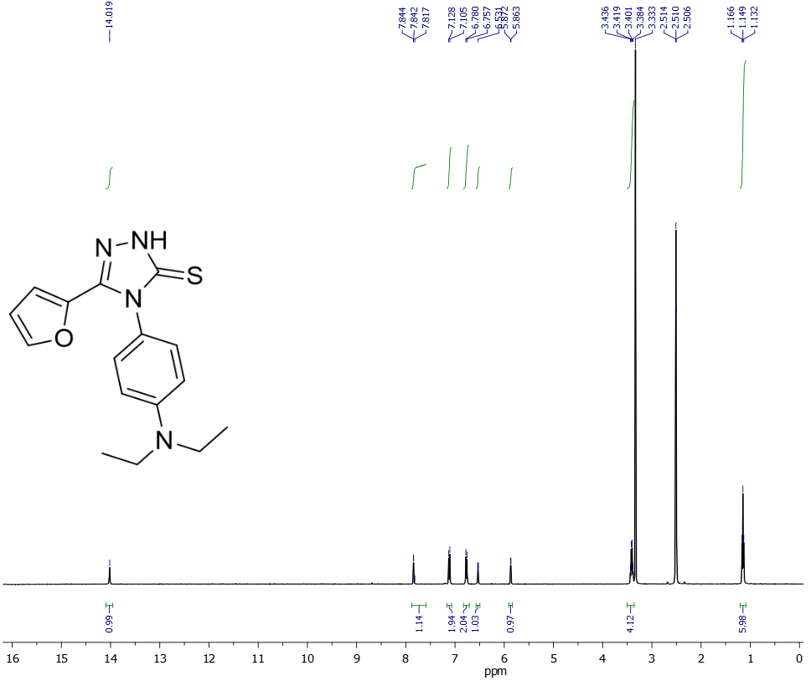

**Figure 55**. 1H NMR spectrum of compound **24**

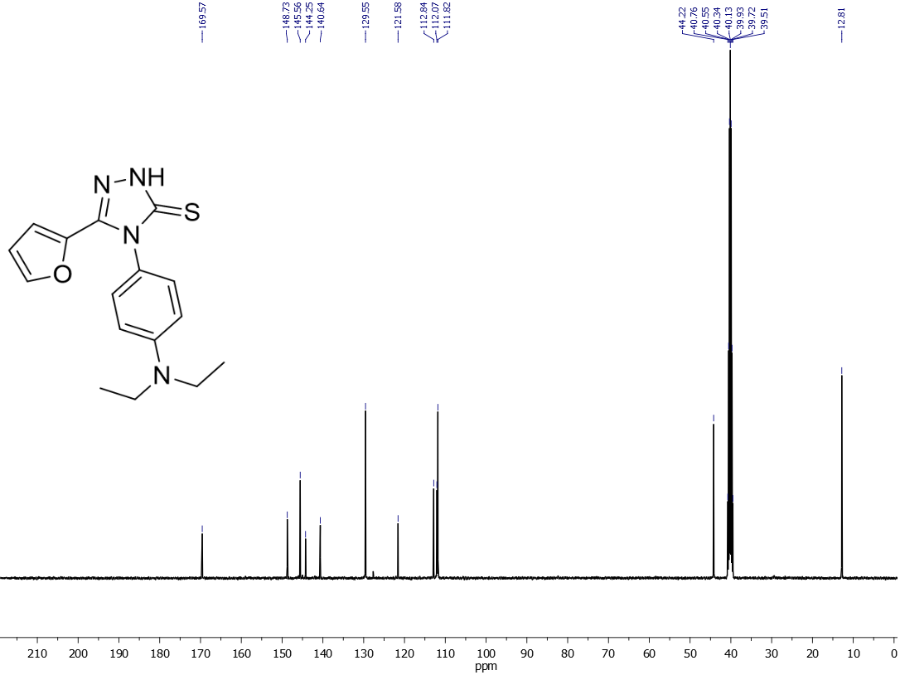

**Figure 56**. 13C NMR spectrum of compound **24**