Supplementary information
Topoarchitected polymer networks expand the space of material properties
Xiao Liu¹, Jingping Wu¹, Keke Qiao¹, Guohan Liu¹, Zhengjin Wang¹, Tongqing Lu¹, Zhigang Suo^{2*}, and Jian Hu^{1*}
¹State Key Lab for Strength and Vibration of Mechanical Structures, International Center for Applied Mechanics, Department of Engineering Mechanics, Xi’an Jiaotong University, Xi’an 710049, China
²John A. Paulson School of Engineering and Applied Sciences, Kavli Institute for Bionano Science and Technology, Harvard University, Cambridge, Massachusetts 02138, United States
Email: hujian@mail.xjtu.edu.cn, suo@seas.harvard.edu

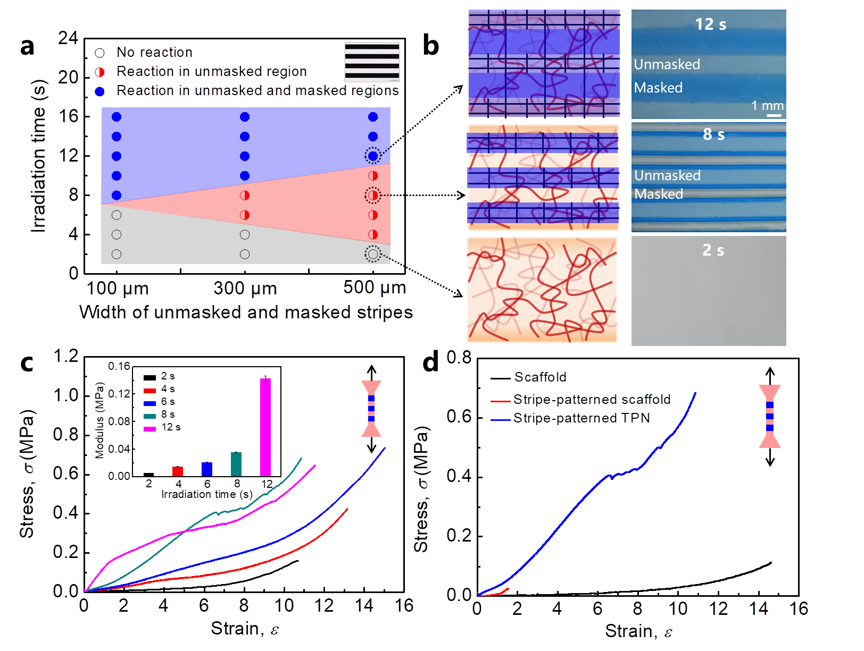
Figure S1 | Process conditions of stripe-patterned TPNs. a, The morphology of the second network varies with the irradiation time and stripe width. The inset is a micrograph of a mask with alternating unmasked and masked stripes of 500 μm in width. On the plane of the irradiation time and stripe width are three zones. In the gray zone, the second network does not form. In the blue zone, the second network forms in both masked and unmasked region. In the red zone, the second network only forms in the unmasked region. b, Schematics and micrographs of the hydrogels. The samples are prepared at different irradiation time, using the mask with the stripe width of 500 μm. c, For the hydrogels prepared with various irradiation times, stress-strain curves are measured in the tensile direction vertical to the stripes. The modulus shows an abrupt increase from 0.04 MPa to 0.14 MPa when the irradiation time varies from 8 s to 12 s, due to the formation of the second network in the masked region. d, Stress-strain curves of the hydrogels at the three stages shown in Fig. 1e.
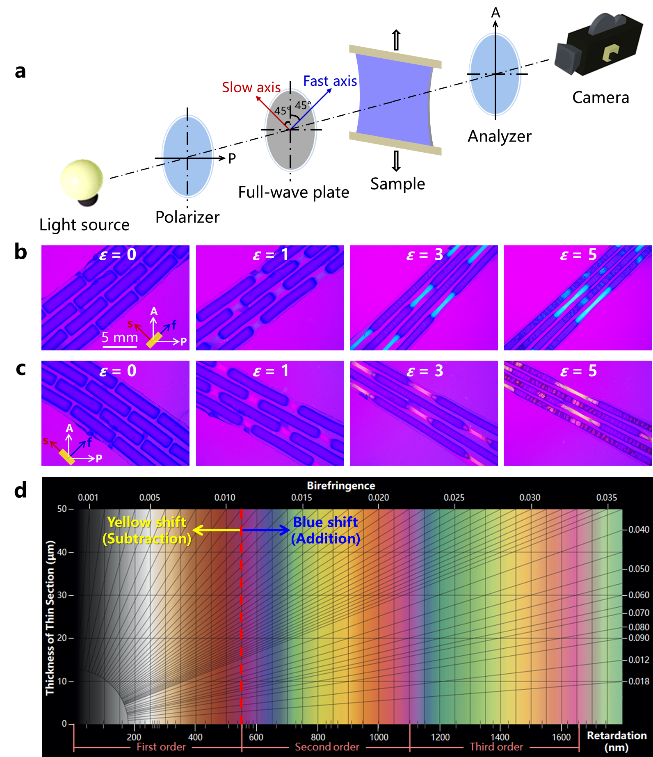
Figure S2 | Birefringence mechanism of stretched TPNs under polarizing optical microscope. a, Schematic for the configuration of polarizing optical microscope, equipped with the crossed polarizers and a 45° aligned 560 nm full-wave plate. b, c, In-situ polarizing optical observation of TPNs with the tensile direction parallel (b) or perpendicular (c) to the fast axis of the full-wave plate. The micrographs show blue (b) or yellow (c) shift with the increase of strain, due to the orientation-induced enhanced birefringence. A: Analyzer; P: Polarizer; s: slow axis of the full-wave plate; f: fast axis of the full-wave plate. d, Michel-Levy interference color chart issued by Zeiss Microscopy. The pink background color with 560 nm retardation (highlighted by the red dashed line) shifts to blue when the fast axis of the sample and the full-wave plate are parallel (retardation addition), but shifts to yellow when perpendicular (retardation subtraction). The fast axis of the PAAm matrix, where color change occurs, is along the tensile direction, because PAAm gels have a negative birefringence.

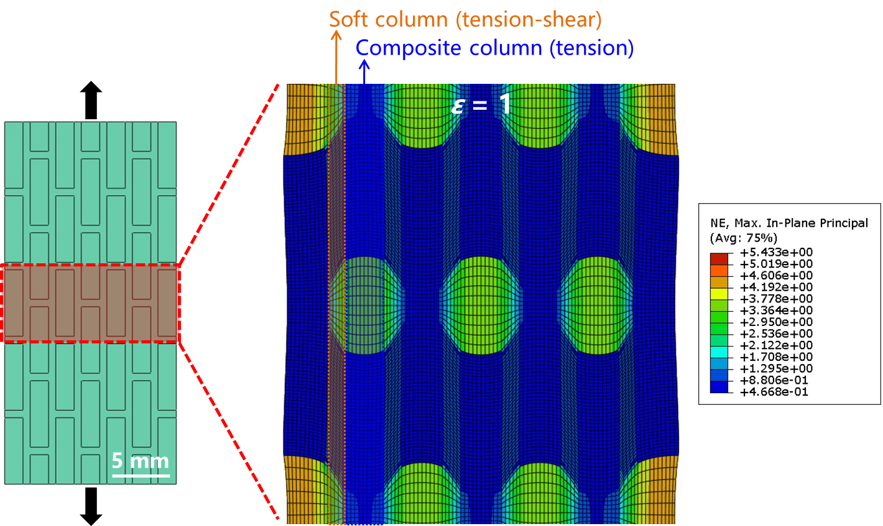
Figure S3 | Finite element simulation for the tension of TPNs. When the sample is stretched to ε = 1, the strain distribution shows complex tension-shear coupling strain in the soft column and pure tensile strain in the composite column.

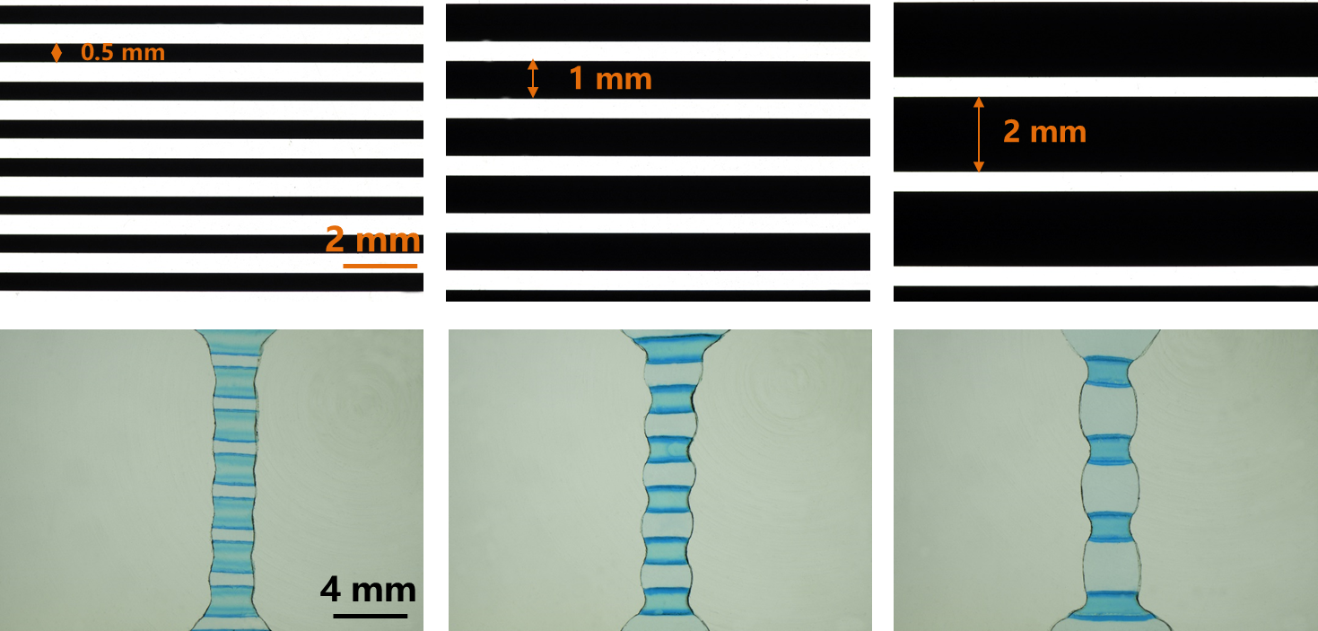
Figure S4 | Effect of the interval between two neighboring hard phase of stripe-patterned TPNs on the swelling of the soft phase. As the increase in the width of masked stripe from 0.5 mm to 2 mm and fixing the width of unmasked stripe at 500 μm, the hard phase loses the ability to restrict the swelling of the soft phase, which is evidenced by the expanded volume of the soft phase.

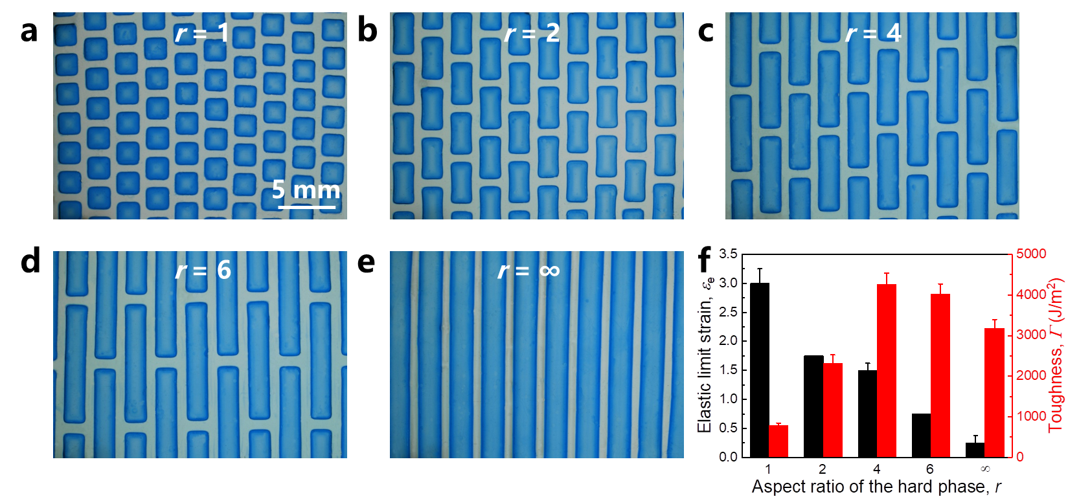
Figure S5 | Effect of the aspect ratio of the hard phase on the mechanical properties of TPNs. a-e, Optical micrographs of TPNs with varied aspect ratio r of the hard phase. For simplicity, we only change the length of the hard phase and keep the other geometric parameters constant. f, Effect of the aspect ratio on the elastic limit strain and toughness of TPNs.

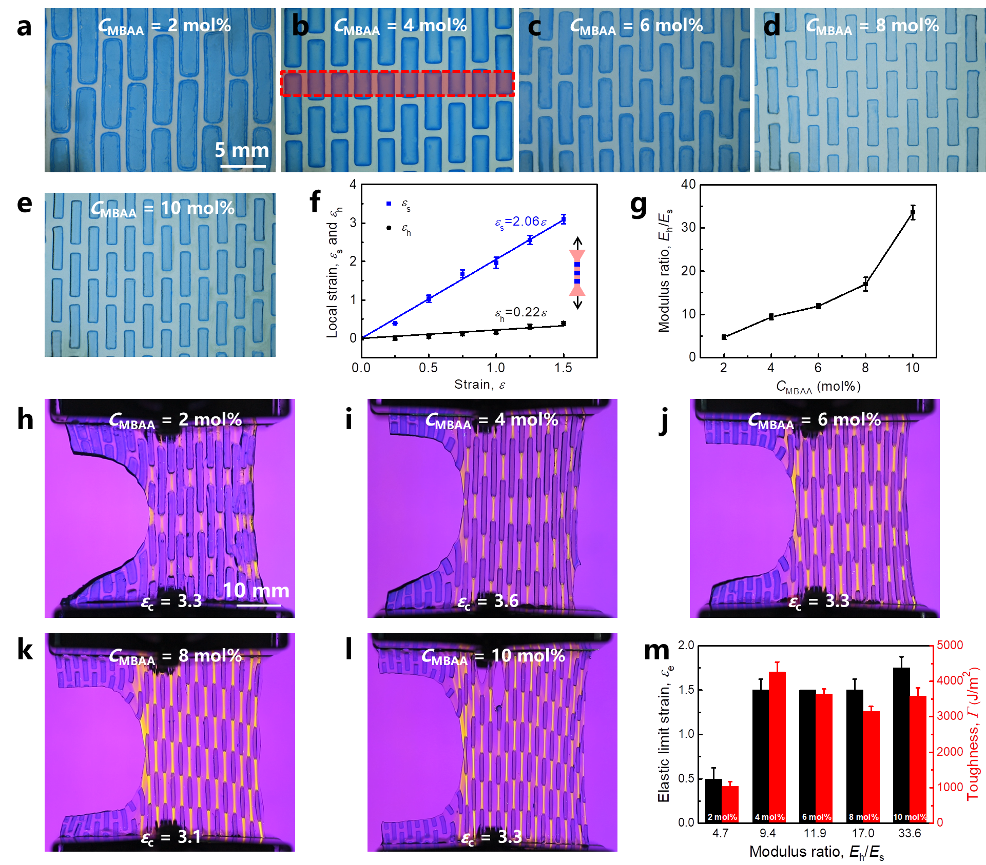
Figure S6 | Effect of the modulus ratio on the mechanical properties of TPNs. a-e, Optical micrographs of TPNs with varied crosslinker concentration C_{MBAA} for the second network. f, Strain of the soft and hard phases ε_{s} and ε_{h} in a stripe-patterned TPN as a function of the applied strain ε in the linear elastic region. The stripe-patterned TPN is obtained by cutting the overlap region of the staggered-patterned TPN, marked by the red box in (b). The tensile process of the stripe-patterned TPN obeys series model (isostress model), so the modulus ratio of the hard phase to the soft phase E_{h}/E_{s} = ε_{s}/ε_{h} = k_{s}/k_{h}, here k means the slope of the fitting line. g, Dependence of E_{h}/E_{s} on C_{MBAA}. h-i, In-situ polarizing optical observation of various precut TPNs at the critical strain ε_{c}. m, Effect of E_{h}/E_{s} on the elastic limit strain and toughness of TPNs.
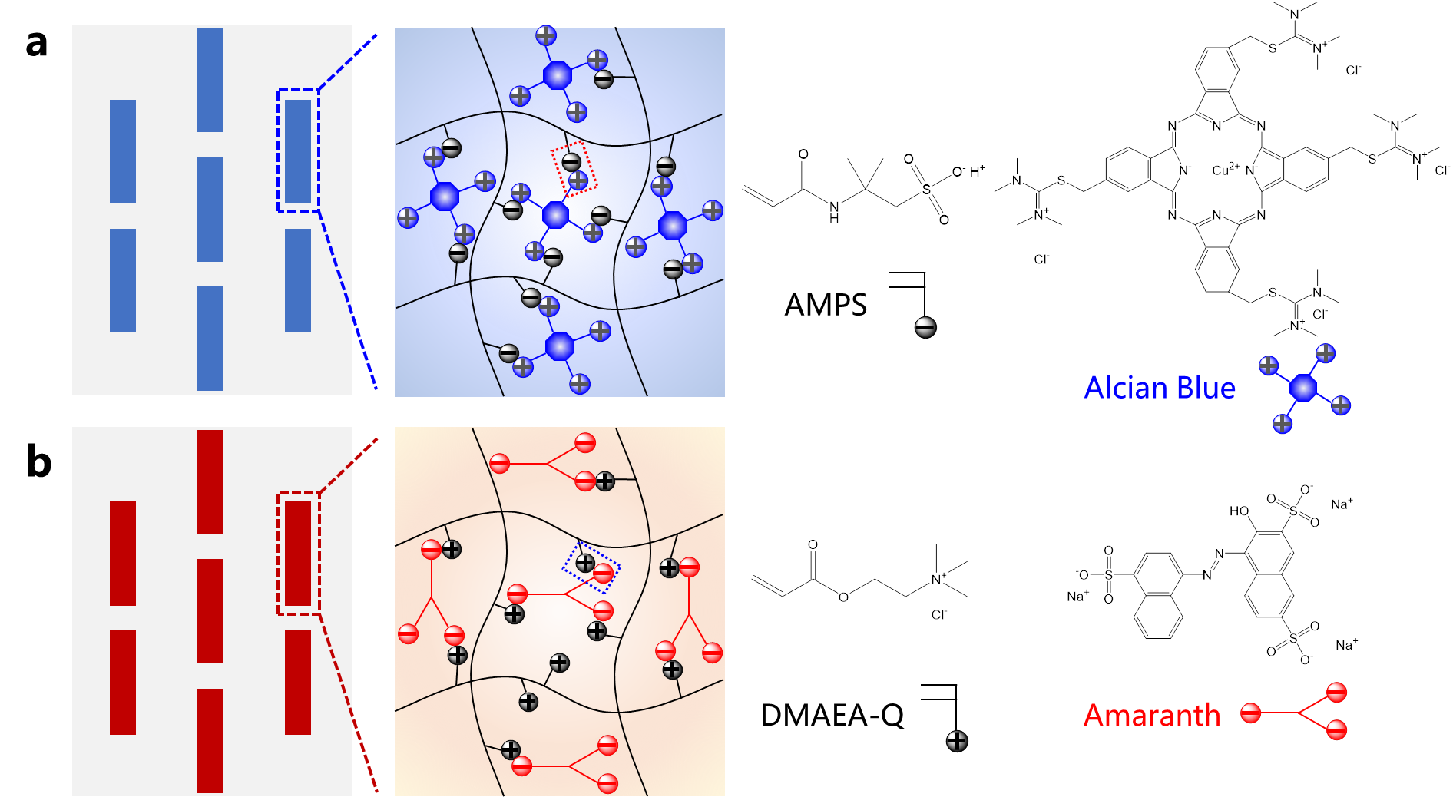
Figure S7 | Dyeing mechanism of TPNs. a, b, Based on electrostatic attraction, the PAMPS-based gel (a) and the PDMAEA-Q-based gel (b) are selectively dyed by Alcian Blue and Amaranth in the hard phase, respectively.

