SUPPLEMENTARY MATERIAL FOR: SHORT-LIVED SPECIES MOVE UPHILL FASTER UNDER CLIMATE CHANGE

Joséphine Couet, Emma-Liina Marjakangas, Andrea Santangeli, John-Atle Kålås, Åke Lindström, Aleksi Lehikoinen

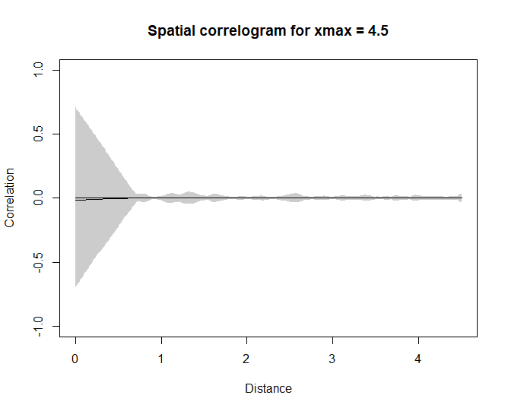
Figure S1. Spatial autocorrelation of the linear mixed model residuals of the relationship between the average altitudinal shift across bird species and the geographical and spatial variables. Spatial correlogram illustrates the spatial autocorrelation of the residuals from the model for a maximal distance of 4.5 degree decimal, which corresponds to 500 km of distance.

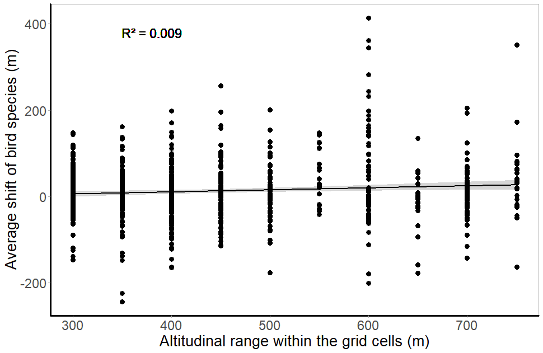
Figure S2. Range shift of species in a given grid cell based on the altitudinal range of the grid. One dot is one species in a given grid cell.

Table S1. Definitions and references of each species’ trait used for the analysis of the role of species-specific differences in the altitudinal range shifts. References to data, trait definition, and computation tool origin are included. For full references, see the main text.
Trait | Definition | Reference(s)
Clutch size | Annual mean number of eggs | Storchová & Hořák 2018
Longevity | Mean of maximum longevity (years) | De Magalhaes & Costa 2009
Body mass | Mean body mass (g) | Wilman et al. 2014
Main habitat | Main habitat that the species uses, divided into four categories: farmland-urban, forest, wetland and rocky outcrops, montane | Lehikoinen & Virkkala 2016
Diet specialization | Quantified as Shannon’s diversity index (calculated with R package ‘vegan’, Oksanen et al., 2019) of the proportional use of different diet categories: invertebrate, vertebrate (endotherm), vertebrate (ectotherm), fish, vertebrate (unknown), scavenge, fruit, nectar or pollen, seed, other plant material. | Wilman et al. 2014
Migration strategy | Migration behaviour divided into four categories: resident, partial migrant (including species from which a part of the population migrates), short distance migrant (including species that winter in the Baltic countries or Western Europe), long distance migrant (including wintering further than the Mediterranean area) | Laaksonen & Lehikoinen 2013
Species temperature index | Long-term average temperature experienced by individuals across the range (species temperature index, STI). The values were obtained from the combination of the spatial distribution of the mean temperature (WordlClim v. 1.0) of birds breeding season (from March to August) and data from the EBCC atlas of European breeding birds. | Devictor et al. 2008, Hijmans et al. 2015, Hagemeijer & Blair 1997
Population trend | The population tendency in the study area during the breeding season between the period 1998-2019, divided into three categories: decreasing population, stable population, increasing population. | Svensk Fågeltaxering 2019

References

De Magalhaes JP, Costa J (2009) A database of vertebrate longevity records and their relation to other life‐history traits. Journal of Evolutionary Biology 22:1770–1774.
Devictor V, Julliard R, Couvet D, Jiguet F (2008) Birds are tracking climate warming, but not fast enough. Proceedings of the Royal Society B: Biological Sciences, 275:2743–2748.
Hagemeijer WJ, Blair MJ (1997) The EBCC atlas of European breeding birds. Poyser, London.
Hijmans RJ, Cameron SE, Parra JL, Jones PG, Jarvis A (2005) Very high resolution interpolated climate surfaces for global land areas. International Journal of Climatology: A Journal of the Royal Meteorological Society 25(15):1965–1978.
Laaksonen TK, Lehikoinen A (2013) Population trends in boreal birds: continuing declines in long-distance migrants, agricultural and northern species. Biological Conservation 168:99–107.
Oksanen J, Blanchet FG, Friendly M, Roeland K, Legendre P, McGlinn D, Minchin PR, O'Hara RB, Simpson GL, Solymos P, Stevens MHH, Szoecs E, Wagner H (2019) vegan: Community Ecology Package. R package version 2.5–6. https://CRAN.R-project.org/package=vegan
Storchová L, Hořák D (2018) Life‐history characteristics of European birds. Global Ecology and Biogeography 27:400–406.
Svenska Fågel Taxering 2019: https://www.fageltaxering.lu.se/resultat/trender/trender-standardrutterna
Wilman H, Belmaker J, Simpson J, la Rosa de C, Rivadeneira MM, Jetz W (2014) EltonTraits 1.0: species-level foraging attributes of the world’s birds and mammals. Ecology 95:2027. https://doi.org/10.1890/13-1917.1

Table S2. List of species and their traits included in the analyses. For migration strategy (Migr.), the levels are: 1 = resident, 2 = partial migrant (species from which a part of the population migrates), 3 = short distance migrant (wintering in the Baltic countries or Western Europe), and 4 = long distance migrant (wintering further than the Mediterranean area). For the habitat, the levels are: 1 = farmland-urban, 2 = forest, 3 = wetlands (rocky outcrops), and 4 = montane. Finally, for the population tendency (trend), the levels are: 1= decreasing, 2 = no trend, and 3= increasing population.
Species | English name | Body mass | Diet | Migr. | Habitat | STI | Trend | Clutch size | Longevity | Order | Family
Acanthis flammea | Common redpoll | 13 | 1.089 | 2 | 2 | 8.19 | 1 | 5 | 12.2 | Passeriformes | Fringillidae
Actitis hypoleucos | Common sandpiper | 48 | 1.221 | 4 | 3 | 11.21 | 1 | 4 | 14.5 | Charadriiformes | Scolopacidae
Anthus pratensis | Meadow pipit | 18.4 | 0.500 | 3 | 4 | 9.95 | 2 | 4 | 8.8 | Passeriformes | Motacillidae
Anthus trivialis | Tree pipit | 23.33 | 1.228 | 4 | 2 | 11.24 | 3 | 4 | 8.8 | Passeriformes | Motacillidae
Apus apus | Swift | 37.6 | 0.000 | 4 | 1 | 12.45 | 1 | 2.5 | 21.1 | Caprimulgiformes | Apodidae
Bucephala clangula | Goldeneye | 918.56 | 0.940 | 3 | 3 | 8.47 | 1 | 9.5 | 18.4 | Anseriformes | Anatidae
Buteo lagopus | Rough-legged buzzard | 949.76 | 0.639 | 3 | 2 | 5.23 | 2 | 3.5 | 18.8 | Accipitriformes | Accipitridae
Calcarius lapponicus | Lapland bunting | 27.84 | 0.693 | 3 | 4 | 4.06 | 1 | 5.5 | 6 | Passeriformes | Calcariidae
Certhia familiaris | Treecreeper | 9 | 0.673 | 2 | 2 | 11.12 | 3 | 5.5 | 8.2 | Passeriformes | Certhiidae
Chloris chloris | Greenfinch | 26 | 0.000 | 2 | 1 | 12.60 | 1 | 5 | 13.6 | Passeriformes | Fringillidae
Chroicocephalus ridibundus | Black-headed Gull | 284 | 0.802 | 2 | 3 | 11.07 | 1 | 2.5 | 32.9 | Charadriiformes | Laridae
Columba palumbus | Common Wood Pigeon | 490 | 1.089 | 3 | 1 | 12.22 | 3 | 1.5 | 17.7 | Columbiformes | Columbidae
Corvus corax | Raven | 927.97 | 2.025 | 1 | 2 | 11.74 | 2 | 5 | 69 | Passeriformes | Corvidae
Corvus cornix | Hooded crow | 570 | 1.557 | 1 | 1 | 12.13 | 1 | 4.333 | 16.8 | Passeriformes | Corvidae
Corvus corone | Carrion Crow | 570 | 1.557 | 2 | 1 | 12.13 | 1 | 4.5 | 19.2 | Passeriformes | Corvidae
Corvus monedula | Jackdaw | 246 | 1.314 | 2 | 1 | 12.96 | 3 | 5 | 20.3 | Passeriformes | Corvidae
Cuculus canorus | Common Cuckoo | 111.36 | 0.325 | 4 | 2 | 12.14 | 3 | 9.2 | 12.9 | Cuculiformes | Cuculidae
Cyanistes caeruleus | Blue tit | 13.3 | 1.221 | 1 | 2 | 12.74 | 3 | 11 | 14.6 | Passeriformes | Paridae
Cygnus cygnus | Whooper swan | 9349.99 | 0.000 | 3 | 3 | 6.27 | 3 | 4 | 26.5 | Anseriformes | Anatidae
Delichon urbicum | House martin | 14.5 | 0.000 | 4 | 1 | 12.35 | 1 | 4 | 15 | Passeriformes | Hirundinidae
Dendrocopos major | Great spotted woodpecker | 74.94 | 1.168 | 1 | 2 | 12.12 | 3 | 5.5 | 12.7 | Piciformes | Picidae
Dryocopus martius | Black woodpecker | 321 | 0.000 | 1 | 2 | 11.12 | 1 | 5 | 14 | Piciformes | Picidae
Emberiza citrinella | Yellowhammer | 29.7 | 0.898 | 2 | 1 | 11.55 | 1 | 4 | 13.2 | Passeriformes | Emberizidae
Emberiza schoeniclus | Reed bunting | 18.4 | 1.030 | 3 | 3 | 11.27 | 1 | 4.5 | 12.2 | Passeriformes | Emberizidae
Erithacus rubecula | Robin | 17.7 | 1.609 | 3 | 2 | 12.00 | 3 | 5 | 19.3 | Passeriformes | Muscicapidae
Ficedula hypoleuca | Pied flycatcher | 13.79 | 0.000 | 4 | 2 | 10.43 | 2 | 6.5 | 15 | Passeriformes | Muscicapidae
Fringilla coelebs | Chaffinch | 23.81 | 0.950 | 3 | 2 | 12.30 | 3 | 4.5 | 29 | Passeriformes | Fringillidae
Fringilla montifringilla | Brambling | 23.19 | 1.055 | 3 | 2 | 7.03 | 1 | 6 | 14.8 | Passeriformes | Fringillidae
Gallinago gallinago | Snipe | 112.94 | 0.639 | 3 | 3 | 10.27 | 3 | 4 | 18.2 | Charadriiformes | Scolopacidae
Garrulus glandarius | Jay | 159.46 | 1.280 | 1 | 2 | 12.47 | 2 | 6 | 17.9 | Passeriformes | Corvidae
Gavia arctica | Black-throated diver | 2251.1 | 0.802 | 3 | 3 | 6.83 | 2 | 2 | 28 | Gaviiformes | Gaviidae
Grus grus | Common Crane | 5499.99 | 1.609 | 3 | 3 | 9.50 | 3 | 2 | 43 | Gruiformes | Gruidae
Hirundo rustica | Swallow | 17.91 | 0.639 | 4 | 1 | 12.43 | 3 | 4.5 | 16 | Passeriformes | Hirundinidae
Lagopus lagopus | Willow Ptarmigan | 566.86 | 0.325 | 1 | 2 | 6.74 | 1 | 7.5 | 9 | Galiiformes | Phasianidae
Lagopus muta | Rock Ptarmigan | 535.3 | 0.802 | 1 | 4 | 6.03 | 2 | 6.5 | 12 | Galiiformes | Phasianidae
Larus canus | Common Gull | 412.53 | 1.194 | 3 | 3 | 8.57 | 2 | 3 | 33.7 | Charadriiformes | Laridae
Lophophanes cristatus | Crested tit | 11.04 | 0.950 | 1 | 2 | 11.71 | 3 | 6.5 | 11.6 | Passeriformes | Paridae
Loxia curvirostra | Crossbill | 38.29 | 1.030 | 2 | 2 | 10.49 | 3 | 4 | 16.1 | Passeriformes | Fringillidae
Luscinia svecica | Bluethroat | 17.23 | 1.089 | 4 | 4 | 10.16 | 2 | 5.5 | 11.4 | Passeriformes | Muscicapidae
Lyrurus tetrix | Black cock | 1068.66 | 0.940 | 1 | 2 | 9.00 | 2 | 8.5 | 12.2 | Galiiformes | Phasianidae
Motacilla alba | Pied wagtail | 23.93 | 0.000 | 3 | 3 | 11.99 | 1 | 5.5 | 13.7 | Passeriformes | Motacillidae
Motacilla flava | Yellow wagtail | 17.68 | 0.940 | 4 | 3 | 12.14 | 2 | 5 | 8.8 | Passeriformes | Motacillidae
Muscicapa striata | Spotted flycatcher | 15.9 | 0.500 | 4 | 2 | 12.15 | 3 | 5 | 11.8 | Passeriformes | Muscicapidae
Numenius arquata | Curlew | 802.99 | 1.089 | 3 | 1 | 10.05 | 1 | 4 | 31.8 | Charadriiformes | Scolopacidae
Numenius phaeopus | Whimbrel | 364.57 | 1.089 | 4 | 3 | 5.89 | 2 | 4 | 24.2 | Charadriiformes | Scolopacidae
Oenanthe oenanthe | Wheatear | 25.39 | 0.802 | 4 | 3 | 11.62 | 2 | 5.5 | 10.1 | Passeriformes | Muscicapidae
Parus major | Great tit | 16.25 | 1.471 | 1 | 2 | 12.34 | 3 | 10 | 15.4 | Passeriformes | Paridae
Periparus ater | Coal tit | 9.2 | 1.471 | 1 | 2 | 11.91 | 2 | 8.5 | 9.5 | Passeriformes | Paridae
Phoenicurus phoenicurus | Redstart | 14.59 | 0.500 | 4 | 2 | 11.31 | 3 | 6 | 10.2 | Passeriformes | Muscicapidae
Phylloscopus collybita | Chiffchaff | 8.3 | 0.639 | 3 | 2 | 11.95 | 3 | 5.5 | 8 | Passeriformes | Phylloscopidae
Phylloscopus sibilatrix | Wood warbler | 9.2 | 0.500 | 4 | 2 | 11.38 | 2 | 6 | 10 | Passeriformes | Phylloscopidae
Phylloscopus trochilus | Willow warbler | 8.7 | 0.639 | 4 | 2 | 10.46 | 2 | 6 | 11.8 | Passeriformes | Phylloscopidae
Pica pica | Magpie | 217.48 | 1.748 | 1 | 1 | 12.16 | 2 | 6 | 21.7 | Passeriformes | Corvidae
Pluvialis apricaria | Golden plover | 214 | 0.940 | 3 | 4 | 7.00 | 2 | 4 | 12.8 | Charadriiformes | Charadriidae
Poecile montanus | Willow tit | 11.1 | 0.950 | 1 | 2 | 10.20 | 1 | 7.5 | 11.3 | Passeriformes | Paridae
Prunella modularis | Dunnock | 20.24 | 0.693 | 3 | 2 | 10.91 | 3 | 5 | 20.8 | Passeriformes | Prunellidae
Regulus regulus | Goldcrest | 5.54 | 0.000 | 2 | 2 | 10.81 | 1 | 10 | 7 | Passeriformes | Regulidae
Saxicola rubetra | Whinchat | 16.6 | 0.802 | 4 | 1 | 11.30 | 1 | 5.5 | 6.9 | Passeriformes | Muscicapidae
Spinus spinus | Siskin | 13.24 | 1.314 | 2 | 2 | 10.24 | 3 | 4 | 13.5 | Passeriformes | Fringillidae
Stercorarius longicaudus | Long-tailed Jaeger | 287.9 | 0.898 | 4 | 4 | 3.57 | 2 | 2 | 14 | Charadriiformes | Stercorariidae
Sturnus vulgaris | Starling | 77.14 | 1.696 | 3 | 1 | 11.80 | 1 | 5 | 22.9 | Passeriformes | Sturnidae
Sylvia atricapilla | Blackcap | 16.7 | 1.168 | 4 | 2 | 12.62 | 3 | 5 | 13.8 | Passeriformes | Sylviidae
Sylvia borin | Garden warbler | 18.2 | 0.943 | 4 | 2 | 11.32 | 3 | 4.5 | 24 | Passeriformes | Sylviidae
Sylvia communis | Greater whitethroat | 15.1 | 0.898 | 4 | 1 | 12.65 | 3 | 4.5 | 8.9 | Passeriformes | Sylviidae
Sylvia curruca | Lesser whitethroat | 11.44 | 1.089 | 4 | 2 | 11.64 | 1 | 5 | 9 | Passeriformes | Sylviidae
Tringa glareola | Wood sandpiper | 62.05 | 0.000 | 4 | 3 | 7.67 | 2 | 4 | 11.6 | Charadriiformes | Scolopacidae
Tringa nebularia | Greenshank | 187 | 0.639 | 4 | 3 | 6.45 | 2 | 4 | 24.4 | Charadriiformes | Scolopacidae
Tringa ochropus | Green sandpiper | 71.4 | 0.802 | 4 | 2 | 9.88 | 3 | 4 | 11.5 | Charadriiformes | Scolopacidae
Tringa totanus | Redshank | 129 | 0.639 | 3 | 3 | 11.04 | 3 | 4 | 26.9 | Charadriiformes | Scolopacidae
Troglodytes troglodytes | Wren | 9.74 | 1.228 | 3 | 2 | 12.24 | 3 | 6.5 | 7 | Passeriformes | Troglodytidae
Turdus iliacus | Redwing | 61.2 | 1.280 | 3 | 2 | 8.25 | 1 | 5 | 18.8 | Passeriformes | Turdidae
Turdus merula | Blackbird | 102.73 | 1.221 | 2 | 2 | 12.58 | 3 | 4 | 21.8 | Passeriformes | Turdidae
Turdus philomelos | Song thrush | 67.74 | 1.089 | 3 | 2 | 11.40 | 3 | 4 | 17.7 | Passeriformes | Turdidae
Turdus pilaris | Fieldfare | 106 | 0.611 | 3 | 1 | 10.03 | 1 | 5.5 | 18.1 | Passeriformes | Turdidae
Turdus torquatus | Ring ouzel | 109 | 1.314 | 3 | 4 | 9.03 | 3 | 4 | 9.1 | Passeriformes | Turdidae
Turdus viscivorus | Mistle thrush | 117.37 | 1.332 | 3 | 2 | 11.92 | 3 | 4 | 21.2 | Passeriformes | Turdidae
Vanellus vanellus | Lapwing | 218.37 | 0.000 | 3 | 1 | 11.53 | 1 | 4 | 24.5 | Charadriiformes | Charadriidae

Table S3. Results of the sensitivity mixed model analyses for different combinations of the data selection criteria: the minimum altitudinal range within the grid cell (Ar), the minimum relative abundance of the included species per grid cell (Rag), and the minimum number of grid cells where the included species occur (Nbg). Each sensitivity model was structured as follows: Mean altitude ~ Period + Grid longitude + Altitudinal range grid + (1|Species) + (1|Country/Grid identity) (in a syntax of lmer –function in R). For each variable, the slope is reported. Asterisks (*) represents the significance of the respective slope (*** p < 0.001; ** p < 0.01; * p < 0.05).
Combinations | Rag: 5  Ar: 300  Nbg: 1 | Rag: 5  Ar: 300  Nbg: 3 | Rag: 5  Ar: 300  Nbg: 5 | Rag: 3  Ar: 300  Nbg: 1 | Rag: 3  Ar: 300  Nbg: 3 | Rag: 3  Ar: 300  Nbg: 5 | Rag: 10  Ar: 300  Nbg: 1 | Rag: 10  Ar: 300  Nbg: 3
Number of species | 99 | 78 | 61 | 114 | 89 | 74 | 81 | 55
Number of grids | 37 | 37 | 37 | 37 | 37 | 37 | 36 | 36
Intercept | 388.35** | 390.66** | 401.17** | 374.71* | 390.28** | 385.63** | 364.59* | 363.89*
Study period | 12.65*** | 12.29*** | 13.54*** | 12.67*** | 13.05*** | 13.75*** | 10.23** | 10.28*
Mean longitude of the grid cell | -18.75** | -18.77 ** | -18.75** | -18.19* | -18.38* | -18.20* | -17.47* | -17.52*
Altitudinal range of the grid cell | 0.81*** | 0.81*** | 0.81*** | 0.81*** | 0.80*** | 0.80*** | 0.83*** | 0.83*

Table S4. Species-specific estimates of altitudinal density shifts of 77 bird species in Norway and Sweden.

Species | Longevity | ∆ Mean shift
Acanthis flammea | 12.2 | 62.0
Actitis hypoleucos | 14.5 | -6.7
Anthus pratensis | 8.8 | 14.8
Anthus trivialis | 8.8 | 7.2
Apus apus | 21.1 | 27.3
Bucephala clangula | 18.4 | -23.4
Buteo lagopus | 18.8 | -66.5
Calcarius lapponicus | 6 | -10.3
Certhia familiaris | 8.2 | 10.9
Chloris chloris | 13.6 | -3.1
Chroicocephalus ridibundus | 32.9 | -19.1
Columba palumbus | 17.7 | 13.9
Corvus corax | 69 | -8.2
Corvus cornix | 16.8 | -15.1
Corvus corone | 19.2 | 32.2
Corvus monedula | 20.3 | -3.1
Cuculus canorus | 12.9 | 10.3
Cyanistes caeruleus | 14.6 | 16.5
Cygnus cygnus | 26.5 | 28.4
Delichon urbicum | 15 | 27.0
Dendrocopos major | 12.7 | 30.6
Dryocopus martius | 14 | 20.7
Emberiza citrinella | 13.2 | -1.0
Emberiza schoeniclus | 12.2 | 21.1
Erithacus rubecula | 19.3 | 4.4
Ficedula hypoleuca | 15 | 6.9
Fringilla coelebs | 29 | 14.3
Fringilla montifringilla | 14.8 | 10.8
Gallinago gallinago | 18.2 | 44.3
Garrulus glandarius | 17.9 | 31.1
Gavia arctica | 28 | -16.4
Grus grus | 43 | -15.5
Hirundo rustica | 16 | 21.8
Lagopus lagopus | 9 | 36.6
Lagopus muta | 12 | 6.8
Larus canus | 33.7 | 8.3
Lophophanes cristatus | 11.6 | 31.2
Loxia curvirostra | 16.1 | 99.3
Luscinia svecica | 11.4 | 17.4
Lyrurus tetrix | 12.2 | -24.0
Motacilla alba | 13.7 | -36.3
Motacilla flava | 8.8 | 41.6
Muscicapa striata | 11.8 | 9.2
Numenius arquata | 31.8 | -54.7
Numenius phaeopus | 24.2 | -1.1
Oenanthe oenanthe | 10.1 | 31.4
Parus major | 15.4 | 5.6
Periparus ater | 9.5 | 12.7
Phoenicurus phoenicurus | 10.2 | 4.5
Phylloscopus collybita | 8 | 27.0
Phylloscopus sibilatrix | 10 | -19.9
Phylloscopus trochilus | 11.8 | 11.7
Pica pica | 21.7 | -4.8
Pluvialis apricaria | 12.8 | 11.3
Poecile montanus | 11.3 | 48.3
Prunella modularis | 20.8 | 7.4
Regulus regulus | 7 | 13.1
Saxicola rubetra | 6.9 | 20.8
Spinus spinus | 13.5 | 10.9
Stercorarius longicaudus | 14 | 25.2
Sturnus vulgaris | 22.9 | -1.8
Sylvia atricapilla | 13.8 | -3.5
Sylvia borin | 24 | 18.0
Sylvia communis | 8.9 | 49.9
Sylvia curruca | 9 | 32.1
Tringa glareola | 11.6 | 10.7
Tringa nebularia | 24.4 | -1.7
Tringa ochropus | 11.5 | 15.9
Tringa totanus | 26.9 | -26.5
Troglodytes troglodytes | 7 | 37.6
Turdus iliacus | 18.8 | 6.6
Turdus merula | 21.8 | 14.0
Turdus philomelos | 17.7 | 9.5
Turdus pilaris | 18.1 | 3.6
Turdus torquatus | 9.1 | -2.1
Turdus viscivorus | 21.2 | 20.8
Vanellus vanellus | 24.5 | 4.5

