**Supporting information**

**Facile stearoyl chloride grafted cotton filter fabric and its application in oil-water separation**

Yuan Hea,b, Yejun Luoa,b,c, Zheng Lia,b,c, Chao Yana,b,c, Yufang Chena,b,c,d,e*, Tao Jina,b,c,d,e*

a Guangzhou CAS Test Technical Services Co., Ltd, Guangzhou 510650, People’s Republic of China

b Guangzhou Institute of Chemistry, Chinese Academy of Sciences, Guangzhou 510650, People’s Republic of China

c University of Chinese Academy of Sciences, Beijing 100049, People’s Republic of China

d Guangdong Provincial Key Laboratory of Organic Polymer Materials for Electronics, Guangzhou 510650, People’s Republic of China

e CAS Engineering Laboratory for Special Fine Chemicals, Guangzhou 510650, People’s Republic of China

*Corresponding Author

Corresponding Authors E-mail: yfchen@gic.ac.cn; jintao@gic.ac.cn

**Content**

1. Chemicals and reagent
2. Characterization and measurement
3. Hydrophobic modification of cotton filter fabric
4. Formula
5. Figures and Tables
6. Chemicals and reagent

100% unbleached cotton filter fabric was purchased commercially from an industrial

production company (Hangzhou). Stearyl chloride, N,N,N',N'-tetramethyl ethylene diamine (TEMED) were purchased from Sigma-Aldrich. Absolute ethanol (EtOH), acetone, DMF, THF, CH2Cl2, CHCl3, CS2, CuSO4 and NaOH were purchased from the Guangzhou Chemical Reagent Factory.

1. Characterization and measurement

 Fourier transform infrared spectroscopy (FTIR) was conducted on RFX-65A, Analect, America. Thermal gravimetric analyzer (TG) was conducted on [Mettler-Toledo](http://www.baidu.com/link?url=J3U941JNPqggiB2-sVxqGmpdBOIC_dpUAct2odPau7O3PpVTTPxHvrYQhKrjHYvYbrH-IH3YyaK0o7FVLSzR2ZDmRk3Blk0hvkR8x7ij9yC" \t "https://www.baidu.com/_blank) TGA2 from [Switzerland](http://www.baidu.com/link?url=aYnNl3adK9IJQA9jROWJWToZjx9EDlfwaF_ibzZQEODrHZAySNk0bX_OrrF4a0g4PUBOSmDvA4w0iReYb2-oYakyHVjm23q4qDmeoDoaH-C" \t "https://www.baidu.com/_blank). Scanning electronic microscopy (SEM) and energy dispersive spectrometer (EDS) were measured on Zeiss Merlin from German. Contact angle (CA) data were recorded by a CA measurement (JC2000C, Zhongchen, China, ± 0.5o error) using 2.5 μL water droplet each time for 5 sites per sample at room temperature. For droplet holding experiments, the samples were conserved in a moist culture dish. Oil-water separation was performed on an extraction filter with effective area of 3.14 cm2. Oil-water mixture contained 5 mL CuSO4-dyed water and 5 mL CHCl3.

1. Hydrophobic modification of cotton filter fabric

Raw cotton filter fabric pieces (3 × 3 cm) were first washed by the mixture of water, ethanol, acetone (1:1:1 in vol.%) with ultrasonic assistance for 10 min. Then the cleaned samples were soaked in the activator solution (16 vol.% CS2 + 1.17 g/mL NaOH in EtOH) for 2 h. The activated cotton filter fabrics were obtained by EtOH wash. The activated fabric and 50 mL CH2Cl2 were added into a 250 mL two-necked round bottom flask. Under N2 protect and roughly stirring, 1.33 mL stearoyl chloride and 1.0 mL TEMED were dropped into the reaction system subsequently. Then N2 was kept bubbled for 30 min and the reaction system temperature was kept at 30 oC for 12 h. After that, the hydrophobic modified cotton filter fabric was washed by 1 M NaOH (aq) with ultrasonic assistance for 1 min, following washed by water, EtOH and CH2Cl2, respectively.

1. Formula

The flux (J, L m-2 h-1 ) was calculated as follows:

J = V / (A × t)

where V is the volume of the permeation organics, A is the effective area (3.14 cm2) of the extraction filter, and t is the time of measurement.

1. Figures the Tables



**Fig. S1** Contact angle vs. droplet holding time of the hydrophobic modified cotton filter fabrics prepared under different conditions.

**Tab. S1** Hydrophobic modification conditions of 3 samples.

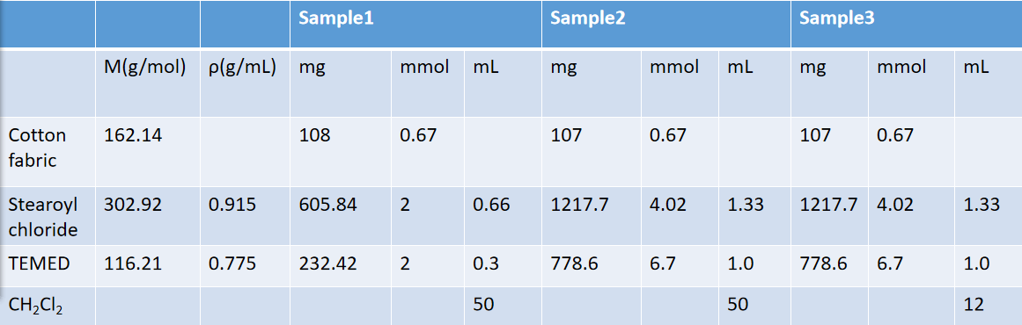

The M value of cotton fabric is calculated according to glucose monomer.

**Fig. S2** Contact angle vs. droplet holding time of the hydrophobic modified cotton filter fabrics prepared under different solvent.

**Tab. S2** Hydrophobic modification in different solvent.

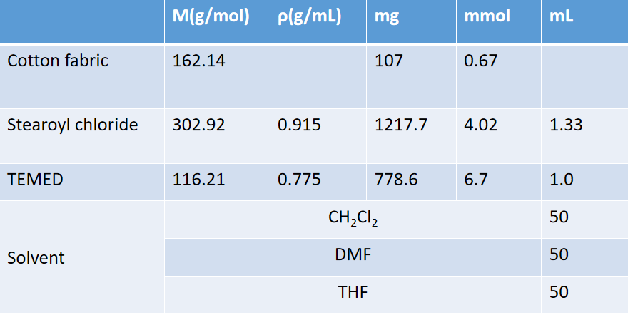

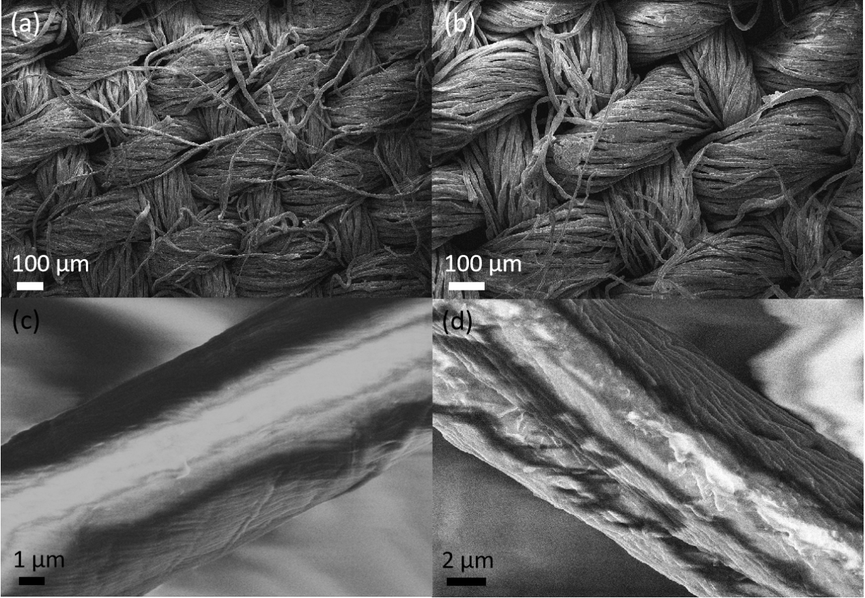

**Fig. S3** SEM images of cotton filter fabric (a,c) before and (b,d) after hydrophobic modification.

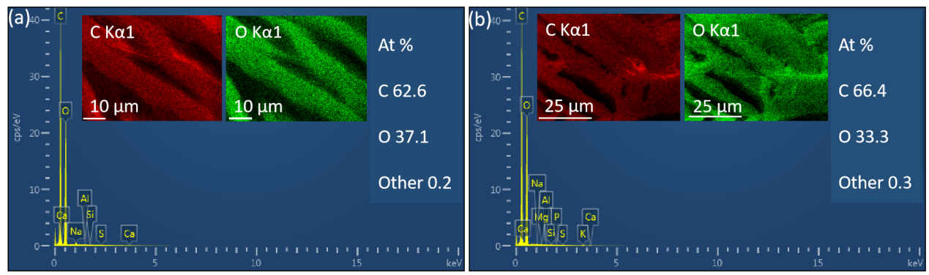

**Fig. S4** EDS spectra of cotton filter fabric (a) before and (b) after hydrophobic modification. Insets are corresponding mappings of carbon (red) and oxygen (green).