The ARRIVE Guidelines Checklist
Animal Research: Reporting In Vivo Experiments
Carol Kilkenny¹, William J Browne², Innes C Cuthill³, Michael Emerson⁴ and Douglas G Altman⁵
¹The National Centre for the Replacement, Refinement and Reduction of Animals in Research, London, UK, ²School of Veterinary Science, University of Bristol, Bristol, UK, ³School of Biological Sciences, University of Bristol, Bristol, UK, ⁴National Heart and Lung Institute, Imperial College London, UK, ⁵Centre for Statistics in Medicine, University of Oxford, Oxford, UK.

 |  | ITEM | RECOMMENDATION | Section/  Paragraph
 |  |  |  | P1/ Title
 |  |  |  | P1/ Abstract
 | INTRODUCTION
 | 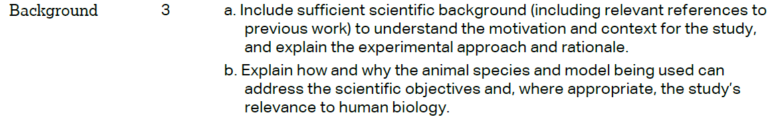 |  |  | a:  P3/Introduction/ paragraph 2 & P4/Introduction/ paragraph 1,2  b: P4/Introduction/ paragraph 2, line 103-105
 |  |  |  | P4/Introduction/ paragraph 2, line 103-105
 | METHODS
 |  |  |  | P4/ Materials and Methods/ line 112-114
 | 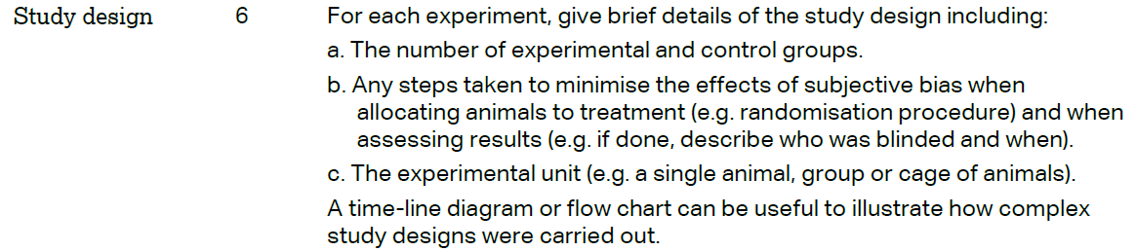 |  |  | a: P5/ Materials and Methods/ paragraph 1/ line 115-121  b: P5/ Materials and Methods/ line 118  &  P6/ Materials and Methods/ paragraph 1/ line 142-143  c: P4/ Materials and Methods/ line 110
 | 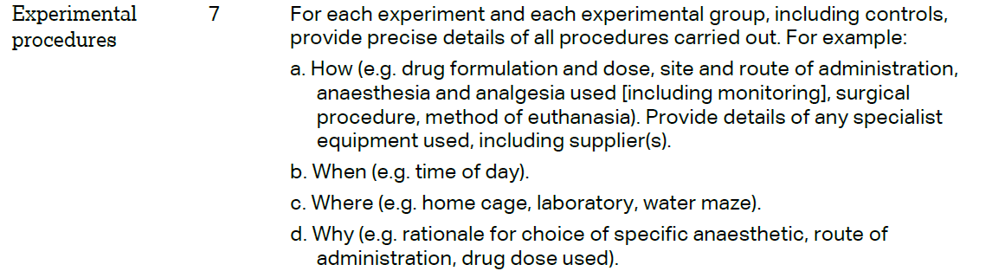 |  |  | P5/ Materials and Methods/ paragraph 1, 2,3/ line 115-133
 | 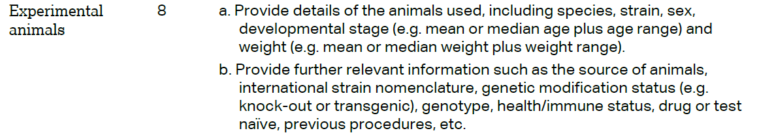 |  |  | a: P4/ Materials and Methods/ line 109-110  b: NA
e ARRIVE guidelines. Originally published in PLoS Biology, June 2010¹
 | 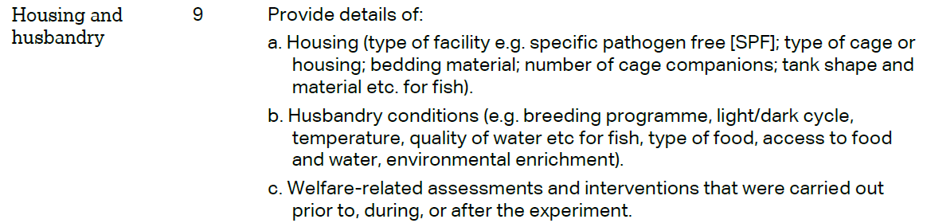 | a: P4/ Materials and Methods/ line 110  b: P4/ Materials and Methods/ line 111  & P5/ Materials and Methods/ paragraph 2/ line 123  c: P4/ Materials and Methods/ line 111-114
 | 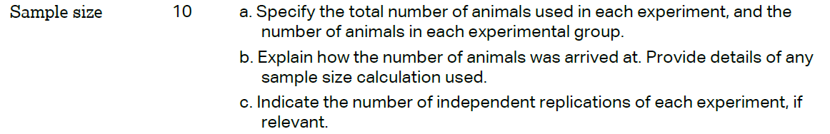 | a: P5/ Materials and Methods/ paragraph 1/ line 115,119  b: P5/ Materials and Methods/ paragraph 1/ line 121  c: NA
 | 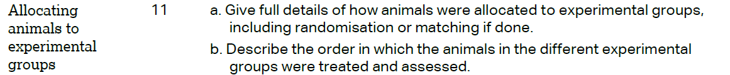 | a: P5/ Materials and Methods/ paragraph 1/ line 115-122  b: NA
P5/ Materials and Methods/ line 134 &
P6/ Materials and Methods/ line 137
 | 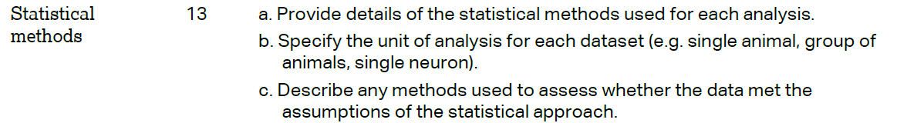 | P6/ Statistical Analysis/ paragraph 2/ line 144
 | RESULTS
 |  | NA
 |  | a: P6/ Results/ paragraph 1/ line 150
 |  | Table 1& figure 1 & Figure 2
 |  | NA
 | DISCUSSION
 | 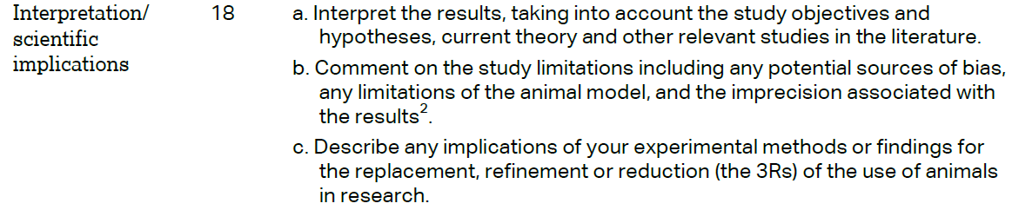 | a: P7-9/ Discussion  b: P9/ Discussion/ line 217  C:NA
P9/ Discussion/ paragraph 1 line 206-208
&
P9/ Discussion/ paragraph 3 line 212-216

 |  | P11/ Funding/ line 246
