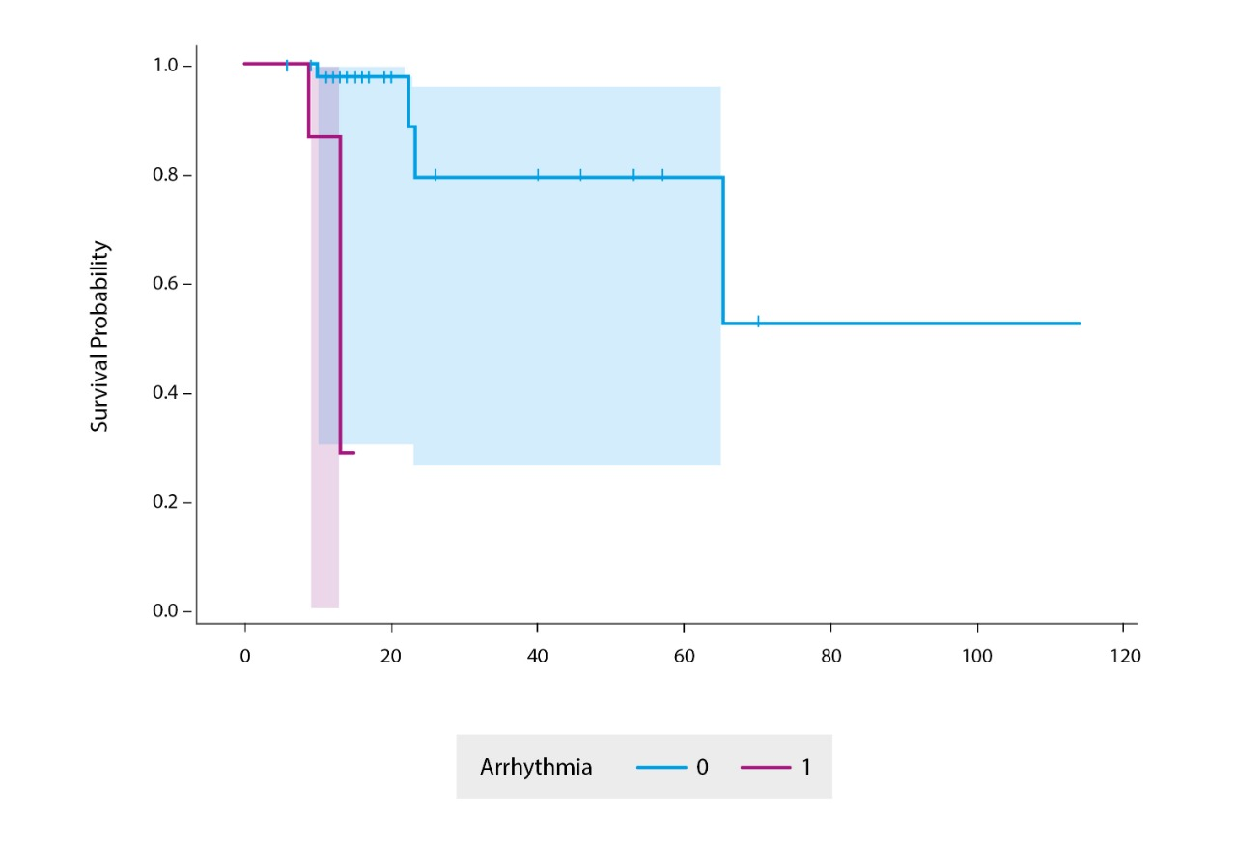

Additional file 2 . Estimated survival curve, based on a Cox model. The absence of arrhythmia has an HR=0.031, 95%CI=0.002-0.408, p=0.031; indicating that patients with arrhythmia tend to die faster than patients without it.

