*Analysis of the mean concentrations of G class antibodies against the S1 subunit of SARS-CoV-2 in the SARS-recovered and vaccinated subgroups*

|  |  |  |  |  |  |  |  |  |
| --- | --- | --- | --- | --- | --- | --- | --- | --- |
| **Descriptives** | | | | | | | | |
| IgG_concentration (BAU/ml) | | | | | | | | |
|  | N | Mean | Std. Deviation | Std. Error | 95% Confidence Interval for Mean | | Minimum | Maximum |
| Lower Bound | Upper Bound |  |  |
| **uninfected, unvaccinated** | 24 | 3,57 | 1,17 | 0,24 | 3,08 | 4,06 | 3,20 | 8,56 |
| **asymptomatic SARS-recovered, unvaccinated** | 15 | 112,59 | 90,36 | 23,33 | 62,55 | 162,63 | 3,20 | 296,40 |
| **symptomatic SARS-recovered, unvaccinated** | 82 | 236,52 | 321,93 | 35,55 | 165,78 | 307,25 | 13,63 | 1920,00 |
| **2 weeks after the first vaccine dose, uninfected** | 8 | 91,36 | 132,92 | 46,99 | -19,76 | 202,49 | 3,55 | 404,45 |
| **3 weeks after the first vaccine dose, uninfected** | 11 | 1209,40 | 2274,54 | 685,80 | -318,66 | 2737,46 | 67,62 | 7680,00 |
| ***3 weeks after the first vaccine dose, SARS-recovered*** | *9* | *4397,00* | *2484,64* | *828,21* | *2487,14* | *6306,86* | *1666,00* | *10068,00* |
| **1 week after the second vaccine dose, uninfected** | 17 | 2228,53 | 1898,88 | 460,55 | 1252,21 | 3204,85 | 106,02 | 7045,00 |
| ***1 week after the second vaccine dose, SARS-recovered*** | *10* | *11940,33* | *6097,60* | *1928,23* | *7578,37* | *16302,29* | *2280,30* | *19200,00* |
| **2 weeks after the second vaccine dose, uninfected** | 39 | 4261,08 | 3919,54 | 627,63 | 2990,51 | 5531,64 | 78,00 | 12650,50 |
| ***2 weeks after the second vaccine dose, SARS-recovered*** | *22* | *10241,42* | *5918,31* | *1261,79* | *7617,39* | *12865,45* | *198,70* | *19638,00* |
| **3 weeks after the second vaccine dose, uninfected** | 24 | 3327,63 | 1950,69 | 398,18 | 2503,93 | 4151,34 | 880,00 | 8677,00 |
| ***3 weeks after the second vaccine dose, SARS-recovered*** | *36* | *7442,47* | *4831,99* | *805,33* | *5807,56* | *9077,38* | *168,50* | *19865,00* |
| **4 weeks after the second vaccine dose, uninfected** | 55 | 2658,50 | 1709,19 | 230,47 | 2196,44 | 3120,56 | 235,50 | 7805,00 |
| ***4 weeks after the second vaccine dose, SARS-recovered*** | *31* | *4490,81* | *2840,27* | *510,13* | *3448,99* | *5532,63* | *210,50* | *10391,50* |
| **5 weeks after the second vaccine dose, uninfected** | 68 | 2474,46 | 1571,94 | 190,63 | 2093,97 | 2854,95 | 166,00 | 9836,50 |
| ***5 weeks after the second vaccine dose, SARS-recovered*** | *26* | *3190,51* | *2103,04* | *412,44* | *2341,07* | *4039,95* | *160,00* | *10135,50* |
| **Total** | **477** | **3161,42** | **3918,83** | **179,43** | **2808,85** | **3514,00** | **3,20** | **19865,00** |

|  |  |  |  |  |  |
| --- | --- | --- | --- | --- | --- |
| **Tests of Homogeneity of Variances** | | | | | |
|  | | Levene Statistic | df1 | df2 | Sig. |
| IgG_concentration (BAU/ml) | Based on Mean | 22,709 | 15 | 461 | ,000 |
| Based on Median | 15,241 | 15 | 461 | ,000 |
| Based on Median and with adjusted df | 15,241 | 15 | 164,019 | ,000 |
| Based on trimmed mean | 21,057 | 15 | 461 | ,000 |

|  |  |  |  |  |  |
| --- | --- | --- | --- | --- | --- |
| **ANOVA** | | | | | |
| IgG_concentration (BAU/ml) | | | | | |
|  | Sum of Squares | df | Mean Square | F | Sig. |
| Between Groups | 3908014005,181 | 15 | 260534267,012 | 35,305 | ,000 |
| Within Groups | 3402009785,832 | 461 | 7379630,772 |  |  |
| Total | 7310023791,012 | 476 |  |  |  |

**Means Plots**

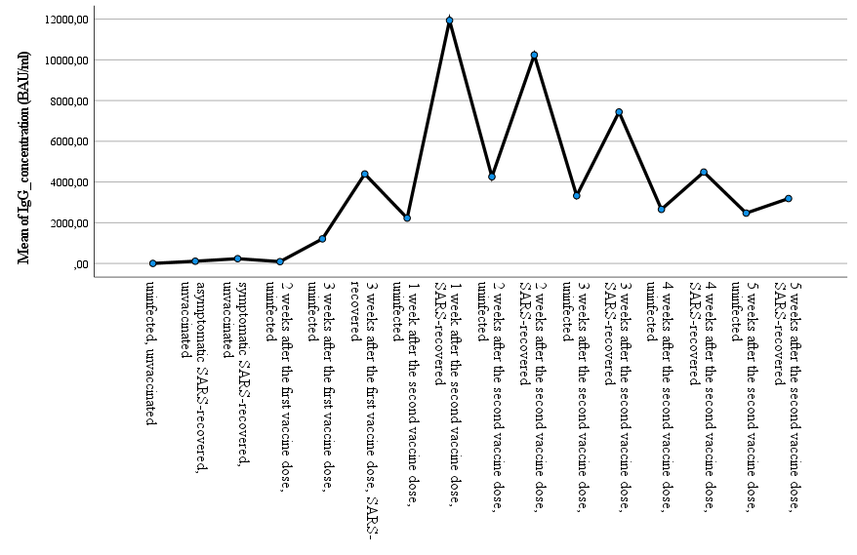

Mean anti-SARS-CoV-2 IgG concentrations by gender and age of the study participants.

|  |  |  |  |  |  |  |  |  |  |  |
| --- | --- | --- | --- | --- | --- | --- | --- | --- | --- | --- |
|  | **Female** | | | | | **male** | | | | |
|  | **<= 35** | **36 – 45** | **46 - 55** | **56 – 64** | **65+** | **<= 35** | **36 - 45** | **46 - 55** | **56 - 64** | **65+** |
| **uninfected, unvaccinated** | 3.20 | 3.20 | 5.32 | 3.27 | . | 4.29 | 3.20 | 3.20 | 3.20 | 3.20 |
| **asymptomatic SARS-recovered, unvaccinated** | 57.43 | . | 59.53 | 94.95 | 104.32 | 45.41 | 115.10 | 233.41 | 58.09 | . |
| **symptomatic SARS-recovered, unvaccinated** | 113.49 | 121.95 | 287.37 | 437.77 | 200.30 | 101.42 | 136.60 | 88.26 | 155.35 | 438.51 |
| **2 weeks after the first vaccine dose, uninfected** | 58.83 | 131.04 | 43.79 | . | 3.55 | . | 4.32 | . | 26.08 | 404.45 |
| **3 weeks after the first vaccine dose,uninfected** | 375.49 | 945.10 | . | 5192.90 | 83.82 | . | 67.62 | . | 148.40 | 170.72 |
| **3 weeks after the first vaccine dose, SARS-recovered** | 5685.00 | 1666.00 | 3335.67 | 6125.00 | . | . | . | . | . | 3840.00 |
| **1 week after the second vaccine dose, uninfected** | 2117.15 | 1747.20 | 1251.96 | 3652.10 | 2316.65 | 4449.00 | 2112.00 | . | 2050.90 | . |
| **1 week after the second vaccine dose, SARS-recovered** | 9164.00 | 14182.00 | 10740.15 | 14382.17 | . | . | . | . | . | 8624.25 |
| **2 weeks after the second vaccine dose, uninfected** | 7460.89 | 8190.83 | 6441.80 | 2970.64 | 2285.33 | 2010.00 | 248.00 | 2354.00 | 1528.90 | 1580.67 |
| **2 weeks after the second vaccine dose, SARS-recovered** | 8126.67 | 9335.13 | 12698.25 | 10439.00 | 10290.17 | 3840.00 | . | . | . | 12160.00 |
| **3 weeks after the second vaccine dose, uninfected** | 4799.08 | 4772.90 | 2818.60 | 2929.80 | 1367.50 | 2015.50 | 3836.80 | 2521.35 | 1368.10 | 2369.00 |
| **3 weeks after the second vaccine dose, SARS-recovered** | 4203.33 | 10009.61 | 5087.21 | 7463.86 | 5376.00 | 4022.90 | 8649.50 | 5255.50 | . | . |
| **4 weeks after the second vaccine dose, uninfected** | 3223.93 | 3209.92 | 2484.94 | 1779.22 | 2260.75 | 2506.00 | 4119.67 | 1056.50 | 3264.50 | 1193.50 |
| **4 weeks after the second vaccine dose, SARS-recovered** | 5575.08 | 5218.65 | 3249.83 | 2165.00 | 7926.50 | 5406.25 | 3062.67 | 5076.50 | . | . |
| **5 weeks after the second vaccine dose, uninfected** | 2549.78 | 2515.36 | 2332.80 | 2448.29 | . | 1094.50 | 2451.63 | 3254.10 | 2275.00 | 1093.50 |
| **5 weeks after the second vaccine dose, SARS-recovered** | 3333.50 | 2255.25 | 2968.57 | 3915.75 | 2338.25 | 4809.50 | . | 3301.50 | 3760.50 | . |

One-way ANOVA for comparisons between subgroups













