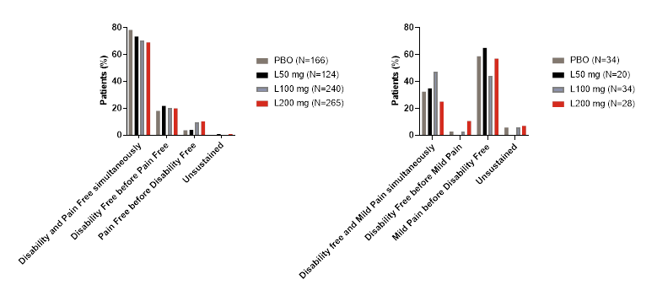

Supplemental Figure 1. Relative timing of freedom from functional disability and pain status by dose.
Sequence of outcomes in patients that experienced functional disability freedom and either pain freedom (left panel) or mild pain (right panel) at 2 hours.
Notes: “Unsustained” category represented patients who experienced freedom from MBS or functional disability freedom and either freedom from pain or improvement to mild and then moved out of that group prior to 2 hours post-dose. The denominator was the total population that achieved the MBS freedom or disability freedom at 2 hours post-dose in either the pain free or mild pain groups.

