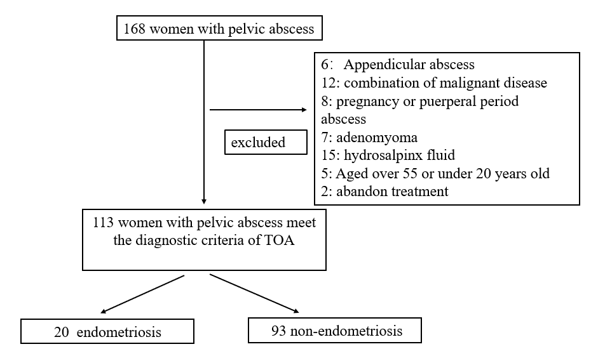
Supplement Figure1. Characteristics of 168 patients hospitalised pelvic abscess between January 2008 and December 2018 at Peking University people’ s Hospital. TOA tube ovarian abscess.

