Supplementary Materials for
Ultra-robust stretchable electrode for e-skin: in situ assembly using a nanofiber scaffold and liquid metal to mimic water-to-net interaction
Jinwei Cao, Fei Liang, Huayang Li, Xin Li, Youjun Fan, Yiming Yin, Fali Li, Jin Xu, Hanfang Feng, Dan Xu, Huali Yang, Yiwei Liu, Run-Wei Li* & Guang Zhu*
*email: runweili@nimte.ac.cn (R.L.); Guang.Zhu@nottingham.edu.cn (G.Z.)
Supplementary Figures
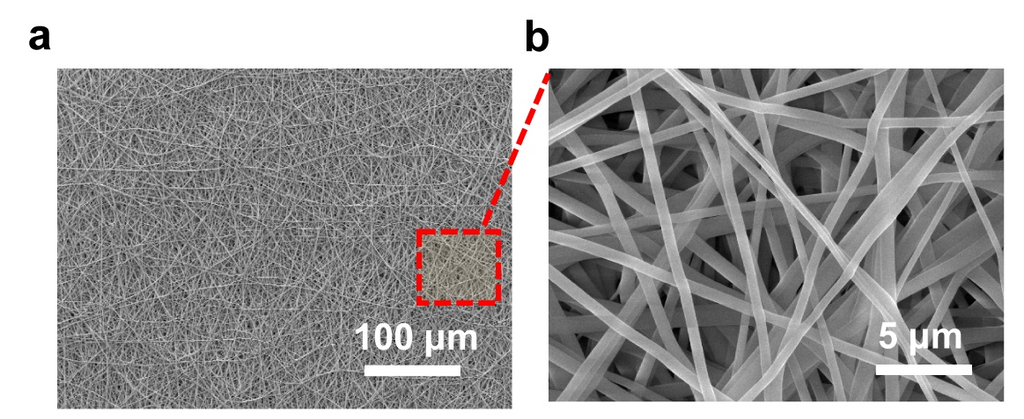
Supplementary Figure 1. Characterization of TPU nanofiber scaffold. a SEM images of TPU scaffold fabricated by electrospinning, and (b) the magnified morphology of TPU nanofiber with an average diameter of ~600 nm.

Supplementary Figure 2. Fabrication process of liquid metal nanoparticles in isopropanol solution for electrospraying.

Supplementary Figure 3. Mechanism of the dynamic balance of LM film on TPU nanofiber scaffold: there are two forces working on the LM: Laplace pressure difference F_{l} and gravitational force F_{g.}

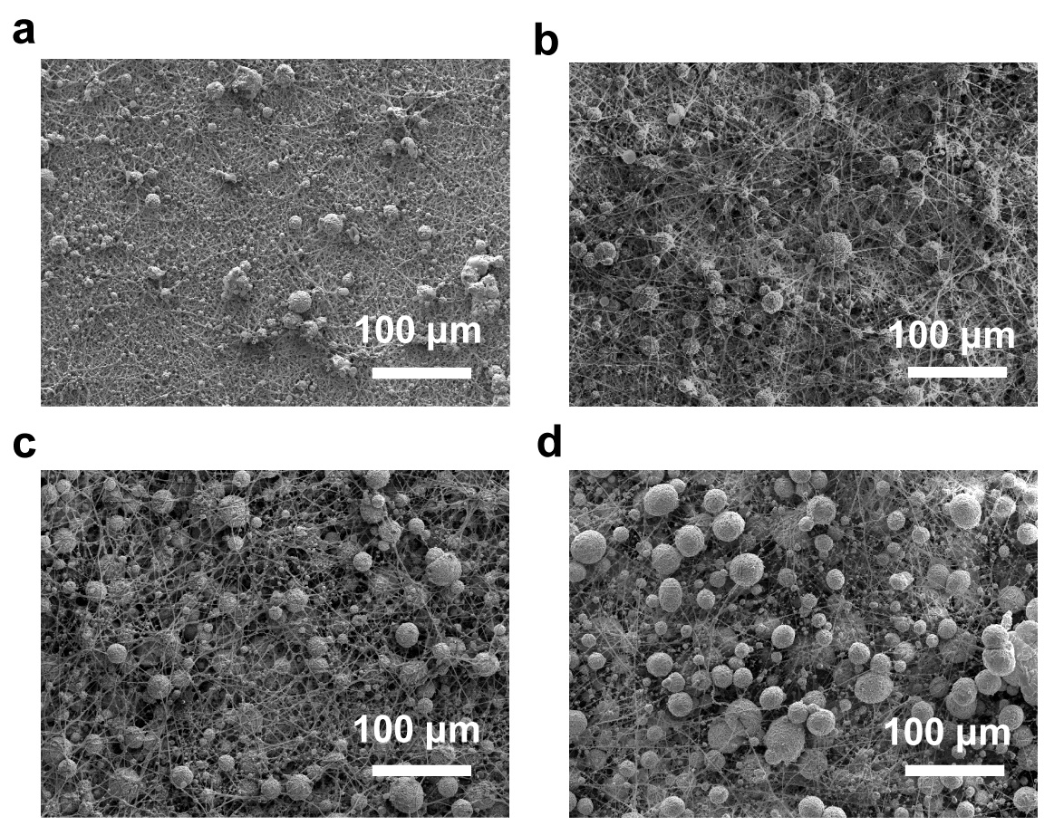
Supplementary Figure 4. Characterization of LM nanoparticles @ TPU scaffold composite (LNSC). a‒d Top-view SEM images of LNSC with different electropraying speed of LM solution, i.e., 0.02 mm/min, 0.04 mm/min, 0.06 mm/min, 0.08 mm/min, respectively.

Supplementary Figure 5. a Schematic illustration of NHSE in unstrained, stretched, and relaxed after 100, 000 stretch cycles. b Top-view SEM images of NHSE after 100, 000 stretching cycles at 100% strain and (c) the enlarged wrinkle structure of NHSE.

Supplementary Figure 6. The electrical resistance of the stretched NHSE at 100% , 200% and 300% strain under 1, 000 water washing cycles (initial sample size: 1 cm × 1 cm).

Supplementary Figure 7. Electrical resistance variation of NHSE under external stimuli. The resistance of the NHSE as a function of time under unstrained (0%), 100% strained, and 200% strained dipped in synthetic perspiration of (a) pH 4.7 and (b) pH 8.8, respectively.

Supplementary Figure 8. Schematic diagram of water membrane on fish net. a‒c The schematic diagram of water membrane on fish-net under 0% strain, small strain and large strain, respectively.

Supplementary Figure 9. Micromorphology changes of LM nanoparticles @ TPU scaffold composite (LNSC) under different strain. a‒c Top-View SEM of elongated LNSC under uniaxial deformation. d‒f Corresponding EDS mapping of Ga elements under strain of 100%, 300% and 500%, respectively.

Supplementary Figure 10. Two-dimensional FFT alignment of the NHSE under uniaxial strain of 0%, 100%, 300%, 500%, respectively.
Supplementary Figure 11. Morphology of liquid metal (LM) on pure TPU film under uniaxial elongation. a, b The top-down view image of LM film on pure TPU film. c‒f Morphology of LM and TPU under strain of 100% and 300%, and the corresponding EDS mapping of Ga element.

