Supplemental informations
Supplemental table 1. The expression of selected circRNA (RPM) in three groups
and independent sample t-test between ACLF and HC
CircRNA | HC (n=3) | CHB (n=3) | ACLF (n=3) | ACLFvsHC
 | mean±SD | mean±SD | mean±SD | P-value
circRNA_00389 | 0.2392±0.1132 | 0.0815±0.0156 | 0.0322±0.0188 | 0.035
circRNA_02808 | 0.0962±0.0453 | 0.0634±0.0613 | 0.0201±0.0142 | 0.053
circRNA_03646 | 0.1444±0.0115 | 0.1170±0.0564 | 0.0219±0.0158 | 0.001
circRNA_04205 | 0.1088±0.0308 | 0.0691±0.0046 | 0.0264±0.0127 | 0.014
circRNA_06400 | 0.6958±0.2890 | 0.4577±0.2799 | 0.1713±0.0272 | 0.035
circRNA_09331 | 0.1297±0.0703 | 0.0830±0.0271 | 0.0146±0.0119 | 0.050
circRNA_17523 | 0.1603±0.0940 | 0.0933±0.0321 | 0.0356±0.0153 | 0.087
circRNA_19214 | 0.1930±0.1023 | 0.1093±0.0632 | 0.0224±0.0160 | 0.047
circRNA_05781 | 0.1519±0.0839 | 0.0924±0.0419 | 0.0409±0.0186 | 0.091
circRNA_07485 | 0.1124±0.0333 | 0.0659±0.0440 | 0.0318±0.0152 | 0.021
circRNA_07734 | 0.1823±0.0611 | 0.1156±0.0991 | 0.0565±0.0275 | 0.035
circRNA_08533 | 0.3798±0.2071 | 0.1382±0.1155 | 0.0243±0.0209 | 0.042
circRNA_16562 | 0.2216±0.11947 | 0.0569±0.04378 | 0.0651±0.08233 | 0.135
circRNA_17526 | 0.2214±0.1506 | 0.0888±0.0191 | 0.0321±0.0268 | 0.100
circRNA_04487 | 0.0345±0.0098 | 0.0635±0.0281 | 0.1354±0.0342 | 0.015
circRNA_15699 | 0.0426±0.0093 | 0.0702±0.0211 | 0.1370±0.0607 | 0.095
circRNA_16083 | 0.2046±0.0971 | 0.2923±0.1392 | 1.0133±0.2018 | 0.006
circRNA_16987 | 0.0495±0.0243 | 0.0567±0.0244 | 0.3220±0.0788 | 0.009

Supplemental table 2. The expression of selected mRNA (fpkm) in three groups and ANOVA test
mRNA-id | HC (n=3) | CHB (n=3) | ACLF (n=3) | P-value
 | mean±SD | mean±SD | mean±SD
NM_000361.2 | 1.526±0.576 | 3.254±1.201 | 13.978±4.360 | 0.002
NM_001005862.2 | 1.609±0.639 | 0.668± 0.183 | 0.041±0.039 | 0.007
NM_001199139.1 | 0.047±0.043 | 0.510±0.422 | 4.591±0.785 | <0.001
NM_004633.3 | 0.216±0.225 | 1.479±0.931 | 159.220±98.032 | 0.021
NM_005204.3 | 0.834±0.178 | 2.902±0.716 | 7.480±3.148 | 0.012
NM_006720.3 | 3.090±0.990 | 1.228±0.739 | 0.342±0.278 | 0.010
NM_014790.4 | 1.688±0.255 | 0.724±0.133 | 0.178±0.111 | <0.001
NM_080913.3 | 1.649±1.325 | 6.342±3.601 | 17.297±4.355 | 0.003
XM_005257807.2 | 1.942±0.722 | 0.764±0.212 | 0.164±0.223 | 0.008
XM_011511061.1 | 0.143±0.032 | 0.574±0.251 | 1.531±0.537 | 0.007
XM_011520156.1 | 2.850±1.863 | 0.730±0.262 | 6.377±1.656 | 0.009
XM_011520271.1 | 3.739±1.129 | 1.711±0.603 | 0.580±0.503 | 0.008
XM_011524254.1 | 4.112±1.333 | 1.550±1.396 | 0.138±0.225 | 0.013
XM_011524699.1 | 9.874±3.598 | 2.428±2.342 | 0.085±0.080 | 0.007
XM_011531698.1 | 2.835±0.633 | 5.713±2.783 | 11.122±1.922 | 0.006
XM_011537524.1 | 3.118±1.143 | 1.148±0.745 | 0.263±0.450 | 0.014
NM_080913.3 | 1.649±1.325 | 6.342±3.601 | 17.297±4.355 | 0.003
XM_005257807.2 | 1.942±0.722 | 0.764±0.212 | 0.164±0.223 | 0.008
XM_011511061.1 | 0.143±0.032 | 0.574±0.251 | 1.531±0.537 | 0.007

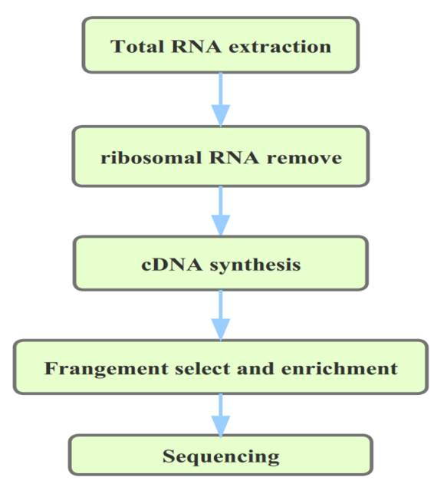
Supplemental Figure 1. rRNA-depleted RNA-Seq experimental process.
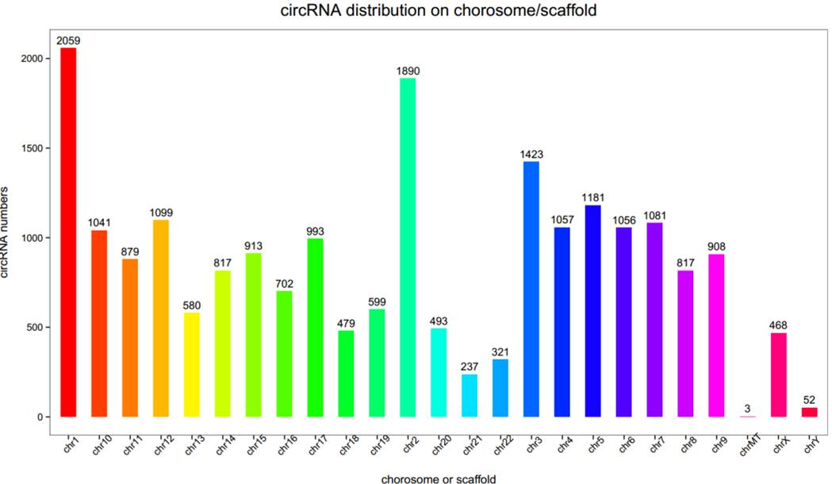
Supplemental Figure 2. Distribution of circRNAs on each chromosome.

Supplemental Figure 3. Gene Oncology (GO) analysis of ACLF risk status according to the down (A) and up (B)-regulated circRNAs.

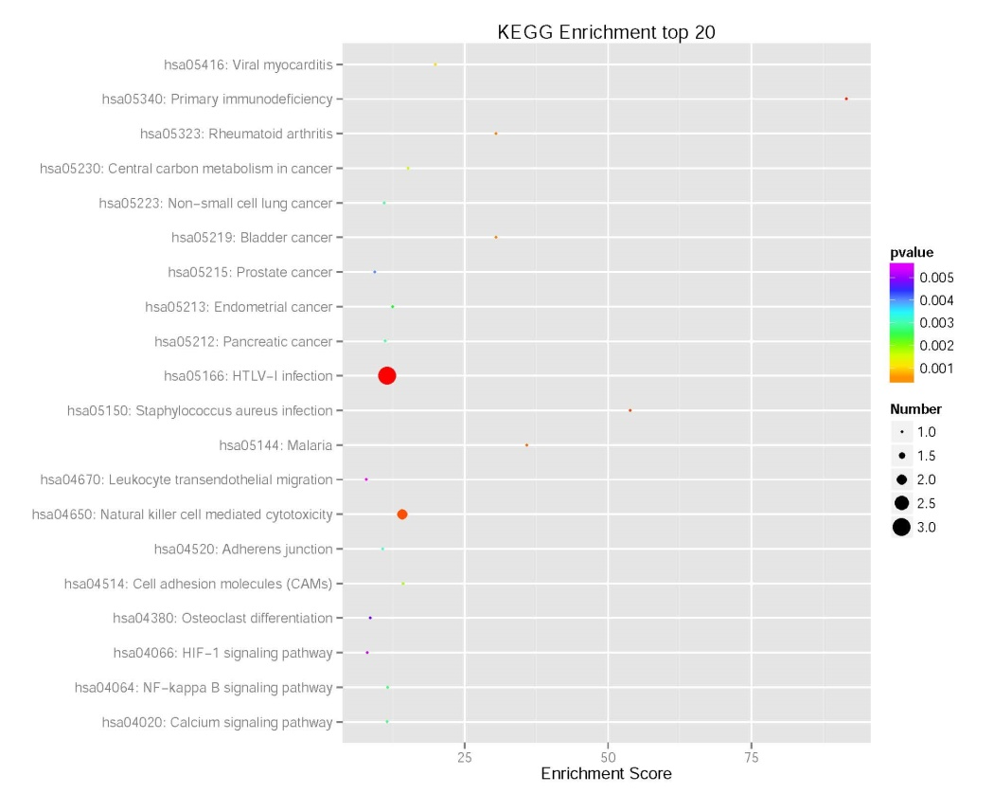
A
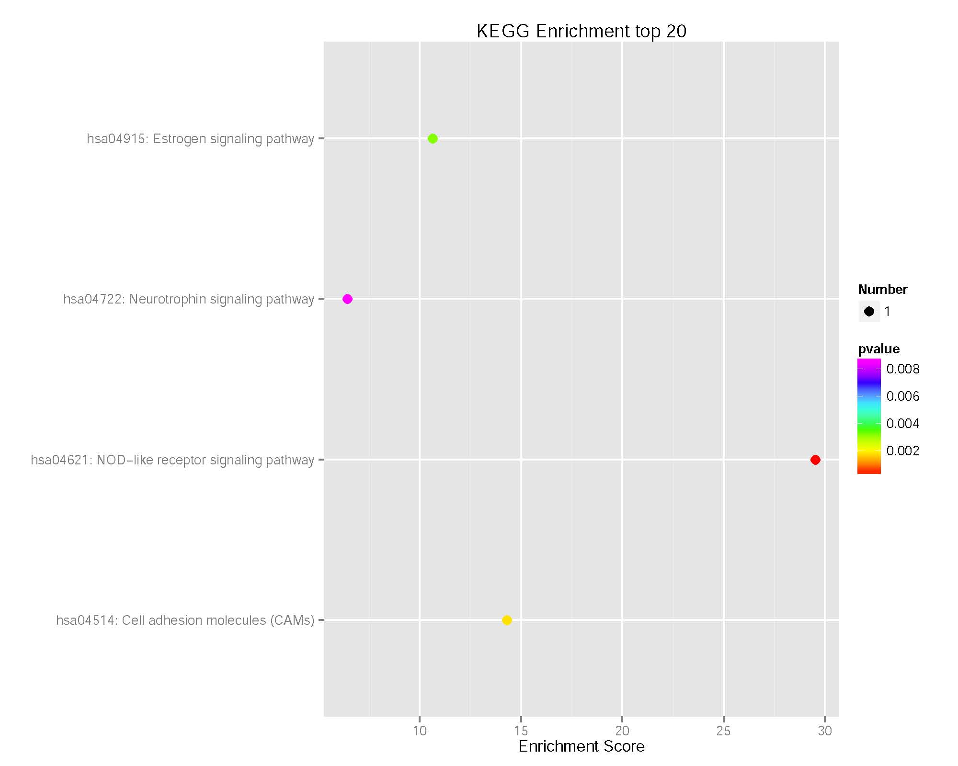
B
Supplemental Figure 4. KEGG enrichment analysis, A Down-regulated circRNAs, B Up-regulated circRNAs

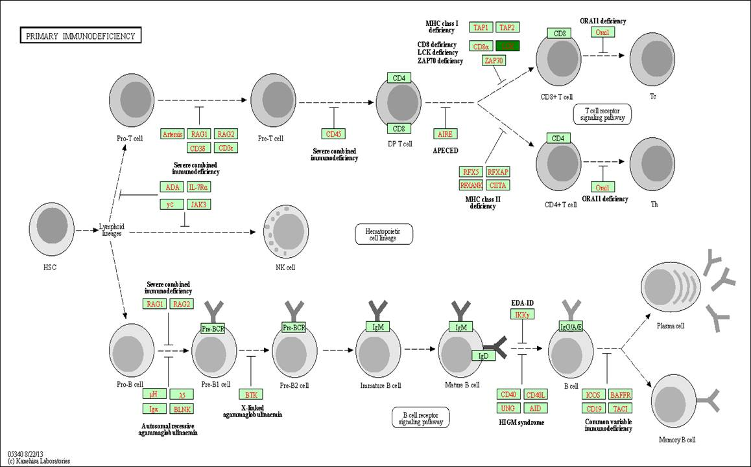
Supplemental Figure 5. The hsa05340 map according to KEGG enrichment; red indicates up-regulated circRNAs, green indicates down-regulated circRNAs.
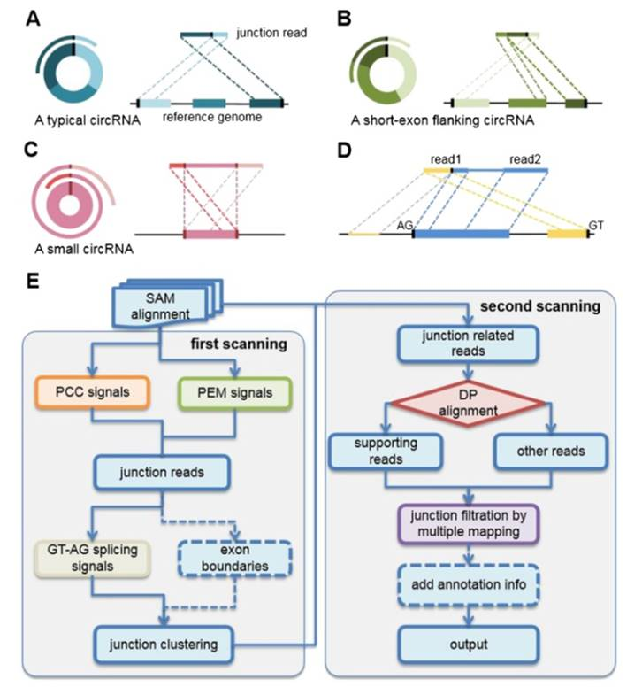
Supplemental Figure 6. Predictive flow diagram generated by CIRI software.

