Supplementary Figures
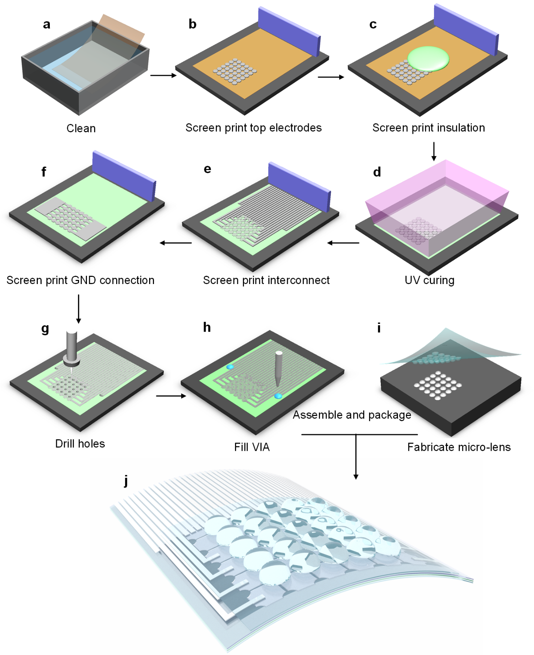
Supplementary Fig. 1. Fabrication of the flexible blood stethoscope. a, Clean PVDF film. b, Screenprint top electrode layer on PVDF film. c, Screenprint the insulation layer on PVDF film. d, UV cure the insulation layer. e, Screenprint interconnection layer on the insulation layer of PVDF film. f, Evaporate the bottom ground (GND) electrode layer on the backside of PVDF film. g, Drill pinholes with an electronic cutter. h, Fill the via hole with conductive silver epoxy. i, Fabricate micro-lens with mould. j, The micro-lens array is mounted on top of the as-fabricated PVDF acoustic sensor array secured by applying PDMS precursor on the edge of the micro-lens array to achieve the blood stethoscope.

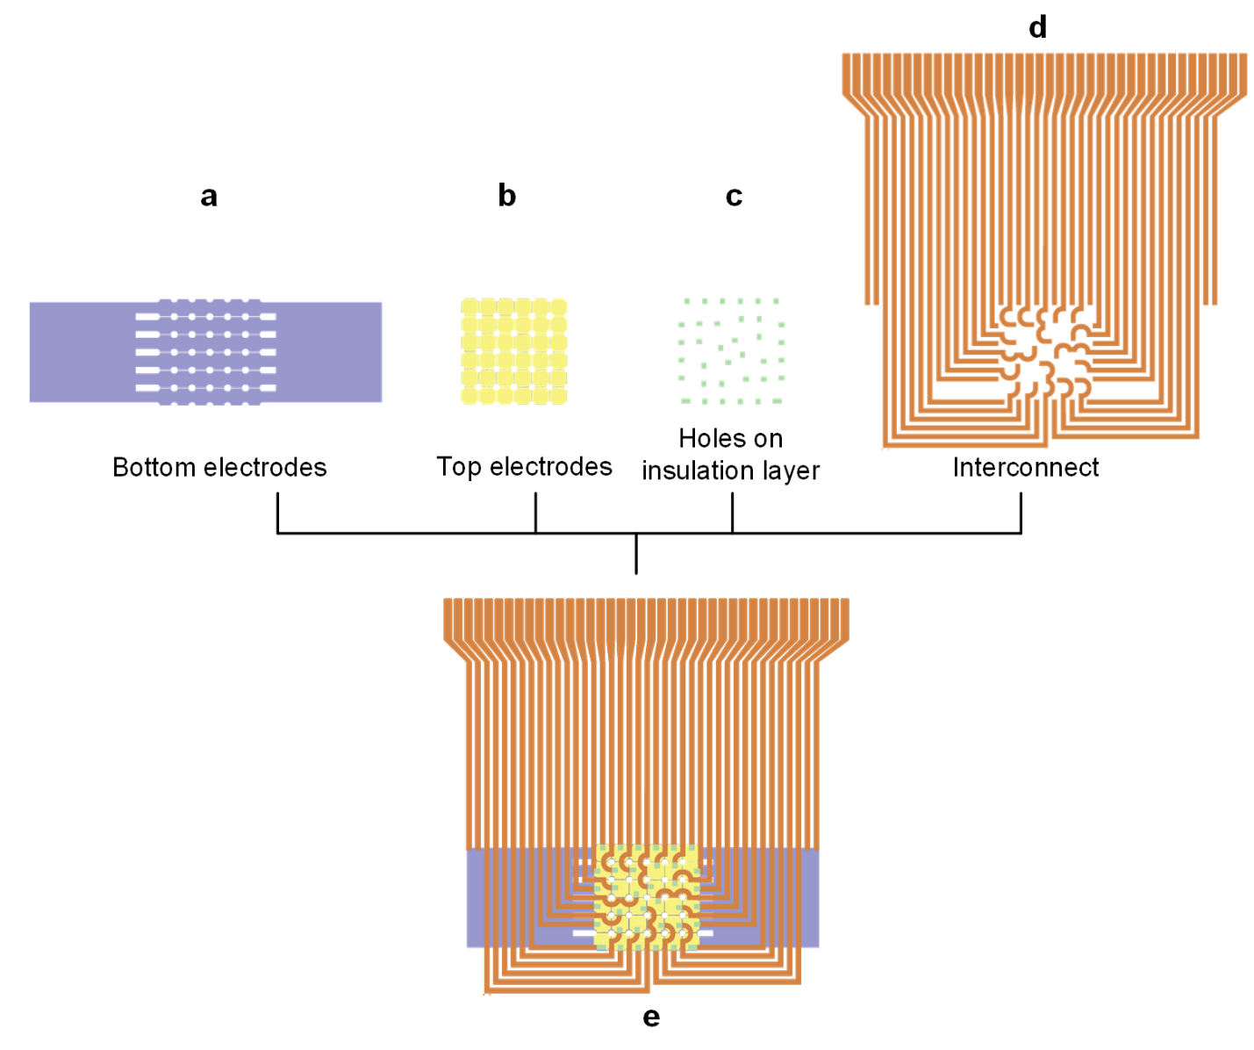
Supplementary Fig. 2. Electrodes design. a, Bottom ground electrodes. b, Top electrodes. c, Insulation holes. d, Interconnection layer. e, The integrated multilayer electrodes.

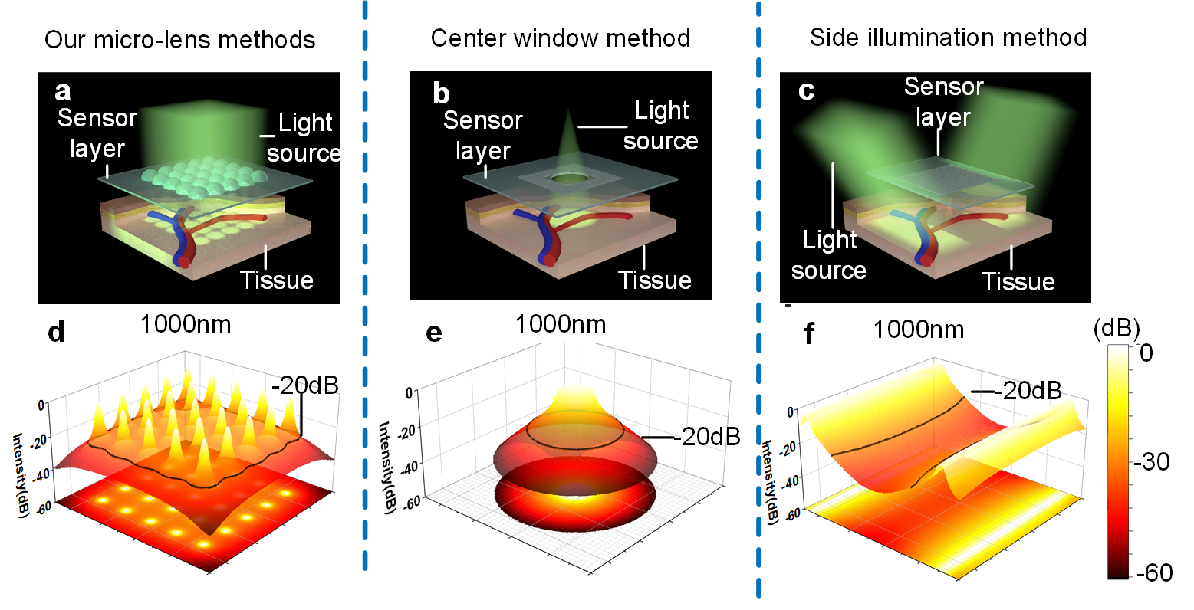
Supplementary Fig. 3. Monte Carlo simulation of our micro-lens method with other methods for Optical illumination at wavelength 1000 nm. a-c, Schematic diagram of different optical element methods. Our micro-lens array method (a) is compared with other classical methods including the center window method (b) and the side illumination method (c). d-e, The 1000 nm light fluence distributions after penetrating 1 mm tissue (The light transmission media is assumed to be dermis tissue with optical scattering and absorption coefficients of 97 cm⁻¹ and 0.24 cm⁻¹, at 1000 nm wavelength, respectively). Our micro-lens array method (d) shows a larger effective illumination area (determined by -20 dB illumination intensity) than the center window method (e) and the side illumination method (f).
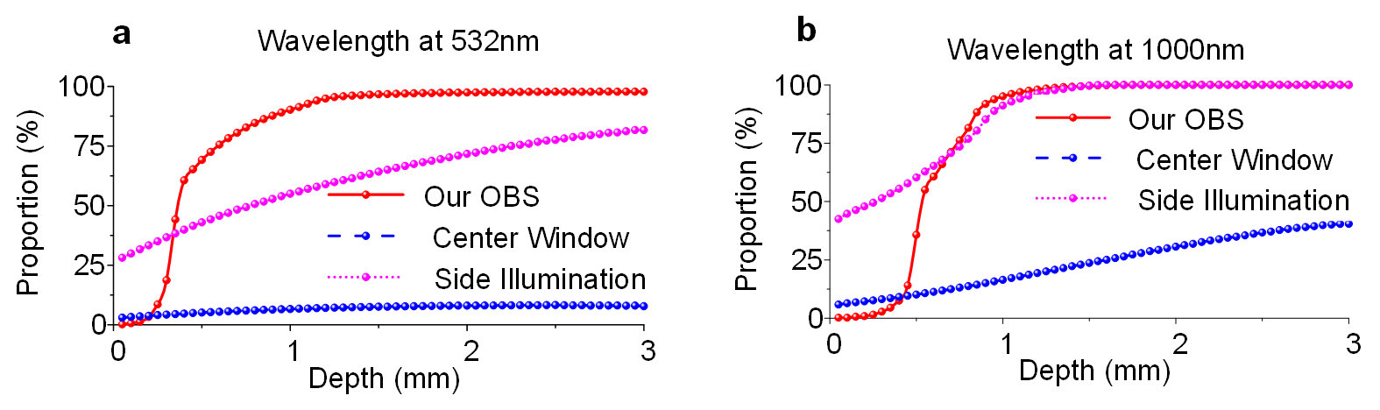
Supplementary Fig. 4. The proportion of effective illumination area at different tissue depths with wavelengths, 532 nm (a) and 1000 nm (b).

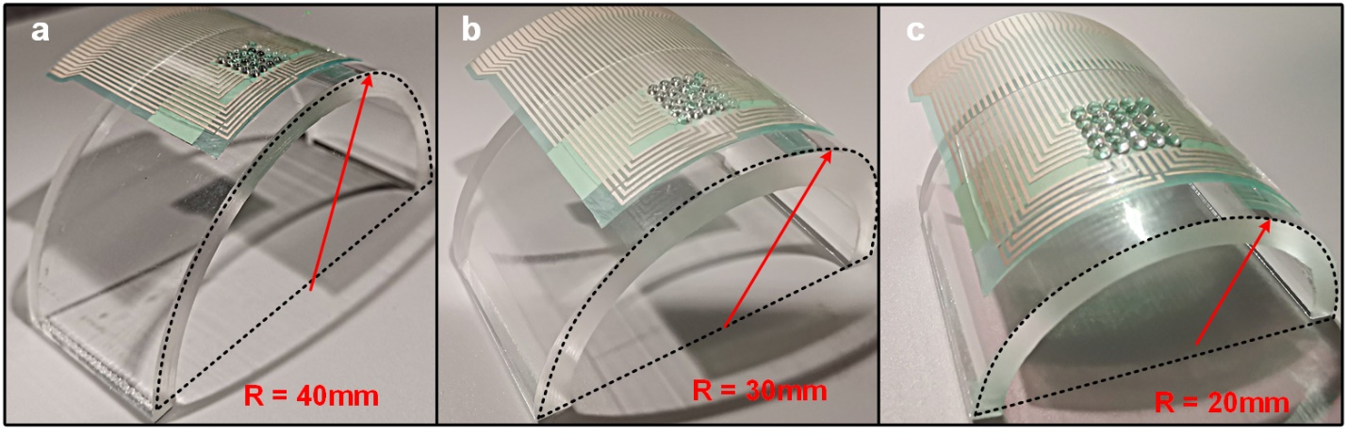
Supplementary Fig. 5. Photographs of our OBS Bending tests. a, Attaching onto a curvy surface with a radius of curvature R = 40 mm. b, Attaching onto a curvy surface with radius of curvature R = 30 mm. c, Attaching onto a curvy surface with a radius of curvature R = 20 mm.

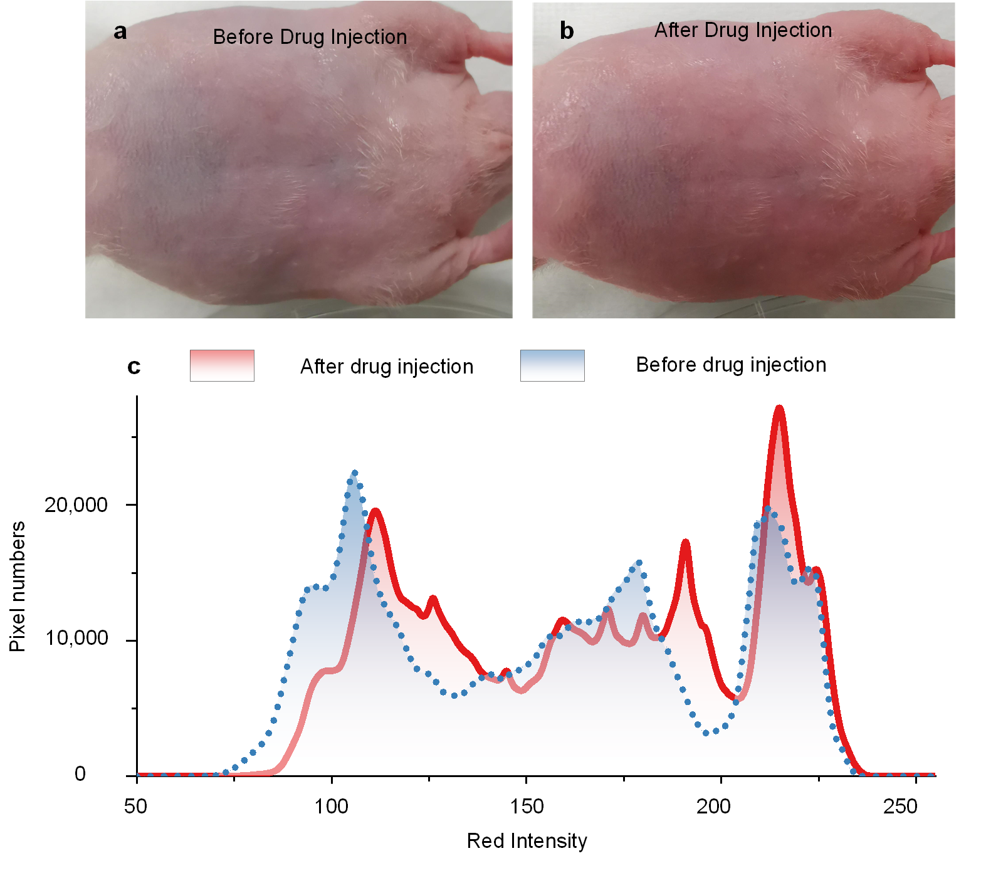
Supplementary Fig. 6. The diffusion of Rhodamine B from blood to tissue. a-b, Photographs of mice before drug injection (a) and after drug injection (b). c, The histogram of red color intensity in (a) and (b). After drug injection, the mean red color intensity increases from 143 to 156.
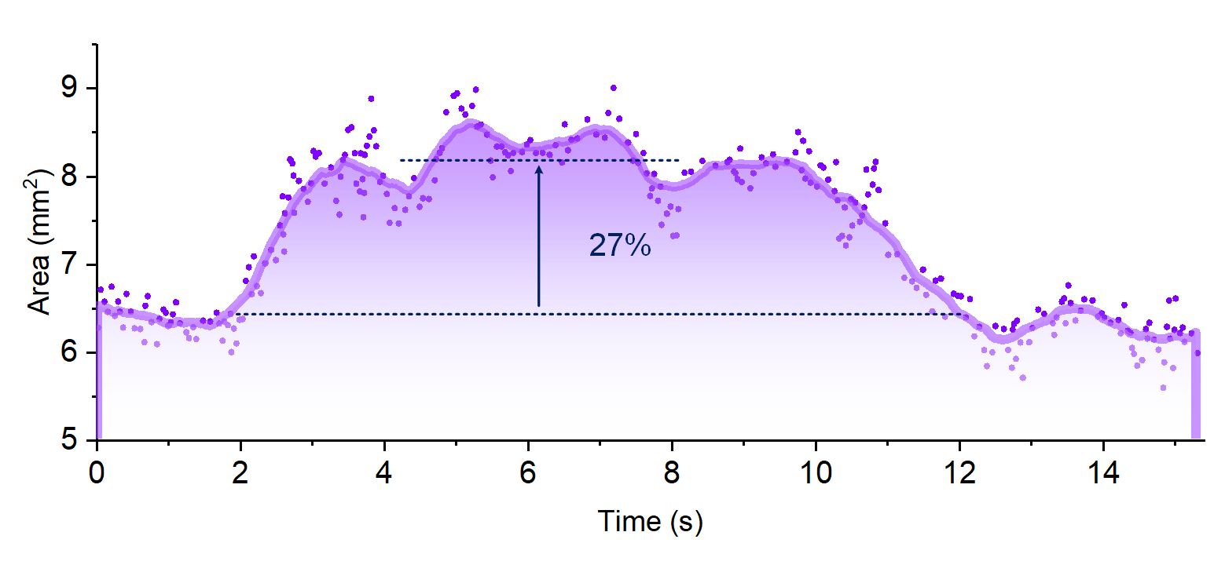
Supplementary Fig. 7. The cross-section area of the dorsal hand vein. The area increased by 27% under vascular occlusions.

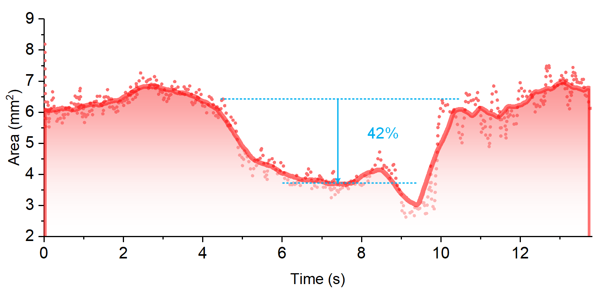
Supplementary Fig. 8. The cross-section area of the radial artery. The area decreased by 42% under vascular occlusions.

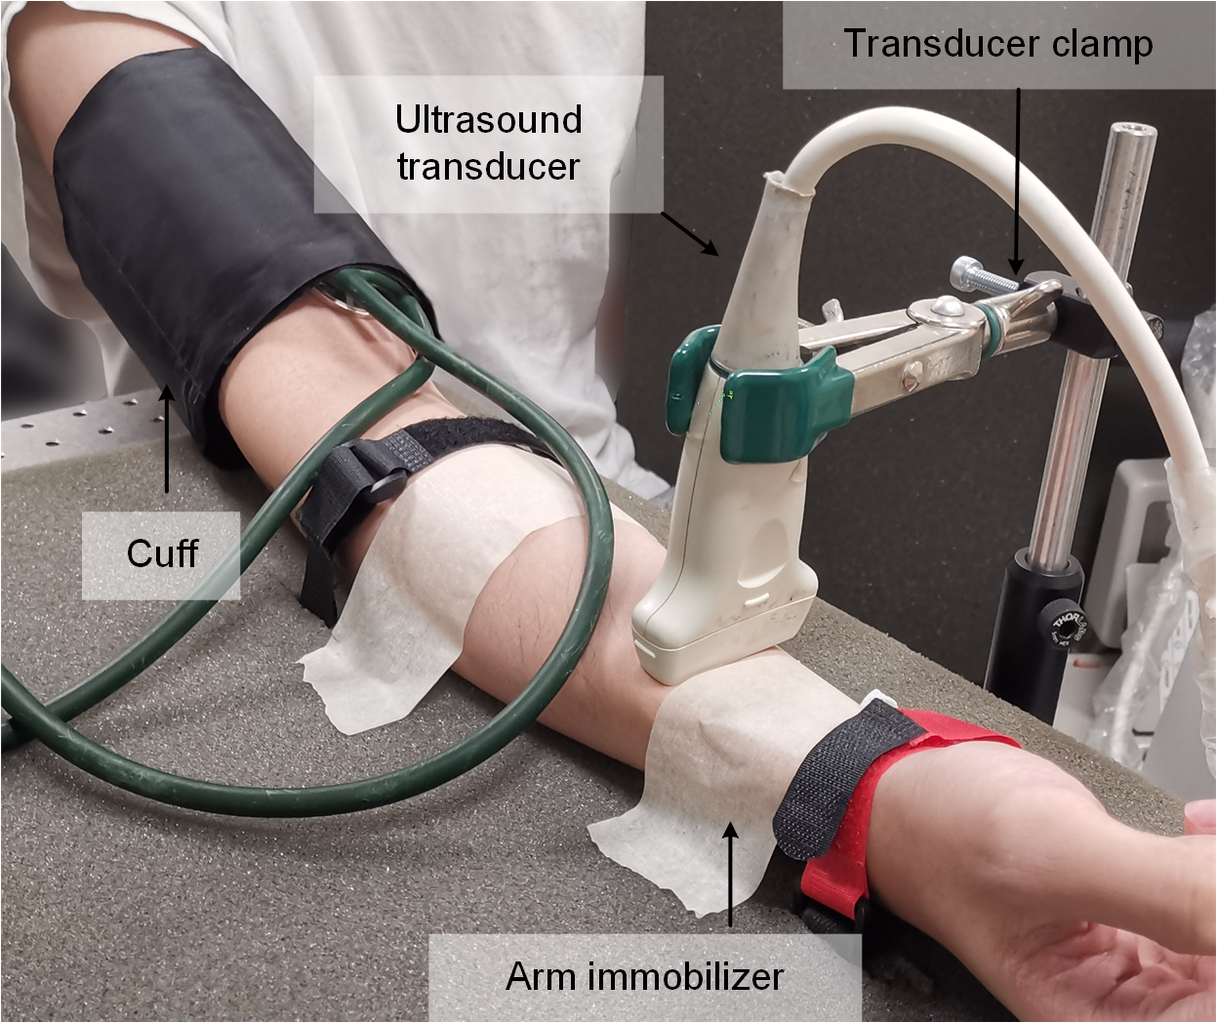
Supplementary Fig. 9. The complicated fixture and process for the FMD tests using traditional ultrasound system.

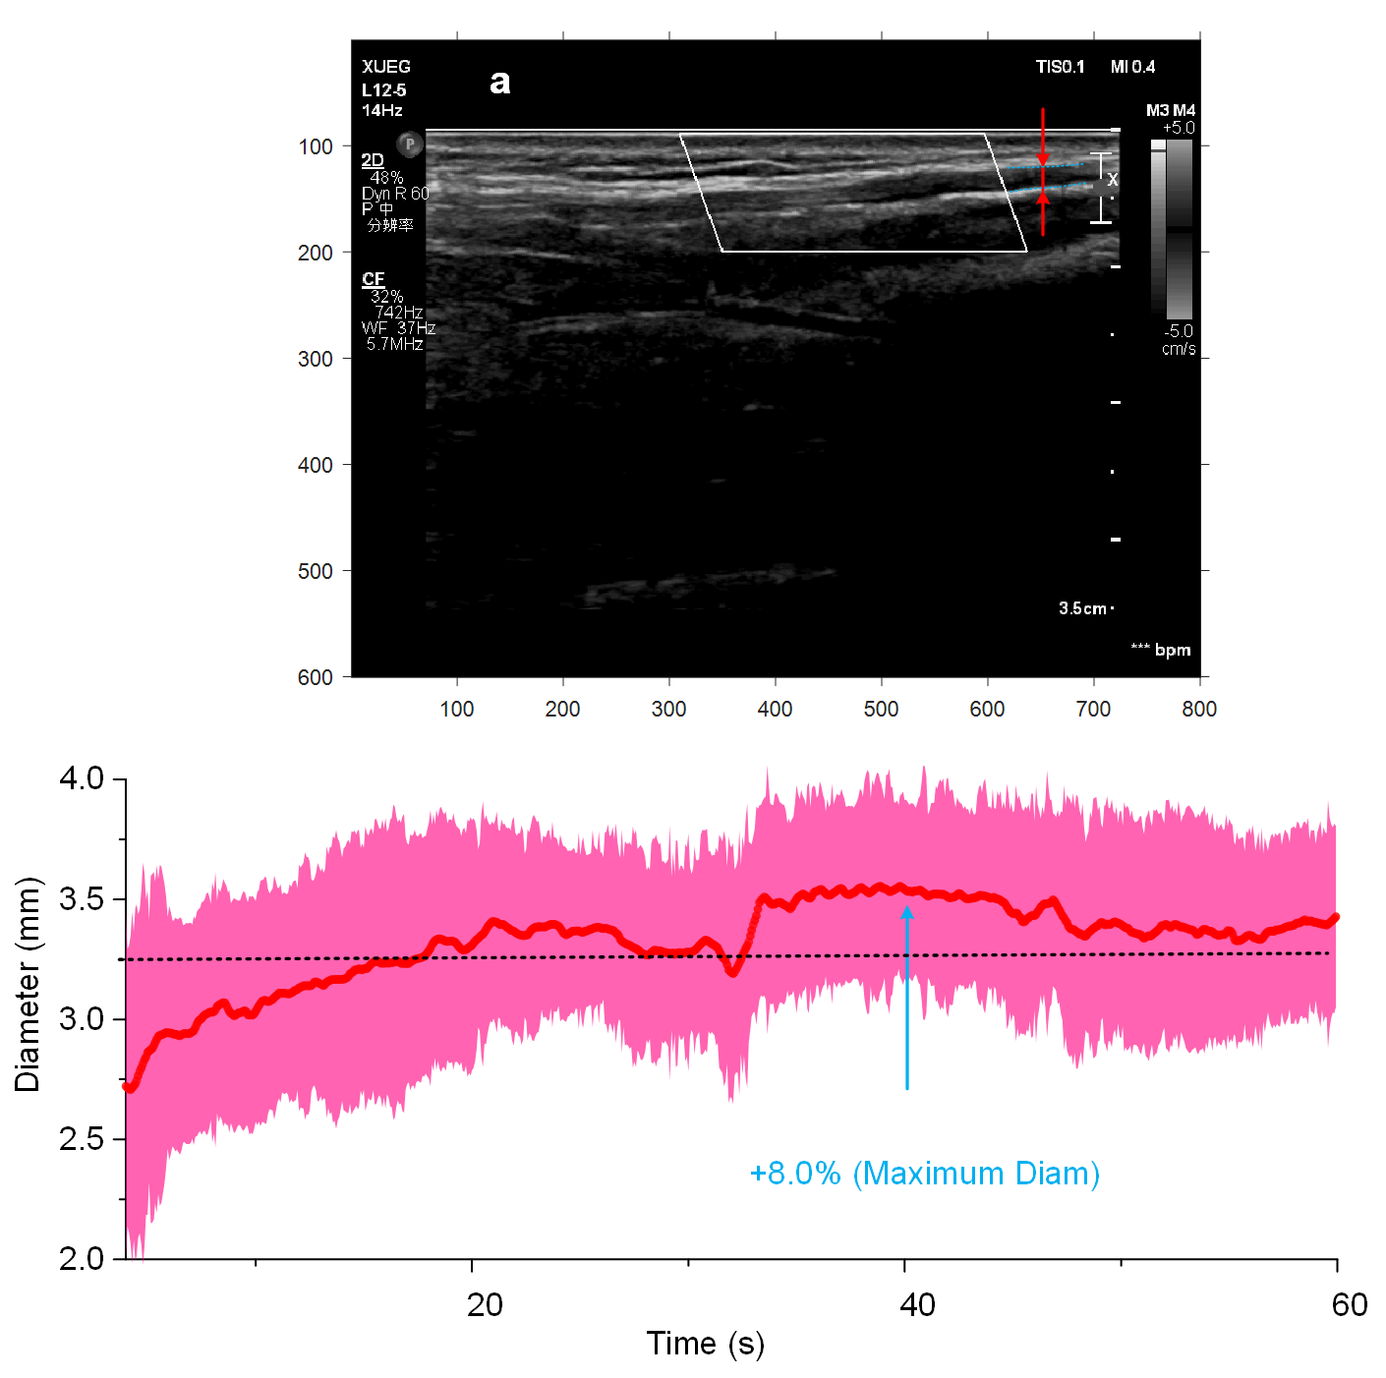
Supplementary Fig. 10. An FMD trail testing with a medical ultrasound system. a, The snapshot of ultrasound imaging. The blue dot line marked out the radial artery monitored. b, The diameter of the radial artery. Its FMD value is about 8.0%.

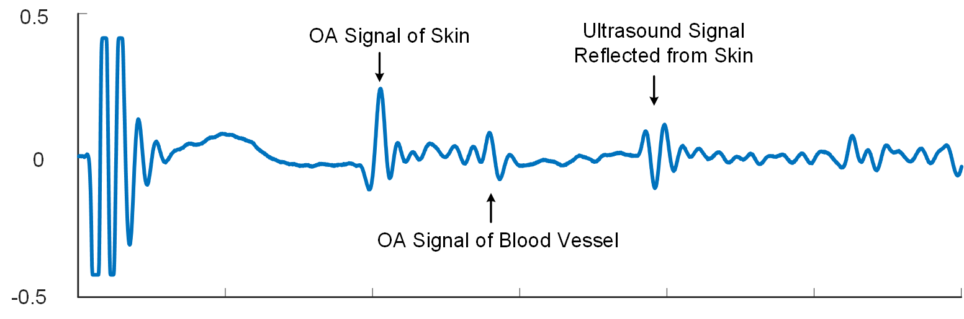
Supplementary Fig. 11. A typical signal recorded by our OBS. The passive ultrasound wave is excited by the light diffused and reflected from the skin surface, then spreads to the skin and is reflected from the skin. Due to the round-trip of ultrasound signals, the ultrasound signals can be easily distinguished from OA signals in time.
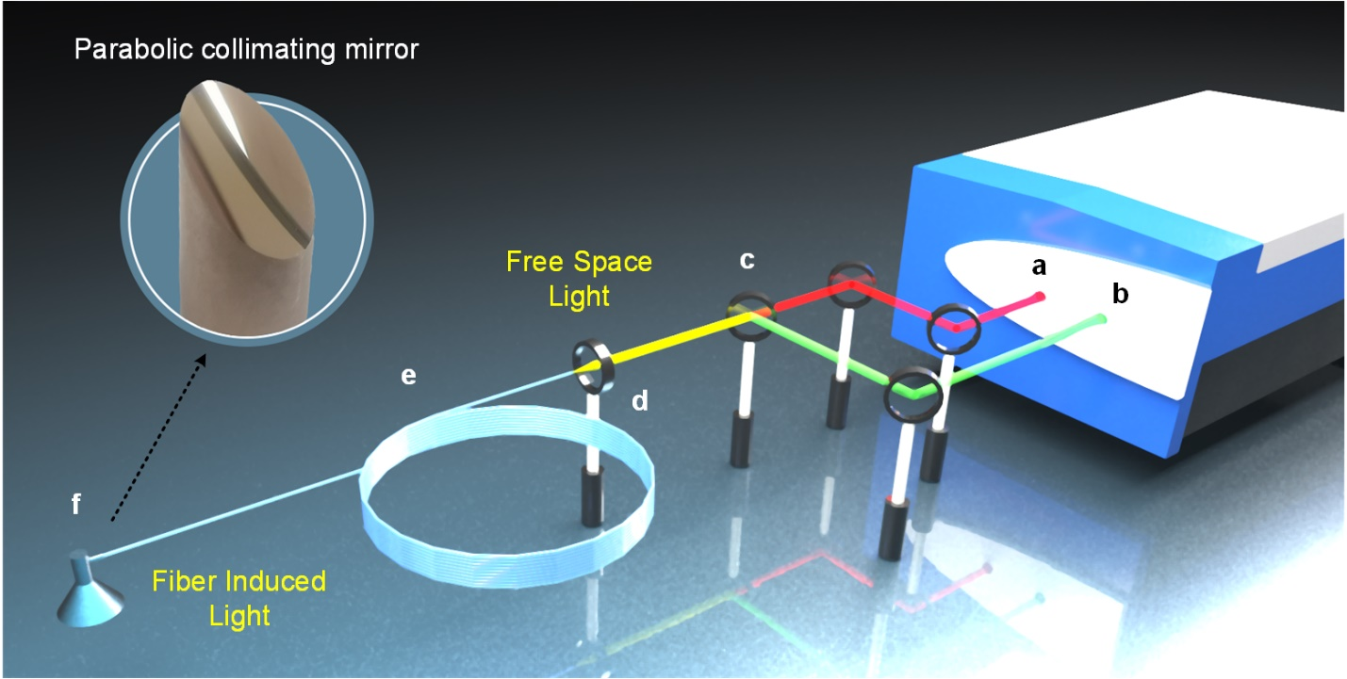
Supplementary Fig. 12. Laser setup for multi-spectral experiment. a, The 680-2600 nm tunable laser output. b, The 532 nm base laser output. c, The dichroic mirror. d, The convex lens. e, The multi-mode fiber bundle. f, The customized parabolic mirror. The zoomed-in schematic shows a parabolic mirror for collimation. Other optical components are reflection mirrors.

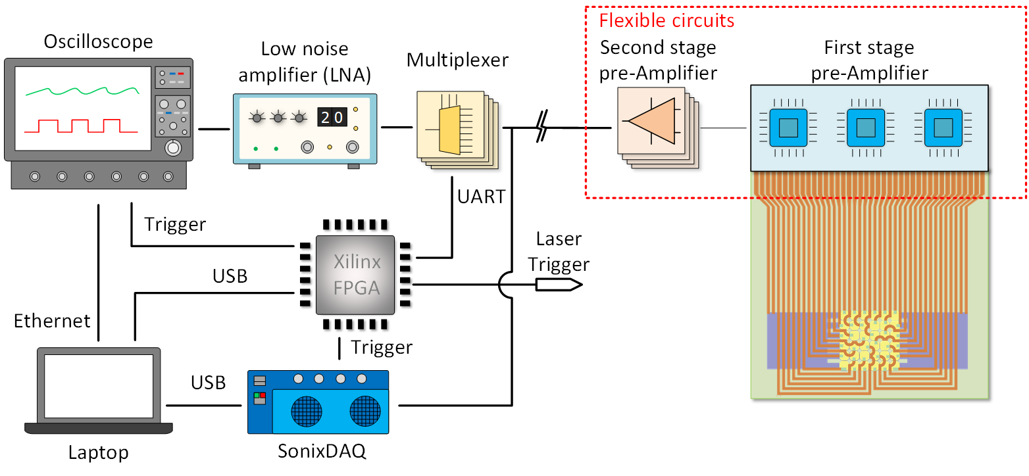
Supplementary Fig. 13. Schematic diagram of the data acquisition system. The system consists of customized 36-channel two-stage pre-amplifiers (MAX4805A, maxim integrated, and TLV3544, Texas Instruments) for 30 dB pre-amplification, analogue multiplexers (TMUX1108, Texas Instruments) for observation channel selection, a low-noise amplifier (5072PR, Olympus) for an additional 30 -50 dB amplification, an oscilloscope (Lecroy) for data acquisition of observation channel, a multi-channel data acquisition box (SonixDAQ) for imaging data recording, and an FPGA board (Minized, AVENT) for controlling.

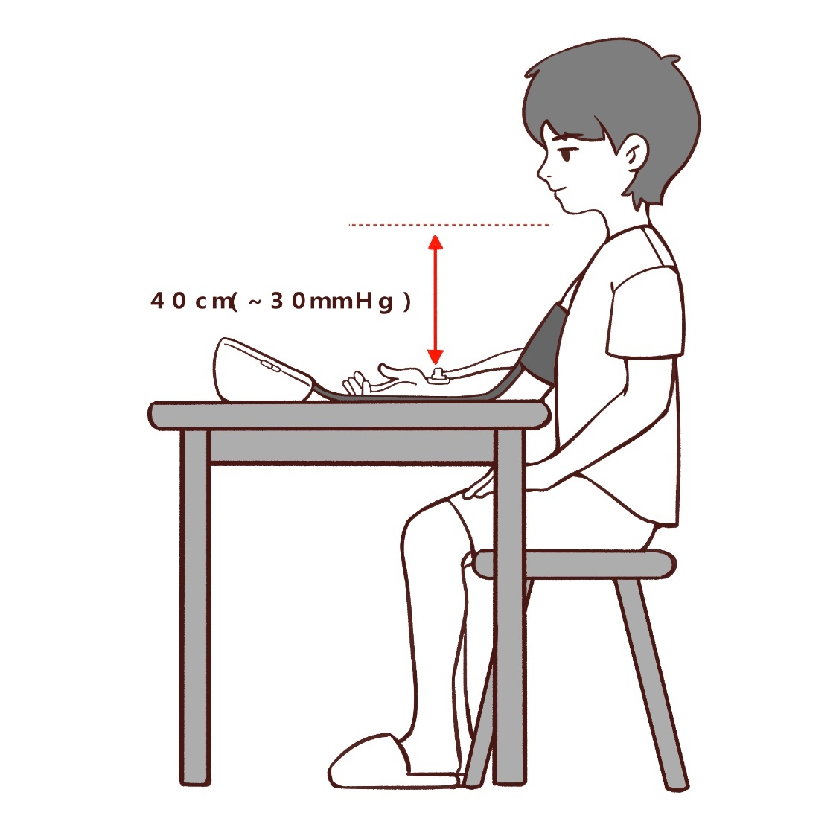
Supplementary Fig. 14. The sitting posture for venous distensibility testing. The volunteer keeps the height difference between testing points and the neck of 40 cm. In such a posture, the dorsal hand vein's pressure under the cuff releasing condition is about 30 mmHg.

Supplementary Notes
Supplementary Note 1. Light Delivery Efficiency.
The light delivery efficiency is tested with an experimental setup, as shown in Supplementary Fig. 9. The illumination source is a 532 nm pulse laser with an energy of 2 mJ. A powermeter (Gentec-EO MAESTRO, Canada) is used to record the energy of light that penetrates through the sensor head, as shown in Fig. N1. All the micro-lens layer patched on the sensor are with a 1.6 mm diameter for each lens, while their PDMS thickness is 650 µm, 500 µm, 350 µm, 250 µm, 200 µm and 150 µm, respectively. Also, six flat PDMS films (no micro-lens) with the corresponding thicknesses are also tested as control groups. The tested results are listed in Table N1. From the results, the micro-lens could significantly improve the light delivery efficiency, and a thicker layer of micro-lens can obtain higher efficiency. The main reason is a thicker layer provides a longer light path for laser focusing. For the micro-lens layer thicker than 500 µm, the improvement of light delivery efficiency tends to be slow, but the flexibility of the device is severely weakened. Therefore, the best selection of the PDMS thickness is less than 300-500 µm.
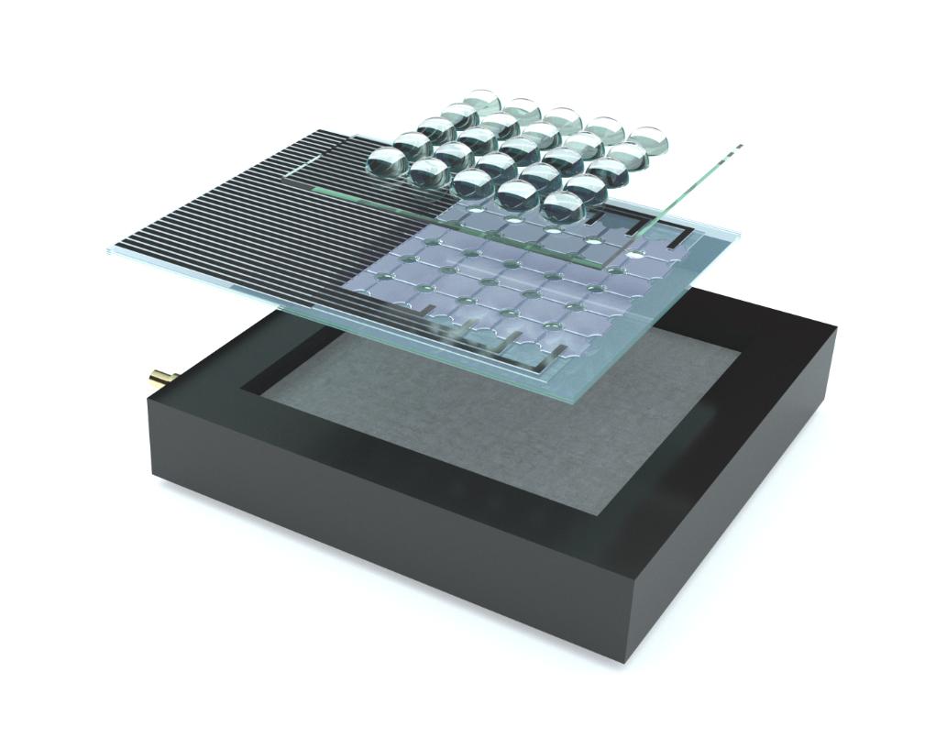
Fig. N1. The schematic of light delivery testing with powermeter.
Table. NI. The Light delivery efficiency with different micro-lens
 | 650 µm | 500 µm | 350 µm | 250 µm | 200 µm | 150 µm
Micro-lens | 1.31mJ/ (66%) | 1.29mJ /(65%) | 1.20mJ/ (60%) | 1.10mJ/ (55%) | 1.03mJ/ (52%) | 0.96mJ/ (48%)
No micro-lens | 0.466mJ/ (23.3%) | 0.472mJ/ (23.6%) | 0.48mJ/ (24%) | 0.491mJ/ (24.5%) | 0.492mJ/ (24.6%) | 0.497mJ/ (24.8%)

Supplementary Note 2. The comparison of transparent acoustic sensors.
Table N2 provides an intuitive comparison of different transparent acoustic sensor designs in terms of piezo material, transparency, and resistance. In our OBS, the electrodes are made of silver which has high bendability and conductivity. Benefited from the particular design, its transparency can exceed 65%, covering a wide range of wavelengths (400 nm-1100 nm). In [2][3], PVDF is also used as piezo-material, but ITO electrodes make the connection resistance over 100 order higher than silver. A 400 nm ITO has little advantage of transparency. In [3], the PVDF thickness is only 9 µm, while our OBS can reach 110 µm; note that PVDF also absorbs light. CMUT is a silicon-based transducer, and LiNbO₃ is rigid; hence, both are unbendable. The transparency advantages of ITO are not obvious, but the drawback of high resistance is unneglectable. According to [1, 2], a large resistance not only causes signal loss in circuit transmission but also constructs an RC low-pass filter with the side effect of the sensor element to cut-off the high-frequency signals to deteriorate the acoustic resolution.

Table. N2 Comparison of Different Transparent Acoustic Sensor Designs
Piezo-material | Piezo-thickness | Electrodes | Electrodes  Thickness | Transparency | Resistance | Solutions
PVDF | 110 µm | Ag | 7 µm | 65% (400 nm-1100 nm) | 10⁻²~10⁰ Ω | Our OBS
PVDF | 40 µm | ITO | 200 nm | 80% (450 nm ~2000 nm) | 10²-10⁴ Ω | [2]
PVDF | 9 µm | ITO | 400 nm | 60% (450 nm ~1100 nm) | / | [1]
CMUT | 2.5 µm | ITO | 150 nm | 50% (400 nm-1000 nm) | 1 KΩ | [3, 4]
CMUT | 3.3 µm | ITO | 300 nm | 70% (500 nm-600 nm)  50% (600 nm-800 nm) | 35-50 Ω/sq | [5]
LiNbO3 | 250 µm | ITO | 200 nm | 80% (690 nm~ 970 nm) | / | [6]

Supplementary Note 3. Monte Carlo Simulations.
The software package MXCLab [7] is used to simulate the light fluence distribution under different illumination conditions. The optical absorptions and scattering coefficients of dermis tissues at different wavelengths are referred to [8]. In all simulations, the voxel is defined as a cube with a side length of 0.05 mm, and the whole grid is defined as 213×213×60. For our proposed illumination solution, the light sources are simulated as 25 cones with a cone angle of 43.6 degrees. In the center window method, a light source with the geometry of conical frustum is designed to illuminate the target. The top radius of the conical frustum is 1.6 mm, and its cone angle is also 43.6 degrees. For the side illumination case, the light sources are simulated as two rectangles that are 0.5 mm×10.6 mm in size. The two lights are respectively titled as 45 and -45 degrees to strike into the tissues. A total of 200 million photons are transmitted into the tissues in all three simulations, and results are collected after photons have scattered and been absorbed for 0.5 ns.

Supplementary Note 4. Light Pattern.
In order to clearly record the image of the light pattern, here, a continuous 633 nm laser (HRS015B, Thorlabs) is employed as the light source. The laser beam is expanded by concave (LC1582-A, Thorlabs) and convex (LA1608-A, Thorlabs) lens and regularized with a rectangle iris (GCM-5711M, DHC Ltd, China). Then the light is shooting onto our blood stethoscope. A white paper is attached to the sensor back as a screen, and a CCD camera is used (EOS 80D, Canon) to record the light pattern.
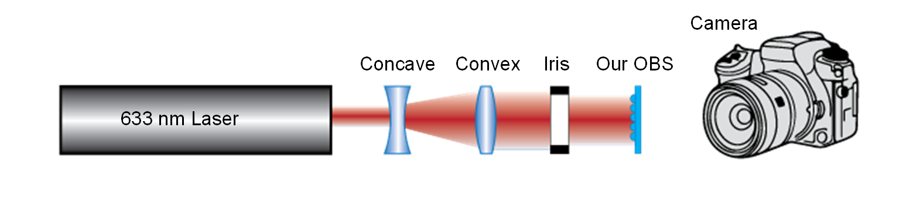
Fig. N2. The schematic of light pattern testing with a CCD camera.

Supplementary Note 5. Multi-spectral imaging.
Firstly, the multi-spectral imaging experiment is emulated using black and blue point tapes as targets as shown in Fig. N3e. A tunable laser (Radiant 532LD, Opotek Ltd), which generates a 5-7 ns duration pulse with 10 Hz repetition frequency in a spectrum ranging from 680 nm to 2600 nm, illuminates the tapes. Four wavelengths of 532 nm, 750 nm, 808 nm, and 1064 nm are used to excite the optoacoustic signals with average energies of 2 mJ, 6 mJ, 6 mJ and 6.5 mJ per pulse, respectively. Our designed devices detect the optoacoustic signals, and signals are recorded by the data acquisition system. The final interpolated images are plotted in Fig. N3a-d, where two tapes are expressed as two cylindrical scatter clusters in figures. A larger cluster represents a stronger optoacoustic source. According to [9], the amplitudes of optoacoustic waves are determined by light fluence, heat conversion efficiency, optical absorptions, and Grueneisen parameters of targets. In our case, both two tapes are made of PVC (the same Grueneisen and heat conversion efficiency) but with different color (different optical absorption spectra); thus, the amplitudes of received signals should be linearly proportional to the product of light fluence and absorption spectra. As the absolute laser energies vary in different wavelengths, we extracted the amplitude ratios between two tapes under different wavelengths. We then compared the ratio with the absorption spectra results by UV-1800 UV/Visible scanning spectrophotometer (Shimadzu Ltd) as shown in Fig. N3f. The measured ratios under these four wavelengths are almost the same as those calculated from the absorption spectra in Fig. N3g. The differences between ratios are mainly related to the inconsistency of light fluences and acoustic sensitivity.
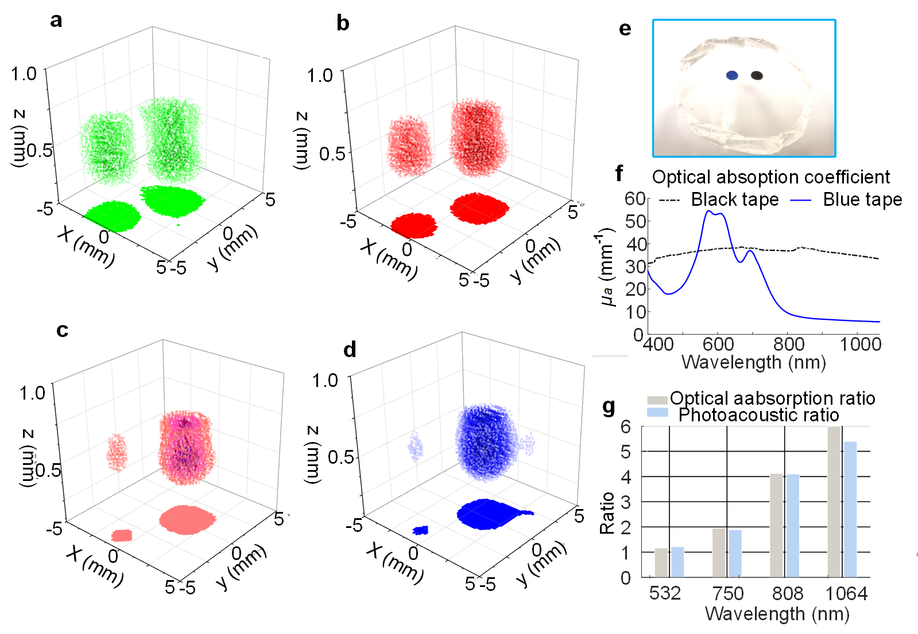
Fig. N3. Multi-spectrum imaging on phantom. a, Photoacoustic imaging using 532 nm laser light. b, Photoacoustic imaging using 750 nm laser light. c, Photoacoustic imaging using 808 nm laser light. d, Photoacoustic imaging using 1064 nm laser light. e, Photograph of phantoms. f, The optical absorption coefficients of two tapes. g, A comparison of optical absorption and optoacoustic amplitude ratios.

Supplementary Note 6. Manson’s model.
Manson’s model is a convenient tool to estimate the impedance of PVDF sensors [10]. Figure. N4 is a Manson’s model of the OBS device, including the front layer, the rear layer, and the acoustic loads. In our case, both the rear layer and the front layer are multilayer structures. According to [11], the Z_{A} and Z_{C} of front and rear layers, as well as PVDF and Z_{R} of acoustic loads, can be calculated by
$$h={e_{33}}/{ε^{S}},C_{o}=ε^{S}\frac{A}{d},$$
$$ϕ=hC_{o},C=C_{o}\left(1 - j ϕ\right),$$
$$γ=j\left(ω/v\right)\left(1 - j Ψ/2\right),$$
$$B=jρvA\left(1 + j Ψ/2\right),$$
$$Z_{A}=-jBtanh\left(γ d/2\right), \\ Z_{C}=-jBcosech\left(γ d\right),$$
$Z_{R}=ρv.$ (1)
where $ε^{S}$ is the clamped dielectric constant, $e_{33}$ is the piezoelectric stress constant, $v$ is the acoustic velocity of material, $ω$ is the radian frequency, $ρ$ is the density of the material, $A$ is the area of the material, $d$ is the thickness of the material, $Ψ$ is equal to the mechanical loss tangent, $C_{o}$ is the static capacitance of piezoelectric material. The acoustic impedance of the OBS can then be obtained by a calculation of series-parallel impedance following Fig. N4. The detailed parameters of the PVDF and other materials are listed in Table. N3 and Table. N4, respectively.
Figure. N4 Manson’s model including front and rear layers and acoustic loads.
Table N3. PVDF parameters
Parameters | PVDF
$ρ$(kg/m³) | 1780
$v$(m/s) | 2200
$$e_{33}$$ | -0.16
$$Φ$$ | 0.17
$$Ψ$$ | 0.077

Table N4. Densities and sound speeds of materials
Material | $ρ$(kg/m³) | $v$(m/s)
PDMS | 969 | 1119
Ag | 10530 | 3600
Cu | 8900 | 4720
Cr | 7140 | 5940
Air | 1.3 | 340

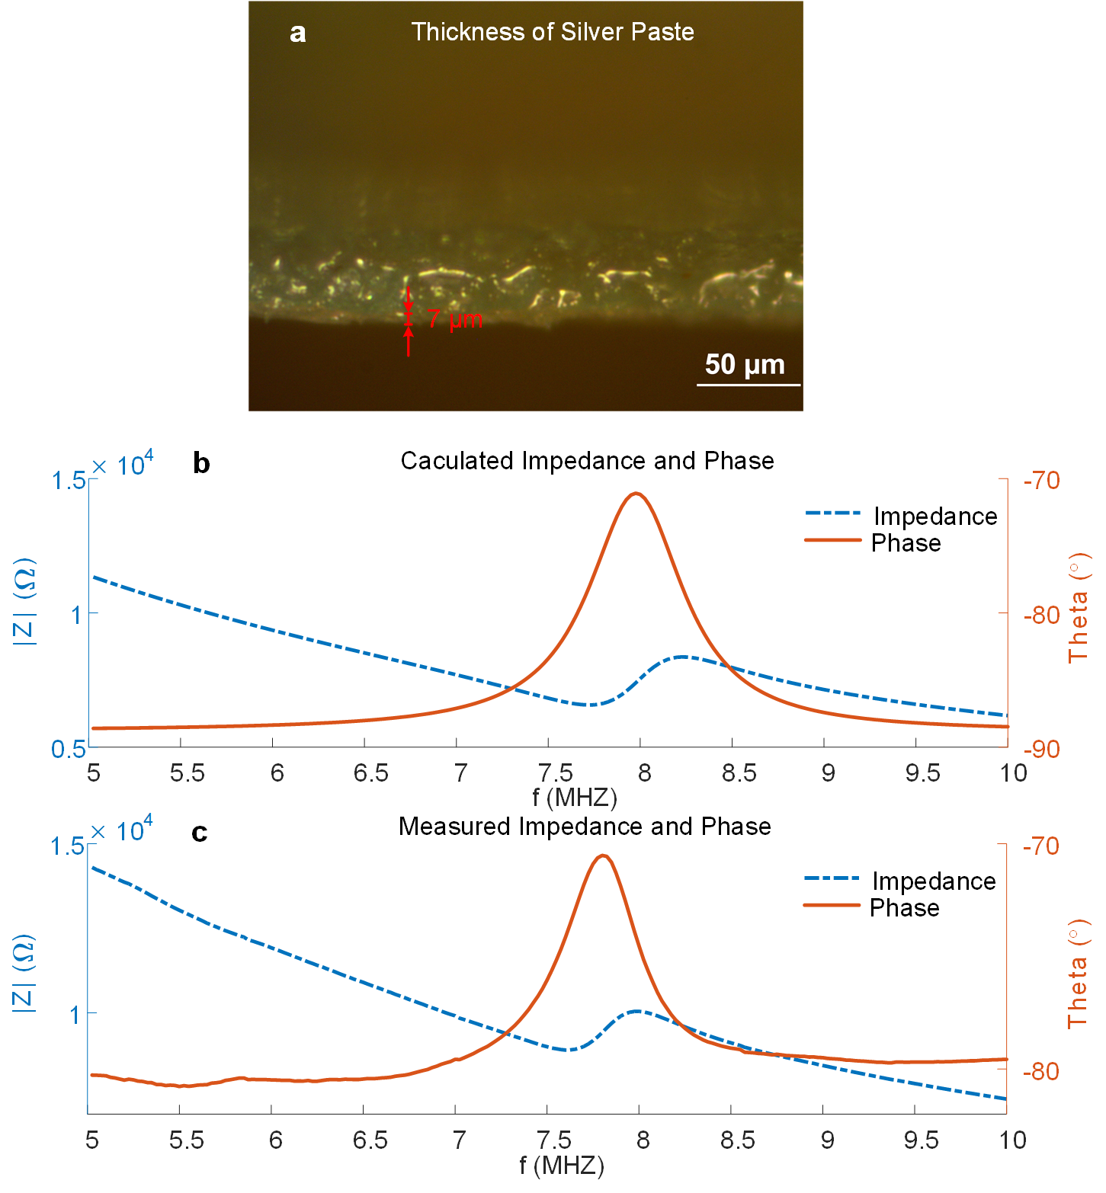
Fig. N5. Impedance analysis with Manson’s model. a, The photograph of OBS sliver paste layer. b, The impedance and phase calculated by Manson’s model. c, The impedance and phase of our OBS.

Supplementary Note 7. Acoustic characterization calculation.
The axial resolution of the sensor is expressed as
$R_{axial}=0.88\frac{c}{∆f}$ (2)
Where $c$ is the speed of sound, and $∆f$ is the bandwidth of the sensor.
The acoustic wavefield of a single sensor is calculated with integration as
$p\left(r\right)=\int_{S}{\frac{e^{-jω{\left\|r - r_{d}\right\|}/c}}{\left\|r - r_{d}\right\|}dr_{d}}$ (3)
where $r$ is the position of the measuring point, and $r_{d}$ represents the position of points inside the sensor. $S$ denotes the surface of the sensor, $ω$ is the angular frequency. The acoustic field of view (AFOV) of OBS is written by summing the wavefields of all 36 sensors as
$p\left(r\right)=\sum_{k=1}^{36}{\left[\int_{S_{k}}{\frac{e^{-jω{\left\|r - r_{d}^{\left(k\right)}\right\|}/c}}{\left\|r - r_{d}\right\|}dr_{d}^{k}}\right]}$ (4)
where the $r_{d}^{k}$ represents the position of the differential point of sensor $k$, and $S_{k}$ is the integral region of sensor $k$.
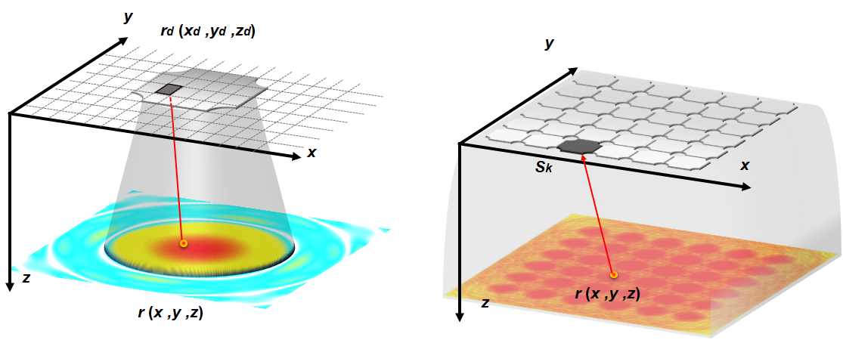
Fig. N6. The schematics of the AFOV calculations. a, The acoustic wavefield of a single element. b, The AFOV of 36 acoustic elements.
Supplementary Note 8. Derivation of 3D imaging algorithm [12, 13].
The 3D imaging using OBS under a uniform light illumination could be described as a classical acoustic receiving model, as [14]
$∇^{2}p\left(x , y , z , t\right)-\frac{1}{c^{2}}\frac{∂^{2}}{∂t^{2}}p\left(x , y , z , t\right)=0,$ (5)
subject to the initial conditions
$$p\left(x , y , z , t\right)|_{t=0}=S\left(x , y , z\right),$$
$$∂p\left(x , y , z , t\right)/∂t|_{t=0}=0.$$
where $S\left(x , y , z\right)$ is the acoustic source terms which is only excited at the moment of laser irradiation. Assuming the acoustic elements lie on the skins at a depth $z=0$, all sound sources are buried under the skin as $z>0$. Thus, the pressures recorded by the acoustic elements are represented as $p\left(x , y , z = 0 , t\right)$. Therefore, the image reconstruction could be treated as using $p\left(x , y , z = 0 , t\right)$ to solve $S\left(x , y , z\right)$.
Firstly, the recorded pressures data $p\left(x , y , z = 0 , t\right)$ is decomposed into a set of harmonic plane wave components as
$p\left(x , y , z = 0 , t\right)=∭P\left(k_{x} , k_{y} , z = 0 , ω\right)e^{ik_{x}x}e^{ik_{y}y}e^{-iωt}dk_{x}dk_{y}dω$ (6)
where $k_{x}$ , $k_{y}$ , and $ω$ represent the wavenumber of $x$, $y$, and $t$, respectively. A phase shift term can be applied to the plane wave component to backpropagate the wavefields to an arbitrary depth $z_{s}$ as
$P\left(k_{x} , k_{y} , z_{s} , ω\right)=P\left(k_{x} , k_{y} , z = 0 , ω\right)e^{ik_{z}\left(z_{s} - z\right)},$ (7)
where $k_{z}$ is determined by the $k_{x}$ , $k_{y}$ , and $ω$ of each wave component with relation as
${\left(ω / c\right)}^{2}=k_{x}^{2}+k_{y}^{2}+k_{z}^{2}.$ (8)
It is convenient to obtain the source term at depth $z_{s}$ using an inverse Fourier transform on $P\left(k_{x} , k_{y} , z_{s} , ω\right)$ with a condition $t=0$, as
$S\left(x , y , z_{s}\right)=∭P\left(k_{x} , k_{y} , z_{s} , ω\right)e^{ik_{x}x}e^{ik_{y}y}dk_{x}dk_{y}dω$. (9)
However, such a method solves the $S\left(x , y , z\right)$ layer by layer. To improve computational efficiency, an integral transform is introduced to modify Eq.9. By substituting Eq. 7 into Eq.9, a general form of backpropagation is written as
$S\left(x , y , z\right)=∭P\left(k_{x} , k_{y} , z = 0 , ω\right)e^{ik_{x}x}e^{ik_{y}y}e^{ik_{z}z}dk_{x}dk_{y}dω.$ (10)
According to Eq.10, the derivative of $ω$ is expressed as
$dω=ck_{z}dk_{z}/\sqrt{k_{x}^{2}+k_{y}^{2}+k_{z}^{2}}.$ (11)
Substituting Eq.11 into Eq.10, the backpropagation is rewritten by transforming the integral from $ω$ domain to $k_{z}$ domain,
$S\left(x , y , z\right)=∭P\left(k_{x} , k_{y} , z = 0 , ω \left(k_{x} , k_{y} , k_{z}\right)\right)e^{ik_{x}x}e^{ik_{y}y}e^{ik_{z}z}ck_{z}/\sqrt{k_{x}^{2}+k_{y}^{2}+k_{z}^{2}}dk_{x}dk_{y}dk_{z}.$ (12)
Although Eq. 12 is in the form of a 3-D inverse Fourier transform, the non-uniform grid of $k_{z}$ may cause numerical artifacts. A more accurate solution is using NUFFT to upgrade Eq.12 as
$S\left(x , y , z\right)=∭P\left(k_{x} , k_{y} , z = 0 , ω \left(k_{x} , k_{y} , k_{z}\right)\right)e^{ik_{x}x}e^{ik_{y}y}e^{ik_{z}z}ck_{z}/\sqrt{k_{x}^{2}+k_{y}^{2}+k_{z}^{2}}ΦD_{p}dk_{x}dk_{y}dk_{z},$ (13)
where $Φ$ is a sinc interpolation basis and $D_{p}$ is a down-sampling function. The main drawback of NUFFT is that it was only applied to homogenous media. For heterogeneous media, the wave propagation also could be easily expressed in the wavenumber domain. Assuming an L-th layered media as shown in Fig. N7a, the backpropagation in Eq.7 is rewritten as
$P\left(k_{x} , k_{y} , z_{s} , ω\right)=P\left(k_{x} , k_{y} , ω , z = 0\right)\prod_{l=1}^{L-1}{e^{ik_{l}d_{l}}}e^{ik_{L}\left(z_{s} - z_{L}\right)},$ (14)
where $k_{q}$, $k_{L}$ and $z_{L}$ are defined as
$$k_{l}=\sqrt{{ω^{2}}/{c_{l}^{2}}-k_{x}^{2}-k_{y}^{2}},$$
$$k_{L}=\sqrt{{ω^{2}}/{c_{L}^{2}}-k_{x}^{2}-k_{y}^{2}},$$
$$z_{L}=\sum_{l=1}^{L-1}{d_{l}.}$$
It can be seen that Eq. 14 is similar to Eq. 7 but with one more phase term of $\prod_{l=1}^{L-1}{e^{ik_{l}d_{l}}}$. Therefore, a direct solution is to use phase shift (PS) migration to extrapolate the wavefield to depth $z_{L}$ and then implement NUFFT to achieve the source term in the L-th layer as
$S\left(x , y , z\right)=NUFFT\left\{P \left(k_{x} , k_{y} , ω , z = 0\right) \prod_{l=1}^{L-1}{e^{ik_{l}d_{l}}}\right\}.$ (15)
The whole flow-chart of PS-NUFFT is shown in Fig. N7B. Noted that, for an L-th layered media, the Eq.14 should be implemented L times for imaging the whole region (from layer 1 to layer L).
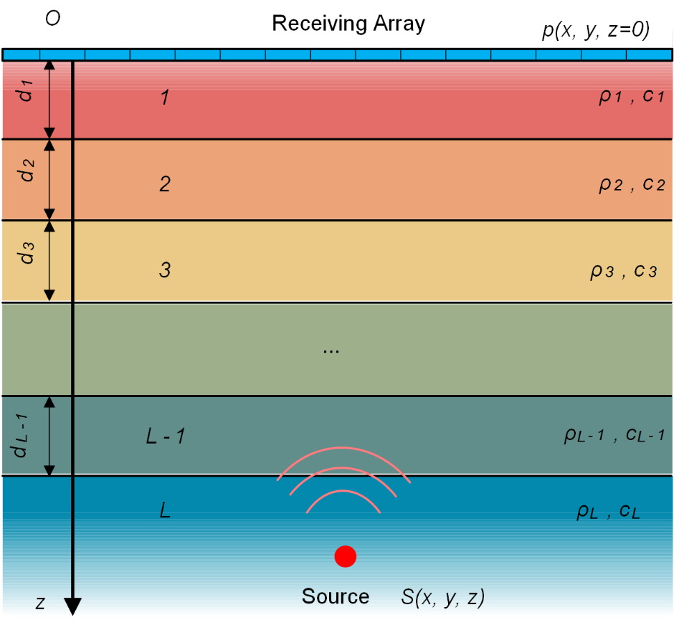
Fig. N7a. The L-th layered media with an acoustic source at depth z.
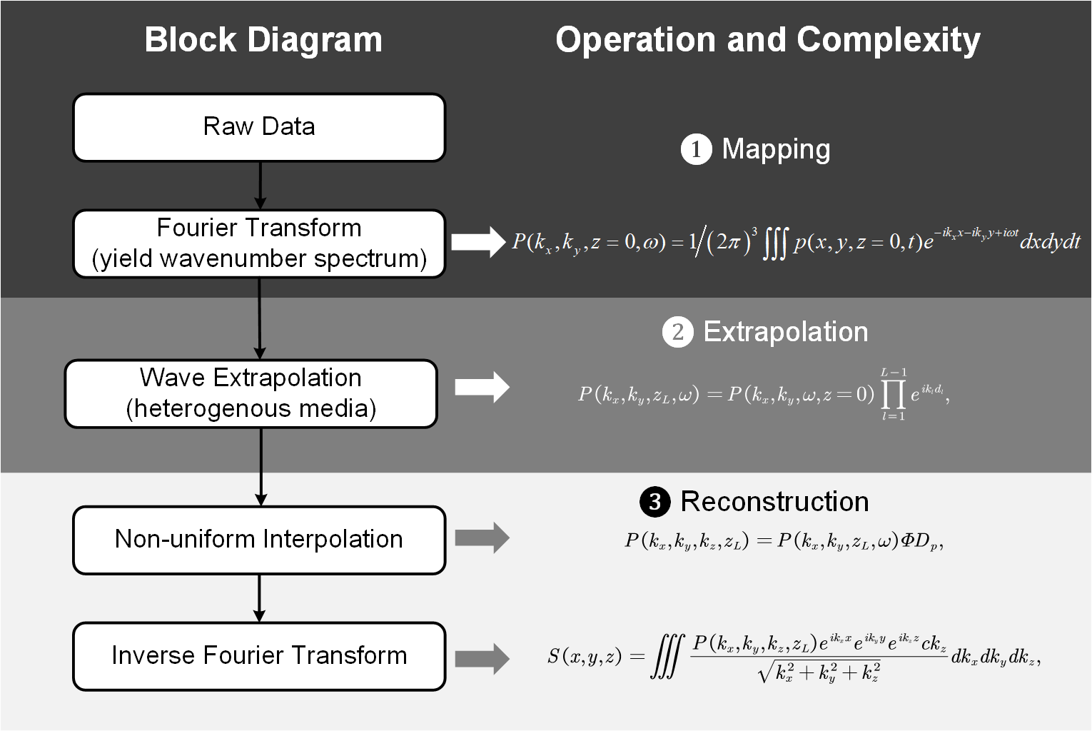
Fig. N7b. The flow-chart of PS-NUFFT.
Supplementary Note 9. Simulation for 3D imaging algorithm verification.
The simulation is based on the phantom of the blood vessel, and its data are generated using K-wave 1.2.1 Matlab 2017b [15]. The media is set as a two-layered media, as shown in Fig. N8. Its upper layer is defined as the dermis (skin) with a sound speed of 1730 m/s, a density of 1150 kg/m³ and a thickness of 2.2 mm, while the bottom layer is the hypodermis layer filled with fat having a sound speed of 1450 m/s, a density of 950 kg/m³and a thickness of 3.2 mm. The blood vessel is buried in a depth of 5 mm. All the sensor elements are aligned at a depth of 0 mm with a pitch of 0.1 mm and a total range of 25.6 mm. The ultrasound waves are recorded from 0 µs to 7 µs with a sampling frequency of 60 MHz (total 420 sampling points).

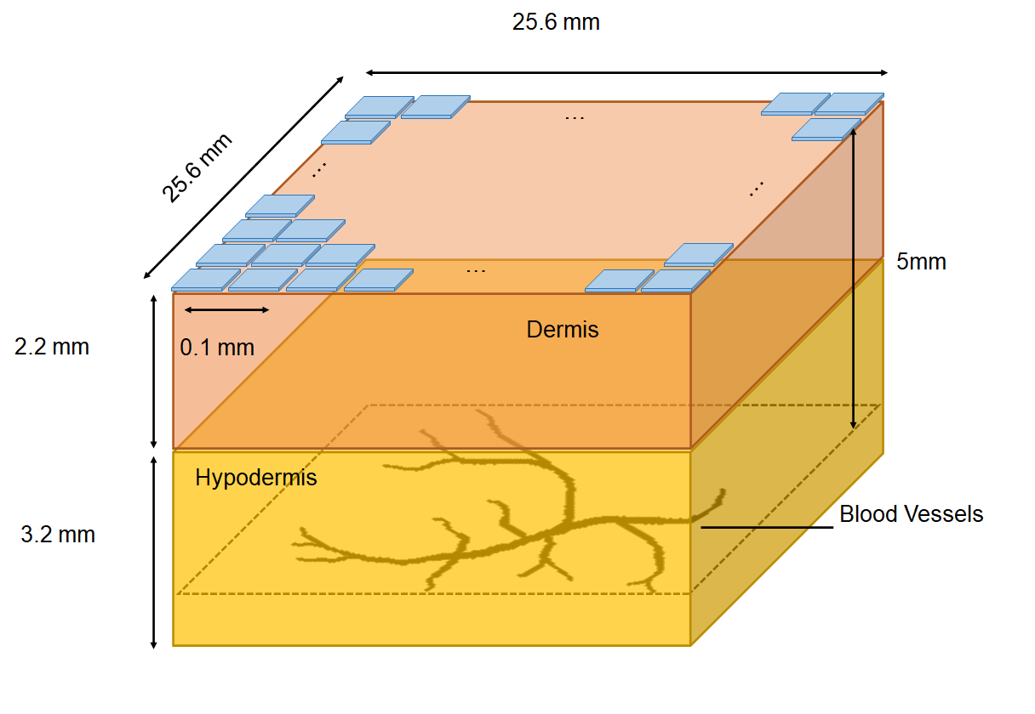
Fig. N8. Simulation Phantom. The acoustic sources (blood vessels) are buried in a two-layered media at a depth 5 mm. The top layer of media is the dermis with a sound speed of 1730 m/s, a density of 1150 kg/m³ and a thickness of 2.2 mm. The bottom layer is hypodermis with a sound speed of 1450 m/s, a density of 950 kg/m³ and a thickness of 3.2 mm.
Supplementary Note 10. Fluorescence test of the decay rate of Rhodamine B
Rhodamine B is able to fluoresce and can be detected by fluorometers. The fluorescence test was in vitro testing with a monochromator microplate reader (Infinile M200, TECAN); hence, the mice blood should be invasively sampled.
Sample Preparation: Before the Rhodamine B was injected into the mouse, we took 5 µL blood from the mouse tail twice as the baseline. After the Rhodamine B was injected, the mouse was taken 5 µL of blood from its tail every 5 mins. The whole process continued for 2 hours, and 24 blood samples were collected. Every blood sample was mixed with a 5 µL blood anticoagulant after drawing out from the tail and then diluted with 190 µL water to provide sufficient liquid volumes for fluorescence test (Fig. N9a).
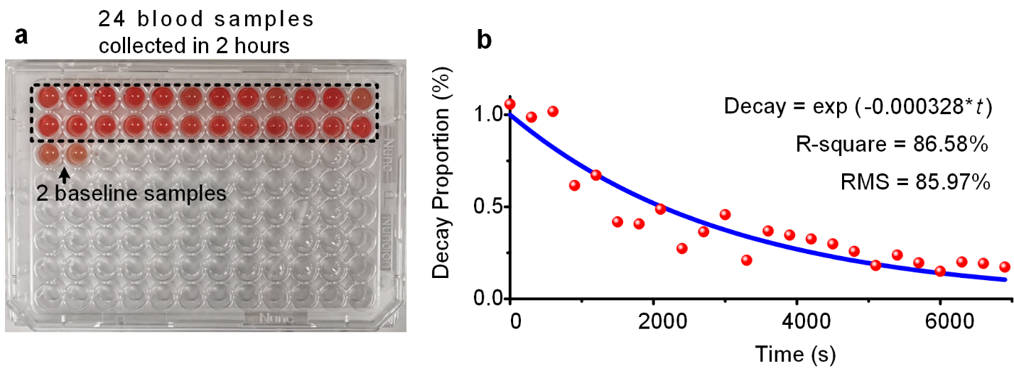
Figure. N9 Fluorescence tests. a, The blood samples. b, The decay trendline of Rhodamine B estimated by fluorescence tests.
Fluorescence Test: The excitation light wavelength was set as 560 nm with a bandwidth of 9 nm, and the tested emission wavelength was set as 590 nm with a bandwidth of 20 nm. The number of flashes was 25 with an integration time of 20 µs. This test was under an ambient temperature of 23.2 °C. The total decay rate of Rhodamine B was about -3.28×10⁻⁴ per second (Fig. N9b). In comparison, the decay rate of Rhodamine B measured by fluorescence test at 3600 s – 5700 s was about -3.22×10⁻⁴ per second, which was closed to our OBS’s monitored result of -3.61×10⁻⁴ per second.

Supplementary Note 11. Medical ultrasound image processing.
The processing of medical ultrasound images mainly includes six steps: window selection, binarization, morphological operations, edge outline and filling. In Fig. N9a, a window of 80*140 pixels was used to select the artery image out from the medical ultrasound data. The blood vessels are usually presented as shadows in ultrasound images. Then, the selected image was binarized, as shown in Fig. N9b. To remove the small gaps and discontinuities, two morphological open and one close operation were applied to the binary image as plotted in Fig. N9c. Subsequently, an edge operation was employed to extract the artery profile. The arterial cross-sectional area could be conveniently estimated with the filled profile as depicted in Fig. N9d.
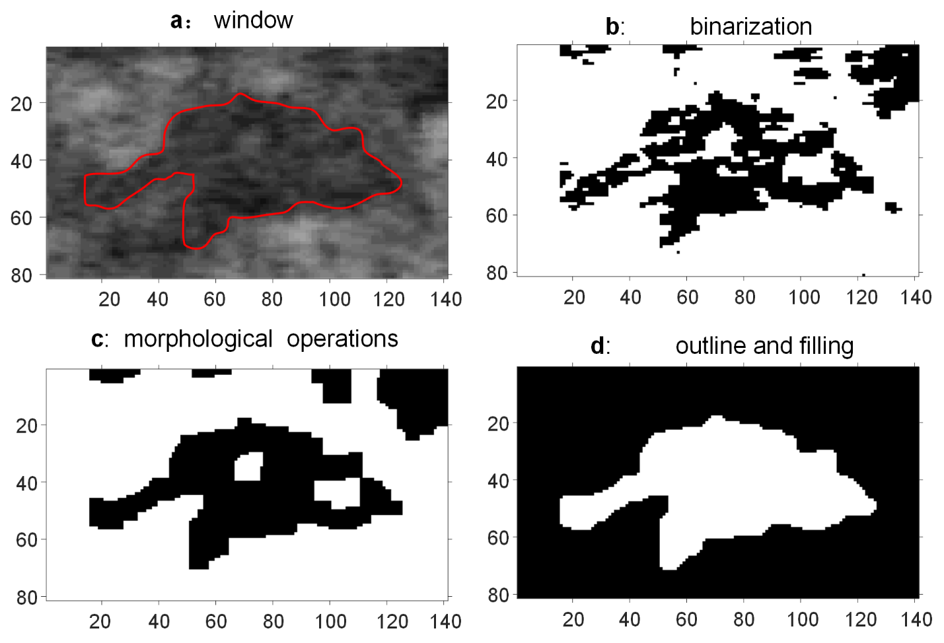
Fig. N10. The image processing of ultrasound image. a, Selection ROI with a specific window. b, Binarize ultrasound image. c, Removing small discontinuities with morphological operations. d, Removing large gaps by filling the outlines.

Supplementary Videos
V1. 3D imaging of blood hypoxia.
V2. 3D imaging of drug concentration decay.
V3. Perfusion experiments on human dorsal vein measured by OBS. The images are reconstructed with PS-NUFFT and post-rendered by Python.
V4. Perfusion experiments on human dorsal vein measured by medical ultrasound imaging. The images are post-processed following Supplementary Note. 9.
V5. Perfusion experiments on the human radial artery. The images are reconstructed with PS-NUFFT and post-rendered by Python.
V6. Perfusion experiments on human radial artery measured by medical ultrasound imaging. The images are post-processed following Supplementary Note. 9.
V7. FMD experiments on human radial artery using medical ultrasound imaging for cross-validation.

Reference

[1] C. Fang, H. Hu, and J. Zou, "A Focused Optically Transparent PVDF Transducer for Photoacoustic Microscopy," IEEE Sensors Journal, 2019.
[2] J. J. Niederhauser, M. Jaeger, M. Hejazi, H. Keppner, and M. Frenz, "Transparent ITO coated PVDF transducer for optoacoustic depth profiling," Optics Communications, vol. 253, no. 4, pp. 401-406, 2005/09/15/ 2005.
[3] X. Zhang, O. Adelegan, F. Y. Yamaner, and O. Oralkan, "CMUTs on glass with ITO bottom electrodes for improved transparency," in 2016 IEEE International Ultrasonics Symposium (IUS), 2016, pp. 1-4: IEEE.
[4] X. Zhang, X. Wu, O. J. Adelegan, F. Y. Yamaner, and Ö. Oralkan, "Backward-mode photoacoustic imaging using illumination through a CMUT with improved transparency," IEEE transactions on ultrasonics, ferroelectrics, and frequency control, vol. 65, no. 1, pp. 85-94, 2017.
[5] Z. Li, A. K. Ilkhechi, and R. Zemp, "Transparent capacitive micromachined ultrasonic transducers (CMUTs) for photoacoustic applications," Optics express, vol. 27, no. 9, pp. 13204-13218, 2019.
[6] A. Dangi, S. Agrawal, and S.-R. Kothapalli, "Lithium niobate-based transparent ultrasound transducers for photoacoustic imaging," Optics letters, vol. 44, no. 21, pp. 5326-5329, 2019.
[7] Q. Fang and D. A. Boas, "Monte Carlo simulation of photon migration in 3D turbid media accelerated by graphics processing units," Optics express, vol. 17, no. 22, pp. 20178-20190, 2009.
[8] S. L. Jacques, "Coupling 3D Monte Carlo light transport in optically heterogeneous tissues to photoacoustic signal generation," Photoacoustics, vol. 2, no. 4, pp. 137-142, 2014.
[9] M. Xu and L. V. Wang, "Photoacoustic imaging in biomedicine," Review of scientific instruments, vol. 77, no. 4, p. 041101, 2006.
[10] L. F. Brown and J. L. Mason, "Disposable PVDF ultrasonic transducers for nondestructive testing applications," IEEE Transactions on Ultrasonics, Ferroelectrics, and Frequency Control, vol. 43, no. 4, pp. 560-568, 1996.
[11] L. F. Brown, "Design considerations for piezoelectric polymer ultrasound transducers," IEEE transactions on ultrasonics, ferroelectrics, and frequency control, vol. 47, no. 6, pp. 1377-1396, 2000.
[12] H. Jin, R. Zhang, S. Liu, and Y. Zheng, "Fast and High-Resolution Three-Dimensional Hybrid-Domain Photoacoustic Imaging Incorporating Analytical-Focused Transducer Beam Amplitude," IEEE Transactions on Medical Imaging, vol. 38, no. 12, pp. 2926-2936, 2019.
[13] H. Jin, R. Zhang, S. Liu, and Y. Zheng, "Rapid Three-Dimensional Photoacoustic Imaging Reconstruction for Irregularly Layered Heterogeneous Media," IEEE Transactions on Medical Imaging, vol. 39, no. 4, pp. 1041-1050, 2020.
[14] H. Jin, S. Liu, R. Zhang, S. Liu, and Y. Zheng, "Frequency Domain Based Virtual Detector for Heterogeneous Media in Photoacoustic Imaging," IEEE Transactions on Computational Imaging, vol. 6, pp. 569-578, 2020.
[15] B. Treeby and B. T. Cox, "k-Wave: MATLAB toolbox for the simulation and reconstruction of photoacoustic wave fields," Journal of biomedical optics, vol. 15, no. 2, pp. 021314-021314, 2010.

