- Wet 2015 b. Dry 2016
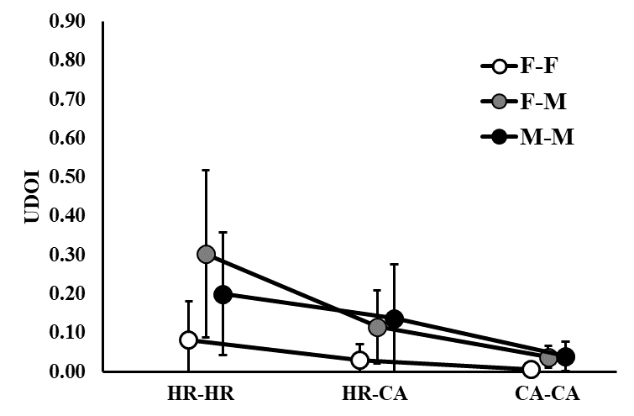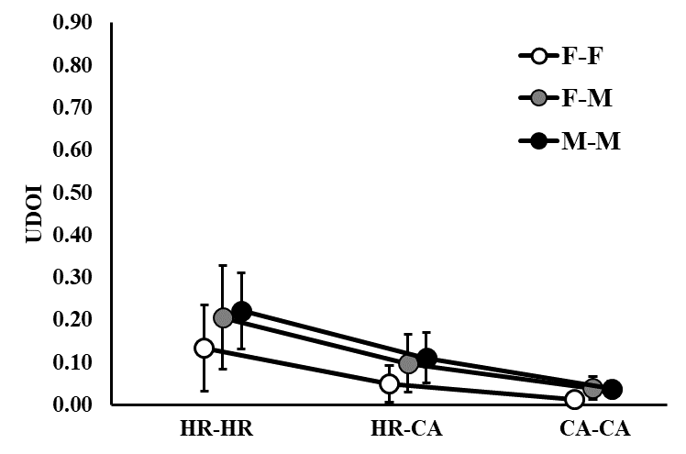
c. Wet 2016 d. Dry 2017
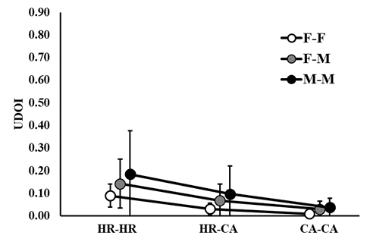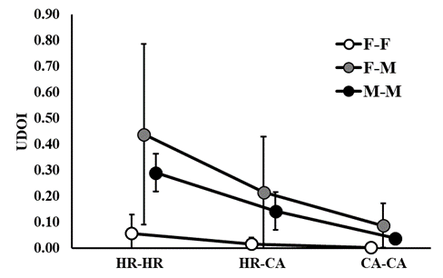
e. Wet 2017
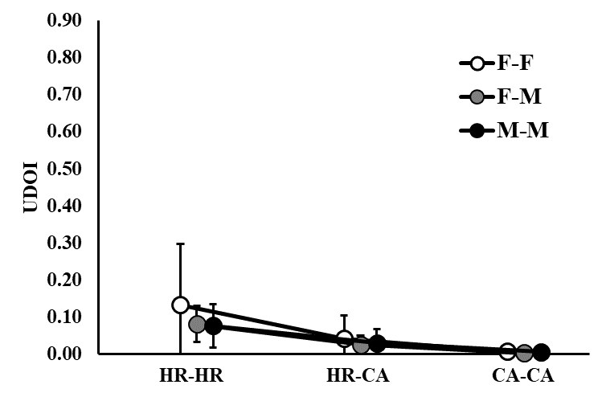
Figure S1. Average space-use overlap (measured by utilization distribution of overlap index (UDOI)) estimates with associated 95% confidence intervals for wild pigs at Buck Island Ranch, FL in the Wet 2015 (a.), Dry 2016 (b.), Wet 2016 (c.), Dry 2017 (d.), and Wet 2017 (e.) seasons. Female-female (F-F), female-male (F-M), and male-male (M-M) interactions are shown the home range to home range (HR-HR), home range to core area (HR-CA) and core area to core area (CA-CA) space-use levels.
- Wet 2015 b. Dry 2016
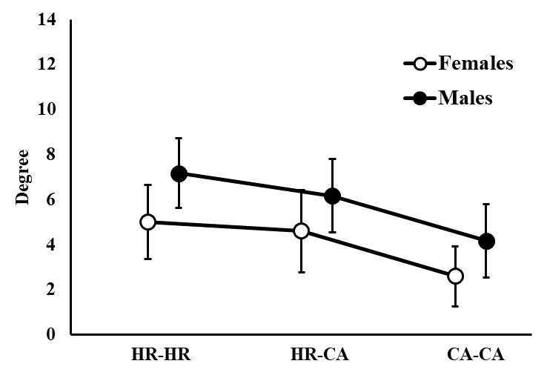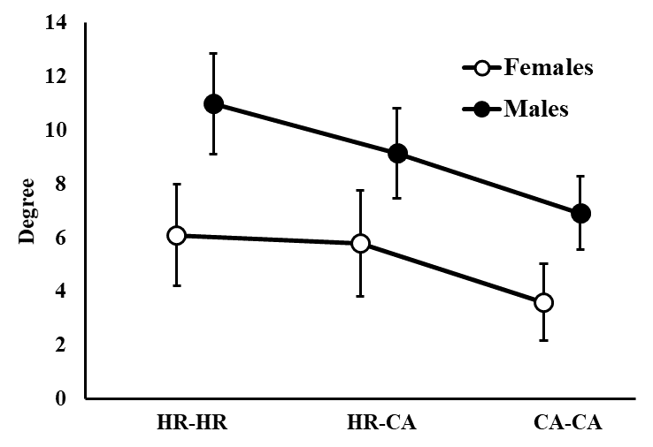
c. Wet 2016 d. Dry 2017
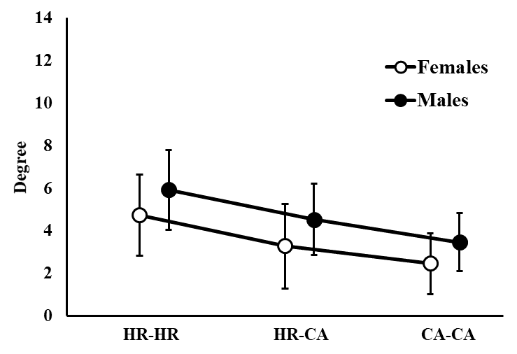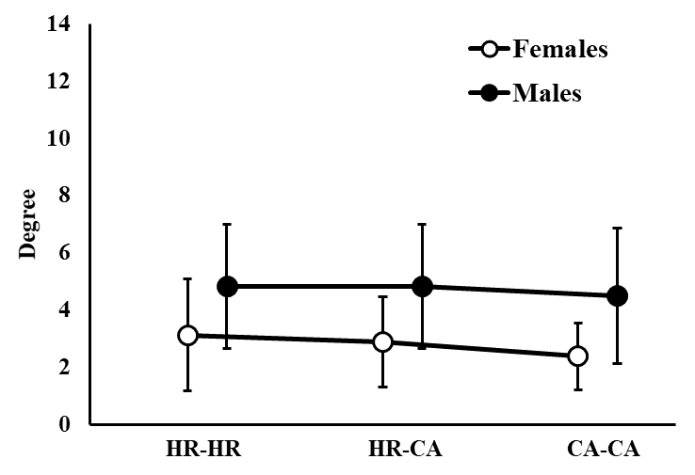
e. Wet 2017
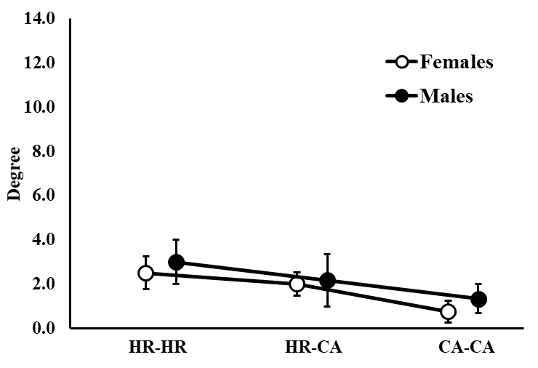
Figure S2. Average degree with associated 95% confidence intervals for wild pigs at Buck Island Ranch, FL in the Wet 2015 (a.), Dry 2016 (b.), Wet 2016 (c.), Dry 2017 (d.), and Wet 2017 (e.) seasons. Estimates were created for males and females for home range to home range (HR-HR), home range to core area (HR-CA) and core area to core area (CA-CA) interactions.

