Supporting Information

70-year anthropogenic uranium imprints of nuclear activities in Baltic Sea sediments

Mu Lin1, Jixin Qiao*,1, Xiaolin Hou1, Olaf Dellwig2, Peter Steier3, Karin Hain3, Robin Golser3, and Liuchao Zhu1

1Department of Environmental Engineering, Technical University of Denmark, DTU Risø Campus, DK-4000 Roskilde, Denmark

2Department of Marine Geology, Leibniz Institute for Baltic Sea Research Warnemünde, IOW, 18119 Rostock, Germany

3VERA Laboratory, Faculty of Physics, Isotope Physics, University of Vienna, Währinger Straße 17, A-1090 Vienna, Austria

*Corresponding Author: Phone: +45 46775367; e-mail: jiqi@env.dtu.dk.

This 28-page Supporting Information file includes supplementary text for methods, calculations and discussions, 9 figures, 6 tables, and SI references.

1. Details for the Analytical Methods

**1.1 Dating for sediment cores**

Because the commonly used 210Pb dating method was compromised especially by redox-driven Mn shuttling partly causing negative 210Pb values (**Fig. S3**), an event-stratigraphic approach was applied to the Gotland Basin sediment core 7-MUC4 and the Landsort Deep composite core 11-10MUC2/36-MUC3 obtained in this work. This dating approach has been successfully utilized in the previous studies on the Mn-rich sediments from the Landsort Deep and the Gotland Basin.1–3

In the depth profiles of the Gotland Basin sediment core 7-MUC4, ten time markers were identified through geochemical and radiological analyses, including the Mn enrichments following the Major Baltic Inflows (1978, 1994, 2003, and 2014), Chernobyl-accident-derived 137Cs and 241Am peaks (1986), initial and maximum global-fallout-derived 241Am (1954 and 1963), maximum Pb pollution identified by stable 206/207Pb ratios (1970 - 1978), and onset of modern Hg pollution reflected by Hg/Al ratios (1950) (**Fig. S1**). Constant sedimentation rates were assumed between ten allocated time markers, and the resulting age-depth relation are presented in **Fig. S2**. As the observational uncertainty depends on the sample resolution and sedimentation rate, different dating uncertainties were assigned to different sections along the core**.**

Dating of the Landsort Deep composite core 11-10MUC2/36-MUC3 is following the similar approach but a bit more complicated. The age model for the short core 36-MUC3 was originally developed by Häusler et al..1 Five basic time markers were identified in the depth profiles of 206/207Pb isotope ratios, 241Am and 137Cs activities by the Pb pollution, Chernobyl accident, and nuclear weapons testing (blue arrows in **Fig. S3**). The authors concluded that longer-lasting but non-sulfidic water column conditions represent an important prerequisite for exceptional Mn carbonate formation in the surface sediments, which forms one of the most prominent features in the study area. On the other hand, sediments deposited during periods of substantial sulfide presence in the water column are virtually free of Mn carbonate. Encouraged by these findings, additional time markers were identified by the comparison of the instrumental O2/H2S time-series and the sedimentary Mn signatures, which is apparently closely related to the water column redox changes (red arrows in **Fig. S3**). In addition, one time marker was recognized by a drop in U burial resulting from a short-term water column oxygenation in 2004 - 2006. The combined age-depth relation of the basic and additional time markers for core 36-MUC3 is shown in **Fig. S4.**

For dating of core 11-10MUC2 obtained at the same site, the developed age model of core 36-MUC3 was transferred to the new core 11-10MUC2 by using Mn, U/Al, 137Cs, and 206/207Pb signatures (**Fig. S5**). This parallelization was based on similar signatures of the geochemical records, which allowed the identification of twenty-nine time markers for the construction of the age model for the core 11-10MUC2. The depth profile of the core 11-10MUC2 was extended to the mid-1940s by adding six samples from core 36-MUC3, and the age-depth relation of the composite core 11-10MUC2/36-MUC3 is presented in **Fig. S6**. Although the transferred age model suffers from potential changes in sedimentation rates and the ingrowth of diagenetic minerals, the dated sedimentary Mn contents of the composite core 11-10MUC2/36-MUC3 and O2/H2S time-series from the water column of the Landsort Deep (ICES Dataset on Oceanography) agreed well (**Fig. S7**).

**1.2 Determination of Al, Hg, Mn, U contents, 206/207Pb ratios and TOC in the sediments**

Sedimentary Al, Mn, and U contents, as well as stable Pb isotopes, in the Baltic Sea sediment cores were analyzed after acid dissolution of ~50 mg of freeze-dried and homogenized sediment aliquots. The sediment sample was weighed and digested in closed Teflon vessels at 180°C for 12 h using a mixture of 1 mL HNO3 (65%, analytical grade, purified by sub-boiling distillation system, Merck), 2 mL HClO4 (70%, suprapure quality, Roth), and 2 mL HF (48%, suprapure quality, VWR). After evaporation to near-dryness, residues were fumed-off three-times with 6 M HCl (suprapure quality, Merck) and finally diluted with 50 mL of 2 vol% HNO3.4 The U contents were determined by inductively coupled plasma mass spectrometry (ICP-MS, iCAP Q, Thermo Fisher Scientific) coupled to a PrepFast system (Elemental Scientific) allowing online dilution of the external calibration stock solution and the acid-digestion solutions as well as the online addition of the internal standard (Ir). After automated dilution of the acid digestions to Pb concentrations of about 1 µg L-1 by the PrepFast system, 206Pb and 207Pb were also measured by ICP-MS. Instrument performance was optimized for the international reference material NIST SRM-981 giving a precision and accuracy of 0.31% and -0.04%, respectively. The contents of Al and Mn were measured by inductively coupled plasma optical emission spectrometry (ICP-OES, iCAP 7400 Duo, Thermo Fisher Scientific) using external calibration and internal standard (Sc). Analytical precision and accuracy of the U, Al, and Mn measurements were checked by the reference material SGR-1b (USGS), which were better than 4% and 2%, respectively. The Hg contents were measured by a direct mercury analyzer (DMA-80; Milestone). Precision and accuracy were monitored with the reference materials BCR-142R (CBR) and TH-2 (NWRI, Canada) and were better than 3.3% and -1.5%, respectively. The total organic carbon (TOC) contents in the Baltic Sea sediment cores were calculated by the differences between total carbon (TC) and total inorganic carbon (TIC) contents determined by elemental analyzers (TC: Euro EA, Euro Vector; TIC: multi EA 2000, Analytik Jena) using pre-treatment with 50 vol% H3PO4 (analytical grade, Merck) in case of TIC.

**1.3 Determination of dissolved U, particulate U, and sulfide in seawater and porewater**

The concentrations of dissolved U in the water column and porewaters were measured by ICP-MS coupled to a sea*FAST*-pico system (Elemental Scientific) for matrix removal and pre-concentration, which was previously applied for Mo and W.4 Analytical precision and accuracy for the dissolved U measurements in the reference materials NASS-7 and CASS-6 (NRCC) were better than 4% and 5%, respectively. Except for pre-treatment with 1 mL HClO4 for 1 h at 150 °C to decompose the polycarbonate filter material before total acid digestion, the U concentrations of the suspended particulate matter from the water column at site LD 1 were determined in the same way as the sediment samples. Total sulfide in porewater and water column samples was determined by the Cline (1969) method.5

**1.4 Determination of 236U/238U and 233U/238U and 233U/236U atomic ratios in the sediments**

The atomic ratios of 236U/238U and 233U/238U in the Baltic Sea sediment cores were analyzed by accelerator mass spectrometry (AMS) with an optimized radiochemical procedure modified from our previous work.6,7 As strong acids are able to leach anthropogenic 236U from soil and sediments quantitatively,8,9 acid digestion with *Aqua regia* (HCl: HNO3=3:1, v/v) rather than total dissolution was adopted in our procedure to deal with gram amounts of sediment samples. About 93% and 84% of 238U in the Gotland Basin and Landsort Deep cores (obtained by total dissolution using HNO3-HClO4-HF) were leached by *Aqua regia* digestion, respectively. A leaching experiment on core 7-MUC4 indicates that a single *Aqua regia* digestion is enough to extract >99% of leachable 238U and 236U from the sediments (**Table S6**).

Specifically, 1- 10 g aliquots of homogenized sediment was weighed to a semi-closed flask and ashed at 550 ℃ for 12h. After adding 60-100 mL of *Aqua regia* (HCl: HNO3=3:1 (v/v), 37% and 65%, analytical grade, purified by sub-boiling distillation system, VWR), the sample was heated on a hot plate at 150 ℃ for 0.5 h and then 200 °C for 2 h. The leachate was filtrated through a glass microfiber filter (Whatman), and the residue was rinsed with 10 mL of 0.5 M HNO3 for three times. After weighing, the leachate was adjusted to pH = 8 - 9 by gradually adding 25% NH3·H2O solution to co-precipitate uranium with Fe(OH)3. After centrifuging at 3000 rpm for 10 min, the supernatant was discarded. The co-precipitate was dissolved with 16 mL of 65% HNO3 and the solution was diluted with ultrapure water to a final concentration of 3 M HNO3. The sample solution was loaded to a 2 mL of UTEVA column pre-conditioned with 20 mL of 3M HNO3. The column was rinsed with 20 mL of 3 M HNO3 twice and then 20 mL of 6 M HCl to remove the matrix elements and interferences. Uranium was eluted from the column with 10 mL of 0.025 M HCl. After addition of 2 mg of Fe3+, the eluate was adjusted to pH = 8 - 9 to co-precipitate uranium with Fe(OH)3. The precipitate was dried in an oven at 90 °C for 4 h and then baked in a furnace at 800 °C for 12 h. Finally, uranium incorporated in a Fe2O3 matrix was pressed into an aluminum sputter target holder for the AMS measurement. Procedure blanks were prepared for each batch of 7 samples following the same analytical protocol as mentioned above, and 100 mg of Fe3+ as carrier was added in the *Aqua regia* digestion before co-precipitation. All of nine procedure blanks contained less than 5.3 ng of 238U, 1.8 × 106 atoms of 236U, and 9.6 × 104 atoms of 233U, which were negligible compared with minimum amounts of 238U, 236U, and 233U in the sediment samples except for the lowermost layer.

To avoid introduction of extra 236U and 233U, 238U in the *Aqua regia* leachate was used as an intrinsic chemical yield tracer instead of additional 233U or 232U standard solution, and our radiochemical procedure provided satisfactory chemical yields (80 - 100%) for 236U and 233U. Specifically, 238U concentrations were measured in 100 μL of *Aqua regia* leachate and final uranium eluate from the UTEVA column using an ICP-MS (Agilent, 8800 Triple Quadrupole ICP-MS) after proper dilution with 0.5 M HNO3.In or Bi solution was added as internal standard. Relative measurement uncertainty of 238U in the leachates and eluates was 1 - 10 %.

The 236U/238U and 233U/238U atomic ratios in the sputter targets were measured using AMS at the Vienna Environmental Research Accelerator (VERA) facility at the University of Vienna, and the detailed method and instrument configuration has been reported elsewhere.10,11 Due to the existence of 236U or 233U in procedure blanks, the actual 236U/238U or 233U/238U atomic ratios in the original sample (Rs236(233)) were calculated for blank correction according to the following equations:

$$R_{S}^{236(233)}=\frac{R_{m}^{236(233)}m_{m,elu}-R_{b}^{236(233)}m_{b,elu}}{Ym_{t}} (1)$$

$$Y=\frac{m_{m,elu}-m_{b,elu}}{m_{m,lea}-m_{b,lea}} (2)$$

where Rm236(233) and Rb236(233) are the 236U/238U or 233U/238U atomic ratios measured in the sample and blank targets; mm,elu and mb,elu are the 238U masses in the eluate of sample and blank, which equal to the masses of eluate times the 238U concentrations in the eluate measured by ICP-MS; mt is the total mass of 238U in the sample aliquot, which equals to the mass of sample aliquot times the 238U concentration in the sample determined by ICP-MS after total acid digestion; Y is the chemical yield of the radiochemistry procedure; mm,lea and mb,lea are the 238U masses in the leachate of sample and blank, which equal to the leachate masses times 238U concentrations in the leachate of sample and blank measured by ICP-MS. It should be noted that AMS cannot determine absolutely the amount of 238U in the sample target. Our previous work indicated that the chemical yield of uranium in target preparation normally exceeds 97%,6 thereby the 238U mass in the sputter target was assumed to equal to the 238U mass in the eluate.

After the blank correction of the 236U/238U and 233U/238U atomic ratios, the 233U/238U atomic ratios in sediment samples can be calculated by Rs233/236 = Rs233 / Rs236.

**1.5 Background control measures for 236U and 233U analyses**

In order to reduce the background level of 236U and 233U in the procedure blanks, several measures were implemented,7 including:

(1) Except for 25 wt% NH3·H2O solution (analytical grade, VWR), all the reagents involved in this work were suprapure quality or purified in different ways. A sub-boiling distillation system were utilized for the purification of analytical grade concentrated HCl (37%, VWR) and HNO3 (65%, VWR or 65%, Merck). 0.05 g/mL Fe solution prepared by dissolving FeCl3·6H2O (analytical grade, Sigma-Aldrich) in 3 M HNO3 was purified by a UTEVA column (100-150 μm, Triskem International).

(2) All sample preparation steps were performed in a laminar flow bench (Safe 2020, Thermo Fisher Scientific) or with enclosed labware to avoid any possible 236U and 233U contamination from ambient dusts.

(3) Teflon and disposable labware replaced most of ordinary glassware to reduce potential cross-contamination in the experiment, and the reusable labware were cleaned by boiling with 6 M HCl to remove any adsorbed uranium after each usage.

**1.6 Determination of 137Cs and 241Am activities in the sediment**

In order to determine the 137Cs and 241Am activities in the Baltic Sea sediment cores, 2 - 15 g of sediment aliquots were packed in the petridishes and directly measured by gamma spectrometry using high-purity germanium (HPGe) detectors. The relative uncertainties of 137Cs measurement results were better than 40% and 10% for the layers before and after 1960, respectively.

2. Details for the Calculations

**2.1 Quantification of anthropogenic 236U from different sources**

As discussed in the main text, the main source term of 236U in the Baltic sediments before the late 1960s should be global fallout (when 233U/236U > 1.4 × 10-2). Since the mid-to-late 1960s, a two end-member linear mixing model is adopted to calculate the contributions of global-fallout-derived and reactor-derived 236U to the total 236U in the sediment based on the atomic ratio of 233U/236U (eq. 3-4). 1.4 × 10-2 and 10-6 are considered as the representative 233U/236U atomic ratios for the endmembers of global-fallout-derived and reactor-derived 236U, respectively.11,12 In addition, the Chernobyl-derived 236U is estimated separately by the difference of reactor-derived 236U/238U atomic ratios before and after the accident in the Landsort Deep composite core. We assume that there is no Chernobyl-derived 236U in the Gotland Basin sediment core as no significant different 236U/238U and 233U/236U are observed in ~1986 segment.

$$R_{S,GF}^{236}=\frac{R_{S}^{233/236}-R_{NR}^{233/236}}{R_{GF}^{233/236}-R_{NR}^{233/236}}R_{S}^{236} (3)$$

$$R_{S,NR}^{236}=\left(1-\frac{R_{S}^{233/236}-R_{NR}^{233/236}}{R_{GF}^{233/236}-R_{NR}^{233/236}}\right)R_{S}^{236} (4)$$

where $R_{S, GF}^{236}$ and $R_{S,NR}^{236}$ represent the global-fallout-derived and reactor-derived 236U/238U atomic ratios in the sediment sample; $R_{S}^{233/236}$ and $R_{S}^{236}$ refer to the 233U/236U and 236U/238U atomic ratios in the sediment sample; $R_{GF}^{233/236}$ and $R_{NR}^{233/236}$ are the representative 233U/236U atomic ratios for global fallout-derived and reactor-derived signals, which are 1.4 × 10-2 and 10-6, respectively.

**2.2 Calculation of effective half-life of global-fallout-derived 236U**

The effective half-life of global-fallout-derived 236U in marine waters reflects the net elimination rate of global-fallout-derived 236U in these reservoirs taking all inputs, outputs, dispersion, and sinks into account. An exponential curve regression was adopted to the recent 40-year records of (global-fallout-derived) 236U/238U atomic ratios in the sediment and coral cores,13–15 resulting in the following functions:

$Landsort Deep \left(Baltic Sea\right): R_{GF}^{236}=14.6 ×{10}^{-9}×e^{-0.0210\left(t-1980\right)} \left(R^{2}=0.889\right)$ (3)

$Gotland Basin \left(Baltic Sea\right): R_{GF}^{236}=18.7 ×{10}^{-9}×e^{-0.0332\left(t-1980\right)} \left(R^{2}=0.804\right)$ (4)

$Belize (Caribbean Sea): R_{GF}^{236}=1.27 ×{10}^{-9}×e^{-0.0043\left(t-1980\right)} \left(R^{2}=0.180, not adopted\right)$ (5)

$Iki Island (Japan Sea): R_{GF}^{236}=1.83 ×{10}^{-9}×e^{-0.0128\left(t-1980\right)} \left(R^{2}=0.966\right)$ (6)

$Kume Island \left(Northwest Pacific\right): R_{GF}^{236}=1.99 ×{10}^{-9}×e^{-0.0236\left(t-1980\right)} \left(R^{2}=0.859\right)$ (7)

where $R_{GF}^{236}$ refers to the global-fallout-derived 236U/238U atomic ratios in the sediment or coral core, t refers to the dating result of a specific layer.

According to the regression functions, the effective half-lives of global-fallout-derived 236U () in the marine waters could be calculated as below:

$Landsort Deep \left(Baltic Sea\right): T_{½,GF}^{236}={\ln\left(2\right)}/{0.0210}=33.0 ±2.3 years$ (8)

(9)

(10)

(11)

3. Supplementary Discussions

**3.1 Scavenging processes of U**

Water-column and porewater profiles obtained in the Gotland Basin and Landsort Deep in 2018 (**Fig. 2** and **Fig. S8**) clearly document the scavenging of U from water column to the sediments, as indicated by: i) 10 - 20% offsets between the dissolved U concentrations and salinity-based values calculated from the U-salinity correlation;16 ii) increasing concentrations of particulate U below the redoxcline (O2 < 3 μM and sulfide < 0.2 μM, grey bars in **Fig. 2** and **Fig. S8**);1,17 and iii) the steep gradient of decreasing dissolved U concentrations in the highly sulfidic porewater within the uppermost 10 - 15 cm of sediment. Thermodynamics calculation indicates that the soluble U(VI) can be reduced to insoluble U(IV) in reductive condition (e.g., if H2S is present),18 and the formed U(IV) is easily adsorbed on suspended particles and deposited on the seabed. Hence, the above-mentioned results imply two scavenging processes of U during sulfidic water-column periods: i) the redox-driven removal of dissolved U from the sulfidic water column to the sediment as particulate forms;19 and ii) the diagenesis-driven removal of dissolved U in the sulfidic porewater environment mediated through reductants, facilitating the diffusion of dissolved U from bottom water to the porewater.20–26

**3.2 Areal inventory of 233U from the direct deposition of global fallout**

To estimate the total amount of global fallout 233U, we calculated the areal cumulative inventories of 233U in the peat core ((1.15 ± 0.10) × 1011 atom/m2), Gotland Basin sediment core ((2.42 ± 0.15) × 1011 atom/m2), and Landsort Deep composite core ((2.85 ± 0.12) × 1011 atom/m2). The gentler declines of 233U/238U atomic ratios in the Baltic Sea sediment cores than the peat core indicate that besides direct atmospheric deposition, the sediments continuously received 233U from the scavenging processes mentioned above. The scavenged 233U can originate from the dissolve faction of 233U fallout deposited locally or transported from the North Sea and catchment. The areal cumulative inventories of 233U before 1970 (the end of intensive global fallout) in the Gotland Basin Sediment core ((5.46 ± 0.32) × 1010 atom/m2) and the Landsort Deep composite core ((7.21 ± 0.36) × 1010 atom/m2) are estimated to be the upper limits of the atmospheric 233U deposition in the Baltic region. Hence, the representative areal inventory of 233U from the direct deposition of global fallout is estimated to be (5 - 12) × 1010 atom/m2 in the Northern European region.

**3.3 Interpretations behind the records of peat, coral, and sediment cores**

233U/236U atomic ratios in different records have different interpretations. The corals can retain the dissolved U isotopes in the seawater in their carbonate skeleton with year ring structure, and the 233U/236U atomic ratio in the coral record reveals the integrated ratio of soluble 236U and 233U (e.g. dissolved fraction of global fallout and discharges from civil nuclear industry) cumulated in the marine waters at a specific time. While the peat core can only receive the atmospheric deposition of 236U and 233U and preserve the signals chronologically. For a reasonable comparison, the 233U/236U atomic ratio in the peat record was re-calculated in this work to reflect the integrated ratio of the cumulative inventories of 233U and 236U below the referred depth. The sediment cores can retain not only the soluble 236U and 233U in the water column by scavenging processes but also the particulate 236U and 233U fallout from direct atmospheric deposition. As the particulate fallout has limited remobilization in the anoxic sediments, it is possible to reconstruct the historical levels of 233U/236U atomic ratios in water column from the sedimentary records if the inputs from direct atmospheric deposition can be identified based the depth-profile pattern (e.g. Chernobyl signal).

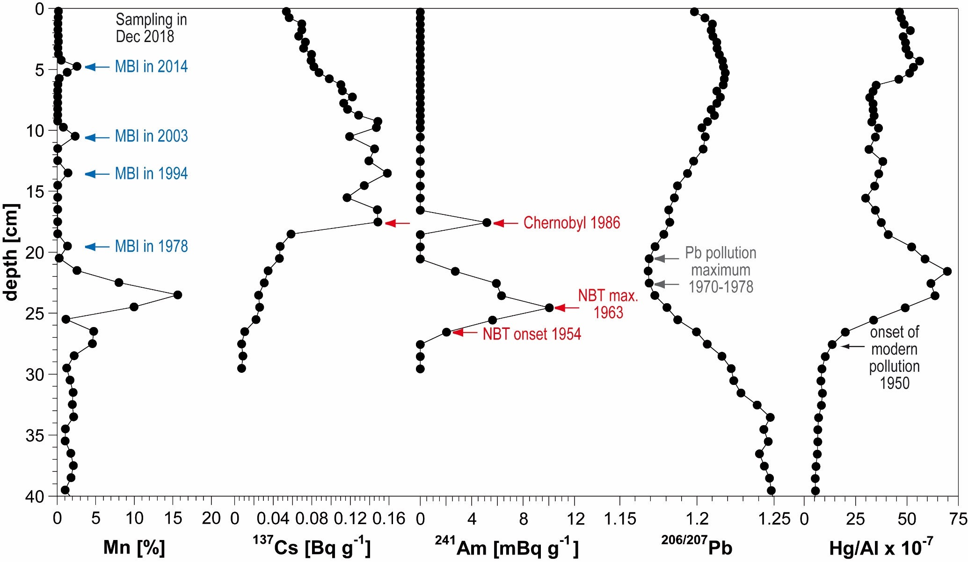

**Fig. S1**. Depth profiles of Mn contents, Al-normalized 137Cs (decay-corrected to 2019) and 241Am activities, 206/207Pb isotopic ratios and Al-normalized Hg contents in the sediment core 7-MUC4 collected in the Gotland Basin in December 2018.

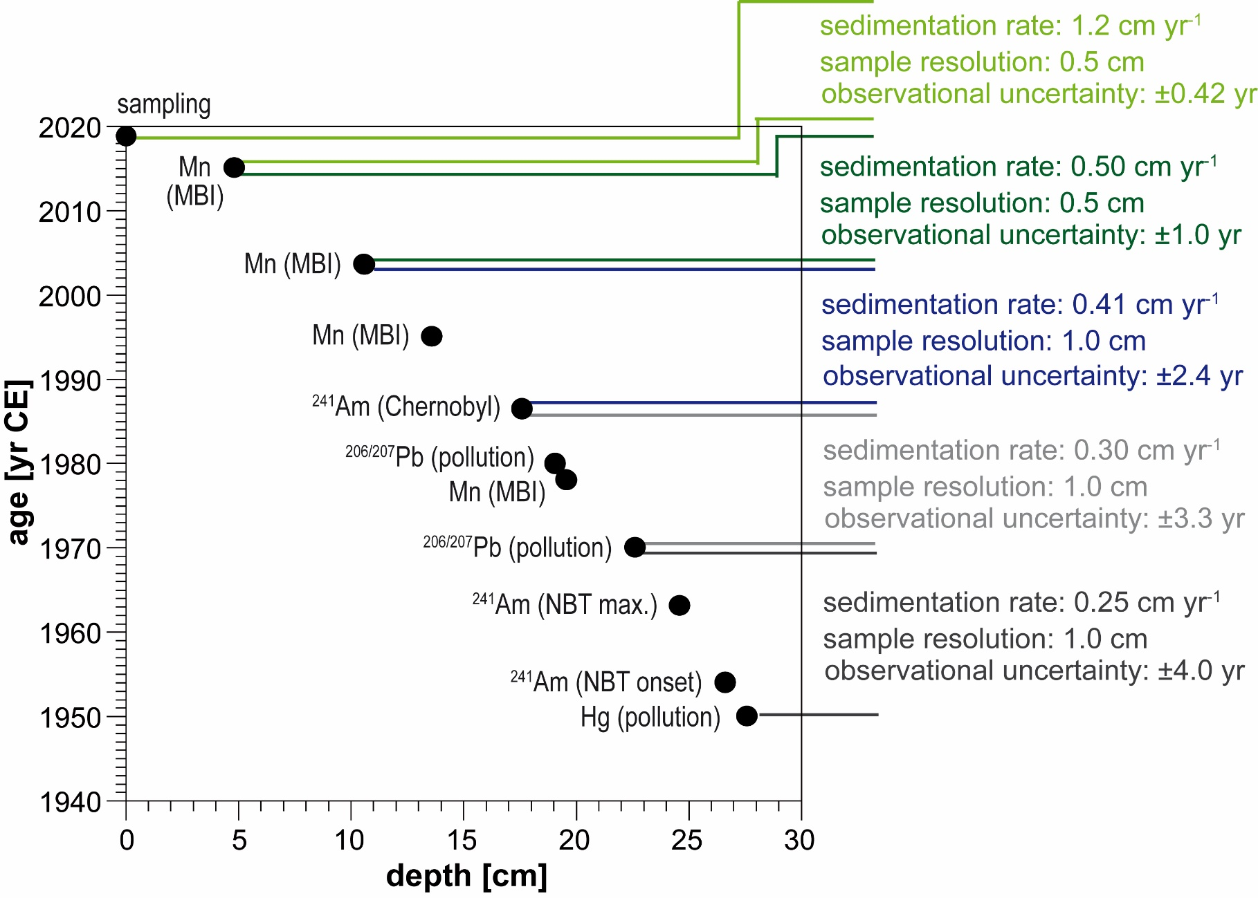

**Fig. S2**. The age-depth relation for the Gotland Basin sediment core 7-MUC4 based on individual time markers showing resulting sedimentation rates and observational uncertainty, respectively.

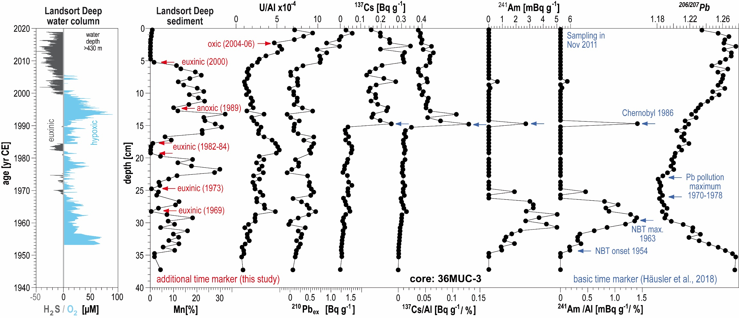

**Fig. S3**. Instrumental time series of O2/H2S in the Landsort Deep below 430 m water depth (ICES Dataset on Oceanography) (17), and the depth profiles of Mn contents, Al-normalized U contents, excess 210Pb (210Pbex) and 137Cs activities, Al-normalized 137Cs and 241Am activities, and 206/207Pb isotopic ratios in the Landsort Deep sediment core 36-MUC3 collected in November 2011. Except for U, sediment data originate from Häusler et al. (2018) (3). The basic and additional time markers have been labeled as blue and red arrows, respectively.

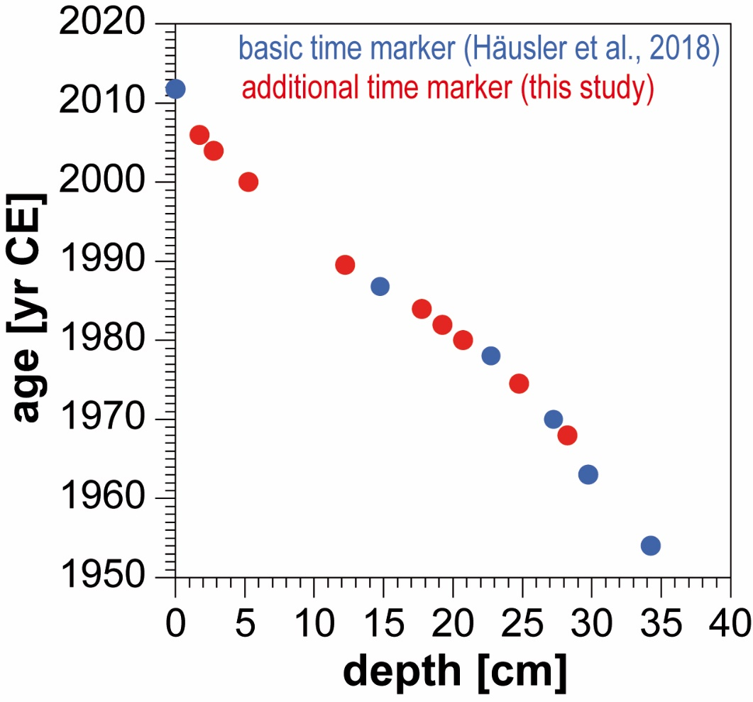

**Fig. S4**. The combined age-depth relation of the basic (blue dots) and additional (red dots) time markers for the Landsort Deep sediment core 36-MUC3.

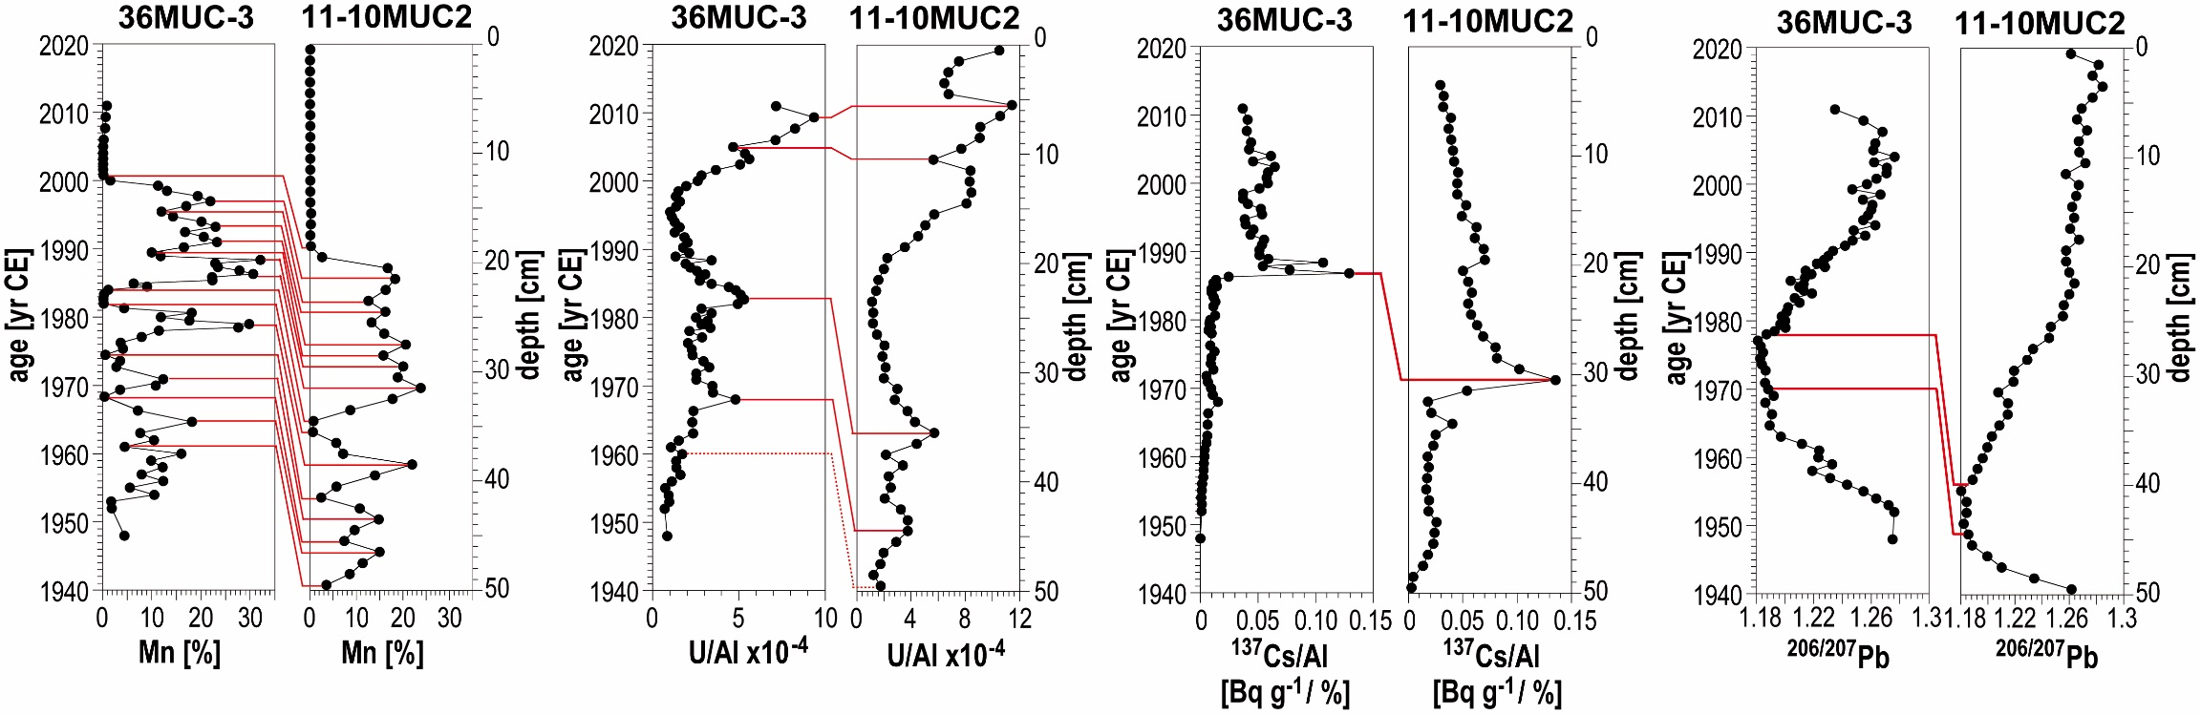

**Fig. S5.** Transfer of the age model from the dated core 36-MUC3 to sediment core 11-10MUC2 obtained in December 2018. The parallelization of time markers was achieved by the comparisons of sedimentary records of Mn contents, Al-normalized U contents, Al-normalized 137Cs activities (decay-corrected to 2019 in core 11-10MUC2), and 206/207Pb isotopic ratios. Both sediment cores originate from the same site LD1, the Landsort Deep (Baltic Sea).

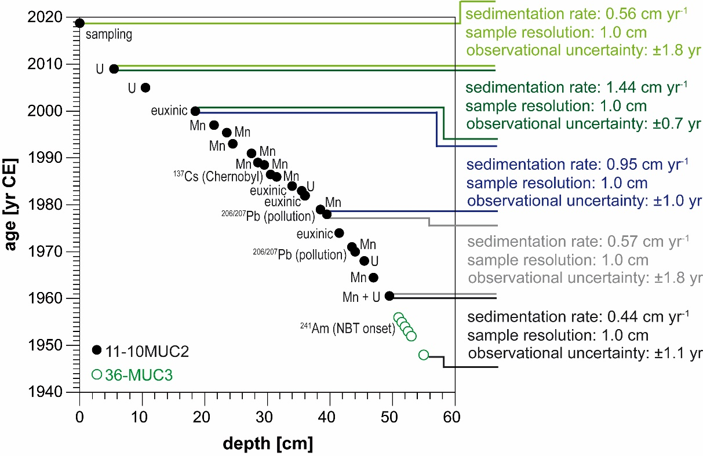

**Fig. S6**. The resulting age-depth relation for the Landsort Deep composite core 11-10MUC2/36-MUC3, among which six complementary samples are from the core 36-MUC3 to extend the covered time period. Sedimentation rates and observational uncertainties resulted from linear interpolation between the individual time markers.

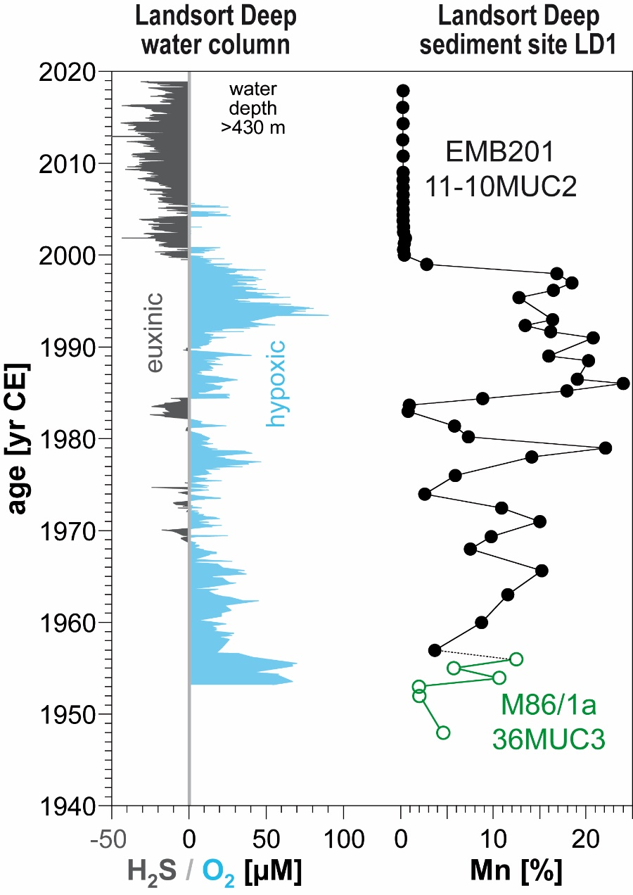

**Fig. S7.** Comparison between the instrumental time series of O2/H2S in the Landsort Deep below 430 m water depth (ICES Dataset on Oceanography) (17) and the depth profile of Mn contents in the dated Landsort Deep composite core 11-10MUC2/36-MUC3. The black and open green dots represent core 11-10MUC2 and core 36-MUC3, respectively.



**Fig. S8. Comparison of water-column time series and the sedimentary record, as well as water column and pore water profiles from the Landsort Deep, Baltic Sea.** (A) Instrumental water-column time series of O2 and total sulfide in the Gotland Basin (ICES Dataset on Oceanography) (17); (B) Record of U contents in the sediment core 11-10MUC2 collected at site LD1 (58°38.36'N, 18°16.04'E) in the Landsort Deep; (C) Profiles of salinity, concentrations of O2, total sulfide, particulate and dissolved U (green dot line = salinity-based U concentrations) in the water column at site LD1; (D) Concentrations of total sulfide and dissolved U in the pore waters at site LD1. The grey bar in (C) represents the redoxcline (O2 < 3 μM and sulfide < 0.2 μM) in the water column. The sediment core 11-10MUC2, water column, and pore water samples were obtained during EMB201 cruise in December 2018.



**Fig. S9. Contemporary comparison of global-fallout-derived (GF-derived) 236U/238U atomic ratios.** Sediment cores were obtained in the Gotland Basin and Landsort Deep (Baltic Sea) and coral cores were collected in the Caribbean Sea, the Japan Sea and the Northwest Pacific Ocean (14–16).

**Table S1. Overview of the resolved records of 236U and 233U in the published and present studies.** (PPG: Pacific Proving Grounds; SF: Sellafield; LH: La Hague)

|  |  |  |  |  |  |  |  |  |  |
| --- | --- | --- | --- | --- | --- | --- | --- | --- | --- |
| **Sample**  **description** | **Time**  **range** | **Sources** | **236U/238U**  **atomic ratio**  **[×10-9]** | **236U**  **areal inventory**  **[atom/m2]** | **236U input**  **[kg]** | **233U/238U**  **atomic ratio**  **[×10-11]** | **233U**  **areal inventory**  **[atom/m2]** | **233U input**  **[kg]** | **Reference** |
| Coral core  (Belize, Caribbean Sea) | 1944 - 2006 | Global fallout;  close-in fallout (PPG) | < 0.01 - 1.84 | / | 1060 (Global fallout);  240 (Close-in fallout) | / | / | / | (18) |
| Coral core  (Iki Island, Japan Sea) | 1935 - 2010 | Global fallout;  close-in fallout (PPG) | 0.10 - 6.15 | / | / | / | / | / | (28) |
| Shell  (Traeth Melynog, Irish Sea) | 1971 - 2018 | Global fallout;  reprocessing plant (SF) | 62.0 - 1.74 × 103 | / | > 237 (SF, after 1970) | / | / | / | (19) |
| Shell  (Balgzand, Wadden Sea) | 1967 - 2017 | Global fallout;  reprocessing plant (LH) | 13.3- 1.60 × 102 | / | 25 (LH) | / | / | / | (19) |
| Coral core  (Kume Island, Northwest Pacific Ocean) | 1940 - 1970 | Global fallout;  close-in fallout (PPG) | 0.05 - 10.5 | / | / | < 0.2 - 15.7 | / | / | (14, 27) |
| Peat core  (Black Forest, Germany) | 1917 - 1992 | Global fallout | 7.2 × 102 - 9.20 × 103 | (5.57 ± 0.35) × 1012 | / | 1.1 × 102 - 1.78 × 104 | / | / | (14, 49) |
| Sediment core  (Gotland Basin, Baltic Sea) | 1940 - 2018 | Global fallout;  reprocessing plants and local facilities | 0.47 - 35.9 | (1.53 ± 0.10) × 1013 (global fallout);  (2.00 ± 0.29) × 1013 (civil nuclear industry) | / | 2.72 - 36.3 | (2.42 ± 0.15) × 1011 | 7 - 15  (Global fallout) | This work |
| Sediment core  (Landsort Deep, Baltic Sea) | 1946 - 2018 | Global fallout;  Chernobyl accident;  reprocessing plants and local facilities | 0.23 - 51.5 | (1.60 ± 0.07) × 1013 (global fallout);  (1.57 ± 0.17) × 1013 (Chernobyl accident & civil nuclear industry) | / | 0.27 - 40.8 | (2.66 ± 0.11) × 1011 | 7 - 15  (Global fallout) | This work |

Table S2. Leaching experiment of the Baltic Sea sediments. In the leaching experiment, the first *Aqua regia* digestion was performed on six samples of core 7-MUC4. After filtrating the leachates and resining the residues, a second *Aqua regia* digestion was conducted for the residues. The leaching rate is calculated as the ratio of leached 238U from each *Aqua regia* digestion and total sedimentary 238U obtained by total dissolution using HNO3-HClO4-HF digestion.

|  |  |  |  |  |  |
| --- | --- | --- | --- | --- | --- |
| **Sample** | **Depth**  **[cm]** | **Leached 238U**  **[μg/g-sediment]** | **Leached 236U**  **[atoms/g-sediment]** | **Leaching rate**  **[%]** | |
| **First *Aqua regia* digestion (sediment)** | | | | |
| 7-MUC4_8.25 | 8 - 8.5 | 48.3 ± 0.8 | (2.23 ± 0.04) × 109 | 94.3 | |
| 7-MUC4_8.75 | 8.5 - 9 | 46.4 ± 0.7 | (2.12 ± 0.04) × 109 | 94.9 | |
| 7-MUC4_9.25 | 9 - 9.5 | 33.3 ± 0.4 | (1.50 ± 0.04) × 109 | 88.0 | |
| 7-MUC4_16.5 | 16 - 17 | 35.0 ± 0.7 | (3.29 ± 0.09) × 109 | 93.1 | |
| 7-MUC4_17.5 | 17 - 18 | 34.8 ± 0.7 | (3.42 ± 0.19) × 109 | 92.6 | |
| 7-MUC4_18.5 | 18 - 19 | 36.9 ± 0.5 | (3.46 ± 0.28) × 109 | 91.0 | |
| **Second *Aqua regia* digestion (residue of first digestion)** | | | | |
| 7-MUC4_8.25 | 8 - 8.5 | 0.076 ± 0.037 | < 9.61 × 105 | 0.1 | |
| 7-MUC4_8.75 | 8.5 - 9 | 0.062 ± 0.041 | < 7.25 × 105 | 0.1 | |
| 7-MUC4_9.25 | 9 - 9.5 | 0.103 ± 0.039 | < 7.44 × 105 | 0.3 | |
| 7-MUC4_16.5 | 16 - 17 | 0.171 ± 0.011 | (7.74 ± 1.51) × 106 | 0.5 | |
| 7-MUC4_17.5 | 17 - 18 | 0.165 ± 0.015 | (2.06 ± 0.30) × 107 | 0.4 | |
| 7-MUC4_18.5 | 18 - 19 | 0.211 ± 0.015 | (1.72 ± 0.41) × 107 | 0.5 | |

Table S3. Measurement results of U, Mn, Al, TOC contents, and mass ratio of U/Al in the sediment core 7-MUC4 collected in the Gotland Basin, the Baltic Sea. The elemental and TOC contents are salt-corrected, and the analytical precisions are better than 5%.

| **Depth [cm]** | **Year [yr CE]** | **U [mg/kg]** | **Mn [%]** | **Al [%]** | **TOC [%]** | **U/Al [×10-4]** |
| --- | --- | --- | --- | --- | --- | --- |
| 0 - 0.5 | 2018.7 ± 0.4 | 31.3 | 0.28 | 2.71 | 19.7 | 11.5 |
| 0.5 - 1 | 2018.3 ± 0.4 | 28.2 | 0.22 | 2.73 | 21.1 | 10.3 |
| 1 - 1.5 | 2017.9 ± 0.4 | 26.4 | 0.18 | 2.86 | 20.7 | 9.25 |
| 1.5 - 2 | 2017.5 ± 0.4 | 24.0 | 0.17 | 3.07 | 20.4 | 7.82 |
| 2 - 2.5 | 2017.1 ± 0.4 | 25.2 | 0.22 | 3.07 | 20.3 | 8.20 |
| 2.5 - 3 | 2016.6 ± 0.4 | 22.9 | 0.23 | 3.11 | 20.0 | 7.37 |
| 3 - 3.5 | 2016.2 ± 0.4 | 20.0 | 0.18 | 3.21 | 19.9 | 6.24 |
| 3.5 - 4 | 2015.8 ± 0.4 | 19.2 | 0.25 | 3.20 | 19.9 | 5.98 |
| 4 - 4.5 | 2015.4 ± 0.4 | 18.3 | 0.74 | 3.22 | 19.1 | 5.69 |
| 4.5 - 5 | 2015.0 ± 0.4 | 17.0 | 3.42 | 3.34 | 16.5 | 5.09 |
| 5 - 5.5 | 2014.0 ± 1.0 | 16.4 | 1.75 | 3.38 | 16.5 | 4.84 |
| 5.5 - 6 | 2013.0 ± 1.0 | 21.8 | 0.37 | 3.41 | 16.7 | 6.39 |
| 6 - 6.5 | 2012.0 ± 1.0 | 47.4 | 0.17 | 3.58 | 17.6 | 13.2 |
| 6.5 - 7 | 2011.0 ± 1.0 | 65.7 | 0.11 | 3.57 | 18.3 | 18.4 |
| 7 - 7.5 | 2010.0 ± 1.0 | 66.2 | 0.10 | 3.58 | 17.9 | 18.5 |
| 7.5 - 8 | 2009.0 ± 1.0 | 68.2 | 0.09 | 3.48 | 18.8 | 19.6 |
| 8 - 8.5 | 2008.0 ± 1.0 | 65.6 | 0.09 | 3.42 | 18.0 | 19.2 |
| 8.5 - 9 | 2007.0 ± 1.0 | 62.4 | 0.10 | 3.69 | 17.3 | 16.9 |
| 9 - 9.5 | 2006.0 ± 1.0 | 47.3 | 0.10 | 4.32 | 15.9 | 11.0 |
| 9.5 - 10 | 2005.0 ± 1.0 | 31.4 | 1.01 | 4.58 | 14.7 | 6.87 |
| 10 - 11 | 2003.5 ± 2.4 | 37.5 | 2.91 | 4.50 | 12.9 | 8.35 |
| 11 - 12 | 2000.7 ± 2.4 | 44.1 | 0.11 | 4.29 | 14.5 | 10.3 |
| 12 - 13 | 1997.8 ± 2.4 | 39.9 | 0.09 | 4.33 | 15.6 | 9.21 |
| 13 - 14 | 1995.0 ± 2.4 | 32.2 | 1.67 | 5.06 | 11.6 | 6.37 |
| 14 - 15 | 1992.9 ± 2.4 | 26.5 | 0.08 | 4.94 | 12.7 | 5.36 |
| 15 - 16 | 1990.8 ± 2.4 | 41.6 | 0.10 | 4.78 | 13.8 | 8.71 |
| 16 - 17 | 1988.6 ± 2.4 | 44.0 | 0.09 | 4.72 | 12.6 | 9.32 |
| 17 - 18 | 1986.5 ± 2.4 | 43.5 | 0.09 | 4.95 | 11.9 | 8.79 |
| 18 - 19 | 1983.7 ± 3.3 | 47.2 | 0.08 | 4.75 | 11.7 | 9.94 |
| 19 - 20 | 1980.8 ± 3.3 | 39.8 | 1.60 | 4.72 | 10.3 | 8.44 |
| 20 - 21 | 1978.0 ± 3.3 | 25.8 | 0.33 | 4.17 | 11.4 | 6.18 |
| 21 - 22 | 1974.0 ± 3.3 | 22.4 | 3.10 | 3.50 | 10.3 | 6.39 |
| 22 - 23 | 1970.0 ± 3.3 | 17.8 | 9.22 | 3.05 | 7.90 | 5.82 |
| 23 - 24 | 1966.5 ± 4.0 | 17.4 | 17.5 | 2.58 | 6.79 | 6.77 |
| 24 - 25 | 1963.0 ± 4.0 | 18.9 | 11.2 | 3.38 | 5.66 | 5.59 |
| 25 - 26 | 1958.5 ± 4.0 | 14.2 | 1.31 | 5.14 | 8.34 | 2.77 |
| 26 - 27 | 1954.0 ± 4.0 | 8.54 | 5.17 | 5.96 | 4.18 | 1.43 |
| 27 - 28 | 1950.0 ± 4.0 | 7.36 | 4.86 | 6.40 | 3.71 | 1.15 |
| 28 - 29 | 1946.0 ± 4.0 | 6.14 | 2.31 | 6.82 | 3.58 | 0.90 |
| 29 - 30 | 1942.0 ± 4.0 | 6.13 | 1.31 | 7.05 | 3.48 | 0.87 |

Table S4. Measurement results of U, Mn, Al, TOC contents, and mass ratio of U/Al in the composite sediment core 11-10MUC2/36-MUC3 collected in the Landsort Deep, the Baltic Sea. The elemental and TOC contents are salt-corrected, and the analytical precisions are better than 5%. Except for the lowermost six samples originating from core 36-MUC3, other samples are from core 11-10MUC2.

| **Depth [cm]** | **Year [yr CE]** | **U [mg/kg]** | **Mn [%]** | **Al [ %]** | **TOC [%]** | **U/Al [×10-4]** |
| --- | --- | --- | --- | --- | --- | --- |
| 0 - 1 | 2017.9 ± 1.8 | 33.7 | 0.07 | 2.29 | 20.6 | 10.5 |
| 1 - 2 | 2016.1 ± 1.8 | 31.1 | 0.06 | 3.15 | 18.3 | 7.53 |
| 2 - 3 | 2014.3 ± 1.8 | 32.0 | 0.07 | 3.81 | 14.6 | 6.75 |
| 3 - 4 | 2012.6 ± 1.8 | 26.8 | 0.06 | 3.33 | 12.7 | 6.46 |
| 4 - 5 | 2010.8 ± 1.8 | 29.9 | 0.06 | 3.47 | 16.8 | 6.78 |
| 5 - 6 | 2009.0 ± 1.8 | 38.8 | 0.07 | 2.64 | 22.7 | 11.4 |
| 6 - 7 | 2008.2 ± 0.7 | 40.6 | 0.08 | 2.97 | 19.2 | 10.6 |
| 7 - 8 | 2007.4 ± 0.7 | 41.6 | 0.08 | 3.71 | 15.8 | 9.11 |
| 8 - 9 | 2006.6 ± 0.7 | 39.3 | 0.09 | 3.45 | 17.4 | 9.07 |
| 9 - 10 | 2005.8 ± 0.7 | 32.4 | 0.09 | 3.35 | 16.8 | 7.70 |
| 10 - 11 | 2005.0 ± 0.7 | 28.8 | 0.09 | 4.32 | 12.8 | 5.64 |
| 11 - 12 | 2004.4 ± 0.7 | 34.0 | 0.09 | 3.27 | 16.6 | 8.39 |
| 12 - 13 | 2003.8 ± 0.7 | 39.5 | 0.12 | 4.00 | 14.7 | 8.31 |
| 13 - 14 | 2003.1 ± 0.7 | 43.6 | 0.13 | 4.41 | 13.7 | 8.44 |
| 14 - 15 | 2002.5 ± 0.7 | 41.5 | 0.13 | 4.47 | 11.6 | 8.08 |
| 15 - 16 | 2001.9 ± 0.7 | 28.8 | 0.32 | 4.36 | 11.3 | 5.71 |
| 16 - 17 | 2001.3 ± 0.7 | 29.0 | 0.24 | 5.10 | 10.1 | 5.06 |
| 17 - 18 | 2000.6 ± 0.7 | 24.3 | 0.14 | 4.82 | 8.33 | 4.52 |
| 18 - 19 | 2000.0 ± 0.7 | 20.0 | 0.20 | 4.99 | 9.46 | 3.56 |
| 19 - 20 | 1999.0 ± 1.0 | 11.5 | 2.63 | 4.54 | 8.60 | 2.26 |
| 20 - 21 | 1998.0 ± 1.0 | 7.03 | 16.7 | 3.26 | 6.55 | 1.99 |
| 21 - 22 | 1997.0 ± 1.0 | 5.13 | 18.3 | 3.02 | 5.69 | 1.59 |
| 22 - 23 | 1996.2 ± 1.0 | 5.34 | 16.3 | 3.54 | 5.38 | 1.43 |
| 23 - 24 | 1995.4 ± 1.0 | 5.26 | 12.6 | 4.35 | 5.36 | 1.14 |
| 24 - 25 | 1993.0 ± 1.0 | 4.84 | 16.2 | 3.75 | 5.32 | 1.22 |
| 25 - 26 | 1992.3 ± 1.0 | 4.94 | 13.3 | 3.91 | 6.28 | 1.20 |
| 26 - 27 | 1991.7 ± 1.0 | 5.22 | 16.0 | 3.31 | 5.91 | 1.49 |
| 27 - 28 | 1991.0 ± 1.0 | 5.36 | 20.6 | 2.48 | 6.43 | 2.05 |
| 28 - 29 | 1989.0 ± 1.0 | 6.47 | 15.8 | 3.18 | 6.93 | 1.91 |
| 29 - 30 | 1988.5 ± 1.0 | 5.44 | 20.1 | 2.41 | 6.29 | 2.13 |
| 30 - 31 | 1986.5 ± 1.0 | 5.28 | 18.9 | 2.50 | 6.30 | 2.01 |
| 31 - 32 | 1986.0 ± 1.0 | 4.77 | 23.8 | 1.51 | 5.99 | 3.00 |
| 32 - 33 | 1985.2 ± 1.0 | 6.73 | 17.8 | 2.23 | 6.01 | 2.81 |
| 33 - 34 | 1984.4 ± 1.0 | 10.6 | 8.69 | 2.15 | 5.68 | 4.09 |
| 34 - 35 | 1983.7 ± 1.0 | 11.2 | 0.78 | 3.54 | 8.52 | 2.71 |
| 35 - 36 | 1983.0 ± 1.0 | 22.5 | 0.64 | 3.54 | 10.7 | 5.70 |
| 36 - 37 | 1981.4 ± 1.0 | 18.1 | 5.65 | 3.82 | 8.54 | 4.42 |
| 37 - 38 | 1980.2 ± 1.0 | 9.82 | 7.15 | 4.18 | 8.14 | 2.16 |
| 38 - 39 | 1979.0 ± 1.0 | 6.63 | 22.0 | 1.84 | 5.54 | 3.40 |
| 39 - 40 | 1978.0 ± 1.0 | 6.69 | 14.0 | 2.63 | 7.22 | 2.37 |
| 40 - 41 | 1976.0 ± 1.8 | 9.32 | 5.74 | 3.34 | 10.9 | 2.52 |
| 41 - 42 | 1974.0 ± 1.8 | 9.37 | 2.46 | 4.08 | 10.9 | 2.08 |
| 42 - 43 | 1972.5 ± 1.8 | 10.9 | 10.7 | 3.07 | 8.79 | 3.26 |
| 43 - 44 | 1971.0 ± 1.8 | 8.86 | 14.8 | 2.17 | 7.65 | 3.78 |
| 44 - 45 | 1969.3 ± 1.8 | 12.5 | 9.61 | 3.04 | 7.99 | 3.77 |
| 45 - 46 | 1968.0 ± 1.8 | 11.7 | 7.38 | 3.66 | 7.84 | 2.92 |
| 46 - 47 | 1965.7 ± 1.8 | 6.63 | 15.0 | 3.13 | 5.13 | 1.99 |
| 47 - 48 | 1963.0 ± 1.8 | 7.24 | 11.4 | 3.92 | 5.08 | 1.74 |
| 48 - 49 | 1960.0 ± 1.8 | 6.37 | 8.57 | 4.85 | 4.48 | 1.25 |
| 33 - 33.5 | 1956.0 ± 1.1 | 5.68 | 12.3 | 4.79 | 3.20 | 1.13 |
| 33.5 - 34 | 1955.0 ± 1.1 | 4.02 | 5.54 | 5.18 | 3.14 | 0.74 |
| 34 - 34.5 | 1954.0 ± 1.1 | 5.18 | 10.5 | 5.27 | 2.69 | 0.94 |
| 34.5 - 35 | 1953.0 ± 1.1 | 6.47 | 1.82 | 6.32 | 2.76 | 0.98 |
| 35 - 35.5 | 1952.0 ± 1.1 | 5.23 | 1.86 | 7.30 | 2.93 | 0.70 |
| 37 - 37.5 | 1948.0 ± 1.1 | 5.77 | 4.44 | 4.79 | 2.23 | 0.86 |

Table S5. Measurement results of 236U/238U, 233U/238U, and 233U/236U atomic ratios, 137Cs activities, 241Am activities, and calculation results of global-fallout-derived and reactor-derived 236U/238U atomic ratios in the sediment core 7-MUC4 collected in the Gotland Basin, the Baltic Sea. (GF: global fallout; NR: nuclear reactor)

| **Depth**  **[cm]** | **Year**  **[yr CE]** | **236U/238U**  **[×10-9]** | **233U/238U**  **[×10-11]** | **233U/236U**  **[×10-2]** | **GF-derived 236U/238U**  **[×10-9]** | **NR-derived 236U/238U**  **[×10-9]** | **137Cs**  **[Bq/kg]** | **241Am**  **[Bq/kg]** |
| --- | --- | --- | --- | --- | --- | --- | --- | --- |
| 0 - 0.5 | 2018.7 ± 0.4 | 14.6 ± 1.8 | 7.54 ± 1.21 | 0.52 ± 0.10 | 5.39 ± 0.87 | 9.17 ± 2.64 | 53.8 ± 7.6 | - |
| 0.5 - 1 | 2018.3 ± 0.4 | 14.5 ± 1.5 | 8.13 ± 1.65 | 0.56 ± 0.13 | 5.81 ± 1.18 | 8.72 ± 2.66 | 56.5 ± 3.5 | - |
| 1 - 1.5 | 2017.9 ± 0.4 | 14.0 ± 0.7 | 7.55 ± 1.03 | 0.54 ± 0.08 | 5.39 ± 0.73 | 8.66 ± 1.46 | 69.7 ± 5.1 | - |
| 1.5 - 2 | 2017.5 ± 0.4 | 13.8 ± 0.8 | 6.53 ± 2.13 | 0.47 ± 0.16 | 4.66 ± 1.52 | 9.13 ± 2.30 | 69.5 ± 4.6 | - |
| 2 - 2.5 | 2017.1 ± 0.4 | 12.9 ± 1.2 | 6.18 ± 2.03 | 0.48 ± 0.16 | 4.41 ± 1.45 | 8.53 ± 2.68 | 66.4 ± 4.3 | - |
| 2.5 - 3 | 2016.6 ± 0.4 | 14.6 ± 0.6 | 7.47 ± 1.19 | 0.51 ± 0.08 | 5.34 ± 0.85 | 9.31 ± 1.47 | 73.4 ± 4.3 | - |
| 3 - 3.5 | 2016.2 ± 0.4 | 13.3 ± 1.3 | 5.67 ± 0.77 | 0.43 ± 0.07 | 4.05 ± 0.55 | 9.21 ± 1.87 | 71.7 ± 4.3 | - |
| 3.5 - 4 | 2015.8 ± 0.4 | 14.8 ± 1.2 | 7.73 ± 0.67 | 0.52 ± 0.06 | 5.52 ± 0.48 | 9.28 ± 1.68 | 79.9 ± 5.2 | - |
| 4 - 4.5 | 2015.4 ± 0.4 | 15.5 ± 0.8 | 9.30 ± 0.35 | 0.60 ± 0.04 | 6.64 ± 0.25 | 8.88 ± 1.03 | 79.2 ± 4.4 | - |
| 4.5 - 5 | 2015.0 ± 0.4 | 13.3 ± 2.3 | 7.49 ± 0.65 | 0.56 ± 0.11 | 5.35 ± 0.46 | 7.93 ± 2.73 | 82.1 ± 5.2 | - |
| 5 - 5.5 | 2014.0 ± 1.0 | 17.1 ± 0.9 | 9.13 ± 0.74 | 0.53 ± 0.05 | 6.52 ± 0.53 | 10.6 ± 1.5 | 87.5 ± 5.2 | - |
| 5.5 - 6 | 2013.0 ± 1.0 | 16.9 ± 0.8 | 9.79 ± 0.70 | 0.58 ± 0.05 | 6.99 ± 0.50 | 9.95 ± 1.35 | 98.2 ± 5.4 | - |
| 6 - 6.5 | 2012.0 ± 1.0 | 18.8 ± 1.2 | 11.2 ± 0.3 | 0.60 ± 0.04 | 8.01 ± 0.24 | 10.8 ± 1.4 | 110 ± 6 | - |
| 6.5 - 7 | 2011.0 ± 1.0 | 17.5 ± 0.8 | 10.7 ± 0.3 | 0.61 ± 0.03 | 7.62 ± 0.23 | 9.85 ± 1.03 | 112 ± 6 | - |
| 7 - 7.5 | 2010.0 ± 1.0 | 16.6 ± 0.3 | 8.08 ± 0.83 | 0.49 ± 0.05 | 5.77 ± 0.59 | 10.9 ± 0.9 | 122 ± 7 | - |
| 7.5 - 8 | 2009.0 ± 1.0 | 17.2 ± 0.3 | 8.27 ± 0.47 | 0.48 ± 0.03 | 5.91 ± 0.34 | 11.3 ± 0.6 | 113 ± 7 | - |
| 8 - 8.5 | 2008.0 ± 1.0 | 17.2 ± 0.3 | 9.25 ± 0.75 | 0.54 ± 0.04 | 6.61 ± 053 | 10.6 ± 0.9 | 117 ± 7 | - |
| 8.5 - 9 | 2007.0 ± 1.0 | 17.2 ± 0.3 | 7.16 ± 0.64 | 0.42 ± 0.04 | 5.12 ± 0.46 | 12.0 ± 0.8 | 129 ± 7 | - |
| 9 - 9.5 | 2006.0 ± 1.0 | 15.7 ± 0.5 | 7.72 ± 0.33 | 0.49 ± 0.04 | 5.51 ± 0.40 | 10.1 ± 0.9 | 149 ± 8 | - |
| 9.5 - 10 | 2005.0 ± 1.0 | 22.1 ± 2.2 | 13.4 ± 0.5 | 0.60 ± 0.06 | 9.54 ± 0.36 | 12.6 ± 2.6 | 147 ± 8 | - |
| 10 - 11 | 2003.5 ± 2.4 | 25.1 ± 1.6 | 15.5 ± 0.6 | 0.62 ± 0.05 | 11.1 ± 0.5 | 14.0 ± 2.0 | 119 ± 6 | - |
| 11 - 12 | 2000.7 ± 2.4 | 28.2 ± 1.6 | 16.6 ± 0.4 | 0.59 ± 0.04 | 11.8 ± 0.3 | 16.4 ± 1.8 | 145 ± 8 | - |
| 12 - 13 | 1997.8 ± 2.4 | 29.0 ± 0.8 | 17.5 ± 0.6 | 0.60 ± 0.03 | 12.5 ± 0.4 | 16.5 ± 1.2 | 139 ± 7 | - |
| 13 - 14 | 1995.0 ± 2.4 | 30.6 ± 2.1 | 18.6 ± 0.6 | 0.61 ± 0.05 | 13.3 ± 0.5 | 17.3 ± 2.5 | 159 ± 8 | - |
| 14 - 15 | 1992.9 ± 2.4 | 27.1 ± 0.9 | 16.1 ± 0.7 | 0.59 ± 0.03 | 11.5 ± 0.5 | 15.6 ± 1.4 | 135 ± 7 | - |
| 15 - 16 | 1990.8 ± 2.4 | 33.8 ± 1.8 | 20.3 ± 1.1 | 0.60 ± 0.05 | 14.5 ± 0.8 | 19.3 ± 2.6 | 117 ± 6 | - |
| 16 - 17 | 1988.6 ± 2.4 | 34.6 ± 0.9 | 21.4 ± 0.6 | 0.62 ± 0.02 | 15.3 ± 0.5 | 19.3 ± 1.4 | 148 ± 8 | - |
| 17 - 18 | 1986.5 ± 2.4 | 35.9 ± 2.0 | 19.4 ± 1.3 | 0.54 ± 0.05 | 13.9 ± 0.9 | 22.0 ± 3.0 | 149 ± 8 | 5.18 ± 0.45 |
| 18 - 19 | 1983.7 ± 3.3 | 33.7 ± 2.7 | 19.6 ± 1.4 | 0.58 ± 0.06 | 14.0 ± 1.0 | 19.6 ± 3.7 | 58.4 ± 3.1 | - |
| 19 - 20 | 1980.8 ± 3.3 | 31.9 ± 2.3 | 19.9 ± 1.5 | 0.62 ± 0.06 | 14.2 ± 1.0 | 17.7 ± 3.4 | 47.4 ± 2.6 | - |
| 20 - 21 | 1978.0 ± 3.3 | 26.7 ± 1.9 | 20.5 ± 0.9 | 0.77 ± 0.06 | 14.6 ± 0.6 | 12.1 ± 2.5 | 46.5 ± 2.6 | - |
| 21 - 22 | 1974.0 ± 3.3 | 27.3 ± 2.3 | 24.1 ± 1.8 | 0.88 ± 0.10 | 17.2 ± 1.3 | 10.1 ± 3.6 | 34.9 ± 2.0 | 2.73 ± 0.50 |
| 22 - 23 | 1970.0 ± 3.3 | 21.4 ± 1.3 | 21.3 ± 1.3 | 1.00 ± 0.09 | 15.2 ± 0.9 | 6.17 ± 2.24 | 30.7 ± 1.8 | 5.92 ± 0.60 |
| 23 - 24 | 1966.5 ± 4.0 | 20.2 ± 1.4 | 25.2 ± 1.7 | 1.25 ± 0.12 | 18.0 ± 1.2 | 2.22 ± 2.61 | 25.0 ± 1.4 | 6.34 ± 0.49 |
| 24 - 25 | 1963.0 ± 4.0 | 13.5 ± 0.7 | 26.8 ± 1.4 | 1.98 ± 0.14 | 13.5 ± 0.7 | - | 26.2 ± 1.5 | 10.1 ± 0.7 |
| 25 - 26 | 1958.5 ± 4.0 | 5.65 ± 0.26 | 36.3 ± 1.9 | 6.42 ± 0.44 | 5.65 ± 0.26 | - | 22.3 ± 1.4 | 5.63 ± 0.52 |
| 26 - 27 | 1954.0 ± 4.0 | 4.19 ± 0.28 | 20.4 ± 1.5 | 4.86 ± 0.49 | 4.19 ± 0.28 | - | 10.4 ± 0.7 | 2.04 ± 0.29 |
| 27 - 28 | 1950.0 ± 4.0 | 2.18 ± 0.08 | 11.1 ± 0.3 | 5.07 ± 0.24 | 2.18 ± 0.08 | - | 7.42 ± 0.53 | - |
| 28 - 29 | 1946.0 ± 4.0 | 0.88 ± 0.04 | 5.65 ± 0.31 | 6.39 ± 0.46 | 0.88 ± 0.04 | - | 8.61 ± 0.56 | - |
| 29 - 30 | 1942.0 ± 4.0 | 0.47 ± 0.03 | 2.72 ± 0.25 | 5.74 ± 0.64 | 0.47 ± 0.03 | - | 7.45 ± 0.51 | - |

Table S6. Measurement results of 236U/238U, 233U/238U, and 233U/236U atomic ratios, 137Cs activities, and calculation results of global-fallout-derived, reactor-derived and Chernobyl-derived 236U/238U atomic ratios in the composite sediment core 11-MUC10/36-MUC3 collected in the Landsort Deep, the Baltic Sea. Except for the lowermost six samples originating from core 36-MUC3, other samples are from core 11-10MUC2 (GF: global fallout; NR: nuclear reactor)

| **Depth**  **[cm]** | **Year**  **[yr CE]** | **236U/238U**  **[×10-9]** | **233U/238U**  **[×10-11]** | **233U/236U**  **[×10-2]** | **GF-derived 236U/238U**  **[×10-9]** | **NR-derived 236U/238U**  **[×10-9]** | **Chernobyl-derived 236U/238U**  **[×10-9]** | **137Cs**  **[Bq/kg]** |
| --- | --- | --- | --- | --- | --- | --- | --- | --- |
| 0 - 1 | 2017.9 ± 1.8 | 16.3 ± 0.7 | 10.8 ± 0.5 | 0.66 ± 0.04 | 7.69 ± 0.39 | 8.58 ± 1.04 | - | - |
| 1 - 2 | 2016.1 ± 1.8 | 15.9 ± 0.5 | 9.98 ± 0.27 | 0.63 ± 0.03 | 7.13 ± 0.19 | 8.72 ± 0.67 | - | - |
| 2 - 3 | 2014.3 ± 1.8 | 16.9 ± 0.4 | 10.1 ± 0.4 | 0.60 ± 0.03 | 7.24 ± 0.30 | 9.66 ± 0.75 | - | - |
| 3 - 4 | 2012.6 ± 1.8 | 14.4 ± 0.4 | 8.77 ± 0.30 | 0.61 ± 0.03 | 6.26 ± 0.21 | 8.14 ± 0.60 | - | 87.2 ± 5.0 |
| 4 - 5 | 2010.8 ± 1.8 | 15.4 ± 0.4 | 9.95 ± 0.84 | 0.65 ± 0.06 | 7.11 ± 0.60 | 8.26 ± 1.02 | - | 97.9 ± 5.9 |
| 5 - 6 | 2009.0 ± 1.8 | 16.6 ± 0.4 | 10.3 ± 0.6 | 0.62 ± 0.04 | 7.34 ± 0.40 | 9.25 ± 0.82 | - | 71.5 ± 4.3 |
| 6 - 7 | 2008.2 ± 0.7 | 15.5 ± 0.8 | 10.8 ± 0.4 | 0.70 ± 0.05 | 7.69 ± 0.31 | 7.76 ± 1.10 | - | 95.9 ± 6.0 |
| 7 - 8 | 2007.4 ± 0.7 | 14.4 ± 0.7 | 9.81 ± 0.32 | 0.68 ± 0.04 | 7.01 ± 0.23 | 7.41 ± 0.94 | - | 110 ± 7 |
| 8 - 9 | 2006.6 ± 0.7 | 17.2 ± 0.4 | 11.3 ± 0.3 | 0.66 ± 0.03 | 8.10 ± 0.23 | 9.08 ± 0.66 | - | 107 ± 6 |
| 9 - 10 | 2005.8 ± 0.7 | 16.4 ± 0.5 | 11.6 ± 0.4 | 0.71 ± 0.03 | 8.30 ± 0.25 | 8.06 ± 0.71 | - | 107 ± 7 |
| 10 - 11 | 2005.0 ± 0.7 | 15.6 ± 0.5 | 10.9 ± 0.4 | 0.70 ± 0.03 | 7.76 ± 0.26 | 7.81 ± 0.72 | - | 139 ± 8 |
| 11 - 12 | 2004.4 ± 0.7 | 17.5 ± 0.5 | 11.8 ± 0.4 | 0.67 ± 0.03 | 8.43 ± 0.25 | 9.09 ± 0.71 | - | 112 ± 6 |
| 12 - 13 | 2003.8 ± 0.7 | 18.6 ± 0.4 | 12.2 ± 0.3 | 0.66 ± 0.02 | 8.69 ± 0.24 | 9.86 ± 0.65 | - | 133 ± 9 |
| 13 - 14 | 2003.1 ± 0.7 | 18.5 ± 0.6 | 12.2 ± 0.3 | 0.66 ± 0.03 | 8.70 ± 0.23 | 9.83 ± 0.82 | - | 144 ± 9 |
| 14 - 15 | 2002.5 ± 0.7 | 18.1 ± 0.9 | 12.3 ± 0.6 | 0.68 ± 0.05 | 8.78 ± 0.41 | 9.32 ± 1.29 | - | 170 ± 10 |
| 15 - 16 | 2001.9 ± 0.7 | 20.7 ± 0.6 | 12.8 ± 0.5 | 0.62 ± 0.03 | 9.17 ± 0.33 | 11.5 ± 0.9 | - | 150 ± 9 |
| 16 - 17 | 2001.3 ± 0.7 | 21.3 ± 0.8 | 14.9 ± 0.4 | 0.70 ± 0.03 | 10.6 ± 0.3 | 10.6 ± 1.1 | - | 217 ± 12 |
| 17 - 18 | 2000.6 ± 0.7 | 21.7 ± 0.6 | 14.4 ± 0.4 | 0.66 ± 0.03 | 10.3 ± 0.3 | 11.4 ± 0.9 | - | 194 ± 11 |
| 18 - 19 | 2000.0 ± 0.7 | 22.2 ± 0.8 | 15.8 ± 0.4 | 0.71 ± 0.03 | 11.3 ± 0.3 | 10.9 ± 1.1 | - | 221 ± 12 |
| 19 - 20 | 1999.0 ± 1.0 | 21.5 ± 0.5 | 15.1 ± 0.8 | 0.70 ± 0.04 | 10.8 ± 0.5 | 10.7 ± 1.0 | - | 199 ± 11 |
| 20 - 21 | 1998.0 ± 1.0 | 19.7 ± 0.4 | 14.9 ± 0.5 | 0.76 ± 0.03 | 10.6 ± 0.4 | 9.01 ± 0.79 | - | 99.9 ± 5.8 |
| 21 - 22 | 1997.0 ± 1.0 | 22.2 ± 2.8 | 14.8 ± 1.6 | 0.67 ± 0.11 | 10.6 ± 1.2 | 11.7 ± 3.9 | - | 99.1 ± 5.3 |
| 22 - 23 | 1996.2 ± 1.0 | 19.5 ± 0.8 | 15.3 ± 0.5 | 0.78 ± 0.04 | 10.9 ± 0.4 | 8.58 ± 1.10 | - | 121 ± 6 |
| 23 - 24 | 1995.4 ± 1.0 | 17.0 ± 0.6 | 13.3 ± 0.4 | 0.78 ± 0.04 | 9.52 ± 0.29 | 7.53 ± 0.92 | - | 137 ± 7 |
| 24 - 25 | 1993.0 ± 1.0 | 20.7 ± 0.5 | 14.0 ± 0.4 | 0.68 ± 0.02 | 10.0 ± 0.27 | 10.7 ± 0.8 | - | 121 ± 7 |
| 25 - 26 | 1992.3 ± 1.0 | 20.6 ± 0.6 | 13.2 ± 0.6 | 0.64 ± 0.03 | 9.46 ± 0.41 | 11.1 ± 1.0 | - | 135 ± 8 |
| 26 - 27 | 1991.7 ± 1.0 | 25.8 ± 1.0 | 16.1 ± 0.6 | 0.63 ± 0.03 | 11.5 ± 0.4 | 14.2 ± 1.4 | - | 122 ± 7 |
| 27 - 28 | 1991.0 ± 1.0 | 28.2 ± 0.7 | 18.7 ± 0.6 | 0.67 ± 0.03 | 13.5 ± 0.4 | 14.6 ± 1.1 | - | 104 ± 6 |
| 28 - 29 | 1989.0 ± 1.0 | 29.2 ± 0.8 | 19.1 ± 0.7 | 0.65 ± 0.03 | 13.6 ± 0.5 | 15.6 ± 1.3 | - | 132 ± 7 |
| 29 - 30 * | 1988.5 ± 1.0 | 28.1 ± 0.9 | 18.8 ± 1.0 | 0.67 ± 0.06 | 13.4 ± 0.7 | 14.6 ± 1.6 | - | 121 ± 6 |
| 30 - 31 * | 1986.5 ± 1.0 | 51.5 ± 9.8 | 16.8 ± 0.5 | 0.34 ± 0.05 | 12.4 ± 0.4 | 16.8 ± 7.8 | 22.3 ± 4.2 ** | 162 ± 9 |
| 31 - 32 * | 1986.0 ± 1.0 | 34.7 ± 2.6 | 20.8 ± 3.4 | 0.59 ± 0.05 | 14.7 ± 2.4 | 15.0 ± 3.9 | 5.0 ± 0.4 ** | 37. 8 ± 2.1 |
| 32 - 33 | 1985.2 ± 1.0 | 30.4 ± 1.0 | 18.5 ± 0.6 | 0.61 ± 0.03 | 13.2 ± 0.4 | 17.3 ± 1.4 | - | 18.4 ± 1.5 |
| 33 - 34 | 1984.4 ± 1.0 | 30.3 ± 0.7 | 19.0 ± 0.7 | 0.63 ± 0.03 | 13.5 ± 0.5 | 16.8 ± 1.2 | - | 22.5 ± 2.0 |
| 34 - 35 | 1983.7 ± 1.0 | 33.1 ± 1.1 | 21.0 ± 0.6 | 0.63 ± 0.03 | 15.0 ± 0.4 | 18.1 ± 1.5 | - | 40.5 ± 3.5 |
| 35 - 36 | 1983.0 ± 1.0 | 29.5 ± 0.7 | 19.3 ± 0.5 | 0.65 ± 0.02 | 13.8 ± 0.4 | 15.7 ± 1.1 | - | 37.8 ± 2.8 |
| 36 - 37 | 1981.4 ± 1.0 | 28.6 ± 1.5 | 18.5 ± 0.9 | 0.65 ± 0.04 | 13.2 ± 0.6 | 15.4 ± 2.1 | - | 36.5 ± 2.3 |
| 37 - 38 | 1980.2 ± 1.0 | 25.2 ± 1.2 | 17.7 ± 0.5 | 0.70 ± 0.04 | 12.6 ± 0.3 | 12.6 ± 1.5 | - | 30.6 ± 1.9 |
| 38 - 39 | 1979.0 ± 1.0 | 32.2 ± 0.7 | 21.1 ± 0.5 | 0.65 ± 0.02 | 15.1 ± 0.4 | 17.2 ± 1.0 | - | 14.1 ± 1.0 |
| 39 - 40 | 1978.0 ± 1.0 | 24.3 ± 1.2 | 19.4 ± 0.7 | 0.80 ± 0.05 | 13.8 ± 0.5 | 10.4 ± 1.7 | - | 18.1 ± 1.7 |
| 40 - 41 | 1976.0 ± 1.8 | 23.0 ± 0.6 | 20.4 ± 0.6 | 0.89 ± 0.03 | 14.6 ± 0.5 | 8.42 ± 1.01 | - | 21.3 ± 1.7 |
| 41 - 42 | 1974.0 ± 1.8 | 22.8 ± 0.6 | 20.5 ± 0.6 | 0.90 ± 0.03 | 14.6 ± 0.4 | 8.13 ± 0.98 | - | 27.5 ± 2.6 |
| 42 - 43 | 1972.5 ± 1.8 | 23.4 ± 0.6 | 23.4 ± 0.6 | 1.00 ± 0.03 | 16.7 ± 0.4 | 6.70 ± 0.98 | - | 19.3 ± 1.7 |
| 43 - 44 | 1971.0 ± 1.8 | 23.9 ± 1.2 | 26.1 ± 1.3 | 1.09 ± 0.08 | 18.6 ± 0.9 | 5.27 ± 2.07 | - | 18.4 ± 1.4 |
| 44 - 45 | 1969.3 ± 1.8 | 20.8 ± 0.5 | 23.5 ± 0.5 | 1.13 ± 0.04 | 16.8 ± 0.4 | 3.99 ± 0.89 | - | 23.6 ± 1.9 |
| 45 - 46 | 1968.0 ± 1.8 | 18.8 ± 0.8 | 25.3 ± 1.2 | 1.34 ± 0.09 | 18.1 ± 0.9 | 0.77 ± 1.72 | - | 26.8 ± 1.6 |
| 46 - 47 | 1965.7 ± 1.8 | 16.7 ± 0.7 | 25.6 ± 1.1 | 1.54 ± 0.09 | 16.7 ± 0.8 | - | - | 16.4 ± 1.0 |
| 47 - 48 | 1963.0 ± 1.8 | 11.1 ± 0.5 | 22.2 ± 1.0 | 2.01 ± 0.12 | 11.0 ± 0.7 | - | - | 14.8 ± 0.9 |
| 48 - 49 | 1960.0 ± 1.8 | 5.78 ± 0.20 | 22.2 ± 0.9 | 3.83 ± 0.20 | 5.78 ± 0.61 | - | - | 6.0 ± 0.6 |
| 33 - 33.5 | 1956.0 ± 1.1 | 4.94 ± 0.24 | 17.3 ± 1.0 | 3.50 ± 0.27 | 4.94 ± 0.74 | - | - | 3.8 ± 1.4 |
| 33.5 - 34 | 1955.0 ± 1.1 | 3.65 ± 0.27 | 27.8 ± 2.3 | 7.62 ± 0.85 | 3.65 ± 1.65 | - | - | 6.1 ± 0.8 |
| 34 - 34.5 | 1954.0 ± 1.1 | 2.68 ± 0.12 | 40.9 ± 1.7 | 15.3 ± 1.0 | 2.68 ± 1.21 | - | - | 3.8 ± 1.3 |
| 34.5 - 35 | 1953.0 ± 1.1 | 2.39 ± 0.11 | 17.3 ± 0.9 | 7.23 ± 0.48 | 2.39 ± 0.61 | - | - | 5.0 ± 1.1 |
| 35 - 35.5 | 1952.0 ± 1.1 | 1.27 ± 0.10 | 11.8 ± 0.8 | 9.23 ± 0.96 | 1.27 ± 0.56 | - | - | 5.0 ± 1.4 |
| 37 - 37.5 | 1948.0 ± 1.1 | 0.23 ± 0.06 | 0.27 ± 0.09 | 1.18 ± 0.49 | 0.23 ± 0.06 | - | - | - |

* These samples were analyzed with two replications;

** In the year of 1986, Chernobyl-derived 236U/238U is estimated based on the difference between the peak and the baseline (average of adjacent years) values.

References

(1) Häusler, K.; Dellwig, O.; Schnetger, B.; Feldens, P.; Leipe, T.; Moros, M.; Pollehne, F.; Schönke, M.; Wegwerth, A.; Arz, H. W. Massive Mn Carbonate Formation in the Landsort Deep (Baltic Sea): Hydrographic Conditions, Temporal Succession, and Mn Budget Calculations. *Mar. Geol.* **2018**, *395*, 260–270. https://doi.org/10.1016/j.margeo.2017.10.010.

(2) Dellwig, O.; Schnetger, B.; Meyer, D.; Pollehne, F.; Häusler, K.; Arz, H. W. Impact of the Major Baltic Inflow in 2014 on Manganese Cycling in the Gotland Deep (Baltic Sea). *Front. Mar. Sci.* **2018**, *5*, 248. https://doi.org/10.3389/fmars.2018.00248.

(3) Moros, M.; Andersen, T. J.; Schulz-Bull, D.; Häusler, K.; Bunke, D.; Snowball, I.; Kotilainen, A.; Zillén, L.; Jensen, J. B.; Kabel, K.; Hand, I.; Leipe, T.; Lougheed, B. C.; Wagner, B.; Arz, H. W. Towards an Event Stratigraphy for Baltic Sea Sediments Deposited since AD 1900: Approaches and Challenges. *Boreas* **2017**, *46* (1), 129–142. https://doi.org/10.1111/bor.12193.

(4) Dellwig, O.; Wegwerth, A.; Schnetger, B.; Schulz, H.; Arz, H. W. Dissimilar Behaviors of the Geochemical Twins W and Mo in Hypoxic-Euxinic Marine Basins. *Earth-Sci. Rev.* **2019**, *193*, 1–23. https://doi.org/10.1016/j.earscirev.2019.03.017.

(5) Cline, J. Spectrophotometric Determination of Hydrogen Sulfide in Natural Waters. *Limnol. Oceanogr.* **1969**, *14* (3).

(6) Qiao, J.; Hou, X.; Steier, P.; Nielsen, S.; Golser, R. Method for 236 U Determination in Seawater Using Flow Injection Extraction Chromatography and Accelerator Mass Spectrometry. *Anal. Chem.* **2015**, *87* (14), 7411–7417. https://doi.org/10.1021/acs.analchem.5b01608.

(7) Lin, M.; Qiao, J.; Hou, X.; Golser, R.; Hain, K.; Steier, P. On the Quality Control for the Determination of Ultratrace-Level 236 U and 233 U in Environmental Samples by Accelerator Mass Spectrometry. *Anal. Chem.* **2021**, *93* (7), 3362–3369. https://doi.org/10.1021/acs.analchem.0c03623.

(8) Lee, S. H.; Povinec, P. P.; Wyse, E.; Hotchkis, M. A. C. Ultra-Low-Level Determination of 236U in IAEA Marine Reference Materials by ICPMS and AMS. *Appl. Radiat. Isot.* **2008**, *66* (6–7), 823–828. https://doi.org/10.1016/j.apradiso.2008.02.020.

(9) Sakaguchi, A.; Kawai, K.; Steier, P.; Quinto, F.; Mino, K.; Tomita, J.; Hoshi, M.; Whitehead, N.; Yamamoto, M. First Results on 236U Levels in Global Fallout. *Sci. Total Environ.* **2009**, *407* (14), 4238–4242. https://doi.org/10.1016/j.scitotenv.2009.01.058.

(10) Steier, P.; Hain, K.; Klötzli, U.; Lachner, J.; Priller, A.; Winkler, S.; Golser, R. The Actinide Beamline at VERA. *Nucl. Instrum. Methods Phys. Res. Sect. B Beam Interact. Mater. At.* **2019**, *458*, 82–89. https://doi.org/10.1016/j.nimb.2019.07.031.

(11) Hain, K.; Steier, P.; Froehlich, M. B.; Golser, R.; Hou, X.; Lachner, J.; Nomura, T.; Qiao, J.; Quinto, F.; Sakaguchi, A. 233U/236U Signature Allows to Distinguish Environmental Emissions of Civil Nuclear Industry from Weapons Fallout. *Nat. Commun.* **2020**, *11* (1), 1275. https://doi.org/10.1038/s41467-020-15008-2.

(12) Qiao, J.; Hain, K.; Steier, P. First Dataset of 236U and 233U around the Greenland Coast: A 5-Year Snapshot (2012–2016). *Chemosphere* **2020**, *257*, 127185. https://doi.org/10.1016/j.chemosphere.2020.127185.

(13) Nomura, T.; Sakaguchi, A.; Steier, P.; Eigl, R.; Yamakawa, A.; Watanabe, T.; Sasaki, K.; Watanabe, T.; Golser, R.; Takahashi, Y.; Yamano, H. Reconstruction of the Temporal Distribution of 236U/238U in the Northwest Pacific Ocean Using a Coral Core Sample from the Kuroshio Current Area. *Mar. Chem.* **2017**, *190*, 28–34. https://doi.org/10.1016/j.marchem.2016.12.008.

(14) Winkler, S. R.; Steier, P.; Carilli, J. Bomb Fall-out 236U as a Global Oceanic Tracer Using an Annually Resolved Coral Core. *Earth Planet. Sci. Lett.* **2012**, *359–360*, 124–130. https://doi.org/10.1016/j.epsl.2012.10.004.

(15) Sakaguchi, A.; Nomura, T.; Steier, P.; Golser, R.; Sasaki, K.; Watanabe, T.; Nakakuki, T.; Takahashi, Y.; Yamano, H. Temporal and Vertical Distributions of Anthropogenic 236 U in the J Apan S Ea Using a Coral Core and Seawater Samples. *J. Geophys. Res. Oceans* **2016**, *121* (1), 4–13. https://doi.org/10.1002/2015JC011109.

(16) Ku, T.-L.; Knauss, K. G.; Mathieu, G. G. Uranium in Open Ocean: Concentration and Isotopic Composition. *Deep Sea Res.* **1977**, *24* (11), 1005–1017.

(17) Trouwborst, R. E. Soluble Mn(III) in Suboxic Zones. *Science* **2006**, *313* (5795), 1955–1957. https://doi.org/10.1126/science.1132876.

(18) Langmuir, D. Uranium Solution-Mineral Equilibria at Low Temperatures with Applications to Sedimentary Ore Deposits. *Geochim. Cosmochim. Acta* **1978**, *42* (6), 547–569.

(19) Anderson, R. F.; Fleisher, M. Q.; LeHuray, A. P. Concentration, Oxidation State, and Particulate Flux of Uranium in the Black Sea. *Geochim. Cosmochim. Acta* **1989**, *53* (9), 2215–2224. https://doi.org/10.1016/0016-7037(89)90345-1.

(20) Dunk, R. M.; Mills, R. A.; Jenkins, W. J. A Reevaluation of the Oceanic Uranium Budget for the Holocene. *Chem. Geol.* **2002**, *190* (1–4), 45–67. https://doi.org/10.1016/S0009-2541(02)00110-9.

(21) Barnes, C.; Cochran, J. Uranium Removal in Oceanic Sediments and the Oceanic U Balance. *Earth Planet. Sci. Lett.* **1990**, *97* (1–2), 94–101.

(22) Barnes, C. E.; Cochran, J. K. Geochemistry of Uranium in Black Sea Sediments. *Deep Sea Res. Part Oceanogr. Res. Pap.* **1991**, *38*, S1237–S1254. https://doi.org/10.1016/S0198-0149(10)80032-9.

(23) Barnes, C. E.; Cochran, J. K. Uranium Geochemistry in Estuarine Sediments: Controls on Removal and Release Processes. *Geochim. Cosmochim. Acta* **1993**, *57* (3), 555–569.

(24) Klinkhammer, G. P.; Palmer, M. R. Uranium in the Oceans: Where It Goes and Why. *Geochim. Cosmochim. Acta* **1991**, *55* (7), 1799–1806. https://doi.org/10.1016/0016-7037(91)90024-Y.

(25) Lovley, D. R.; Phillips, E. J. P.; Gorby, Y. A.; Landa, E. R. Microbial Reduction of Uranium. *Nature* **1991**, *350* (6317), 413–416. https://doi.org/10.1038/350413a0.

(26) Mills, R. A.; Thomson, J.; Elderfield, H.; Hinton, R. W.; Hyslop, E. Uranium Enrichment in Metalliferous Sediments from the Mid-Atlantic Ridge. *Earth Planet. Sci. Lett.* **1994**, *124* (1–4), 35–47. https://doi.org/10.1016/0012-821X(94)00083-2.