The control of crystal structure and mechanical property in regenerated cellulose film by coagulation conditions
Tessei Kawano ¹, Satoshi Iikubo ¹, and Yoshito Andou ^{1,2*}
¹ Department of Life Science and Systems Engineering, Graduate School of Life Science and Systems Engineering, Kyushu Institute of Technology, 2-4 Hibikino, Wakamatsu, Kitakyushu, Fukuoka 808-0196, Japan
² Collaborative Research Centre for Green Materials on Environmental Technology, Kyushu Institute of Technology, 2-4 Hibikino, Wakamatsu, Kitakyushu, Fukuoka 808-0196, Japan
* Correspondence: yando@life.kyutech.ac.jp

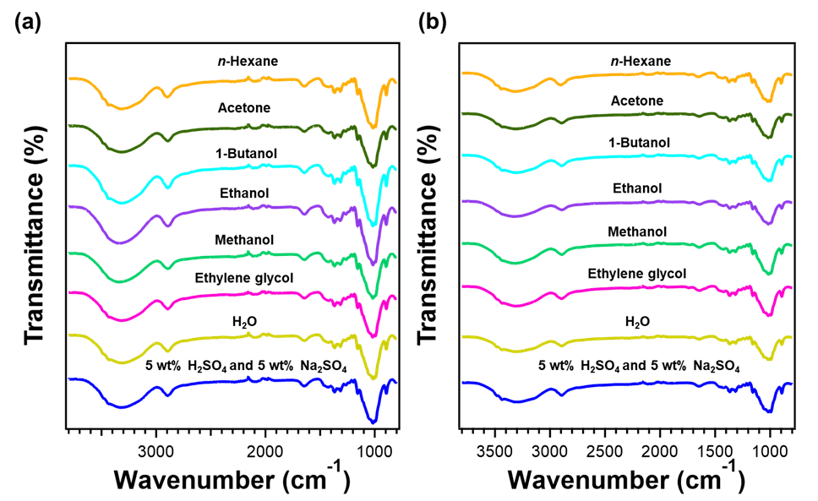
Fig. S1. FT-IR spectra of regenerated cellulose film prepared from (a) CNF and (b) MCC using various solvents as a coagulant

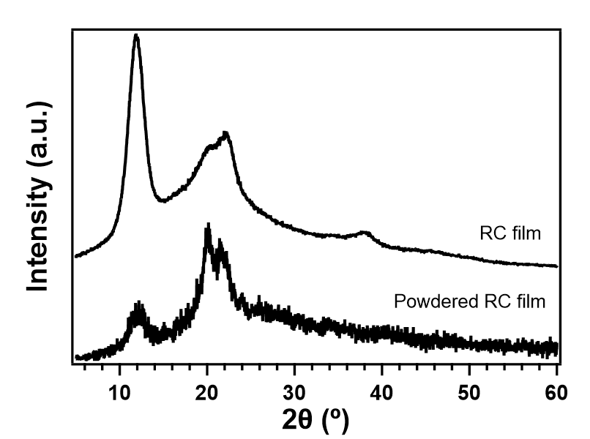
Fig. S2. XRD spectra of the pristine and powdered regenerated cellulose film prepared from MCC through coagulation with 5wt% H₂SO₄ aqueous solution containing 5 wt% Na₂SO₄

Table S1. Mechanical properties of regenerated cellulose films
Cellulose | Coagulant | Tensile strength (MPa) | Elongation at break (%) | Young’s modulus (GPa)
CNF | 5 wt% H₂SO₄ and 5 wt% Na₂SO₄ | 75.95 ± 1.38 | 4.69 ± 0.93 | 3.96 ± 0.35
 | H₂O | 75.09 ± 7.55 | 5.97 ± 1.84 | 3.91 ± 0.25
 | Ethylene glycol | 49.54 ± 4.72 | 2.16 ± 0.12 | 2.66 ± 0.51
 | Methanol | 86.75 ± 6.69 | 12.91 ± 2.76 | 2.94 ± 0.45
 | Ethanol | 72.57 ± 9.95 | 8.92 ± 0.84 | 3.39 ± 0.10
 | 1-Butanol | 75.09 ± 9.09 | 2.43 ± 0.45 | 3.58 ± 0.13
 | Acetone | 68.89 ± 2.10 | 11.88 ± 1.24 | 3.53 ± 0.19
 | n-Hexane | 48.59 ± 4.37 | 8.39 ± 2.03 | 2.37 ± 0.12
MCC | 5 wt% H₂SO₄ and 5 wt% Na₂SO₄ | 75.85 ± 12.14 | 2.30 ± 0.36 | 4.28 ± 0.79
 | H₂O | 17.04 ± 4.25 | 0.79 ± 0.10 | 1.89 ± 0.49
 | Ethylene glycol | 27.70 ± 9.85 | 1.13 ± 0.11 | 2.20 ± 1.15
 | Methanol | 77.08 ± 8.38 | 5.56 ± 2.04 | 2.65 ± 0.22
 | Ethanol | 81.31 ± 6.32 | 4.15 ± 0.95 | 3.21 ± 0.27
 | 1-Butanol | 29.21 ± 4.78 | 1.22 ± 0.15 | 2.44 ± 0.23
 | Acetone | 65.83 ± 5.98 | 2.38 ± 0.25 | 3.25 ± 0.88
 | n-Hexane | 19.42 ± 2.24 | 1.20 ± 0.11 | 1.04 ± 0.17

