Supplementary materials

Antonie van Leeuwenhoek
Fuscibacter oryzae gen. nov., sp. nov., a phosphate-solubilizing bacterium isolated from the rhizosphere of rice plant
Geeta Chhetri, Minchung Kang, Jiyoun Kim, Inhyup Kim and Taegun Seo*

Department of Life Science, Dongguk University-Seoul, Goyang, 10326, South Korea

*Corresponding author:
Taegun Seo
Department of Life Science, Dongguk University-Seoul, Goyang, 10326, South Korea
Tel: +82-31-961-5135
Fax: +82-31-961-5348
E-mail: tseo@dongguk.edu

Footnote: The draft genome and 16S rRNA gene sequences of strain KVB23^{T} have been deposited at GenBank/EMBL/DDBJ under accession numbers JAESVP000000000 and MN955430 respectively.

Fig. S1. Clear zone produced by phosphate solubilizing bacterial isolates KVB23^{T} in Pikovskaya agar plates after 7 days of incubation at 30 ºC.
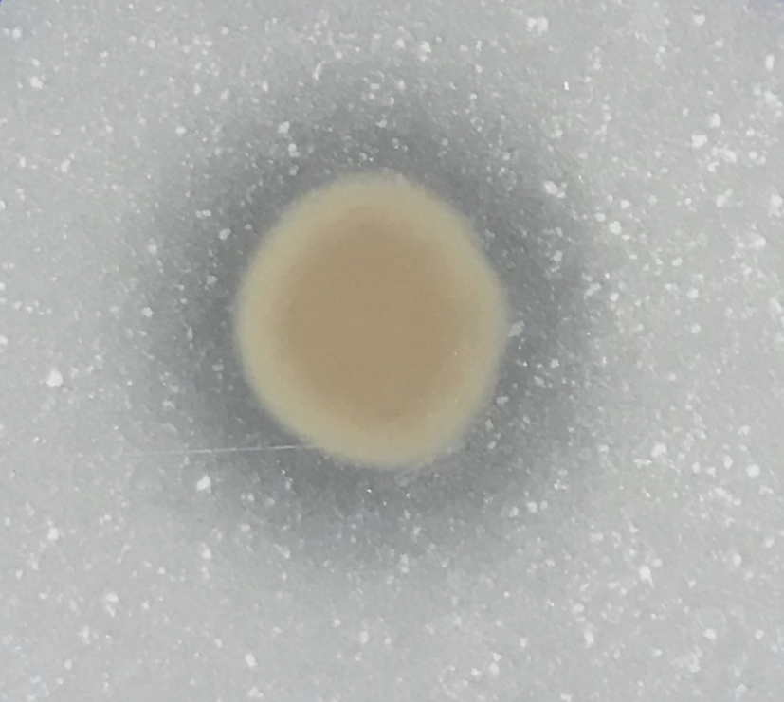

Fig. S2. Maximum-likelihood tree based on 16S rRNA gene sequences showing the relationship between strain KVB23^{T} and related species. Bootstrap values (based on 1000 replications) greater than 50% are shown at branch points. Flavobacterium aquatile ATCC11947^{T} (M62797) was used as an out-group. Bar, 0.050 substitutions per nucleotide position.
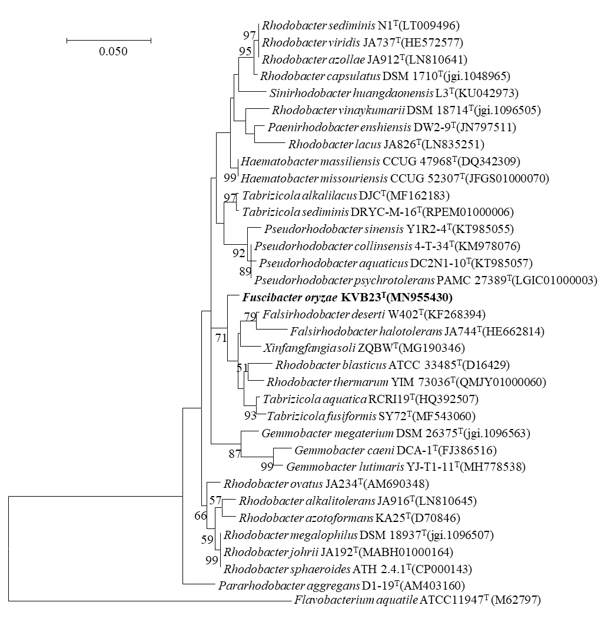

Fig. S3. Maximum parsimony tree based on 16S rRNA gene sequences showing the relationship between strain KVB23^{T} and related species. Bootstrap values (based on 1000 replications) greater than 50% are shown at branch points. Flavobacterium aquatile ATCC11947^{T} (M62797) was used as an out-group. Bar, 20 substitutions per nucleotide position.
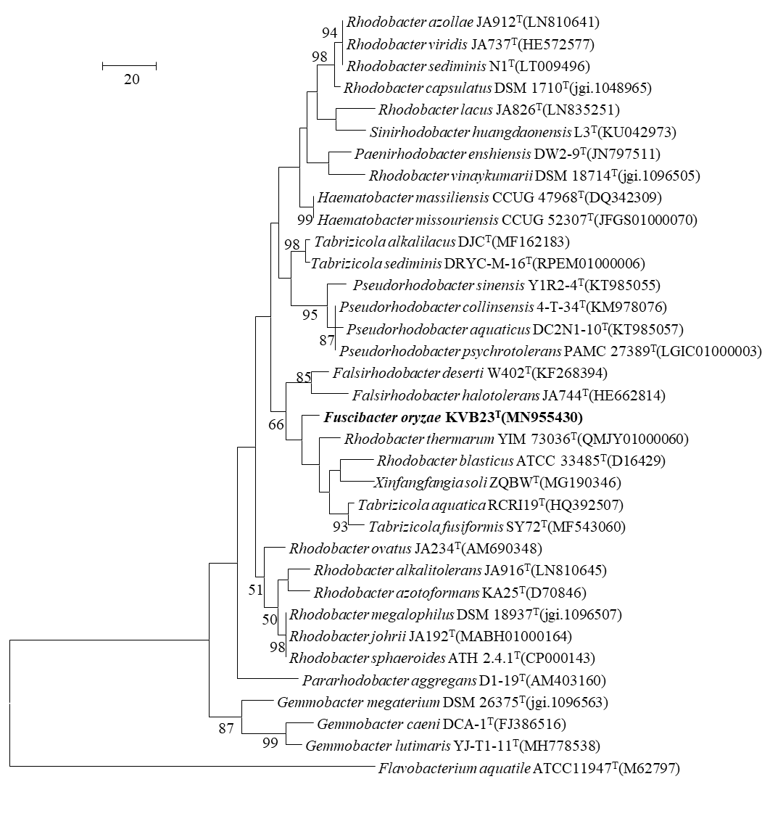

Fig. S4. Phylogenomic tree of strain KVB23^{T} and closely related strains based on core genomes was constructed using UBCG, all genomes of 17 related strains were available on NCBI GenBank. GenBank accession numbers are shown in parentheses. Bootstrap analysis was carried out using 100 replications. Percentage bootstrap values (>50%) are given at branching points. Bar, 0.050 substitution per position.
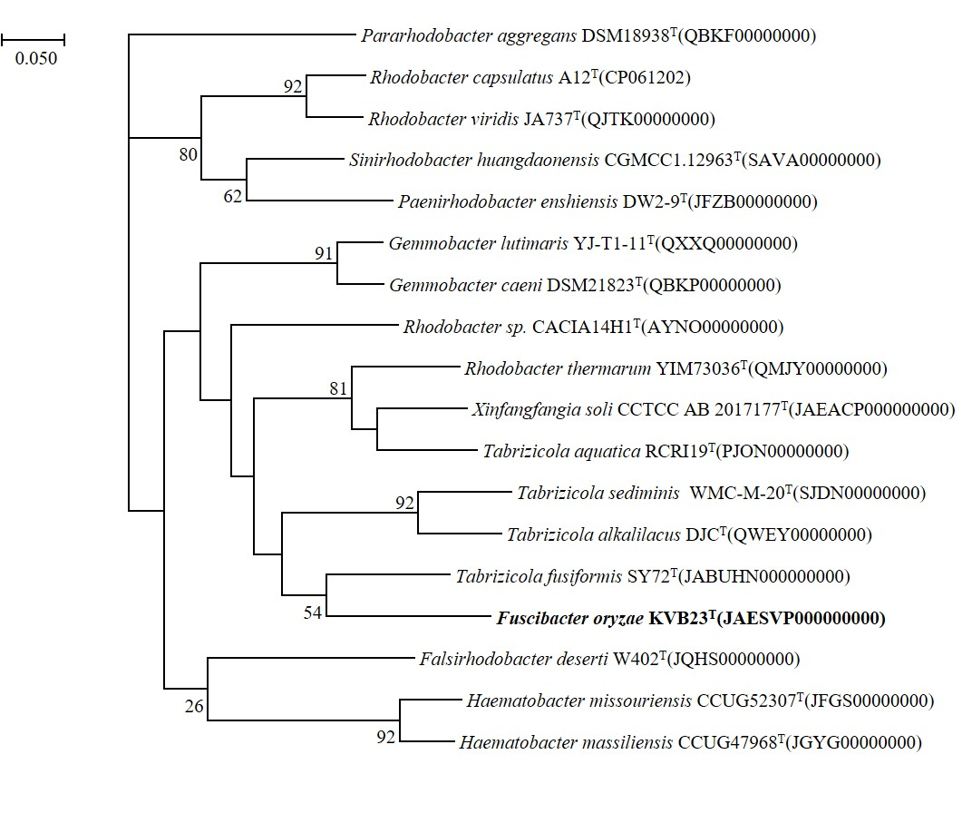

Table S1. Distribution of biosynthetic gene clusters (BGCs) in strain KVB23^{T} and its reference strains
Strains: 1, KVB23^{T}; 2, Tabrizicola fusiformis KCTC 62105^{T}; 3, Rhodobacter thermarum KCTC 52712^{T}; 4, Falsirhodobacter deserti KCTC 32408^{T}.
Secondary metabolites | 1 | 2 | 3 | 4
Redox-cofactor | 1 | - | 1 | 1
Terpene | 1 | 2 | 2 | 2
T1PKS | 1 | 1 | 1 | -
NRPS-like | 1 | 1 | 1 | -
Hserlactone | 3 | 2 | 1 | 1
RRE-containng | 1 | - | - | -
RiPP-like | - | - | 1 | 1

Fig. S5. Venn diagrams of protein clusters encoded by strain KVB23^{T} and the species of Tabrizicola, Rhodobacter and Falsirhodobacter genus based on orthology. (a), KVB23^{T} and Tabrizicola fusiformis KCTC 62105^{T}; (b), KVB23^{T} and Rhodobacter thermarum KCTC 52712^{T}; (c), KVB23^{T} and Falsirhodobacter deserti KCTC 32408^{T} ; (d). The numbers in the diagram indicate the number of orthologous clusters shared among strains.

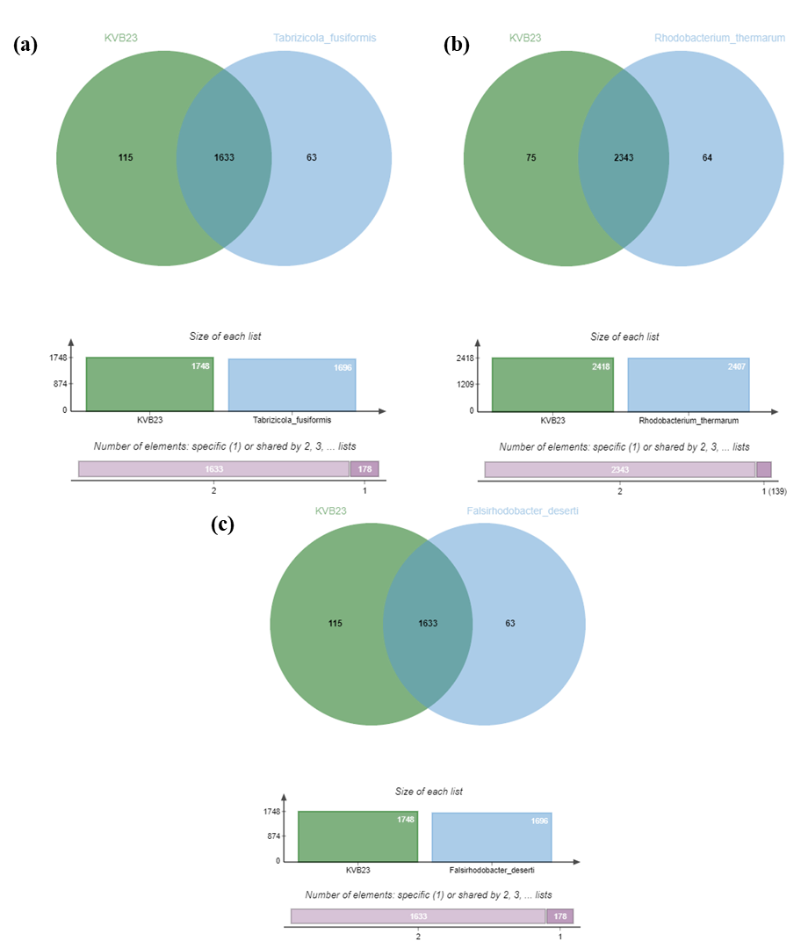
Fig. S6. Two-dimensional thin-layer chromatogram of the polar lipids from strain KVB23^{T} detected with reagents: 5% molybdophosphoric acid (a), molybdenum blue spray reagent (b), ninhydrin reagent (c), and a-napthol reagent (d). Abbreviations: DPG, diphosphatidylglycerol; PE, phosphatidylethanolamine; PGL1-7, unidentified phosphoglycolipids, APGL1-2, unidentified aminophosphoglycolipids; PGL1-7, unidentified phosphoglycolipids; GL, unidentified glycolipid and L1-L4, unidentified lipids.

