Extended Data
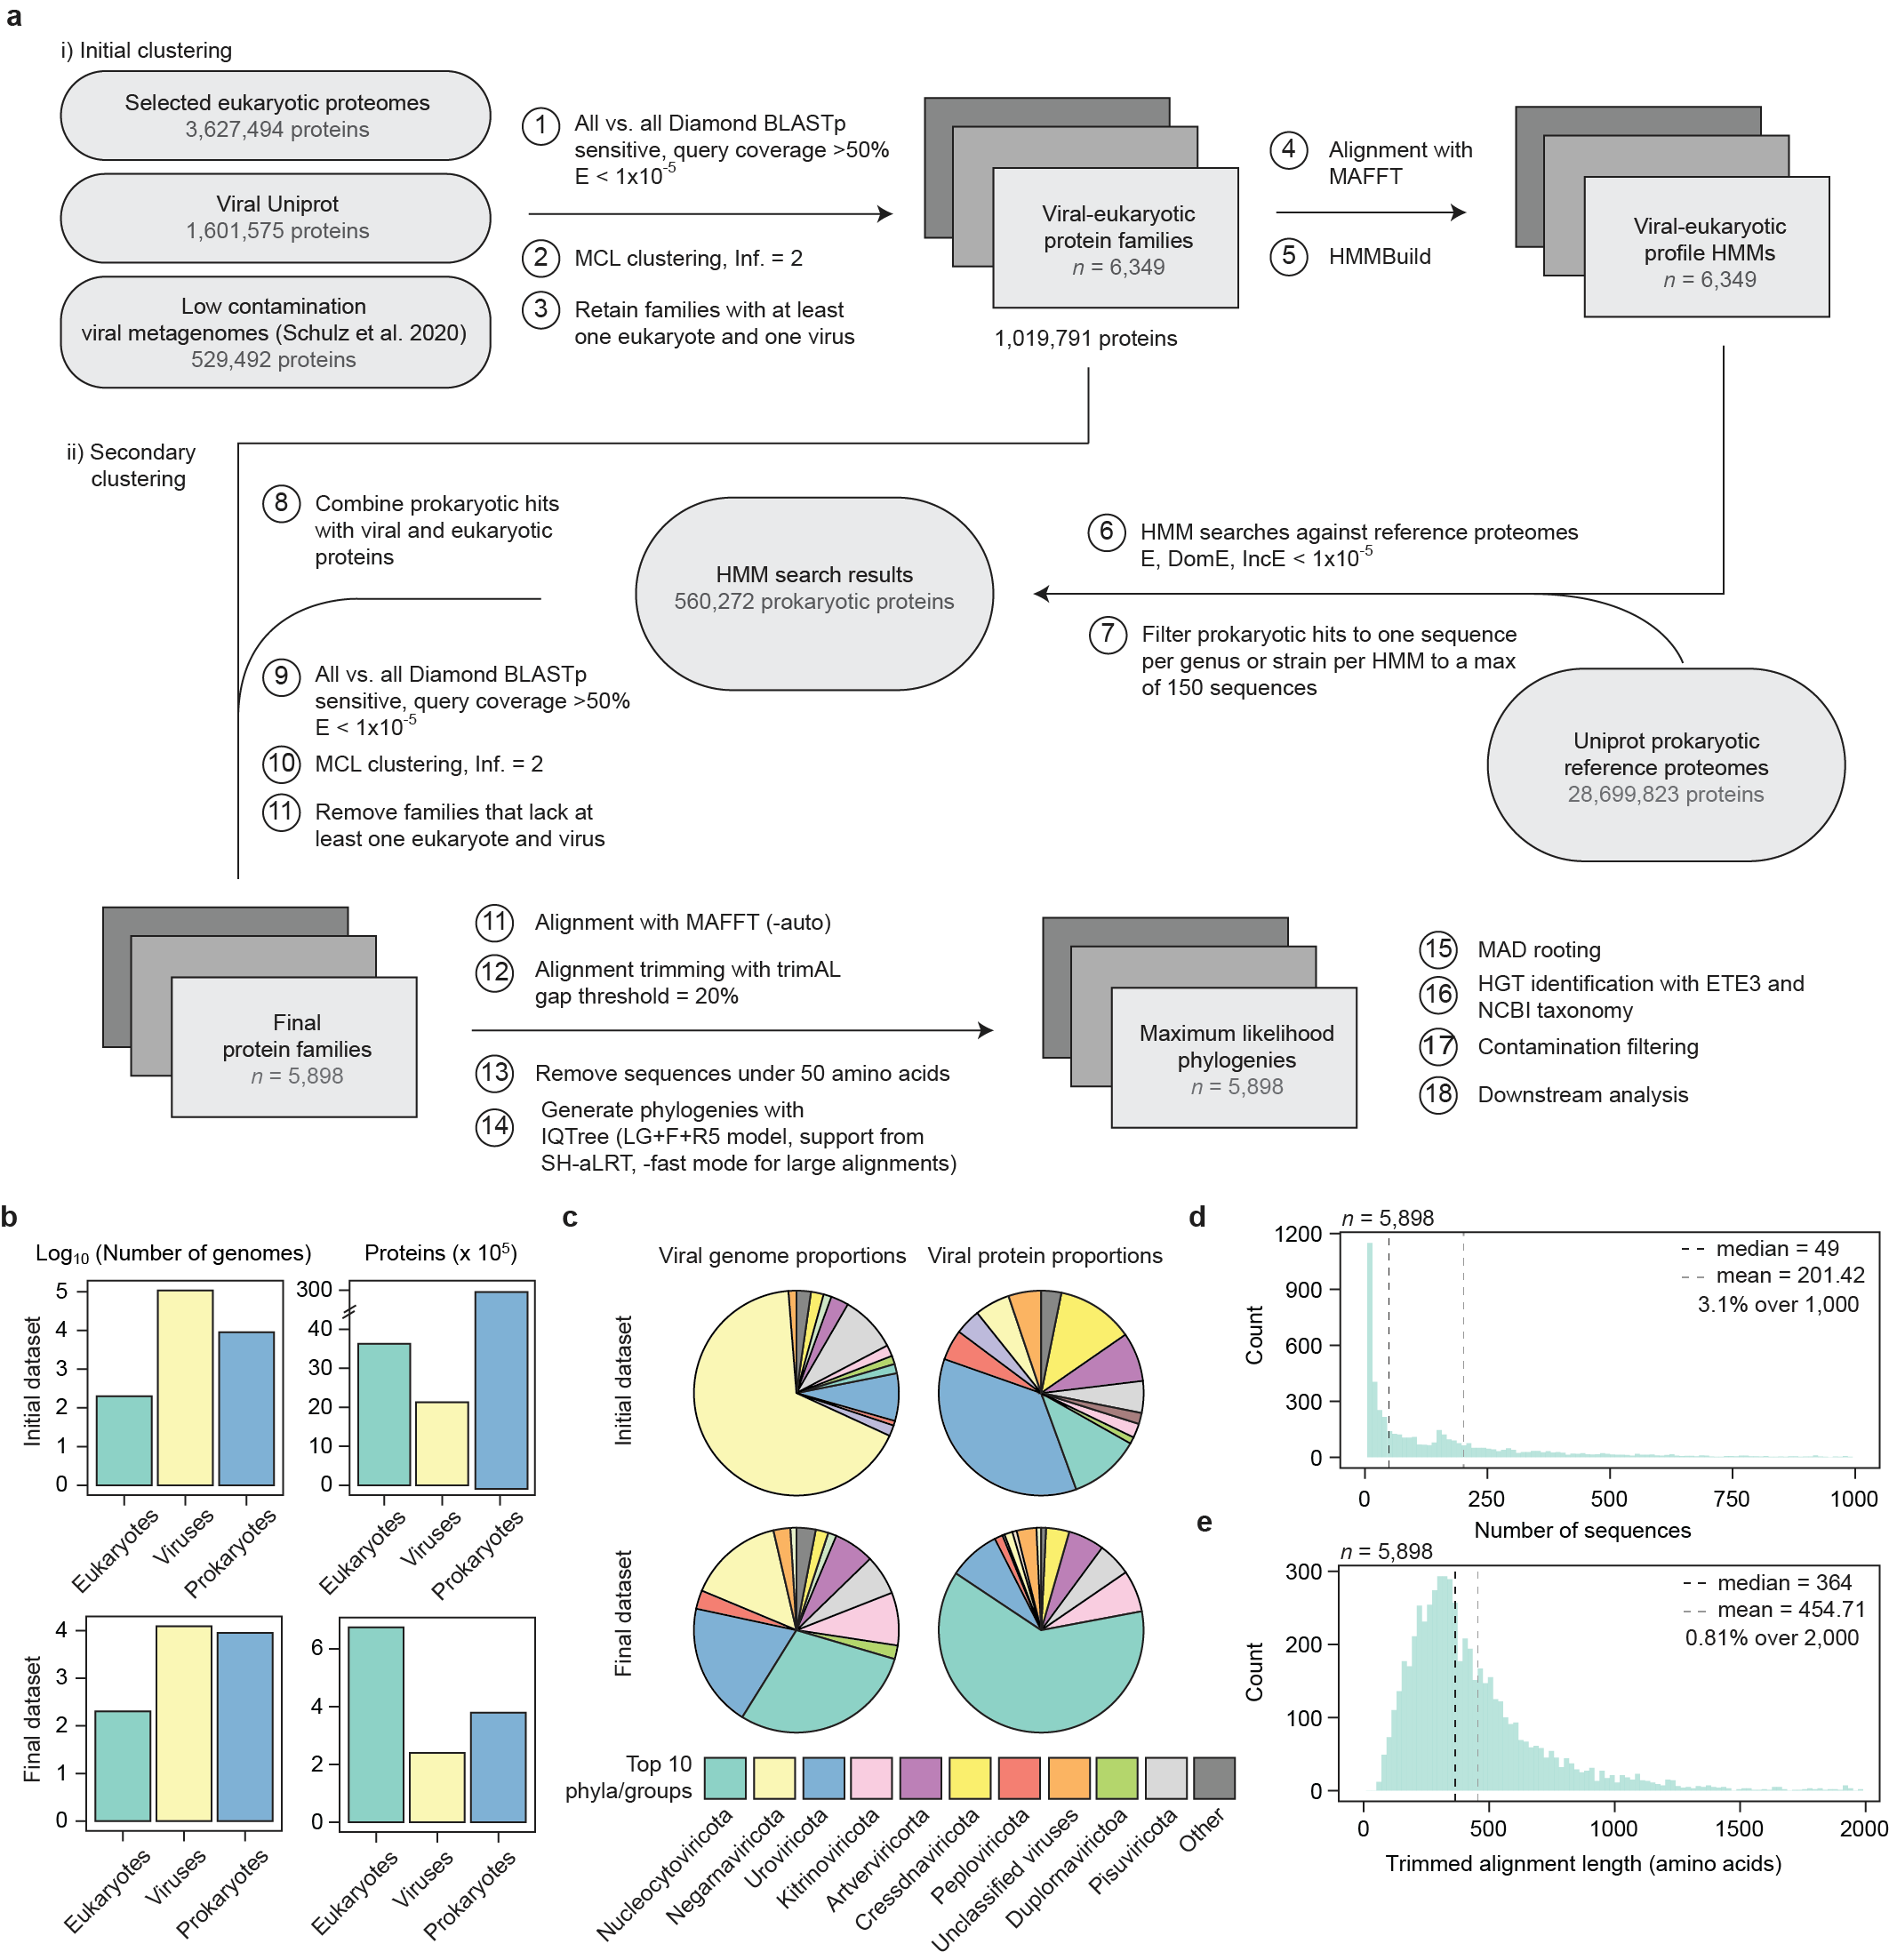
Extended Data Fig. 1. Dataset assembly and statistics. a. A schematic representation of the dataset assembly pipeline. b. The numbers of eukaryotic, viral, and prokaryotic genomes and proteins examined and included in the final dataset. c. The representation of viral phyla and other groups (i.e., those lacking phyla classifications) in the initial and final datasets. d, e. Summary statistics for the final clustered protein families including the number of sequences present (d) and the trimmed alignment length (e). See Materials and Methods for additional information.
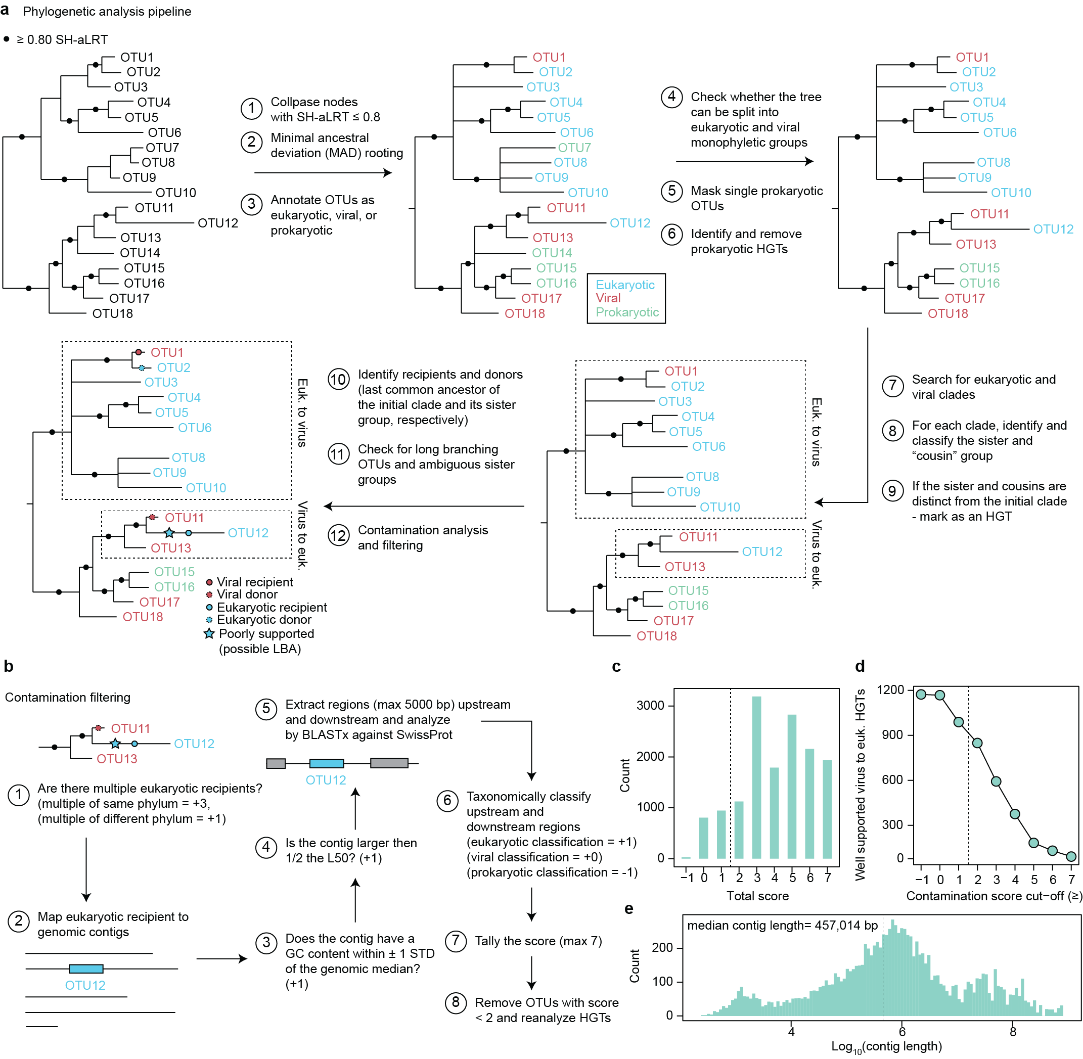
Extended Data Fig. 2. Phylogenetic pipeline and contamination analysis overview. a, b. Schematic representation of the HGT identification and phylogenetic analysis pipeline (d) and the contamination scoring protocol (b). c. The distribution of contamination scores across eukaryotic recipient sequences. d. The number of well-supported HGTs that are identified using different contamination score thresholds. Dashed lines denote the defined scoring threshold (≥ 2). e. The distribution of eukaryotic contig lengths that contain viral HGTs. See Materials and Methods for additional information.

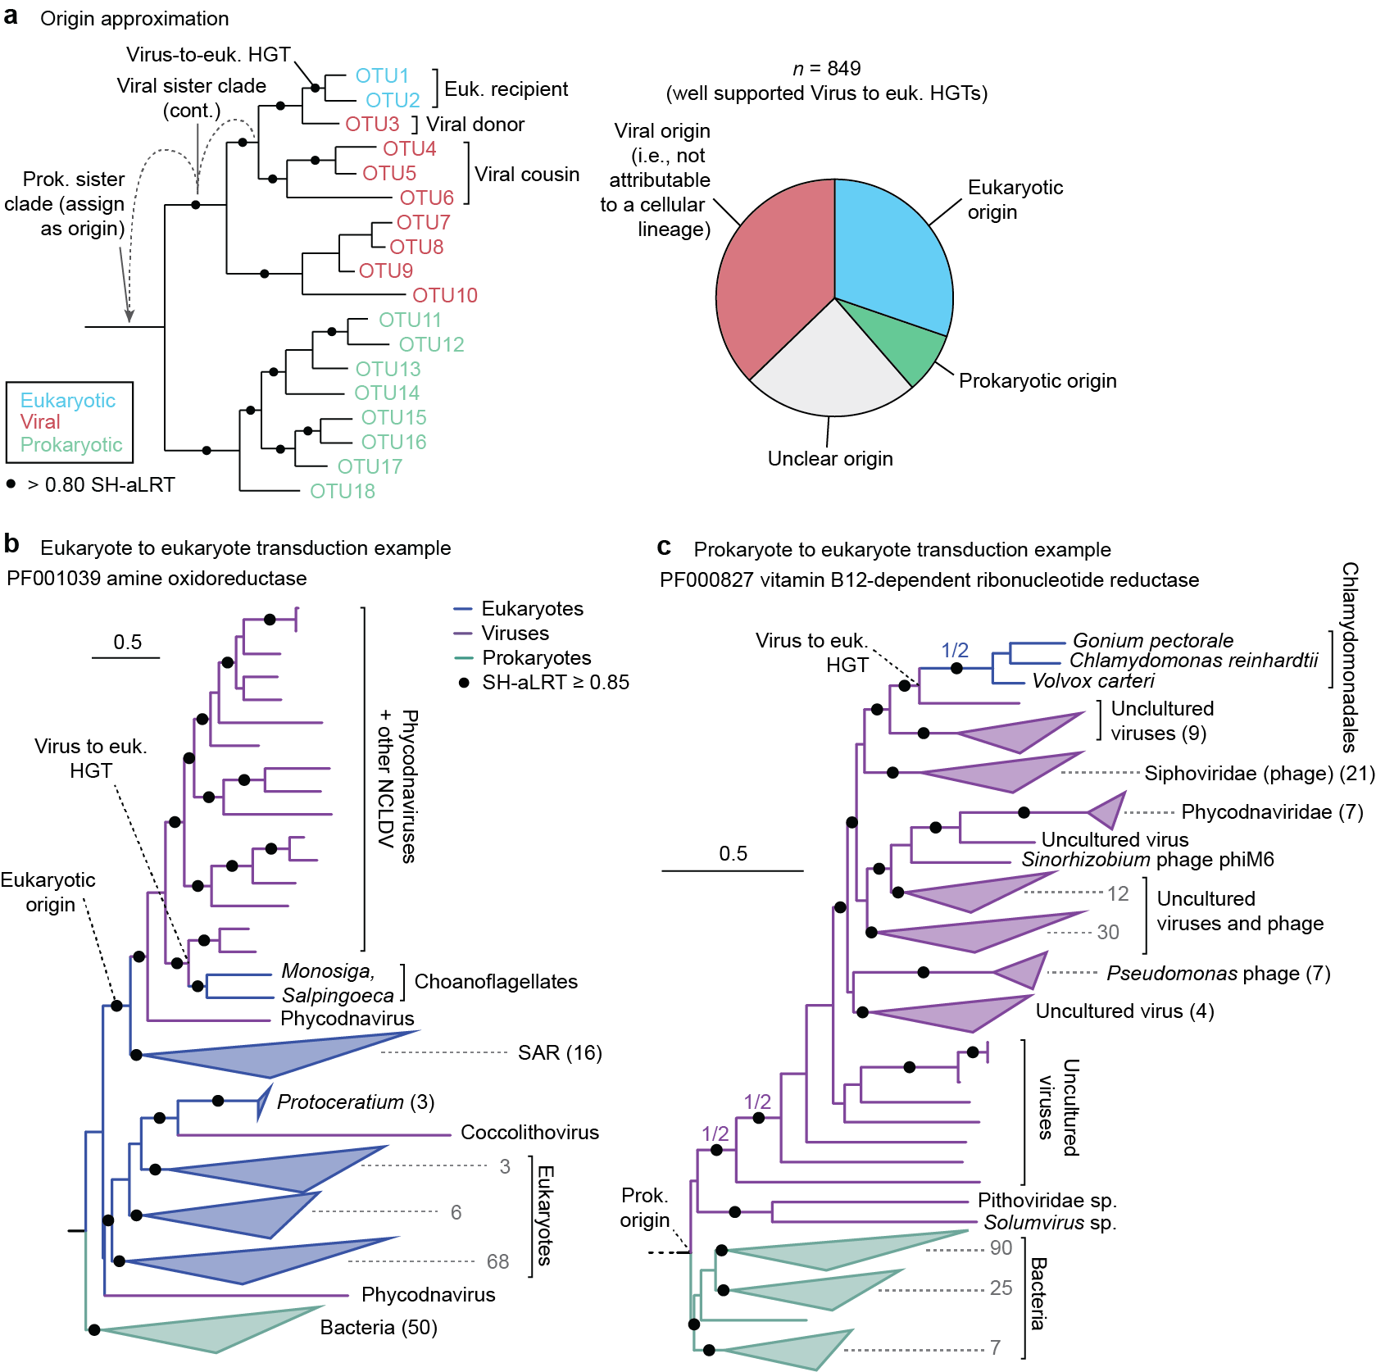
Extended Data Fig. 3. Gene origin identification and transduction examples. a. A schematic illustrating how viral gene origins were approximated by moving up through the phylogeny from the donor towards the root until a cellular lineage was encountered. The pie chart reflects the proportion of well supported virus-to-eukaryotic HGTs that were assigned a given origin. b, c. Example phylogenies illustrating cases of eukaryote-to-eukaryote and prokaryote-to-eukaryote transduction. Phylogenies were generated in IQ-Tree using the LG+R7 (b) or LG+R9 (c) substitution models as selected using ModelFinder and statistical support was assessed using SH-aLRT (n = 1,000) ^{48,49}.

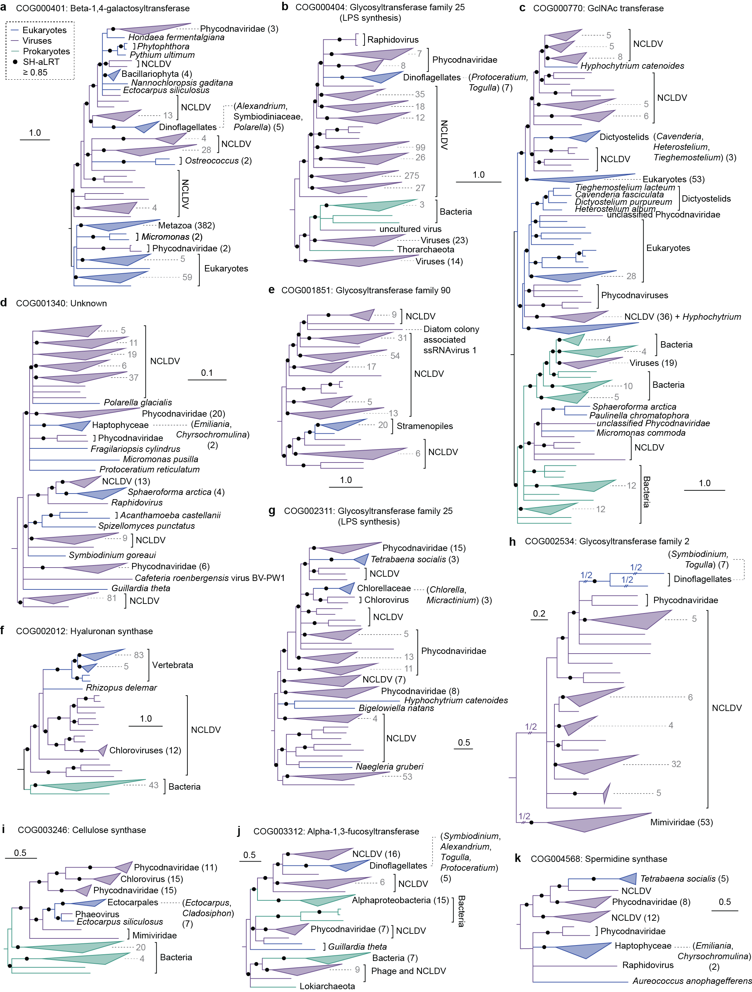Extended Data Fig. 4. Phylogenies for glycosyltransferases denoted in Figure 4. Phylogenetic analyses were conducted in IQ-Tree with statistical support assessed using SH-aLRT (n = 1,000). Substitution models were selected using ModelFinder and included LG+R10 (a), LG+F+R10 (b), LG+R9 (c), LG+F+R8 (d, e), LG+R6 (f), LG+F+R7 (g), LG+F+G4 (h), LG+F+R5 (i, j), and LG+I+G4 (k).

