Supplementary Information for

Mechano-responsive hydrogen-bonding array of thermoplastic polyurethane elastomer captures both strength and self-healing

**Eom et al.**

**1. Supplementary Tables**

**Supplementary Table 1.** Polymer information and polymerization results

|  |  |  |  |  |
| --- | --- | --- | --- | --- |
| Entry*a* | Content of chain-extender*b* (wt%) | *M*n (g mol−1)*c* | *M*w (g mol−1)*c* | PDI*c* |
| **C-IP-SS** | 14.6 | 16,500 | 24,100 | 1.46 |
| **E-IP-SS** | 14.6 | 30,400 | 45,600 | 1.50 |
| **Es-MD** | - | 55,400 | 98,600 | 1.78 |

*a***C**: Poly(hexamethylene carbonate) diol, **E**: Poly(tetramethylene ether)glycol, **Es**: polyester-type macrodiol, **IP**: isophorone diisocyanate, **MD**: 4,4’-methylenebis(phenyl isocyanate), **SS**: bis(4-hydroxyphenyl)disulfide. *b*Based on the weight percentages of chain-extender included in the total monomer weight. *c*Determined by THF-GPC using polystyrene standards (RI detector).

**Supplementary Table 2.** Information on tensile properties of TPU films and the degree of recovery after self-healing

|  |  |  |  |  |
| --- | --- | --- | --- | --- |
| Entry | | **C-IP-SS*a*** | **E-IP-SS*b*** | **Es-MD** |
| Virgin sample | Young's modulus (MPa) | 15.5 ± 0.8 | 1.45 | 8.86 ± 0.4 |
| UTS (MPa) | 42.9 ± 1.4 | 6.76 | 35.8 ± 0.8 |
| Elongation at break (%) | 480 ± 3 | 920 | 880 ± 8 |
| Toughness (MJ m-3) | 75.1 ± 2.3 | 26.9 | 115 ± 2 |
| Cut & healed sample | Young's modulus (MPa) | 15.3 ± 0.4 | 1.47 | -*c* |
| UTS (MPa) | 33.1 ± 0.4 | 5.96 | - |
| Recovery of UTS (%) | 77.2 | 88.2 | - |
| Elongation at break (%) | 400 ± 6 | 920 | - |
| Recovery of elongation (%) | 82.7 | 99.6 | - |
| Toughness (MJ m-3) | 48.4 ± 0.6 | 20.6 | - |
| Recovery of toughness (%) | 64.4 | 76.6 | - |

*a*Self-healing for 48 h at 35 °C. *b*Self-healing for 2 h at 25 °C. Tensile data obtained from the previous report (*Adv. Mater.* **2018**, *30*, 1705145). *c*No mechanical recovery was observed.

**Supplementary Table 3.** Tensile and self-healing properties of elastomers (tensile strength over 10 MPa, and self-healing efficiency over 60%)

|  |  |  |  |  |  |  |
| --- | --- | --- | --- | --- | --- | --- |
|  | Self-healing motif/type of polymer*a* | The highest UTS (MPa) | Self-healing temperature (°C) | Recovery time | UTS recovery (%) | Ref. |
| Elastomer | Disulfide/TPU | 43 | 35 | 24 h  (48 h) | 65  (77) | This work |
| Elastomer | Anisyl group /polyolefin | 17.7 | 25 | 120 h | 71 | 1 |
| Elastomer | M-L, HB/PU | 14.8 | Room temp.*b* | 130 h | 93 | 2 |
| Elastomer | M-L/PEI | 10.5 | 25 | 12 h | ~100 | 3 |
| Elastomer | Electrostatic, HB/dual cross-linked polymer | 27.4 | 25 (humid environ.)*c* | 48 h | 94 | 4 |
| Elastomer | Ditelluride, HB/PUU | 21.7 | Ambient (up to 40 °C) (visible light)*d* | 10 min | 85.6 | 5 |
| Elastomer | Diselenide, HB/PUU | ~15 | Ambient (photo reactor)*e* | 10 min | ~95 | 6 |
| Elastomer | Dioxetane, disulfide/TPU | ~25 | 40 (UV light)*f* | 0.5 h | 100 | 7 |
| Elastomer | HB/PUU | 48.5 | 80 | 48 h | 88 | 8 |
| Elastomer | Disulfide/PU | 26.3 | 70 | 0.5 h | ~98 | 9 |
| Elastomer | Disulfide/TPU | 25 | 70 | 6 h | 86 | 10 |
| Elastomer | M-L/Polyolefin | 24.8 | 80 | 12 h | 79 | 11 |
| Elastomer | Disulfide, HB/PUU | 25 | 100 | 2 h | 92 | 12 |
| Elastomer | M-L/polyisoprene | 21 | 80 | 24 h | 74 | 13 |
| Elastomer | Disulfide/PU | ~20 | 90 | 24 h | 94 | 14 |
| Elastomer | D-A/polyacrylates | 13 | 60 | 1 week | 79 | 15 |
| Elastomer | Oxime-carbamate, HB/poly(oxime-urethane) | 13.5 | 100 | 2 h | ~100 | 16 |
| Elastomer | Boronic ester/ENR | ~10 | 80 | 24 | 85 | 17 |
| Plastic*g* | HB/poly(thiourea-ether) | 45 | 21 | 30 sec | unknown | 18 |
| Plastic | vdW/polyacrylates | 9.74 | Ambient | 86 h | 70 | 19 |
| Plastic | Ionic interaction, HB/PU | 16.9 | 40 | 2 h | 70 | 20 |

*a*TPU: Thermoplastic polyurethane. M-L: Metal-ligand. HB: Hydrogen bonding. PEI: polyethyleneimine. PUU: poly(urethane-urea). D-A: Diels-Alder. ENR: epoxidized natural rubber. vdW: van der Waals.

*b*The exact room temperature was not recorded. Thus, general 25 °C was recorded in the Ashby graph.

*c*Humid environment: Relative humidity of ~90%.

*d*The light intensity of approximately 200000 lx.

*e*A photoreactor (300 W, 400–800 nm) with a higher light intensity of approximately 200000 lx.

*f*A high-pressure mercury lamp (500 W) with 365 nm optical filter.

*g*Recoginized as plastic-type owing to an appearance of a yield point.

**Supplementary Table 4.** The transition strain (έ) and stress (σt) of **C-IP-SS** at different temperatures

|  |  |  |
| --- | --- | --- |
| Temperature (K) | Transition strain (έ) | Transition stress (σt) |
| 243 | 1.40 | 57.46 |
| 253 | 1.56 | 48.12 |
| 263 | 1.79 | 27.41 |
| 273 | 1.89 | 8.40 |
| 283 | 2.17 | 2.57 |
| 293 | 2.38 | 1.40 |
| 303 | 2.38 | 1.00 |
| 308 | 2.38 | 0.65 |
| 313 | 2.38 | 0.47 |

**Supplementary Table 4.** The frequency shift factors (αT) employed in obtaining TTS master curves for **C-IP-SS** and **E-IP-SS**, respectively

|  |  |  |
| --- | --- | --- |
| Measurement temperature (°C) | αT of **C-IP-SS** | αT of **E-IP-SS** |
| 25 | Reference temperature | |
| 35 | 6.2010−2 | 4.4710−1 |
| 45 | 7.6710−3 | 1.2810−1 |
| 55 | 1.8010−3 | 4.7410−2 |
| 65 | 4.0010−4 | 1.7610−2 |
| 75 | 1.1310−4 | 8.2110−3 |
| 85 | 3.3010−5 | 3.4210−3 |

**2. Supplementary Figures**

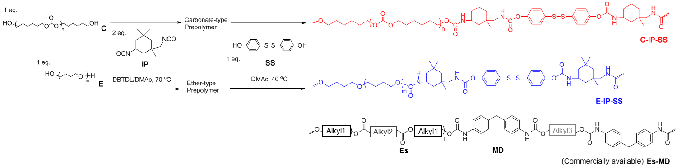

**Supplementary Figure 1**. Synthetic route to TPUs with different components. The TPUs are designated as X-Y-Z, where X, Y, and Z denote the abbreviation of the type of macrodiol, diisocyanate monomer, and chain extender, respectively (**C-IP-SS**, **E-IP-SS**, and **Es-MD**).

**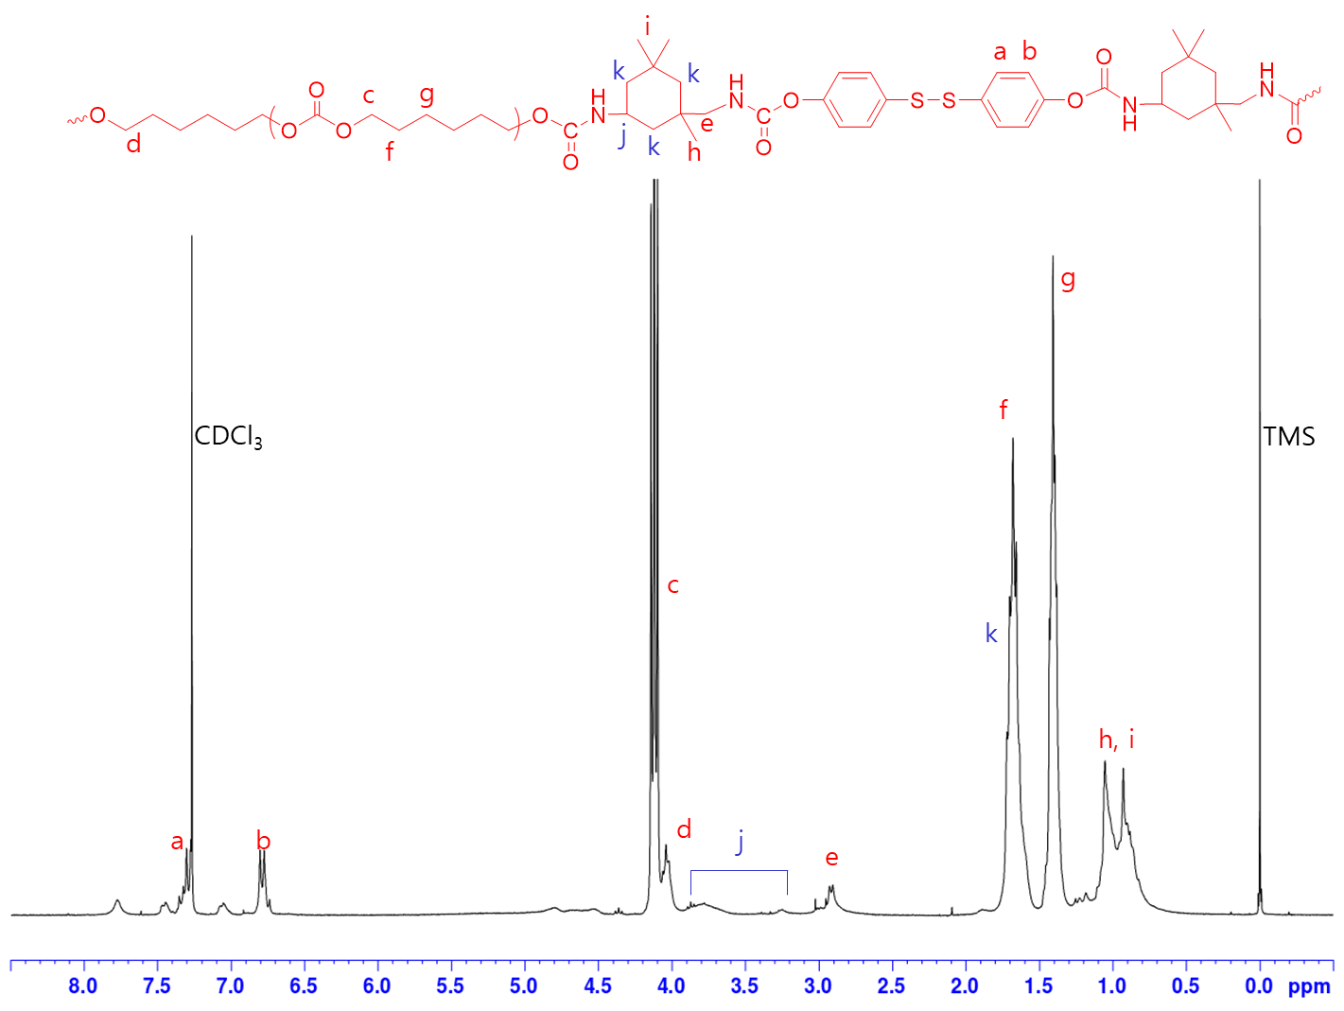**

**Supplementary Figure 2.** 1H NMR spectrum of **C-IP-SS** in CDCl3 (300 MHz). In the 1H NMR spectrum of **C-IP-SS**, the peaks of **SS** aromatic unit appeared at 7.4~6.6 ppm, the peaks of protons adjacent to carbonate group of poly(hexamethylene carbonate) diol (**C**) appeared at 4.2~4.0 ppm, and the peaks of **IP** alkyl unit appeared at 1.1~0.8 ppm. Integral ratio of each units was well-matched with feed molar ratio.

**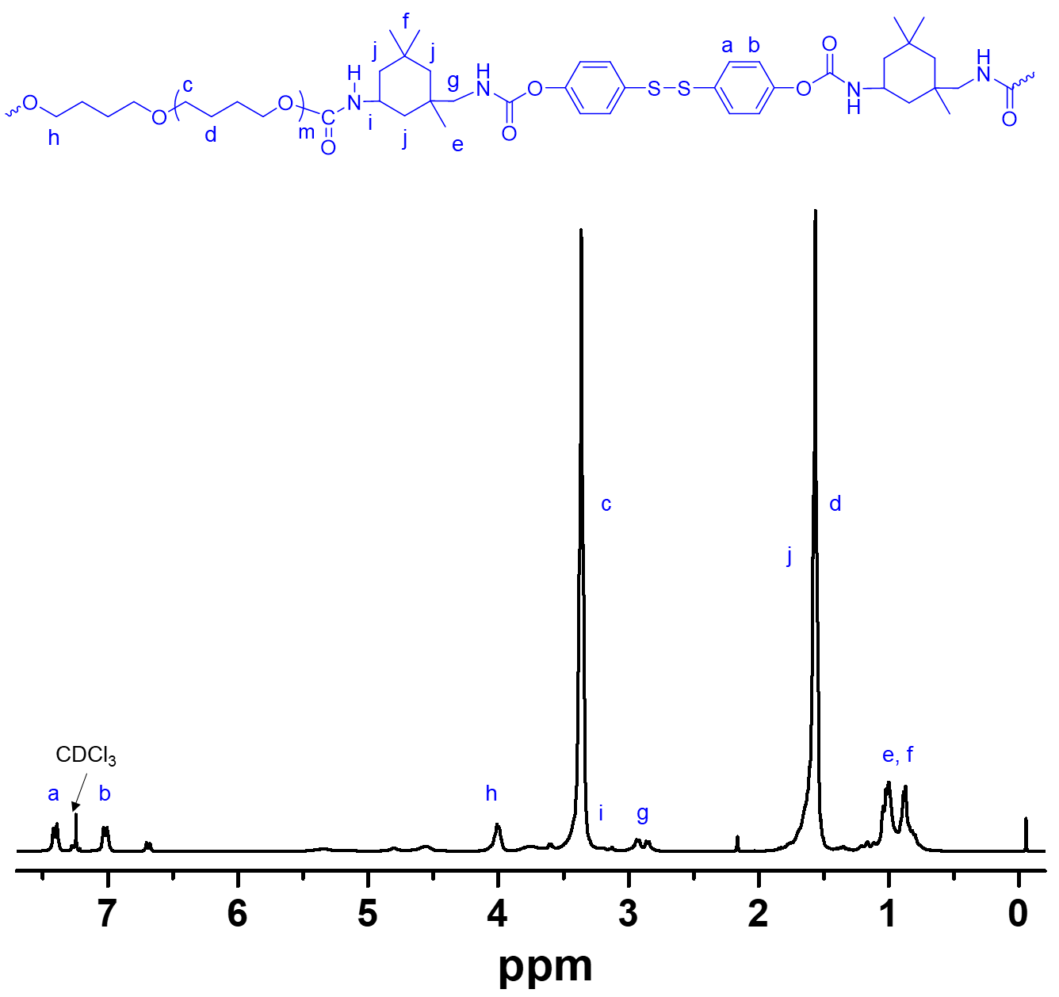**

**Supplementary Figure 3.** 1H NMR spectrum of **E-IP-SS** in CDCl3 (300 MHz). In the 1H NMR spectrum of **E-IP-SS**, the peaks of **SS** aromatic unit appeared at 7.4~6.6 ppm, the peaks of PTMEG (**E**) protons appeared at 3.4 and 1.6 ppm, and the peaks of **IP** alkyl unit appeared at 1.1~0.8 ppm. Integral ratio of each units was well-matched with feed molar ratio.

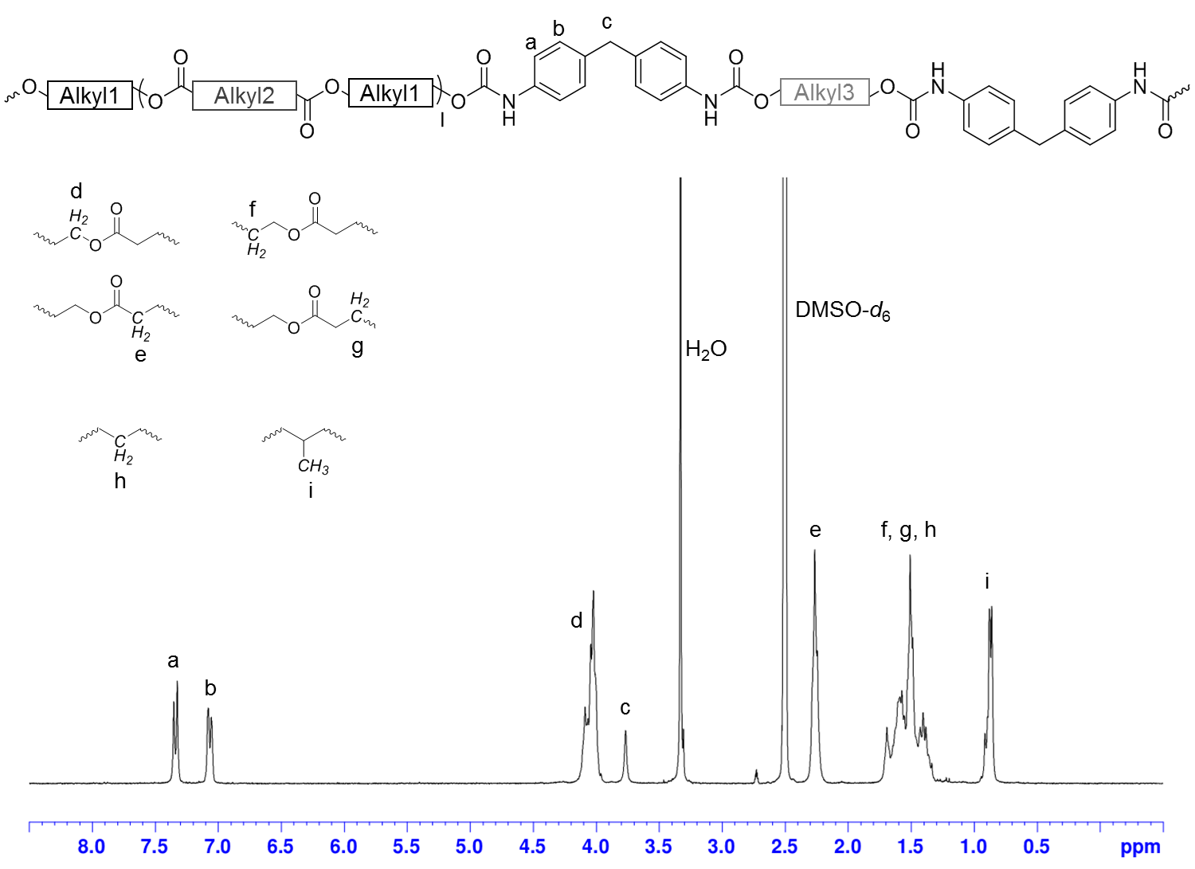

**Supplementary Figure 4.** 1H NMR spectrum of **Es-MD** in DMSO-*d*6 (300 MHz). In the 1H NMR spectrum of **Es-MD**, the peaks of **MD** aromatic unit appeared at 7.4~7.0 and 3.8 ppm. The peaks of protons adjacent to ester C-O appeared at 4.2~4.0 ppm, and those adjacent to ester C=O appeared at 2.3-2.2 ppm, respectively, suggesting that soft segment is composed of polyester-type macrodiol (**Es**). Methylene protons appeared at 1.7~1.3 ppm and α-methyl protons (-CH3) appeared at 1.0~0.8 ppm.

**D:\Dropbox\Dropbox\1. 연구관련\1. 화연\2-4. Self healing TPU (with 김선미)\3. Paper work_Figure\200413\Figure S5, 200413, tif.tif**

**Supplementary Figure 5.** THF-GPC profiles of TPUs.

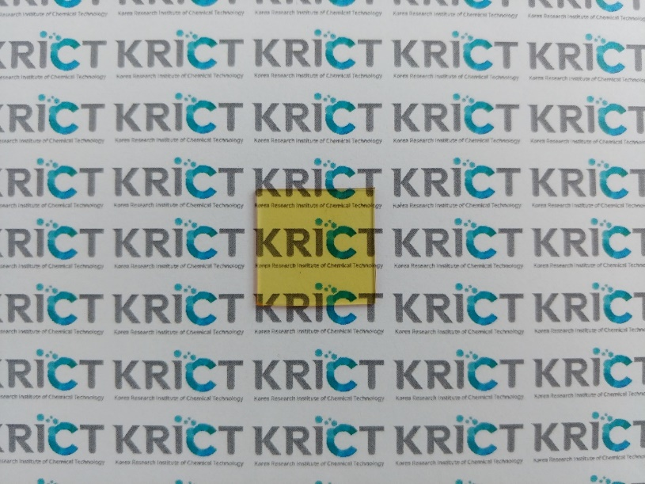



**Supplementary Figure 6.** Photograph of **C-IP-SS** films with a dimension of 20 mm $×$ 20 mm $×$ 1 mm, and transmission spectra with various thicknesses.

D:\Dropbox\Dropbox\1. 연구관련\1. 화연\4. Self healing TPU (with 김선미)\3. Paper work_Figure\200305, Ashby\Ashby plot, 200311.tif

**Supplementary Figure 7.** Ashby plot of “ultimate tensile strength” versus “self-healing temperature” of **C-IP-SS** and other elastomers reported in literature.

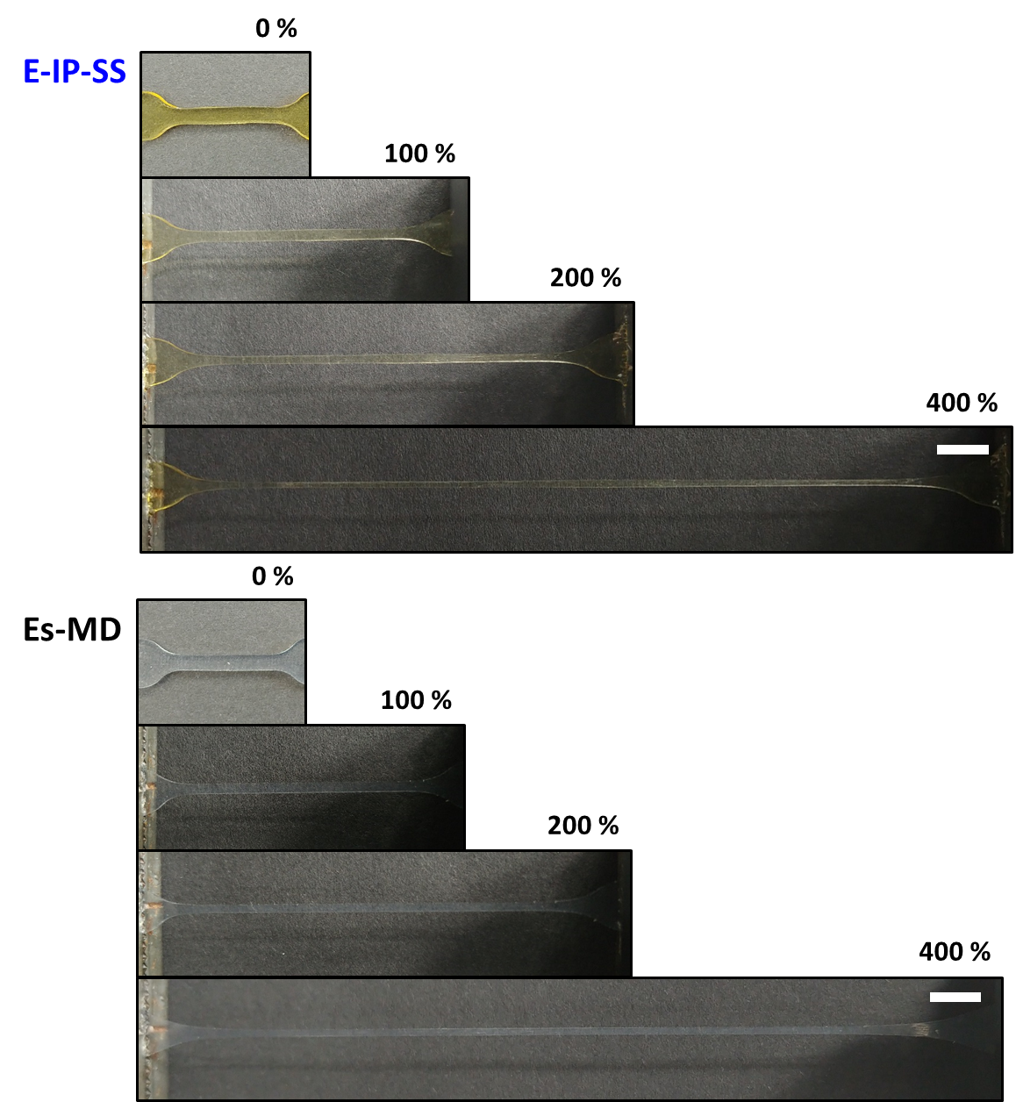

**Supplementary Figure 8.** Photographs of dumbbell-shaped films of **E-IP-SS** and **Es-MD** of various stretching ratio (scale bar: 6 mm).

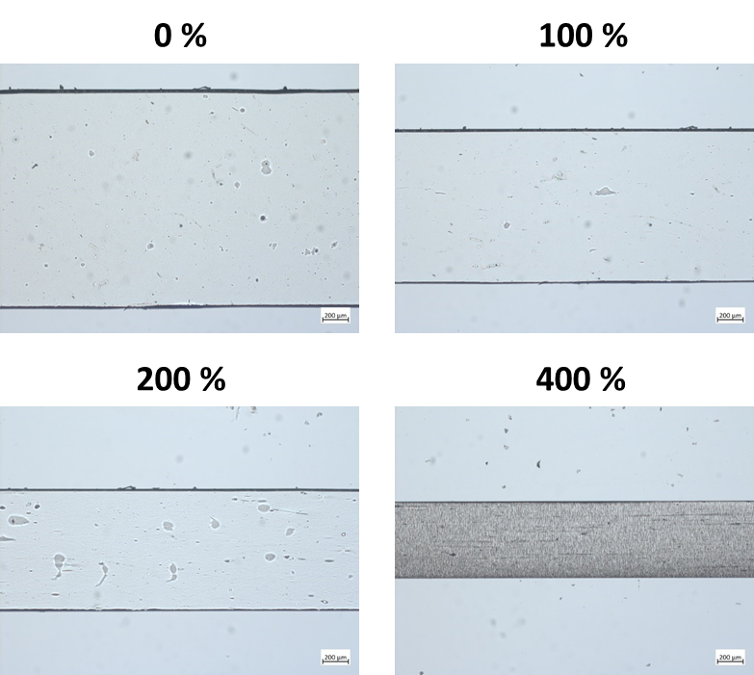

**Supplementary Figure 9.** OM images of dumbbell-shaped film of **C-IP-SS** (thickness: 300 µm) at different strains.

D:\Dropbox\Dropbox\1. 연구관련\1. 화연\4. Self healing TPU (with 김선미)\3. Paper work_Figure\200324, SI figure 모음\Fig S12.tif

**Supplementary Figure 10.** Cyclic stress-strain curves of **C-IP-SS** with two cycles of 200% tensile strains. The second cycle was carried out after waiting for 24 h.

**D:\Dropbox\Dropbox\1. 연구관련\1. 화연\2-4. Self healing TPU (with 김선미)\3. Paper work_Figure\200413\Subfigure\Fig. S12, DSC.tif**

**Supplementary Figure 11.** Differential scanning calorimetry curves of **C-IP-SS** and **Es-MD** (first scan).

D:\Manuscript in prep\2020\논문\18xx-self-healing actuator\Figure 수정_Eom, 200407\1. FTIR fitting\FTIR fitting_EsMD, 200407.tif

**Supplementary Figure 12.** The carbonyl region of FT-IR spectrum with peak deconvolution for **Es-MD**.

D:\Dropbox\Dropbox\1. 연구관련\1. 화연\2-4. Self healing TPU (with 김선미)\3. Paper work_Figure\200413\Figure S13, 200413, tif.tif

**Supplementary Figure 13**. Rheological properties of the three TPUs at 25 °C. (a) Complex viscosity versus angular frequency of 0.05−500 rad s−1. (b) Casson plots to obtain the yield stress. The yield stress was calculated from the square value of the intercept of the plot. (c) The modified Cole−Cole plot.

D:\Dropbox\Dropbox\1. 연구관련\1. 화연\2-4. Self healing TPU (with 김선미)\3. Paper work_Figure\200413\Fig. S14, 200413.tif

**Supplementary Figure 14**. Relaxation time curves of self-healable TPUs, **C-IP-SS** and **E-IP-SS**, over the frequency range of 0.05−500 rad s−1 at 25 °C.

**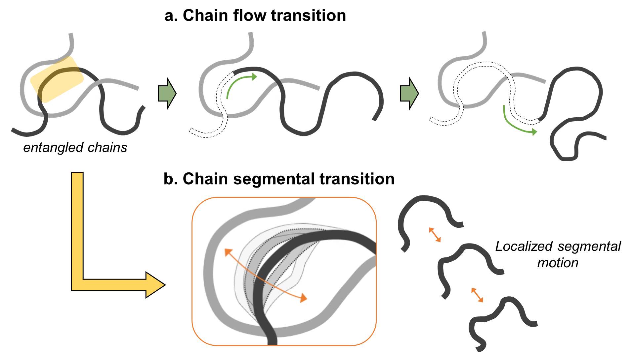**

**Supplementary Figure 15.** Schematic illustration of the movement of (a) chain flow transition and (b) chain segmental transition.

D:\Dropbox\Dropbox\1. 연구관련\1. 화연\2-4. Self healing TPU (with 김선미)\3. Paper work_Figure\200514, Sci. Adv\Fig. S15.tif**Supplementary Figure 16.** The 1D SAXS patterns of (a) **C-IP-SS**, (b) **E-IP-SS** and (c) **Es-MD** at different degrees of stretching.

D:\Dropbox\Dropbox\1. 연구관련\1. 화연\2-4. Self healing TPU (with 김선미)\3. Paper work_Figure\200413\Figure S17, 200413, tif.tif

**Supplementary Figure 17**. The 2D SAXS patterns of the three types of TPUs at different degrees of stretching.

D:\Dropbox\Dropbox\1. 연구관련\1. 화연\4. Self healing TPU (with 김선미)\3. Paper work_Figure\191104, subfigure\1D WAXS_EsMD, 191106.tif

**Supplementary Figure 18**. The 1D WAXS patterns of **Es-MD** at different degrees of stretching.

**D:\Manuscript in prep\2020\논문\18xx-self-healing actuator\Figure 수정_Eom, 200407\SI Fig_CIPSS phase transition, tif.tif**

**Supplementary Figure 19.** Schematic illustration of mechano-responsive change in chain alignment and relevant H-bond array for **C-IP-SS.**

D:\Dropbox\Dropbox\1. 연구관련\화연\4. Self healing TPU (with 김선미)\3. Paper work_Figure\191228\Figure S12, 2D WAXS return, 191228.tif

**Supplementary Figure 20**. The recovery of the 2D WAXS patterns for **C-IP-SS** after instantaneous release of the 400%-stretched specimen.

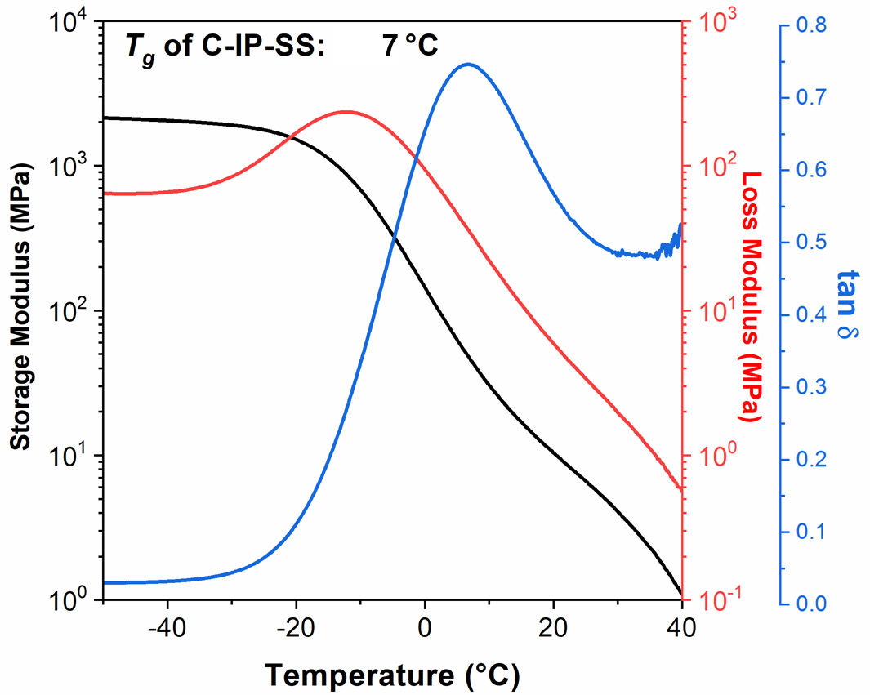

**Supplementary Figure 21**. DMA curves of **C-IP-SS** at 1 Hz over the temperature range of −80 to 80 °C in a liquid N2 atmosphere.

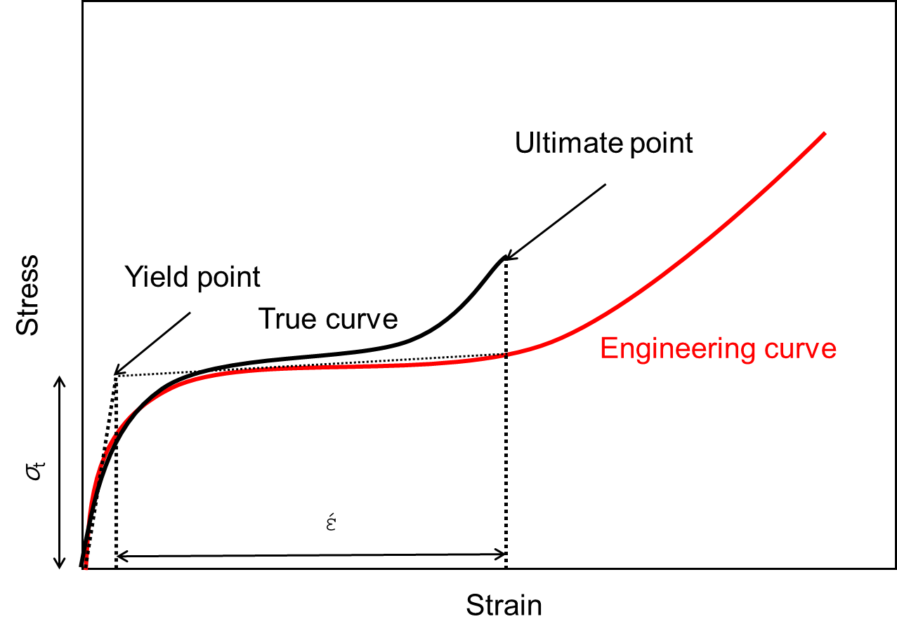

**Supplementary Figure 22**. Typical “engineering” and “true” stress−strain curves of **C-IP-SS**, and the transition stress and strain of **C-IP-SS**.

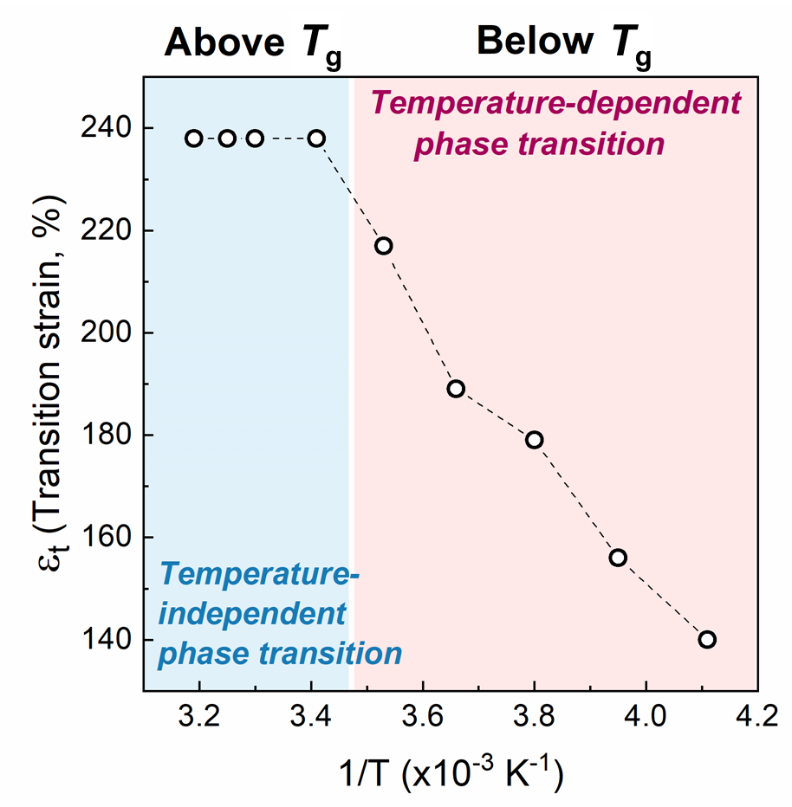

**Supplementary Figure 23**. Transition strain (έ) as a function of temperature (1/T) of **C-IP-SS**.

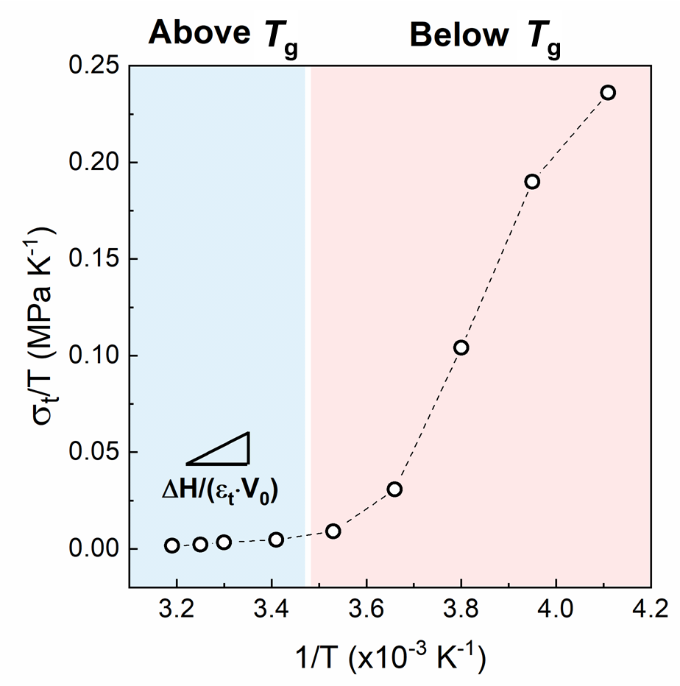

**Supplementary Figure 24**. Plot of (*σ*t/T) as a function of temperature (1/T) of **C-IP-SS**.

**3. Supplementary Note**

**Supplementary Note 1: Calculation of an enthalpy of strain-induced phase conversion for C-IP-SS**

The report by Miserez et al. evaluated an enthalpy change (Δ*H*) of phase transformation of reversibly deformable elastomers. Because this phenomenon is reminiscent of a shape-memory effect in a metallic alloy, it can be modelled by the Clausius-Clapeyron relation21. Our system was also applied to this relation because the mechano reversible change of internal structure of **C-IP-SS** thermodynamically resembles this biomaterial system.

Hence, based on the Gibbs free energy of a system, an applied force *f* can be express as a function of temperature and given by:

( $\frac{∂f}{∂T})= \frac{f}{T}-\frac{∆H}{T∙∆L}$ (1)

Or, being in a different form by considering the Clausius-Clapeyron relationship with force and length replacing pressure and volume:

${(\frac{∂(f/T)}{∂(1/T)})}_{P}=\frac{∆H}{∆L}$ (2)

Δ*L* and Δ*H* respectively represent the changes in length and enthalpy during strain-induced crystallization; temperature T and pressure P.

In our system, *f* indicates the force at a yielding point for the conformational change during reversible crystallization. Hence, the equation (2) can be expressed with respect to stress and strain as:

${(\frac{∂(σ_{t}/T)}{∂(1/T)})}_{P}=\frac{∆H}{ε_{t}∙V_{0}}$ (3)

*σ*t and *ε*t indicate the transition stress and strain, respectively, which are originally defined at stress-induced phase transition point defined in metal science. However, in polymer science, the *σ*t and *ε* are respectively defined by the stress and strain at the point of strain-hardening where amorphous phase is transformed to crystal phase. Typically, strain-hardening occurs from the beginning of yield point to the end of ultimate strength point22,23. In the tensile stress-strain curves of **C-IP-SS**, it is difficult to define the both points because **C-IP-SS** has a too long strain. It can be clear by comparison between the true and engineering curves21,24. The engineering curves were corrected to the true stress-strain curves by the measured Poisson’s ratios (Supplementary Fig. 22). As a result, the *σ*t and *ε* for particular temperature were obtained in Supplementary Table S4.

Then, according to equation (3), we constructed the plot of (*σ*t/T) versus the inverse of the temperature 1/T from our experimental results (Supplementary Figs. 23 and 24). The slope of the plot corresponds to the enthalpy change Δ*H* per unit volume *V*0 when *ε*t is temperature-independent.

In the temperature range of above *Tg* where the reversible transition occurs, *ε*t is constant and the plot of (*σ*t/T) gives a linear curve.

Finally, by solving equation (3), we obtained the enthalpy of the strain-induced crystallization of **C-IP-SS** at above *Tg* ≈ 6.47 cal cm−3 (Δ*H*/*V*0). Approximating the density of polyurethane (TPU) as 1.25 g cm−3, the enthalpy can be converted to 5.17 g cm−3.

**Supplementary References**

1. Wang, H., Yang, Y., Nishiura, M., Higaki, Y., Takahara, A. & Hou, Z. Synthesis of self-healing polymers by scandium-catalyzed copolymerization of ethylene and anisylpropylenes. *J. Am. Chem. Soc.* **141**, 3249-3257 (2019).

2. Zhang, L. et al. A highly efficient self‐healing elastomer with unprecedented mechanical properties. *Adv. Mater.* **31**, 1901402 (2019).

3. Li, F. et al. Facile fabrication of self-healable and antibacterial soy protein-based films with high mechanical strength. *ACS Appl. Mater. Interfaces* **11**, 16107-16116 (2019).

4. Guo, H., Fang, X., Zhang, L. & Sun, J. Facile fabrication of room-temperature self-healing, mechanically robust, highly stretchable, and tough polymers using dual dynamic cross-linked polymer complexes. *ACS Appl. Mater. Interfaces* **11**, 33356-33363 (2019).

5. Fan, W. et al. Achieving fast self-healing and reprocessing of supertough water-dispersed" living" supramolecular polymers containing dynamic ditelluride bonds under visible light. *ACS Appl. Mater. Interfaces* **12**, 6383-6395 (2020).

6. Fan, W., Jin, Y., Shi, L., Du, W. & Zhou, R. Transparent, eco-friendly, super-tough “living” supramolecular polymers with fast room-temperature self-healability and reprocessability under visible light. *Polymer* **190**, 122199 (2020).

7. Yan, C., Yang, F., Wu, M., Yuan, Y., Chen, F. & Chen, Y. Phase-locked dynamic and mechanoresponsive bonds design toward robust and mechanoluminescent self-healing polyurethanes: A microscopic view of self-healing behaviors. *Macromolecules* **52**, 9376-9382 (2019).

8. Song, Y., Liu, Y., Qi, T. & Li, G. L. Towards dynamic but supertough healable polymers through biomimetic hierarchical hydrogen‐bonding interactions. *Angew. Chem. Int. Ed.* **57**, 13838-13842 (2018).

9. Ha, Y.-m. et al. Robust and stretchable self-healing polyurethane based on polycarbonate diol with different soft-segment molecular weight for flexible devices. *Eur. Polym. J.* **118**, 36-44 (2019).

10. Lai, Y., Kuang, X., Zhu, P., Huang, M., Dong, X. & Wang, D. Colorless, transparent, robust, and fast scratch‐self‐healing elastomers via a phase‐locked dynamic bonds design. *Adv. Mater.* **30**, 1802556 (2018).

11. Zou, C. & Chen, C. Polar‐functionalized, crosslinkable, self‐healing, and photoresponsive polyolefins. *Angew. Chem. Int. Ed.* **59**, 395-402 (2020).

12. Hu, J., Mo, R., Jiang, X., Sheng, X. & Zhang, X. Towards mechanical robust yet self-healing polyurethane elastomers via combination of dynamic main chain and dangling quadruple hydrogen bonds. *Polymer* **183**, 121912 (2019).

13. Liu, J. et al. An advanced elastomer with an unprecedented combination of excellent mechanical properties and high self-healing capability. *J. Mater. Chem. A* **5**, 25660-25671 (2017).

14. Liu, M. et al. A high stiffness and self-healable polyurethane based on disulfide bonds and hydrogen bonding. *Eur. Polym. J.*, **124,** 109475 (2020).

15. Peng, Y., Yang, Y., Wu, Q., Wang, S., Huang, G. & Wu, J. Strong and tough self-healing elastomers enabled by dual reversible networks formed by ionic interactions and dynamic covalent bonds. *Polymer* **157**, 172-179 (2018).

16. Fu, D. et al. A facile dynamic crosslinked healable poly (oxime-urethane) elastomer with high elastic recovery and recyclability. *J. Mater. Chem. A* **6**, 18154-18164 (2018).

17. Chen, Y., Tang, Z., Liu, Y., Wu, S. & Guo, B. Mechanically robust, self-healable, and reprocessable elastomers enabled by dynamic dual cross-links. *Macromolecules* **52**, 3805-3812 (2019).

18. Yanagisawa, Y., Nan, Y., Okuro, K. & Aida, T. Mechanically robust, readily repairable polymers via tailored noncovalent cross-linking. *Science* **359**, 72-76 (2018).

19. Urban, M. W., Davydovich, D., Yang, Y., Demir, T., Zhang, Y. & Casabianca, L. Key-and-lock commodity self-healing copolymers. *Science* **362**, 220-225 (2018).

20. Duan, N., Sun, Z., Ren, Y., Liu, Z., Liu, L. & Yan, F. Imidazolium-based ionic polyurethanes with high toughness, tunable healing efficiency and antibacterial activities. *Polym. Chem.* **11**, 867-875 (2020).

21. Miserez, A., Wasko, S. S., Carpenter, C. F. & Waite, J. H. Non-entropic and reversible long-range deformation of an encapsulating bioelastomer. *Nat. Mater.* **8**, 910-916 (2009).

22. Lim, H. & Hoag, S. W. Plasticizer effects on physical–mechanical properties of solvent cast soluplus® films. *AAPS PharmSciTech* **14**, 903-910 (2013).

23. Stachurski, Z. Strength and deformation of rigid polymers: The stress–strain curve in amorphous pmma. *Polymer* **44**, 6067-6076 (2003).

24. Roylance, D. *Stress-strain curves*. (Massachusetts Institute of Technology Press, Cambridge, 2001).